
Bahria University Library Islamabad
Source: The News, Friday May 17, 2024

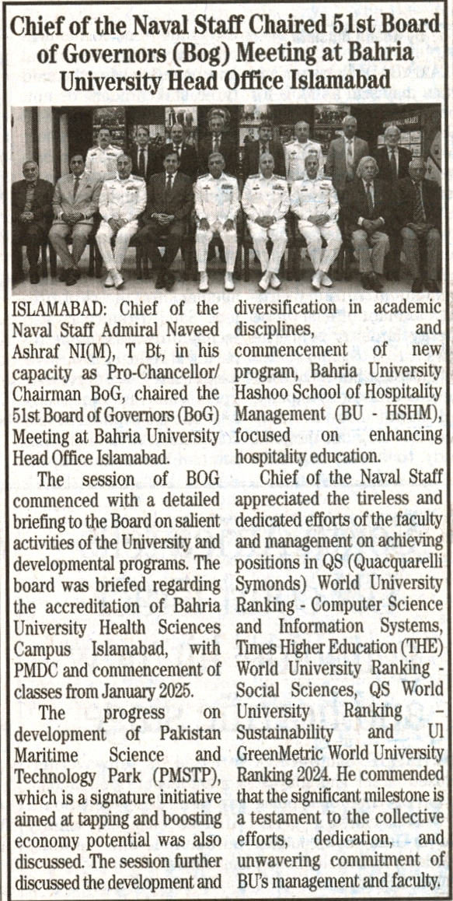

Bahria University Library Islamabad
Source: Pakistan Observer, Friday May 17, 2024

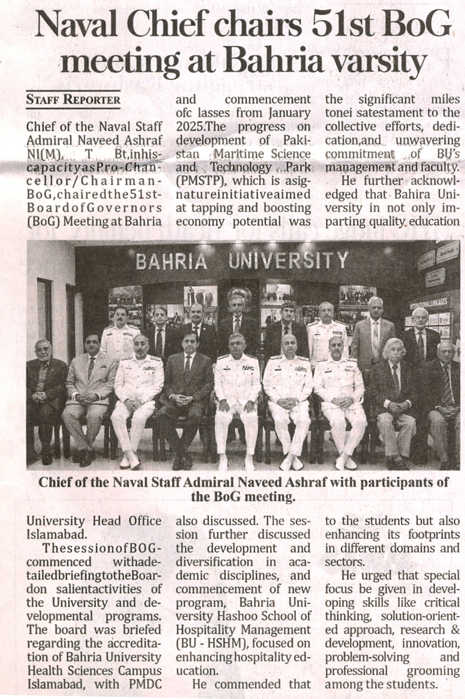

Bahria University Library Islamabad
Source: Express, Friday May 17, 2024

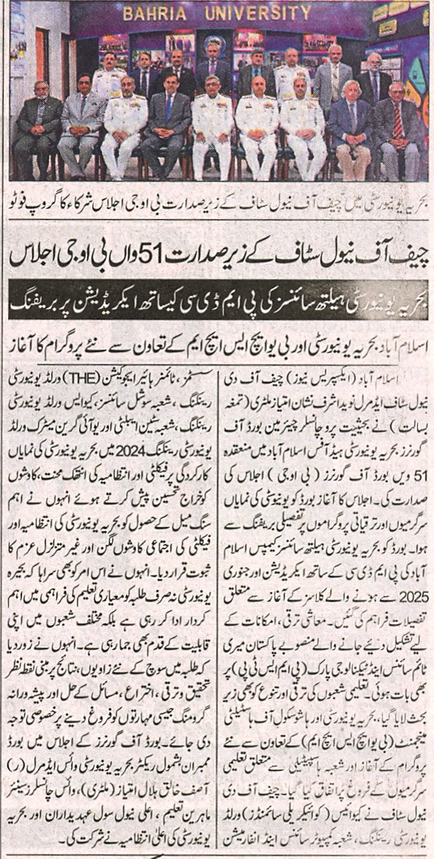

Bahria University Library Islamabad
Source: Dunya, Friday May 17, 2024

