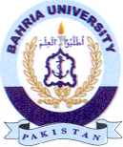Bahria University Library Islamabad
Source: Pakistan Observer, Tuesday May 14, 2024

