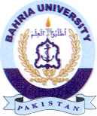Bahria University Library Islamabad
Source: Pakistan Observe, Monday May 13, 2024

