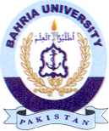Bahria University Library Islamabad
Source: Daily Jang, Saturday May 11, 2024

