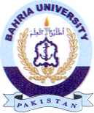Bahria University Library Islamabad
Source: The Nation, Friday May 10, 2024

