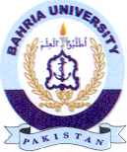Bahria University Library Islamabad
Source: Daily Express, Friday May 10, 2024

