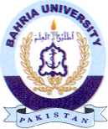Bahria University Library Islamabad
Source: The News, Sunday May 05, 2024

