Bahria University Library Islamabad
Source: The Nation, Thursday May 02, 2024

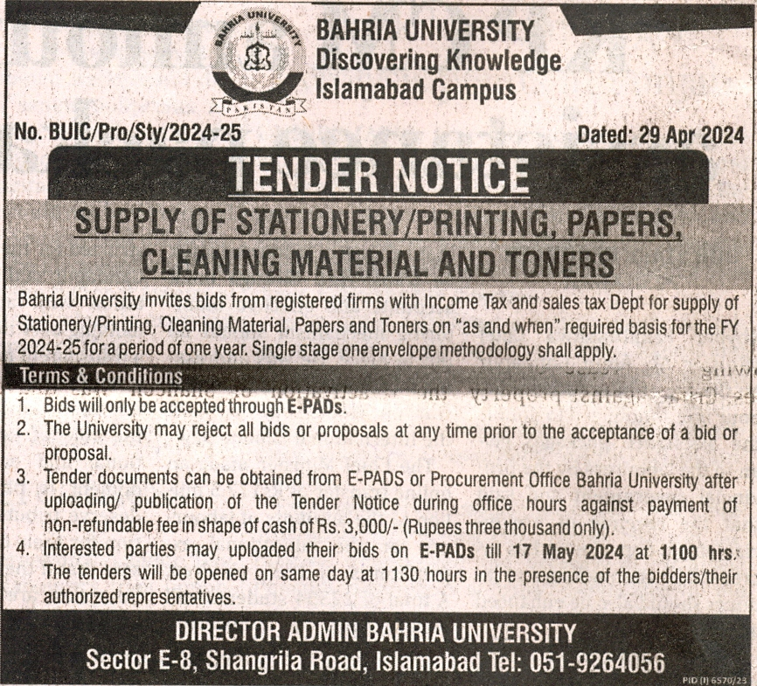

Bahria University Library Islamabad
Source: Daily Jang, Thursday May 02, 2024

