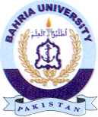Bahria University Library Islamabad
Source: Dawn & Daily Jang, Sunday Apr 21, 2024

