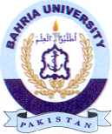Bahria University Library Islamabad
Source: The News, Sunday Apr 21, 2024

