Bahria University Library Islamabad
Source: The News, Tuesday Mar 05, 2024

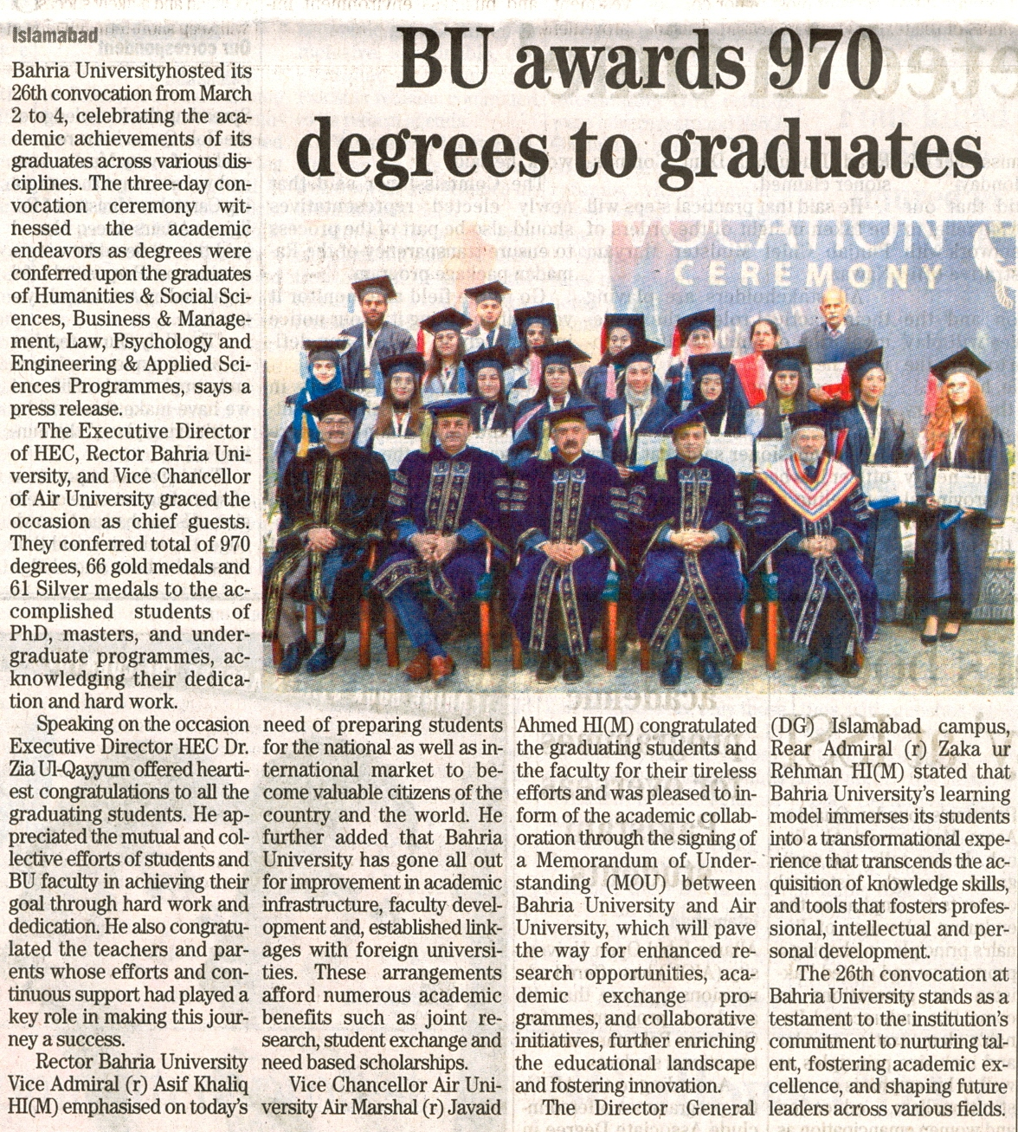

Bahria University Library Islamabad
Source: Daily Dunya , Tuesday Mar 05, 2024

