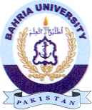Bahria University Library Islamabad
Source: Pakistan Observer, Tuesday Mar 05, 2024

