
Bahria University Library Islamabad
Source: The News, Wednesday Feb 28, 2024

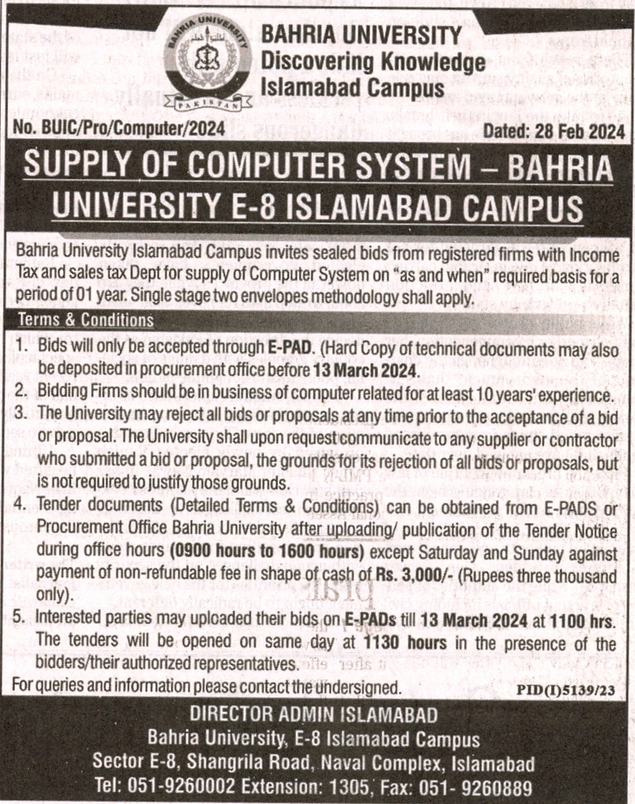

Bahria University Library Islamabad
Source: Nawa-i-Waqt, Wednesday Feb 28, 2024

