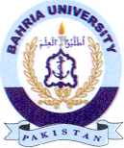Bahria University Library Islamabad
Source: Express Tribune, Sunday February 25, 2024

