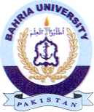Bahria University Library Islamabad
Source: The News, Tuesday Feb 27, 2024

