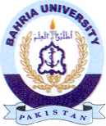Bahria University Library Islamabad
Source: The News , Monday Feb 07, 2024

