Bahria University Library Islamabad
Source: Nai Baat, Saturday Feb 24, 2024

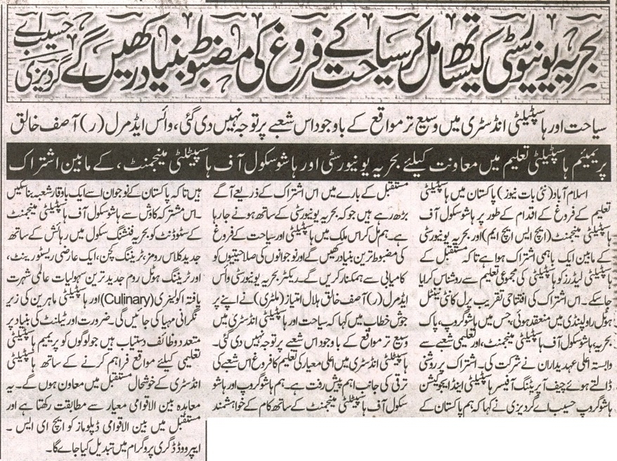


Bahria University Library Islamabad
Source: Daily Dunya, Saturday Feb 24, 2024

