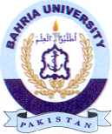Bahria University Library Islamabad
Source: Pakistan Observer, Saturday Feb 17, 2024

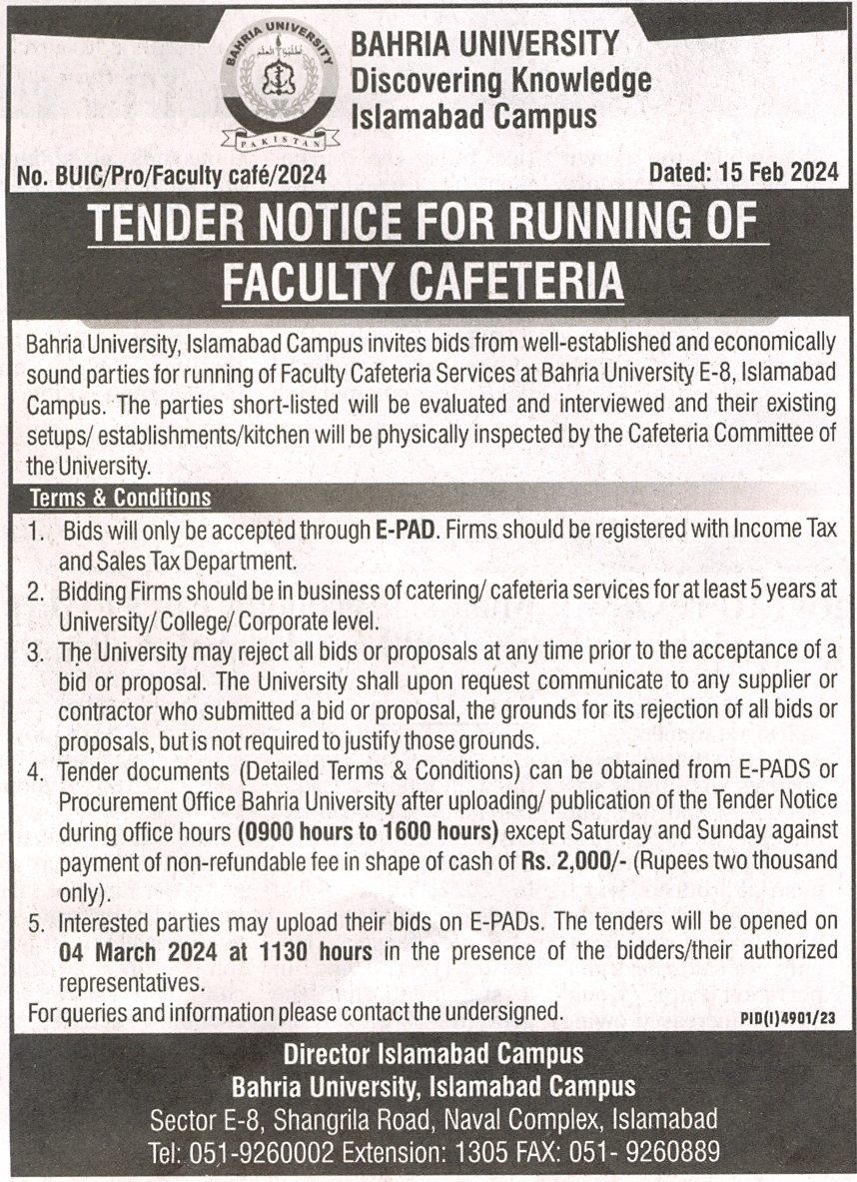

Bahria University Library Islamabad
Source: Daily Express, Saturday Feb 17, 2024

