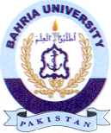
Bahria University Library Islamabad
Source: The News, Wednesday Feb 14, 2024

