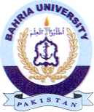Bahria University Library Islamabad
Source: Dawn & Jang, Wednesday Feb 07, 2024

