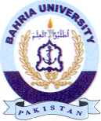Bahria University Library Islamabad
Source: DAWN, Wednesday Jan 31, 2024

