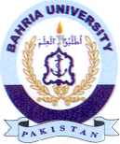Bahria University Library Islamabad
Source: The Express Tribune & Jang, Sunday Jan 28, 2024

