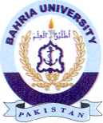Bahria University Library Islamabad
Source: The Express Tribune Nawa-i-Waqt, Friday Jan 26, 2024

