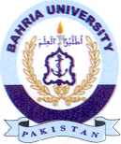
Bahria University Library Islamabad
Source: The News, Sunday Jan 14, 2024

