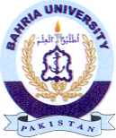Bahria University Library Islamabad
Source: The News & Express, Sunday Dec 31, 2023

