chapter 1
introduction
1.1 background

In recent years, the worldwide obesity pandemic that began in the latter half of the 20th century and continues into the 21st century has directly led to an exponential increase in the prevalence of type 2 diabetes mellitus (T2DM). In the early 1970s, Sims et al. established the term "diabesity" to describe the pathophysiological link between type 2 diabetes and obesity or overweight (Sims et al., 1973), and other researchers went on to investigate the underlying molecular mechanisms. Diabesity refers to the pathophysiological link between type 2 diabetes, obesity, and overweight (Kahn et al., 2006). Although bariatric surgery has been demonstrated to be the most effective treatment for obesity, it is intrusive, unpopular with many patients, costly, and generally underused in clinical settings. It induces diabetic remission and substantial weight reduction in a substantial proportion of people (Mingrone et al., 2015; Schauer et al., 2014). Many non-surgical treatments exist for treating diabetes (Pappachan and Viswanath, 2017). As a result, a huge proportion of diabetics are typically treated with medication alone.
Maintaining adequate glycemic control should be the primary objective for persons with diabetes and obesity, since type 2 diabetes is associated with an elevated risk of microvascular, macrovascular, and metabolic complications. Yet, a number of anti-diabetic medications, including insulin, can result in weight gain, which may have a negative impact on the progression of diabetes. While selecting antidiabetic drugs, doctors should prioritize balancing optimal glucose control with the patient's individualized diabetes treatment plan (Pappachan and Viswanath., 2017; Deol et al., 2017). If clinicians and fundamental scientists had a greater understanding of the molecular mechanisms underlying the effects of anti-diabetic drugs on obesity, they would be better positioned to establish a multimodal strategy with short- and long-term therapy goals for obesity.
As insulin molecules connect to hetero-tetrameric insulin receptors on the surface of target cells, insulin's effects on those cells become apparent. These receptors are positioned on the plasma membrane. Using animal models and human patients, it has been proven that there is an inverse connection between the density of insulin receptors on the surface of cells and the concentration of insulin in the surrounding environment. When there is a larger quantity of insulin in the plasma, the insulin receptors on the cell membranes are thereby downregulated. In instances of insulin resistance, a lower number of receptors per unit area of the cell membrane is one mechanism that produces hyperinsulinemia. Thus, larger insulin levels than would normally be required are required for insulin action to be effective.
Insulin increases weight gain by inhibiting protein catabolism, boosting lipogenesis, lowering the metabolic rate at rest, and accelerating fat synthesis. This exacerbates the effects of insulin's ability to stimulate fat accumulation (Mottalib et al., 2017). A slower rate of protein catabolism, which results in an increase in lean body mass, also contributes to weight gain (Jacob et al., 2006).
Insulin generated endogenously by the pancreas is transported to the liver through the portal vein, where it undergoes first hepatic processing. Unlike endogenously produced insulin, which has a greater effect on the liver, exogenously injected insulin reaches muscles and adipose tissues more efficiently. Hence, hepatic gluconeogenesis is inhibited (Russell-Jones and Khan, 2007). The regaining of weight lost after the correction of glycosuria, osmotic diuresis (which results from uncontrolled diabetes), and insulin-induced catabolism are other factors that contribute to weight gain in persons with diabetes (Conway et al., 2010). Any of these conditions can result in considerable weight gain in insulin-dependent persons. Hence, among insulin-treated diabetics, a rise in both total body weight and fat mass is related with a worsening of the disease.
Diabetologists are frequently required to use high-dose insulin regimens for effective glycemic control, even in patients who are morbidly obese, despite the relationship between the anabolic effect of insulin treatment and substantial weight gain. This diminishes the importance of treating obesity, a diabetes risk factor, in order to battle the disease. When a patient has symptomatic hyperglycemia, requires pre-operative glucose management, or has developed and is suffering from severe diabetes complications, insulin administration often becomes essential to their care (Pappachan and Viswanath, 2017).
Nonetheless, while treating obese T2DM patients, physicians must constantly evaluate the long-term consequences of diabetes and develop the most effective insulin regimens. Wang et al. (2015) discovered a strong correlation between the harshness of insulin regimens and the amount of weight gain. In light of this, clinicians must weigh the advantages and cons of each insulin regimen while treating diabetes.
Metformin is one of the most frequently prescribed medications in the worldwide pharmaceutical industry and has been extensively used for almost 40 years to treat and manage type 2 diabetes. Metformin is commonly assumed to have no effect on weight, despite the fact that several studies have demonstrated that it can cause weight loss of up to 2.9 kg and a 1% decrease in HbA1c. Particularly so when lifestyle adjustments were added (Meneghini et al., 2011; Domecq et al., 2015). A few months following the initial therapy session, the medication's effectiveness in aiding weight loss often becomes apparent.
The medical condition characterized by persistent high levels of blood glucose due to irregularities in insulin regulation is referred to as diabetes mellitus (DM) (Chaudhury et al., 2017). The metabolic abnormalities of proteins, lipids, and carbohydrates demonstrate the anabolic pancreatic hormone action of insulin. Metabolic disorders arise due to decreased insulin secretion and increased insulin resistance (IR) in the liver, skeletal muscles, and adipose tissue. Individuals with pre-diabetes typically do not exhibit any discernible symptoms, whereas unmanaged diabetes can result in pronounced and debilitating symptoms. Children with type 1 diabetes mellitus frequently exhibit symptoms such as excessive thirst (polydipsia), increased appetite (polyphagia), frequent urination (polyuria), compromised visual acuity, and weight reduction. Uncontrolled diabetes may result in the occurrence of ketoacidosis or nonketotic hyperosmolar syndrome, which can lead to severe consequences such as stupor, coma, and even mortality (Kharroubi & Darwish, 2015).
Diabetes is considered to be one of the most ancient ailments known to humankind. Three millennia ago, the ancient Egyptians documented it in their manuscripts. In 1936, a distinction was made between Type 1 and Type 2 diabetes mellitus. In 1988, type 2 diabetes mellitus was incorporated into the classification of metabolic syndrome (Figure 1).

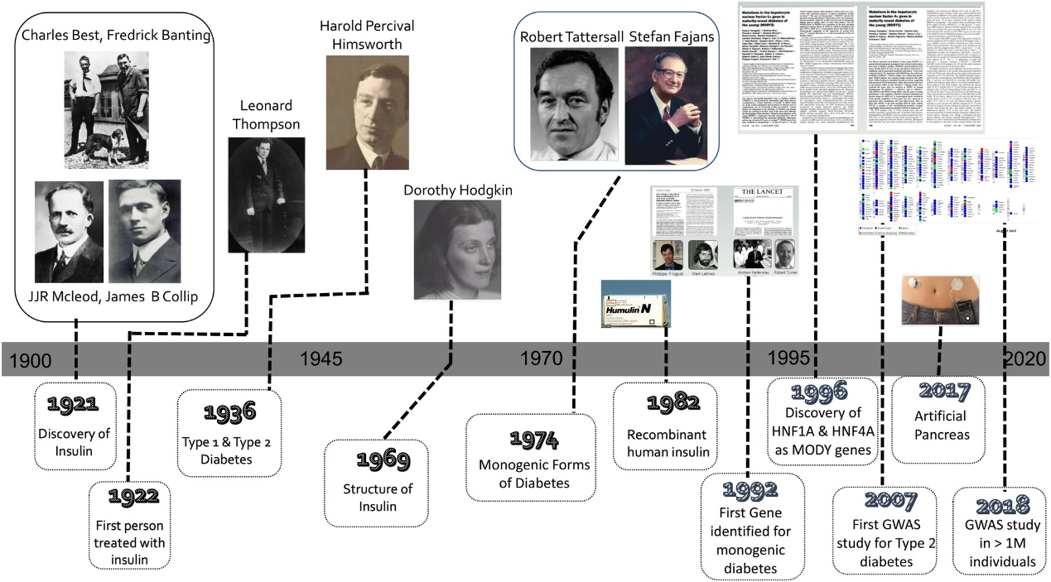
Figure 1: History of Diabetes (Lakhtakia et al., 2013)

Diabetes was depicted as a condition characterized by an overproduction of urine in Egyptian writings dating back to approximately 1500 B.C. The medical community in India has classified the condition into two distinct types, namely Type I and Type II, and have given it the name "Madhu meha" which translates to "Honey urine" due to its sweet taste that is known to attract ants. In the initial century A.D., the disease commonly referred to as "Diabetes" was named by Aretaeus the Cappadocian, who derived the term from the Greek word "Siphon." In 1798, John Rollo introduced the term "Mellitus," derived from the Latin word "sweet like honey," to differentiate this particular type from other variants that lack taste in their urine. According to Lakhtakia (2013), diabetic gangrene was treated with fenugreek, lupin, and zedoary seeds as documented in "The Canon of Medicine." Additionally, abnormal appetite was noted as a symptom of this condition.
Diabetes, a significant health concern, affects a staggering 500 million individuals worldwide. According to recent statistics, the global prevalence of diabetes among adults in 2019 was estimated to be 463 million, resulting in 4.2 million fatalities, and a significant expenditure of 760 billion dollars on treatment. According to a study conducted by Williams et al. (2020), the International Diabetes Federation (IDF) has projected a 51% increase in the number of individuals with diabetes by the year 2045, resulting in a total of 700 million cases.
In 2019, India, the US, and China exhibited the highest prevalence of diabetes among individuals aged 20 to 79 years. It is anticipated that this trend will persist and escalate until 2030. According to a study conducted by Williams et al. (2020), it is projected that Pakistan will exceed the United States in the number of individuals diagnosed with diabetes by the year 2045.
Pakistan and Sudan exhibit the highest diabetes prevalence rates in the MENA region, with figures of 19.9% and 22.1%, respectively. According to a study conducted by R. Williams et al. (2020), Pakistan, Iran, and Egypt have the highest number of individuals aged 20-79 with diabetes, with 19.4 million, 5.4 million, and 8.9 million cases, respectively.
In the years 2019, 2030, and 2045, Pakistan is projected to be among the top 10 countries with the highest prevalence of diabetes, impaired glucose tolerance, and undiagnosed diabetes among individuals aged 20 to 79 years. According to the IDF-2019 report, Pakistan was ranked fourth with a total of 19.4 million individuals diagnosed with diabetes in the year 2019. However, projections indicate that by the year 2045, Pakistan is expected to move up to the third position with an estimated 37.1 million individuals diagnosed with diabetes (Williams et al., 2020).
According to the IDF 2019 report, there are approximately 8.5 million individuals in Pakistan who have diabetes but have not yet received a formal diagnosis. According to a study conducted by R. Williams et al. in 2020, it has been projected that poor glucose tolerance will be ranked 7th and 8th in 2030 and 2045, respectively, with an estimated prevalence of 11.8 million and 16.5 million cases.
According to the International Diabetes Federation (IDF) in 2019, it was projected that there would be an estimated 248,300 deaths related to diabetes among women in the MENA region, while men were anticipated to experience 170,600 diabetes-related deaths. The prevalence of diabetes was found to be higher among women compared to men. According to a study conducted by R. Williams et al. in 2020, Pakistan recorded the highest mortality rate due to diabetes in 2019, with a total of 159,000 deaths.
In 2019, the cost of treating diabetes in the MENA region amounted to EUR 24.9 billion. According to a study conducted by Williams et al. (2020), it is projected that the healthcare expenses associated with diabetes will amount to EUR 38.6 billion by the year 2045.
Diabetes accounted for 15.2% of total healthcare expenditures. The highest economic burden of diabetes is observed in Lebanon (20.4%), Sudan (20.7%), and Pakistan (19.7%). The Sultanate of Oman boasts the lowest DM healthcare costs, which amount to 6.8%. The annual consumption of diabetics in the MENA region exhibits variability. According to the IDF, Pakistan's estimated value is $83.
Type 1 diabetes mellitus (T1DM) is characterized by insulin insufficiency resulting from the autoimmune destruction of β cells by T-cells. Prevalence is highest during the developmental stages of childhood, adolescence, and early adulthood. Frequent urination, excessive thirst, and increased appetite are commonly observed. Type 1 diabetes mellitus (T1DM) is characterized by a reduction in insulin levels, resulting in the development of hyperglycemia and ketoacidosis (Figure 2 and 3).
Pancreatic β-cell death is the underlying cause of immune-mediated diabetes mellitus (DM). The activation of T lymphocytes in an erroneous manner leads to the onset of pancreatitis and the production of antibodies that target β-cells. According to Kakleas et al. (2015), this has the potential to predict immune system failure.
Research suggests that the loss of insulin-secreting β-cells and inflammation may contribute to the development of T1DM induced by the immune system. Nevertheless, the causal relationship between autoantibodies and the onset of immune system-mediated Type 1 Diabetes Mellitus (T1DM) has not been established. The presence of pancreatic islet autoantibodies indicating normoglycemia is indicative of the potential development of immune system-induced Type 1 Diabetes Mellitus. The presence of autoantibodies targeting pancreatic tyrosine phosphatase (IA2A) and glucamic acid decarboxylase (GADA) may serve as an indication of type 1 diabetes mellitus (T1DM) that is induced by the immune system.
The HLA DR and DQ 120 genotypes, in conjunction with insulin-secreting pancreatic β-cells, are implicated in the development of T1DM as a result of immune system-mediated mechanisms. According to Kakleas et al. (2015), environmental factors such as mumps, enterovirus, cytomegalovirus, and ljungan virus, as well as dietary habits and vitamin D insufficiency, can have an impact on human health.
There exist several categories of undetermined etiology within the context of Type 1 Diabetes Mellitus. Individuals exhibit a lifelong deficiency of insulin and are susceptible to ketoacidosis, despite the absence of β-cell autoimmunity. Patients with idiopathic type 1 diabetes mellitus experience periodic episodes of ketoacidosis and insufficient levels of insulin. The etiology of Type 1 Diabetes Mellitus (T1DM) that arises spontaneously, also known as idiopathic T1DM, has been associated with genetic inheritance, albeit not with the Human Leukocyte Antigen (HLA) system. Type 2 diabetes mellitus (T2DM) is distinguished by diminished insulin production in the pancreatic β-cells and insulin resistance (IR) in the periphery. Al-Goblan and colleagues (2014). Elevated levels of plasma fatty acids (FA), enhanced muscle glucose absorption, and increased lipolysis are associated with the development of insulin resistance (IR). The process of hepatic gluconeogenesis ensues subsequent to the aforementioned events. Type 2 diabetes mellitus (T2DM) arises concomitantly from both insulin resistance and β-cell dysfunction. Al-Goblan (2014).
Gestational diabetes is a form of glucose intolerance that arises during pregnancy. Gestational diabetes may be caused by insulin resistance and excessive insulin secretion, as suggested by various studies (Association, 2004; Kampmann et al., 2015; Zhu & Zhang, 2016). Intrauterine growth restriction (IR) typically commences during the second trimester of pregnancy and persists until the third trimester. Insulin resistance (IR) may be induced by placenta-secreted growth hormone, TNF-α, and lactogen. During pregnancy, steroid hormones such as estrogen, progesterone, and cortisol elevate the glucose insulin ratio, leading to compensatory insulin production to counteract insulin resistance. According to Alfadhli (2015), glucose intolerance can be caused by various factors such as enhanced adipose tissues, maternal adipose deposition, decreased physical activity, and high caloric intake.
Monogenic diabetes is caused by abnormalities in a single gene. Accurate diagnosis is essential in elucidating the etiology of an illness, identifying familial risk factors for diabetes, and managing therapeutic interventions. Effective management of diabetes is necessary to prevent long-term complications (Szopa et al., 2015).
Monogenic diabetes encompasses a range of genetic disorders that result in diabetes. These disorders include maturity-onset diabetes, which is associated with mutations in genes such as glucokinase, HNF1A, HNF4A, and ABCCB. Renal cysts and diabetes are linked to mutations in the HNF1B gene, while maternity inherited diabetes and deafness are associated with mutations in the mtDNA 3243 gene. Permanent neonatal diabetes is caused by mutations in genes such as KCNJ11 and insulin, while delay epilepsy and transient neonatal diabetes are linked to mutations in the 6q24 gene. Other monogenic diabetes disorders include Wolfram syndrome, Immunodysregulation polyendocrinopathy enteropathy X-linked syndrome, and Wolcott-Rallison syndrome.
Type 1 and Type 2 Diabetes Mellitus (T1DM and T2DM) have been found to induce modifications in the exocrine pancreas, leading to impaired functionality of both acinar and ductal cells. The etiology and clinical manifestations of exocrine pancreatopathy resulting from diabetes remain unclear. The investigation of exocrine-mediated diabetic pancreatopathy is necessary to identify optimal therapeutic approaches and differentiate it from chronic pancreatitis, as stated by Mohapatra et al. (2016). Exocrine pancreas diseases encompass neoplasia, trauma, pancreatopathy, cystic fibrosis, hemochromatosis, and fibrocalculous pancreatitis, as stated by the Association (2017) (Figure 2 and 3).

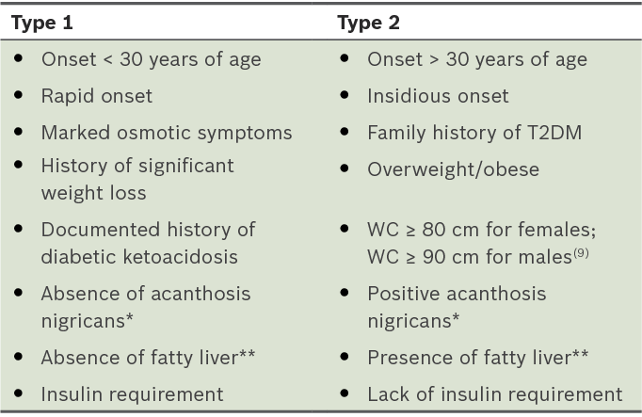
Figure 2: T1DM and T2DM Diabetes (Association 2017)

The global prevalence of hyperglycemia and diabetes is attributed to drug usage. The administration of drugs has been observed to induce insulin resistance or toxicity in pancreatic cells, thereby augmenting gluconeogenesis. Antihypertensive medications do not generate glucose. Thiazide diuretics, β-blockers, renin-angiotensin system inhibitors, and calcium channel blockers have been found to elevate glycemic profiles. Lipid-modifying agents, such as statins, have the potential to induce hyperglycemia and diabetes. Nicotinic acid modifies glycemic events. The administration of high or moderate doses of fluoroquinolones has the potential to induce lethality. The influence of glucose metabolism is affected by nucleoside reverse transcriptase and protease inhibitors. The administration of pentamidine has been observed to negatively impact the maintenance of glucose homeostasis in the pancreas. The administration of phenytoin and valproic acid has been observed to have an impact on glycemic events. The administration of second-generation antipsychotics has been found to induce insulin resistance, hyperglycemia, ketoacidosis, and diabetes. Elevated dosages of antidepressants have been linked to the onset of diabetes. According to the Association (2017), the administration of Theophylline and β-adrenergic agonists may result in hyperglycemia in individuals with ketoacidosis.
The administration of glucocorticoids has been found to induce steroid diabetes. Calcineurin inhibitors have been observed to decrease insulin secretion from pancreatic β cells, leading to the development of hyperglycemia. Oral contraceptives that are rich in estrogen have the potential to induce hyperglycemia. According to Fathallah et al. (2015), the administration of growth hormone and somatostatin drugs results in an elevation of glucose levels.
As per the World Health Organization's report from 2019, cortisol, glucagon, growth hormone, and epinephrine exhibit antagonistic effects towards insulin processes. The occurrence of diabetes has been found to be associated with the secretion of hormones induced by endocrine disorders. The administration of treatment for hormone excess has the potential to alleviate hormone-mediated hyperglycemia. The occurrence of diabetes is attributed to the inhibition of pancreatic insulin secretion by somatostatinoma, which is a tumor that originates from the delta cells of the pancreas. Effective management of tumors is contingent upon maintaining normal glucose levels. The source cited is "Organization" from the year 2019. Diabetes can be caused by various medical conditions such as Cushing syndrome, glucagonoma, hyperthyroidism, acromegaly, pheochromocytoma, and other similar ailments.
Metformin's ability to cure diabetes and obesity is contingent upon many mechanisms, including reduction of hepatic gluconeogenesis, enhancement of peripheral tissue (muscle) insulin sensitivity, and the anorexiant effect on users. Some of the several mechanisms of action of metformin are incompletely understood. Activation of adenosine monophosphate (AMP)-activated protein kinase (AMPK), inhibition of mitochondrial respiratory chain and cyclic AMP production with reduced activation of protein kinase A, and mitochondrial glycerophosphate dehydrogenase, in addition to potential effects on gut microbiome, are among the proposed mechanisms (Zhou et al., 2001; Madiraju et al., 2014; Rena et al., 2013).
According to the findings of a clinical study conducted as part of the Diabetes Prevention Program (DPP), the use of metformin was related with a 31% reduction in the prevalence of type 2 diabetes in obese individuals at high risk who had impaired glucose tolerance (IGT) (Aroda et al., 2017). These data demonstrate conclusively that taking metformin can benefit diabetic patients. Metformin treatment has been proven to benefit polycystic ovarian syndrome (PCOS), gestational diabetes mellitus (GDM), non-alcoholic fatty liver disease (NAFLD), non-alcoholic steatohepatitis (NAS), and cancer when paired with lifestyle modifications (Wu et al., 2015).
By inhibiting the enzyme DPP-4 from degrading GLP-1 and glucose-dependent insulinotropic polypeptide (GIP), these incretin enhancers preserve the active state of the hormones produced by incretins. GLP-1 and GIP both stimulate a glucose-dependent insulin response in the pancreas. In addition, GLP-1 inhibits the production of glucagon, which slows stomach emptying and heightens sensations of fullness. Using DPP-4 inhibitors improved glycemic control, insulin secretion, and beta-cell function in both animal models and human patients with type 2 diabetes. DPP-4 inhibitors lower postprandial glucose excursion, fasting plasma glucose, and HbA1c levels relative to placebo, according to studies. Moreover, these inhibitors reduce the risk of weight gain and hypoglycemia. In addition, this family of drugs has enhanced pancreatic beta cell activity despite having no effect on insulin resistance (Lyu et al., 2017).

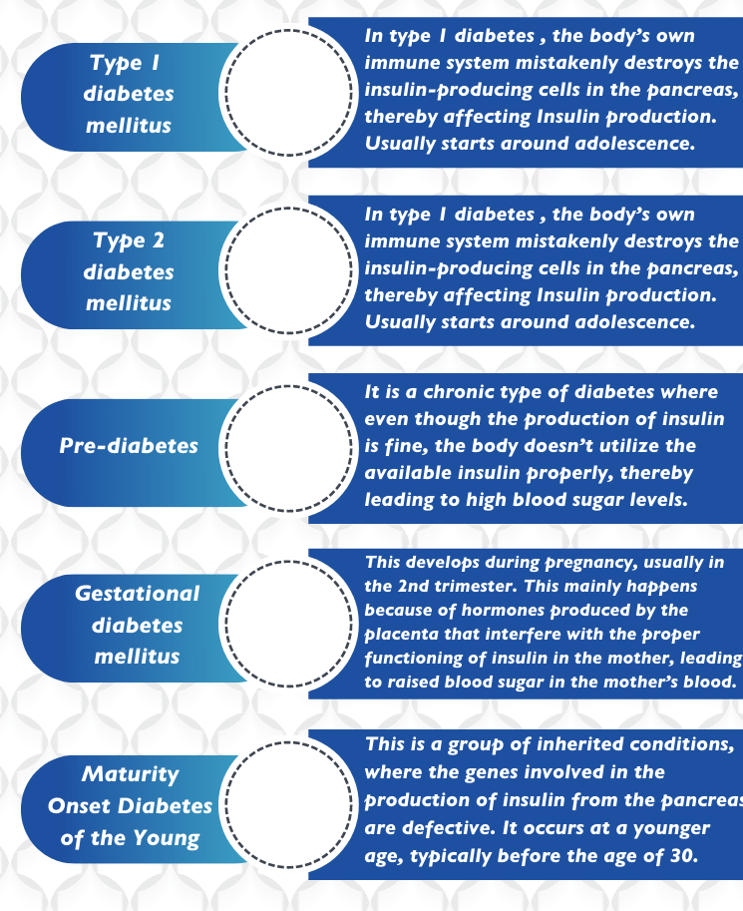
Figure 3: Types of diabetes (Association 2017).

DPP-4 inhibitors now available on the market include sitagliptin, vildagliptin, saxagliptin, linagliptin, alogliptin, gemigliptin, trelagliptin, omarigliptin, evogliptin, gosogliptin, teneligliptin, and anagliptin. There are less recent agents that are still in the development phase. Average HbA1c levels were discovered to have fallen by 0.5% to 1.0%, and the pharmaceutical class has no effect on body weight (Pappachan et al., 2015). If there are no contraindications, this attribute should drive physicians who treat obese patients with diabetes. Asians who took DPP-4 inhibitors exhibited significantly greater gains in HbA1c reduction and pancreatic -cell activity than Caucasians did (Cai et al., 2015). Considering that Asians have a considerably greater prevalence of type 2 diabetes than Caucasians with comparable BMIs, this intriguing discovery should serve as a warning to physicians who treat Asian patients with the condition. Patients at a higher risk of heart failure should be administered these drugs with caution, since heart failure hospitalization rates were shown to be higher in this drug class (Guo et al., 2017), particularly in those with diabetes (HF).
The majority of sodium glucose cotransporters, often known as SGLT, are located in the renal tubules. In these tubules, glucose reabsorption occurs via the subtypes SGLT-1 and SGLT-2. In healthy individuals, the renal glomeruli filter approximately 180 g of glucose per day, of which 90% is reabsorbed by SGLT-2 and 10% by SGLT-1 (Gallo et al., 2015). Moreover, SGLT-2 overexpression in the early stages of diabetes is associated with and accompanied by renal hyper filtration (Hostetter et al., 1982; Cherney et al., 2014). As was initially noticed more than 80 years ago, the pharmacological inhibition of SGLT receptors by phlorizin can produce renal glycosuria. In the past 10 years, only more modern SGLT-2 family medicines have undergone clinical trials. In recent years, however, the medical community and the pharmaceutical industry have given considerable attention to this family of medicines due to its major advantages in the management of diabetes, notably as an insulin-independent method for reducing blood glucose levels. Currently, only dapagliflozin, canagliflozin, empagliflozin, ertugliflozin, tofogliflozin, and ipragliflozin are available as SGLT-2 inhibitors, but several more compounds are in various phases of research. These medications can be taken alone as monotherapy, however they are typically paired with other diabetes medications as add-on therapy.
According to a recent meta-analysis by Vasilakou et al. (2013), the use of SGLT-2 inhibitors decreased HbA1c by an average of 0.66 percent, body weight by an average of 1.8 kg, and systolic blood pressure by an average of 4.45 millimeters of mercury when compared to placebo. There are some positive benefits of treating diabetes and obesity. Current clinical studies employing these medications shown better renal outcomes and beneficial impacts on cardiovascular mortality and morbidity (Zinman et al., 2015 and Wanner et al., 2016). The suggested methods through which SGLT-2 inhibitor medicines provide some protection for the cardiovascular system (Abdelgadir et al., 2018). The weight loss associated with these medicines is caused by the caloric deficit caused by glycosuria. Urinary tract infections and vaginal fungal infections (caused by increased glucose excretion via the kidney) are the most often reported adverse effects, and both may cause a patient to discontinue treatment (Vasilakou et al., 2013; Zinman et al., 2015; Wanner et al., 2016; Abdelgadir et al., 2018).
Empagliflozin was utilized in the first EMPA-REG study, and it was revealed that as long as SGLT-2 inhibitors were administered, the hypoglycemic effects of the medicine steadily declined (Zinman et al., 2015). One possible explanation for this phenomenon is enhanced gluconeogenesis in the liver as a result of increased glucagon synthesis by pancreatic alpha cells (Bonner et al., 2015; Hattersley and Thorens, 2015). Occasionally, hyperglucagonemia may result in fast fat breakdown, which may ultimately lead to ketoacidosis. This is a serious side effect associated with the use of SGLT-2 inhibitors in patients with poorly managed diabetes, and it may be dangerous.
To maintain adequate glycemic control, the majority of individuals with T2DM will take more than one anti-diabetic medication at some point during their diabetes journey. The severity of a patient's diabetes is one of the most important determinants of whether they must undergo therapy with many medications, which can be difficult for physicians to control. As previously mentioned, therapy with different diabetic drugs, particularly insulin, that have the potential to cause weight gain may exacerbate diabetes cases that are already severe. Hence, while determining the optimal diabetes treatment plan for a patient, rational drug combinations that have the lowest potential of aggravating diabetes and the highest possibility of avoiding complications such as cardiovascular disease and renal disease should be considered. To provide patients with the best possible care, this should be done (Pappachan and Viswanath. 2017).
Metformin is still recognized as the therapy of choice for the medical control of diabetes in individuals who do not have any contraindications, such as severe liver or renal disease or medication intolerance. If metformin fails to effectively treat type 2 diabetes, second-line glycemic control medicines must be added. These drugs, which will vary depending on the degree of hyperglycemia, should have the least potential to cause weight gain in order to treat diabetes and its accompanying complications, particularly in individuals who are poor candidates for metabolic surgery. The primary problem for individuals with uncontrolled hyperglycemia is glucotoxicity, which reduces the amount of endogenous insulin secreted and its activities at the tissue level. Keeping adequate glucose control in such settings has been demonstrated to reduce glucotoxicity in animal and human models (Shimo et al., 2015). To decrease glucotoxicity (at pancreatic and target tissue levels) in a patient with uncontrolled diabetes and severe hyperglycemia receiving just metformin, it is always optimum to initiate insulin as an add-on medicine. This is because other anti-diabetic medications are frequently ineffective in such conditions (Solomon et al., 2012; Campos, 2012).
This combination has promise for the early control of diabetes in people who do not choose to use injections or are intolerant to GLP-1RAs, as it does not alter body weight and utilizes multiple mechanisms of action.
In a recent, extensive retrospective study, the addition of DPP-4 inhibitors to metformin resulted in enhanced weight loss and greater decreases in fasting glucose and Hba1c. Contrast this with the group that received low dosages of glicalzide (Fadini et al., 2018). Nevertheless, a previous systematic review and meta-analysis raised concerns that the anti-diabetic efficacy of DPP-4 inhibitors may deteriorate with time (Esposito et al., 2014). Although this conclusion was not consistently seen in a more recent meta-analysis, it may be required in the future to add or change additional diabetes medications in certain cases (Sharma et al., 2017).
Long-term diabetes patients frequently require a mix of anti-diabetic medications. One must find a balance between the expense of the therapy, the patient's capacity to tolerate the therapy, the therapeutic aim, and the patient's freedom of choice when selecting a diabetic treatment regimen based on the available scientific information. Combinations of weight-loss-inducing drugs, such as metformin, DPP-4 inhibitors, and SGLT-2 inhibitors, might be an excellent alternative for patients who are hesitant to take GLP-1RA injections (Pappachan and Viswanath. 2017). The addition of an SGLT-2 inhibitor to the commonly used metformin-sulphonyl urea combo regimen resulted in the greatest improvement in diabetes, as measured by a weight loss of 1.43 to 2.07 kg, despite the fact that other anti-diabetic drugs resulted in comparable reductions in HbA1c levels (Mearns et al., 2015a, Mearns et al., 2015b). In this investigation, the addition of pioglitazone, insulin glargine, and sitagliptin to the previously indicated regimen increased body weight by 1.48 to 3.56 kg compared to the placebo or controls. According to another meta-analysis, adding an SGLT-2 inhibitor or GLP-1RA to a failed metformin-sulphonyl urea combo treatment resulted to weight loss of 1.71 kilograms or 1.14 kilograms, respectively, as well as a drop in systolic blood pressure and better diabetes management (Lozano-Ortega et al., 2016).
Therapeutic aims for glycemic control in people with diabetes are same to those in patients with T2DM (Pappachan and Viswanath. 2017). Current pharmacological regimens, as outlined in this article, have not been linked to a substantial decrease in diabetes in large-scale randomized studies. Physicians should be able to maximize the treatment of this complicated clinical condition by employing a comprehensive strategy that focuses on preventing weight gain via the use of suitable medication combinations and the promotion of healthy lifestyles.
The kidney plays a vital role in maintaining glucose homeostasis. Plasma glucose physiologically is freely filtered in the kidney glomeruli and reabsorbed into the circulation. The sodium glucose co-transporter 2, located in the proximal tubule, is responsible for the glucose reabsorption from the glomerular filtrate in the tubular lumen, which is independent of insulin. Empagliflozin, a SGLT2 inhibitor, reduces glucose reabsorption from the glomerular filtrate to increase urinary glucose excretion (UGE) and reduces hyperglycemia in patients with type 2 diabetes. In addition to the anti-diabetic activity, empagliflozin is also found to be beneficial to the weight loss and moderate reduction in systolic blood pressure (SBP). Meanwhile, there is no increase in hypoglycemia risk using empagliflozin. Extensive clinical trials demonstrated that empagliflozin given as monotherapy or as add-on therapy was well tolerated and significantly reduced HbA1c, fasting plasma glucose (FPG), body weight versus placebo, such as HbA1c (−0.53 to −1.61%), body weight (−2.0 to −3.4 kg), and SBP (−1.7 to −6.4 mmHg). EMPA-REG OUTCOME (Funded by Boehringer Ingelheim and Eli Lilly; EMPA-REG OUTCOME ClinicalTrials.gov number, NCT01131676) showed that there were significant differences between empagliflozin group and placebo group in the rates of death from cardiovascular causes (3.7% vs 5.9%, 38% relative risk reduction), hospitalization for heart failure (2.7% vs 4.1%, 35% relative risk reduction) and death from any cause (5.7% vs 8.3%, 32% relative risk reduction), which demonstrated that empagliflozin could reduce cardiovascular risk in patients with type 2 diabetes.
Linagliptin is a diabetic treatment because it inhibits DPP-4, the enzyme responsible for the breakdown of the incretin hormones glucagon-like peptide-1 (GLP-1) and glucose-dependent insulinotropic polypeptide (GIP) (Forst & Pfützner, 2012). Intestinal L- and K-cells secrete incretins, which are responsible for regulating glucose homeostasis, after a meal. They do this by increasing insulin production and release from pancreatic cells when blood glucose levels are normal or elevated. In addition, GLP-1 blocks pancreatic beta cells from generating glucagon, so decreasing the amount of glucose produced by the liver. By inhibiting the DPP-4 enzyme, linagliptin extends the duration that the intestinal incretins GLP-1 and GIP are active in the body. By increasing glucose-dependent insulin secretion and decreasing glucagon production, it is possible to achieve optimum glucose homeostasis during both fasting and postprandial stages (Forst & Pfützner, 2012). This will result in perfect glucose control in each of these situations. In clinical studies, linagliptin was shown to enhance glycemic management by reducing HbA1c and FPG while having a similar incidence of hypoglycemia and body weight change as placebo (A. Barnett et al., 2012; Taskinen et al., 2011). Even if the rate of hypoglycemia and change in body weight were comparable to the placebo, the same results were obtained. As a result of its incretin-enhancing properties, linagliptin has been shown to retain the bulk and functioning of pancreatic beta cells, hence reducing the progression of the illness (Van Genugten et al., 2012). It has been proven that linagliptin has pharmacological effects on the cardiovascular system, including beneficial effects on blood pressure and the functioning of the left ventricle (Deacon & Holst, 2010).
Both the Comprehensive Diabetes Management Algorithm published in 2013 by the AACE and the 2015 Position Statement published by the ADA/EASD (Garber et al., 2013; Inzucchi et al., 2012) encourage the adoption of combination treatment, which consists of multiple hypoglycemic drugs with different mechanisms of action that complement one another. The anti-diabetic medications empagliflozin and linagliptin are present in Glyxambi®. These anti-diabetic drugs have complimentary modes of action that allow them to maintain glucose homeostasis in people with type 2 diabetes. Empagliflozin works by preventing the kidneys from reabsorb glucose, which reduces the quantity of glucose in the urine. Prior research has demonstrated that the use of SGLT2 inhibitors enhances endogenous glucose production (Merovci et al., 2014). In a similar manner, empagliflozin would reduce fasting plasma glucose (FPG) and postprandial plasma glucose while enhancing endogenous glucose synthesis (Ferrannini et al., 2014). (PPG). After four weeks of therapy, the increase in glucose levels would diminish. Linagliptin, a DPP-4 inhibitor, has the potential to block the rise in endogenous glucose synthesis, hence enhancing the efficacy of empagliflozin to reduce blood glucose levels. In addition, research indicates that the combination is effective in enhancing insulin sensitivity and beta cell function. The American Diabetes Association recommends a glycosylated hemoglobin (HbA1c) goal of less than 7% (Nathan et al., 2009). In a clinical investigation with the combination of empagliflozin and linagliptin, more than half of the patients attained HbA1c levels of less than 7% (Lewin et al., 2015). Empagliflozin and linagliptin are both extremely successful in achieving glucose homeostasis, but there are additional reasons to consider taking them together. In agreement with the findings of Cherney et al., empagliflozin has the capacity to reduce renal hyperfiltration, which represents intraglomerular pressure. It was observed that empagliflozin coupled with linagliptin consistently aids in weight loss (Cherney et al., 2014). Unlike linagliptin, empagliflozin reduces systolic blood pressure by pharmacologic mechanisms including weight loss, osmotic diuresis, decreased arterial stiffness, and direct vascular effects. Combining empagliflozin and linagliptin provides considerable benefits in terms of exerting hypoglycemic effects and promoting kidney, body weight, and blood pressure health (DeFronzo et al., 2015).
When administered alone or in combination, linagliptin and empagliflozin were well tolerated by healthy individuals (Friedrich et al., 2013). A bioequivalence research determined that co-administering similar dosages of empagliflozin and linagliptin was bioequivalent to co-administering the two medicines individually. There was no evidence that the clinical safety data, vital signs, or hypoglycemia altered at any stage during the study. The maximum exposure to linagliptin and empagliflozin reduced by 39% and 32%, respectively, notwithstanding the insignificance of these alterations on clinical outcomes (Kim & Deeks, 2015).
There are no clinically significant changes in pharmacokinetic parameters between healthy volunteers and patients with type 2 diabetes for any of the two medications. Empagliflozin reaches its peak plasma concentrations one and a half hours after oral administration, and it is efficiently absorbed (Kim & Deeks, 2015). The peak plasma concentrations of a single oral dosage of linagliptin are reached between 0.7 and 3 hours after administration. When several oral doses of linagliptin and empagliflozin were administered, steady-state levels were attained on days 5 and 7, respectively (Friedrich et al., 2013). When empagliflozin or linagliptin was provided alone or in combination with the other, there were no changes in their systemic exposure, according to the results of a randomized, open-label, crossover study (Friedrich et al., 2013).
Empagliflozin's mean volume of distribution was 73.8 liters, whereas linagliptin's was 1,110 liters at steady state following oral administration to healthy persons. The plasma protein binding efficiency for empagliflozin is 86.2%, but it fluctuates with concentration for linagliptin, from 99.9% at 1 nmol/L to 75% to 89.0% at 30 nmol/L. Plasma binding is identical in patients with renal or hepatic impairment (Kim & Deeks, 2015).
Empagliflozin's primary metabolic process is glucuronidation, which produces 2-O-, 3-O-, and 6-O-glucuronide (Brand et al., 2012). Empagliflozin does not contain any major metabolites in human plasma, and researchers have not discovered any significant metabolites in human plasma. Even if some metabolism is occurring, the cytochrome P450 system is not involved in any manner. Empagliflozin's principal metabolic activity is glucuronidation, which is mediated by uridine 5'-diphospho-glucuronosyltransferases UGT2B7, UGT1A3, UGT1A8, and UGT9 (Kim & Deeks, 2015). The possibility of interactions between the P-glycoprotein transporter substrate empagliflozin and other substrates is extremely low. Empagliflozin plasma concentrations are expected to increase in the presence of renal and hepatic impairment, even if no dosage adjustment is necessary. The majority of linagliptin is reported to be excreted in its original form following oral treatment, indicating that metabolism is a minor elimination mechanism (Deacon & Holst, 2010). When administered at therapeutic levels to humans, linagliptin produces substantial interactions with plasma proteins. The saturable and highly-affine binding of linagliptin to soluble DPP-4 gave evidence that the plasma concentration of the medication is dose-dependent (Kim & Deeks, 2015).
16 to 20 percent of the authorized dose of empagliflozin is eliminated in the urine when administered to healthy volunteers (Brand et al., 2012; Macha et al., 2012). Empagliflozin's urinary excretion is unaffected by concurrent administration of linagliptin, and linagliptin's urinary excretion is unaffected by concurrent administration of empagliflozin and linagliptin. According to a population pharmacokinetic research, the elimination half-life of empagliflozin is 12.4 hours. When [14C]-empagliflozin was delivered to healthy individuals, about 95.6% of the drug's radioactivity was detected in their urine (54.4% of the total) and feces (41.6% of the total) (Kim & Deeks, 2015). Less than 5% of the total dosage is eliminated through the kidneys, whereas nonrenal elimination pathways account for the bulk of linagliptin elimination (Macha et al., 2012). The elimination half-life of linagliptin varied from 70 to 80 hours when the dose was less than 50 mg, and from 128 to 184 hours when the dose was higher than 50 mg. Empagliflozin had no effect on the amount of linagliptin that was excreted in the urine when the patient was in a steady state for 24 hours (Friedrich et al., 2013).
Patients with type 2 diabetes who lose weight have several advantages, including a reduced risk of insulin resistance and cardiovascular disease. Recommendations from the medical community encourage obese individuals with type 2 diabetes to reduce their overall body mass. Like with other SGLT 2 inhibitors, empagliflozin increased glucose excretion in the urine, resulting in a reduction in body weight (A. H. Barnett, 2013). Nevertheless, linagliptin had no effect on body weight. According to two clinical investigations, linagliptin and empagliflozin did not differ significantly when compared to the separate empagliflozin components, but they did contribute to a significant decrease in weight from baseline in end points when compared to linagliptin (DeFronzo et al., 2015; Lewin et al., 2015). Both studies reached the same conclusion.
A significant body of clinical research provides conclusive evidence that people with diabetes and hypertension have an increased risk of developing cardiovascular disease (Chen et al., 2011). In addition, several studies have demonstrated that having a lower blood pressure reduces the risk of cardiovascular disease (Schrier et al., 2002). According to new guidelines released by the Expert Panel Report, the American and International Societies of Hypertension, and the American Heart Association individuals with diabetes are critical to achieving a blood pressure goal of less than 140/80 mmHg (James et al., 2014; Weber et al., 2014). Among other putative blood pressure-lowering mechanisms, the osmotic diuretic effects, weight reduction, decreased arterial stiffness, or direct vascular activities of empagliflozin may all be beneficial (Cherney et al., 2014). Linagliptin has no effect on blood pressure, nor does it affect weight loss (Taskinen et al., 2011). Two clinical trials comparing linagliptin treatment alone to empagliflozin/linagliptin combination therapy indicated a significant difference between the two in terms of changes in blood pressure from baseline in the studies' endpoints. In contrast, studies have shown that empagliflozin alone has the same ability to detect significant changes as empagliflozin/linagliptin (DeFronzo et al., 2015; Lewin et al., 2015).
Those with type 2 diabetes who received empagliflozin and linagliptin simultaneously were generally well tolerated, according to safety and tolerability evidence from published clinical study. These outcomes were comparable to the safety profiles of linagliptin or empagliflozin when administered as monotherapy. Diabetes patients are more likely to get vaginal or urinary tract infections due to reduced immune function and glycosuria. Infections of the urinary system or genitalia can be highly unpleasant. Both linagliptin and empagliflozin carry a significant risk of developing infections of the urine or vaginal tract, a condition linked with persistent glycosuria. Despite this, additional studies reported no significant difference between the combination therapy and the individual components for genital or urinary tract infections (DeFronzo et al., 2015; Lewin et al., 2015; Taskinen et al., 2011). This ensured that the combination medicine did not cause vaginal or urinary tract infections that were additive or synergistic.
Empagliflozin and linagliptin both have a relatively low risk of producing hypoglycemia due to their unique methods of lowering blood sugar. The incidence rates of hypoglycemia were 3.6%, 2.2%, 3.5%, 14.3%, and 2.3% in the groups that received empagliflozin 25 mg/linagliptin 5 mg, empagliflozin 10 mg/linagliptin 5 mg, and empagliflozin 25 mg and linagliptin 5 mg, respectively (DeFronzo et al., 2015). The trials demonstrated that fixed doses of linagliptin and empagliflozin were typically well tolerated and had no major safety risks. Those with end-stage renal illness, considerable renal impairment, or those undergoing dialysis should not utilize the fixed-dose combination of empagliflozin and linagliptin (Kim & Deeks, 2015). It is essential to remember this idea.
The majority of people with diabetes need combinational therapy to maintain their blood sugar. The individual's weight is top prominent factors in addressing whether they require combinational treatment for diabetes. As stated previously, certain diabetes medications, such as insulin, can cause weight gain, which can worsen diabetes. Therefore, when determining the best way to treat a diabetic patient, it is essential to choose drug combinations with the lowest risk of worsening the condition and the greatest benefit in preventing diabetes complications such as heart disease and kidney disease (Pappachan & Viswanath, 2017). Metformin is still the first drug used to treat diabetes in the absence of contraindications such as advanced liver or kidney disease or drug intolerance. Still increase sugar level by metformin in T2DM patients, there is a need to add second-line glycemic control medication that, based hyperglycemia level, cause the minimum increase in weigh. This is particularly important for those who cannot undergo metabolic surgery.
Previous anti-diabetic drugs (glinides sulfonamides, thiazolidinedione, sulfonylureas, and insulin) increases weight gain (Capoccia & Odegard, 2021; Ghareb et al., 2019; Salve & Jadhav, 2021) . Selecting hyperglycemia treatment, majority of people with T2DM are concerned about gaining weight (Apovian et al., 2019).
Metformin used widely in the treatment of T2DM for nearly four decades, making it top most prescribed medications on the pharmaceutical market globally. This is thought to be weight-neutral; however, multiple studies have shown reduce weight from 0.6 to 2.9 kg range with a 1% reduction in HbA1c, particularly when combined with lifestyle changes (Domecq et al., 2015; Meneghini et al., 2011). Followed by the metformin therapy, decrease in weight-loss is noticeable usually within a few months.
Among the suggested intracellular cascade of metformin are halted mitochondrial respiratory chain and cyclic AMP formation. Moreover, inhibition of protein kinase A (PKA) activation and mitochondrial glycerophosphate dehydrogenase enzyme. Other possibilities include AMPK activation and gut microbiome effects (He, 2020; Wang et al., 2019)
It associated with a 31% lower susceptibility in the development of T2DM in obese pre diabetic patients (Aroda et al., 2017). Furthermore, metformin monotherapy combined with lifestyle changes improved gestational diabetes mellitus (GDM), polycystic ovary syndrome (PCOS), cancer and non-alcoholic fatty liver disease (NAFLD), all of which are directly or indirectly linked to obesity. All of these clearly demonstrate metformin's benefits in patients with diabetes.
Metformin - sodium glucose co-transporter -2 combination is well documented. SGLT2 is inhibited to decrease glucose reabsorption via kidneys. Hence, maximum amount of glucose is excreted through urine and resulted in maintaining optimal blood sugar in people with type 2 diabetes mellitus when used alone or in combination with pioglitazone, glimepiride, sitagliptin, or insulin (T2DM) (Manoj et al., 2020; Tentolouris et al., 2019).
SGLT-2 blood sugar-lowering effect is determined by the amount of filtered glucose load rather than insulin or SGLT1 inhibition (Gronda et al., 2022). These inhibitors has a low natural proclivity for causing low blood sugar (hypoglycemia). They have also been linked to osmotic diuresis and calorie loss as a result of glycosuria (Masuda et al., 2020). SGLT2 inhibitors work in the renal tubules, therefore may affect Ca⁺² (Calcium) and P (phosphate) homeostasis as well as bone mineral density (BMD).
In earlier reports, no change in subcutaneous and visceral adipose tissue (SAT and VAT), weight loss and total body fat mass was found in obese uncontrolled T2DM patients by metformin (Yan et al., 2019). Followed by 50 weeks of study, there were no changes in the bone mineral density markers in patients (Ljunggren et al., 2012). Changes in blood sugar and weight, as well as markers of BMD, and overall safety, have been documented after dapagliflozin treatment for 102 weeks.
Moreover, replacing metformin with empagliflozin and metformin resulted in clinically significant weight loss. By week 24, 26–41% of those taking the combination of empagliflozin and metformin had weight reduction which was at least 5 percent. Based on weight changes over time, empagliflozin + metformin 1,000 mg bid. may not have helped people lose the most weight by week 24. Reduced glucose excretion in the urine leads to calorie loss, which includes both visceral and subcutaneous fat loss.
On other hand, combination therapies of SGLT-2 and DPP4 inhibitors are the focus of attention. In short-term studies with SGLT-2 + DPP4 inhibitors (Empagliflozin-Linagliptin), participants lost two kilograms. As part of a triple therapy regimen, DPP-4 inhibitors had the same magnitude of effect as metformin when combined with metformin (Lasalvia et al., 2022; Vashisht et al., 2018). According to a systematic review, insulin therapy with SGLT2 inhibitors results in reduction of body weight when comparative to DPP-4 inhibitors. After four years, dapagliflozin-induced weight loss has remained stable (Schernthaner et al., 2016). By reducing fat mass and waist circumference, SGLT2 inhibitors promote weight loss. SGLT-2 inhibitors are only FDA-approved oral therapy for type 2 diabetes that promotes healthy weight loss.
Linagliptin , another anti-diabetic drug, unlike empagliflozin and other SGLT 2 inhibitors, linagliptin has no effect on weight loss (Chenchula et al., 2022). With empagliflozin/linagliptin, weight loss from baseline was greater than with linagliptin (Lewin et al., 2015), but the components did not differ statistically.
The incidence of T2DM has risen in recent years. However, bariatric surgery has been shown promising treatment option for obesity-related diabetes and to result in noteworthy reduction in weight in the majority of diabetic patients (Mingrone et al., 2015), it is invasive, unpopular with many patients, costly, and underutilized in clinical practice (Pappachan & Viswanath, 2017). Hence, diabetic patients are frequently treated solely with medical treatment.
Patients with T2DM should have individualized treatment plans that consider their age, comorbid aliments, history, tolerability of medication, and long-lasting results. Diabetic patients' therapeutic goals are the same as those of other T2DM patients (Pappachan & Viswanath, 2017). No large-scale randomized trials have shown significant reductions in diabetes, according to this review, and current drug regimens offer only modest benefits. Clinicians can better manage this complex clinical problem by employing a multifaceted strategy that includes current evidence-based drug combinations and the promotion of healthy lifestyles.
Sodium glucose co-transporter 2 inhibitors (SGLT2i), makes it easier to eliminate 60 grams to 80 gram range of glucose in one day via urine. This causes a daily loss of calories between the range of 240 to 320 and a significant weight loss. When SGLT2i is used, most people lose between 2 and 4 kilograms of weight. This decrease is the same in all studies and with all molecules, whether SGLT2i is given alone or with other glucose lowering medicine. This is important because studies of composition of body using dual energy x-ray absorptiometry (DEXA) show that fat mass makes up 60 percent – 70 percent in the reduction of weight with SGLT2i, dapagliflozin. But this isn't always the case when it comes to analyzing body composition (Fadini et al., 2017). In a sub study that used magnetic resonance imaging, dapagliflozin decreased visceral and subcutaneous fat.
Even though glycosuria lasts for a long time, Ferrannini et al. found that weight loss stops and is much less than what would be predicted by the amount of daily glycosuria if energy intake didn't change. After 24 weeks, the observed and predicted weight loss curves started to move in different directions. To make up for the difference, the person needs to eat more calories (Ferrannini et al., 2015). This effect makes SGLT2i different from GLP-1RA and other ways to lose weight. GLP-1RAs make you feel fuller and eat less, while SGLT2i therapy makes you lose weight even if you eat the same amount of calories or more. Even so, it seems that the reduction in weight seen in the 1st- weeks of SGLT2i treatment has continued (Zinman et al., 2015).
In T2DM, SGLT2 inhibitor empagliflozin, inhibits reabsorption of glucose in kidney (glomerular filtrate), can expect a rise in urine glucose excretion. Empagliflozin can prevent weight loss and blood pressure (Jamalizadeh et al., 2021; Ozer & Yorulmaz, 2020){Ozer, 2020 #161}. Empagliflozin, on the other hand, does not raise the risk of hypoglycemia. Empagliflozin was well-tolerated and decrease glycated hemoglobin (HbA1c), FPG, and weight in multiple clinical trials (Kawamori et al., 2018), including HbA1c, body weight (2.0 to 3.4 kg), and systolic blood pressure (Kaku et al., 2022). The rates of cardiovascular death, heart failure hospitalization, and death from any cause were significantly different between the empagliflozin group with patients of placebo groups in clinical trial.
Metformin used widely in the treatment of T2DM for nearly four decades, making it top most prescribed medications on the pharmaceutical market globally. This is thought to be weight-neutral; however, multiple studies have shown reduce weight from 0.6 to 2.9 kg range with a 1% reduction in HbA1c, particularly when combined with lifestyle changes (Domecq et al., 2015; Meneghini et al., 2011). Followed by the metformin therapy, decrease in weight-loss is noticeable usually within a few months.
SGLT-2 inhibitors and metformin are more effective than metformin alone at controlling blood sugar, losing weight, and improving blood pressure, according to several studies and meta-analyses. Infections of the urinary tract and genital fungal infections were found to be more common in those who took the drug (Maruthur et al., 2016; Molugulu et al., 2017). If metformin monotherapy is ineffective, the ADA and ACP recommend this combination (Herrmann et al., 2016). The combination of canagliflozin and metformin reduced fasting plasma glucose by 1.49 mmol/L, body weight by 2.09–2.66 percent, and improved pancreatic-cell function; however, genital fungal infection and polyuria rates were slightly higher (Yang et al., 2015). As a result of these findings, a combination of metformin and SGLT-2 inhibitors is recommended for the treatment of diabetes.
In a study, the combination of metformin and empagliflozin helped people lose a lot more weight than metformin alone. By the end of week 24, 26–41% of people who took empagliflozin and metformin had lost 5% of their body weight. Based on weight changes, empagliflozin and metformin may not have helped people lose the most weight by week 24. SGLT2 inhibitors cause weight loss by making the body get rid of more glucose in the urine and by stopping the body from getting rid of visceral and subcutaneous fat.
However, linagliptin (DPP-4) inhibits the degradation of the incretin hormones glucagon-like peptide-1 (GLP-1) and glucose-dependent insulinotropic polypeptide (GIP). During meals, the pancreas secretes insulin, which is controlled by incretins produced by L- and K-cells in the intestine (Jonik et al., 2022; Meier et al., 2022). GLP-1 reduces hepatic glucose output by inhibiting pancreatic glucagon secretion. GLP-1 and GIP have a longer half-life when DPP-4 is inhibited by linagliptin. Optimal glucose homeostasis can be achieved by increasing glucose-dependent insulin secretion and decreasing glucagon production during fasting and postprandial periods (Altuntaş, 2019; Bae et al., 2018).{Bae, 2018 #167} Linagliptin has been shown in clinical trials to reduce HbA1c and FPG with similar hypoglycemia and weight changes as placebo. Linagliptin's incretin-stimulating effects have preserved pancreatic cell mass and function, slowing disease progression (Ling et al., 2019). Linagliptin is a medication that can help with blood pressure and left ventricle function. It is possible that the combination of Empagliflozin and Linagliptin will benefit patients with type 2 diabetes.
Empagliflozin and linagliptin, helps patients with type 2 diabetes maintain glucose levels. Empagliflozin reduces blood glucose levels by inhibiting glucose reabsorption by the kidneys. SGLT2 inhibitor therapy increases endogenous glucose production, according to a previous study (Merovci et al., 2014). To compensate for the decrease in FPG and PPG, empagliflozin would increase endogenous glucose production. The increase in glucagon levels would return to normal after four weeks. To lower blood sugar levels, patients with diabetes may benefit from taking linagliptin and empagliflozin together. Furthermore, this combination has been shown to improve cell function and insulin sensitivity. HbA1c (glycosylated hemoglobin) levels in diabetic Americans should be less than 7%. In a clinical trial involving both empagliflozin and linagliptin, more than half of those who took part had a HbA1c level of 7.0 percent. To help manage blood sugar levels, empagliflozin and linagliptin can be taken together if desired. According to Cherney et al., empagliflozin can lower intraglomerular pressure by reducing renal hyper filtration. Empagliflozin and linagliptin have been linked to weight loss success (Cherney et al., 2014). Weight loss, osmotic diuresis, decreased arterial stiffness, and direct vascular effects are among the pharmacological effects of empagliflozin, while linagliptin reduced blood pressure. The hypoglycemic effects, as well as renal, weight, and systolic blood pressure (SBP) benefits, are greatly enhanced when empagliflozin and linagliptin are taken together (DeFronzo et al., 2015).
Sodium-glucose cotransporter 2 reduces kidney glucose absorption. This causes more glucose to be excreted in the urine and better blood sugar control in people with type 2 diabetes (T2DM).
At 24 weeks, overweight people whose T2DM wasn't well controlled by metformin 15 lost weight, body fat, and abdominal subcutaneous and visceral adipose tissue (SAT and VAT). After 50 weeks, neither bone turnover markers nor BMI changed.
In short-term studies, the drug Sglt-2 + dpp4 (Empagliflozin-Linagliptin) caused people to lose 2 kg of weight (Jithin, 2018; Molina-Vega et al., 2018). This effect was also seen when DPP-4 inhibitors were used with metformin as part of triple therapy (Schernthaner et al., 2013). A systematic review shows that adding SGLT2 inhibitors to insulin therapy can help people lose weight. 38 After four years, the weight loss caused by dapagliflozin is still there (Del Prato et al., 2015). SGLT2 inhibitors help to reduce the size of waist and the amount of fat in body. Only sodium glucose cotransporter 2 inhibitors make people with T2DM lose weight in a big way and for a long time.
In type 2 diabetics, losing weight lowers insulin resistance and lowers the susceptibility of CVD. Obese diabetic patients should reduce weight, according to recommendations. Empagliflozin increased urinary glucose excretion, which aided weight loss, but linagliptin had no effect. In two clinical trials, empagliflozin/linagliptin reduced weight from baseline (Barnett, 2013; DeFronzo et al., 2015; Lewin et al., 2015).

1.2 RESEARCH GAP

1.2.1 THEORETICAL GAP

Diabetic patients need the rational approaches that can provide in order to design an effective treatment plan against increase weight gain. Combinations of anti-diabetic medications may assist diabetic patients in selecting the optimal treatment for their condition. To determine the most effective anti-diabetic drug combinations for the treatment of diabetes along with its complications like nephropathy, retinopathy, and neuropathy and increase body mass index, one of the most pressing public health issues of the twenty-first century.

1.2.2 CONTEXTUAL GAP
Some diabetic’s medications (Thiazolidinedione’s) can cause weight gain, complicating diabetes management. There is need to address select diabetics medications based on their ability to balance optimal glycemic control with decrease weight gain.

1.2.3 METHODOLOGICAL GAP

In previous studies, empagliflozin and metformin resulted in clinically significant weight loss (Hadjadj et al., 2016). By week 24, empagliflozin and metformin had lost at least 5% of their body weight. Whereas linagliptin monotherapy has no effect on weight loss but. With empagliflozin/linagliptin, weight loss from baseline was greater than with linagliptin, but the components did not differ statistically. There is the need to address the empagliflozin with linagliptin / or with Metformin combination in reduction of body weight on T2DM. Monotherapy is less effective in reducing the weight of diabetic patients. If we use combinations of antidiabetic drugs, it will be more effective.
1.3 PROBLEM STATEMENT

Certain diabetes medications, such as insulin, can cause weight gain, which can worsen diabetes. Therefore, determining the best way to treat a diabetic patient is essential to choose drug combinations with the lowest risk of worsening the condition. And the treatment option provides greatest benefit in preventing diabetes complications due to increase weight such as heart disease and kidney disease.

1.4 RESEARCH QUESTION/ HYPOTHESIS OF STUDY

A) NULL HYPOTHESIS
There is no difference in the effects of empagliflozin - linagliptin and empagliflozin- metformin combination therapy in reduction of body weight in T2DM.

B) ALTERNATE HYPOTHESIS
There is difference in the effects of empagliflozin - linagliptin and empagliflozin- metformin combination therapy in reduction of body weight in T2DM.

1.5 OBJECTIVES
The present investigation addresses the decrease in weight gain in T2DM patients with following objectives:

- To compare the efficacy profile of empagliflozin - linagliptin and empagliflozin- metformin combination to decrease blood glucose levels patients.

- To compare the safety profile of empagliflozin - linagliptin and empagliflozin- metformin combination therapy in T2D obese patients.

- To compare the difference in the effects of empagliflozin - linagliptin and empagliflozin- metformin combination therapy in reduction of body weight in T2DM.

1.6 SIGNIFICANCE OF THE STUDY

The present study will identify the effect of empagliflozin - linagliptin and empagliflozin- metformin combination therapy in reduction of body weight in T2DM. Moreover, identifies the best therapeutic option between these two effective combinational medicines in reducing weight gain. This study will determine the best way to treat a diabetic patient, that lowest risk of worsening the condition and the greatest benefit in preventing diabetes complications related to weight gain, such as affecting the uterus, cervix, endometrium, ovary, breast, colon, rectum, esophagus, liver, gallbladder, pancreas, kidney, and prostate. Gastrointestinal issues. The condition of being obese is positively correlated with an increased probability of experiencing heartburn, gallbladder disease, and liver complications (Sarma et al., 2021).

chapter 2
LITERATURE REVIEW

Diabetes is considered to be one of the most ancient ailments known to humankind. Three millennia ago, the ancient Egyptians documented it in their manuscripts. In 1936, a distinction was made between Type 1 and Type 2 diabetes mellitus. In 1988, type 2 diabetes mellitus was incorporated into the classification of metabolic syndrome.
Diabetes was depicted as a condition characterized by an overproduction of urine in Egyptian writings dating back to approximately 1500 B.C. The medical community in India has classified the condition into two distinct types, namely Type I and Type II, and have given it the name "Madhu meha" which translates to "Honey urine" due to its sweet taste that is known to attract ants. In the initial century A.D., the disease commonly referred to as "Diabetes" was named by Aretaeus the Cappadocian, who derived the term from the Greek word "Siphon." In 1798, John Rollo introduced the term "Mellitus," derived from the Latin word "sweet like honey," to differentiate this particular type from other variants that lack taste in their urine. According to Lakhtakia (2013), diabetic gangrene was treated with fenugreek, lupin, and zedoary seeds as documented in "The Canon of Medicine." Additionally, abnormal appetite was noted as a symptom of this condition.
Diabesity has become a major public health problem in recent decades. Multiple neurochemical, genetic, inflammatory, and hormonal variables contribute to diabesity's intricate pathogenesis. Despite the fact that bariatric surgery is a very promising therapy option for the successful management of diabesity, many patients reject it because to its limited availability, high cost, invasive nature, and potential for both short- and long-term complications.
Numerous expert organizations cannot agree on the precise conditions that must be satisfied in order to provide diabesity with the highest quality medical treatment. The examination of possible combinations of different anti-diabetic medicines in this study aids the physician in identifying the most effective diabesity. When designing treatment plans, it is essential to consult with the patient and assess the clinical condition. Then, both short- and long-term therapeutic targets should be determined. To achieve the aims, patients must be frequently observed, and their treatment programs must be assessed and modified as necessary. Clinicians should get early and regular scientific data updates in order to establish the best effective treatment options for this severe global epidemic.In recent years, the pharmaceutical industry has pushed a variety of anti-obesity medications on the premise that obese people would profit tremendously from using these medications. Due to their severe side effects, only a small number were subsequently taken off the market. Few medications, including orlistat, lorcaserin, and phentermine/topiramate-extended release (ER), have been shown to elicit a 5% weight loss after one year (Yanovski & Yanovski, 2014). This was also true when the lives of the patients were adjusted. The combination of phentermine and topiramate-ER suppresses appetite and heightens feelings of fullness, whilst lorcaserin, a particular serotonin agonist, lowers the quantity of food consumed by the body. Both of these medications have recently received FDA approval after establishing their effectiveness in treating obese individuals with co-morbid conditions like diabesity (Yanovski & Yanovski, 2014). This approval has been obtained. Orlistat use has been linked to significant weight loss and improvement in diabetes in obese persons (Aldekhail et al., 2015). To accomplish this, lifestyle modifications were made. This medication has been demonstrated to reduce total mean weight by 4.25 kg, when administered in the appropriate therapeutic context, suggesting it a possible treatment for diabesity.
Pakistan and Sudan exhibit the highest diabetes prevalence rates in the MENA region, with figures of 19.9% and 22.1%, respectively. According to a study conducted by R. Williams et al. (2020), Pakistan, Iran, and Egypt have the highest number of individuals aged 20-79 with diabetes, with 19.4 million, 5.4 million, and 8.9 million cases, respectively.
In the years 2019, 2030, and 2045, Pakistan is projected to be among the top 10 countries with the highest prevalence of diabetes, impaired glucose tolerance, and undiagnosed diabetes among individuals aged 20 to 79 years. According to the IDF-2019 report, Pakistan was ranked fourth with a total of 19.4 million individuals diagnosed with diabetes in the year 2019. However, projections indicate that by the year 2045, Pakistan is expected to move up to the third position with an estimated 37.1 million individuals diagnosed with diabetes (Williams et al., 2020).
The administration of the SGLT2 inhibitor empagliflozin during the treatment of type 2 diabetes is likely to result in an elevation in the amount of glucose that is excreted in the urine. This is due to the inhibitory effect of empagliflozin on glucose reabsorption in the kidney's glomerular filtrate. According to recent studies conducted by Jamalizadeh et al. (2021) and Ozer & Yorulmaz (2020), Emphagliflozin has been found to potentially prevent elevations in blood pressure and facilitate weight loss. Empagliflozin, in contrast, does not increase the likelihood of hypoglycemia. Empagliflozin was found to be efficacious in reducing body weight, fasting plasma glucose (FPG), and glycated haemoglobin (HbA1c) in several clinical studies, with no significant adverse effects reported (Kawamori et al., 2018). Furthermore, the aforementioned clinical investigations assessed HbA1c, body mass (2.0 to 3.4 kg), and systolic arterial pressure (Kaku et al., 2022). The clinical study revealed notable distinctions in the rates of cardiovascular mortality, hospitalisations due to heart failure, and overall mortality between the groups administered with empagliflozin and placebo. According to the IDF 2019 report, there are approximately 8.5 million individuals in Pakistan who have diabetes but have not yet received a formal diagnosis. According to a study conducted by R. Williams et al. in 2020, it has been projected that poor glucose tolerance will be ranked 7th and 8th in 2030 and 2045, respectively, with an estimated prevalence of 11.8 million and 16.5 million cases.
According to the International Diabetes Federation (IDF) in 2019, it was projected that there would be an estimated 248,300 deaths related to diabetes among women in the MENA region, while men were anticipated to experience 170,600 diabetes-related deaths. The prevalence of diabetes was found to be higher among women compared to men. According to a study conducted by R. Williams et al. in 2020, Pakistan recorded the highest mortality rate due to diabetes in 2019, with a total of 159,000 deaths.
In 2019, the cost of treating diabetes in the MENA region amounted to EUR 24.9 billion. According to a study conducted by Williams et al. (2020), it is projected that the healthcare expenses associated with diabetes will amount to EUR 38.6 billion by the year 2045.
Diabetes accounted for 15.2% of total healthcare expenditures. The highest economic burden of diabetes is observed in Lebanon (20.4%), Sudan (20.7%), and Pakistan (19.7%). The Sultanate of Oman boasts the lowest DM healthcare costs, which amount to 6.8%. The annual consumption of diabetics in the MENA region exhibits variability. According to the IDF, Pakistan's estimated value is $83.
Type 1 diabetes mellitus (T1DM) is characterized by insulin insufficiency resulting from the autoimmune destruction of β cells by T-cells. Prevalence is highest during the developmental stages of childhood, adolescence, and early adulthood. Frequent urination, excessive thirst, and increased appetite are commonly observed. Type 1 diabetes mellitus (T1DM) is characterized by a reduction in insulin levels, resulting in the development of hyperglycemia and ketoacidosis (Figure 2 and 3).
Pancreatic β-cell death is the underlying cause of immune-mediated diabetes mellitus (DM). The activation of T lymphocytes in an erroneous manner leads to the onset of pancreatitis and the production of antibodies that target β-cells. According to Kakleas et al. (2015), this has the potential to predict immune system failure.
Research suggests that the loss of insulin-secreting β-cells and inflammation may contribute to the development of T1DM induced by the immune system. Nevertheless, the causal relationship between autoantibodies and the onset of immune system-mediated Type 1 Diabetes Mellitus (T1DM) has not been established. The presence of pancreatic islet autoantibodies indicating normoglycemia is indicative of the potential development of immune system-induced Type 1 Diabetes Mellitus. The presence of autoantibodies targeting pancreatic tyrosine phosphatase (IA2A) and glucamic acid decarboxylase (GADA) may serve as an indication of type 1 diabetes mellitus (T1DM) that is induced by the immune system. With more than 600 million obese people and more than 1.9 billion overweight people (39%), the obesity pandemic is sweeping the globe and affecting 13% of adults. In 2014, there were more than 600 million obese persons and more than 1.9 billion overweight people worldwide. Even though the bulk of this population resides in wealthier nations, overweight and obesity are becoming an increasing concern for healthcare systems in developing nations. However, the vast bulk of this population resides in wealthy nations. A high body fat percentage increases the risk of several diseases, including type 2 diabetes mellitus (T2DM), non-alcoholic fatty liver disease, hypertension, heart failure, ischemic heart disease, stroke, obstructive sleep apnea, malignancies, and osteoarthritis. Recent studies conducted in the United States revealed that 21% of adolescents aged 12 to 19 and 18% of children aged 6 to 11 had BMIs that exceeded the 95th percentile (Ogden et al., 2014). In addition, childhood obesity was associated with 45 percent of newly diagnosed cases of type 2 diabetes (D’adamo & Caprio, 2011). "Diabesity" refers to the pathophysiological connection between type 2 diabetes, obesity, and being overweight.
Overeating is associated with an increase in visceral fat, which elevates insulin resistance and may result in type 2 diabetes. Even though various medications exist to aid in the efficient treatment of type 2 diabetes, the medical management of obesity is never straightforward for doctors. Therefore, bariatric surgery is the most promising treatment for diabesity management. However, bariatric surgery is invasive, which many patients dread, expensive, and may often have significant long-term health consequences. Bariatric surgery is an underutilized treatment option for those with diabesity. American Diabetes Association (ADA), European Association for the Study of Diabetes (EASD), International Diabetes Federation (IDF), and Diabetes UK have never officially recommended the optimal way for medically controlling diabetes (DUK). In light of this, the objective of this article is to examine Diabesity's medical treatment options and define the appropriate patient goals for her condition. Medical Management of Diabesity: Do We Have Realistic Targets?
Diabesity pathology and physiology
Insulin resistance, obesity, and type 2 diabetes are indisputablely interrelated (Kahn et al., 2006). When there is a positive energy balance due to overconsumption or underutilization, energy substrates mostly accumulate as fat in adipose tissues. Even though this adiposity is prevalent, visceral tissues predominate in the latter years of adulthood (Tzanetakou et al., 2012). Visceral adiposity is related with a significantly increased metabolic risk for the development of type 2 diabetes compared to general obesity. The pathophysiology of type 2 diabetes is comprised of several neurochemical, genetic, inflammatory, and hormonal systems that play crucial roles. Adipose tissue is crucial in this situation.
Three fundamental theories have been developed to explain the relationship between obesity and the pathophysiological mechanisms that lead to diabesity. (1) According to the "inflammation hypothesis," the production of pro-inflammatory cytokines by extra adipose cells, such as interleukins, tumor necrosis factor, and monocyte chemotactic protein-1, is the cause of enhanced insulin resistance. Eventually, this rising insulin resistance leads to type 2 diabetes. (2) According to the "lipid overflow hypothesis," lipid metabolites from fatty tissues are responsible for insulin resistance by blocking and stimulating insulin signal transduction. (3) According to the adipokine hypothesis, adipokines, a set of hormones and chemicals generated by adipose tissues, have a role in beginning the inflammatory and metabolic cascades that result in insulin resistance and type 2 diabetes.
These metabolic and hormonal processes, together with other factors such as an unfavorable genetic background and lifestyle-related variables, contribute to the complex biochemical cascades that result in diabesity. Recent findings further clearly demonstrate the genetic linkages between obesity and involvement of the central nervous system. Among the links are adipogenesis, insulin secretion/action, neuronal function, glutamate transmission, energy metabolism, and lipid biology (Locke et al., 2015).
Due to the significant microvascular, macrovascular, and metabolic complications caused by insufficient control of type 2 diabetes, efficient glycemic management becomes the main objective for diabesity patients. Nevertheless, a number of diabetic drugs, including insulin, have been related to an increased risk of weight gain in people with type 2 diabetes, which may exacerbate the condition. Therefore, while considering anti-diabetic therapeutic options, physicians should prioritize obtaining adequate glucose control while decreasing the risk of diabesity. To effectively manage diabesity, a multifaceted approach including the formulation of both short- and long-term objectives is essential.
Changing one's lifestyle is the first step in treating type 2 diabetes due to the disease's strong association with unhealthy behaviors. Because obesity is often characterized by an imbalance between overconsumption and underutilization of nutritional energy intake, the primary goal of therapy for obesity and diabesity should be intensive lifestyle modifications. This therapy should also encompass dietary and physical activity modifications.
Recent meta-analyses indicated that patients who are overweight or obese may be able to avoid type 2 diabetes by adopting a lifestyle intervention that includes regular physical activity and dietary modifications (Baillot et al., 2015; Merlotti et al., 2014). Compared to the control group, the intervention group shed a considerable amount of weight and had reduced levels of glycated hemoglobin (HbA1c), indicating that substantial lifestyle changes may be beneficial in the treatment of diabetes (Franz et al., 2015; Terranova et al., 2015). For significant reductions in HbA1c, lipids, and blood pressure, it is suggested to reduce more than 5% of body weight while implementing significant lifestyle changes (Franz et al., 2015). However, studies on the long-term and permanent benefits of lifestyle treatments for diabesity management are conflicting. It is typical for behavioral, psychological, and environmental elements to impact the long-term durability of a therapy. Despite reports of significant improvements in diabesity parameters with low-carbohydrate or very low-carbohydrate diets when combined with various medical therapy [16, 17], it may be challenging to implement such dietary interventions for patients within the framework of standard medical practice.
As insulin is an anabolic hormone, its use is associated with weight gain, which is typically proportional to the amount of insulin used. This is due to the fact that insulin encourages muscle development. If glycemic control is the primary objective, the benefit of resolving diabesity may be lessened since insulin treatment is often more important than weight management. Insulin treatment should be initiated when rapid improvement of glycemic control is required, such as in scenarios involving symptomatic individuals, preoperative stabilization, patients with hyperglycemia, and those with a history of diabetic complications that may develop. Patients with hyperglycemia are among those who should begin insulin treatment.
Nonetheless, while treating obese T2DM patients, medical professionals must continually assess diabesity's long-term side effects and establish the most effective insulin regimens. According to one research (Wang et al., 2015), the severity of an insulin regimen was strongly correlated with weight increase. Therefore, diabesity therapy regimens should consider the advantages and disadvantages of each insulin regimen.
Metformin is often referred to be a weight-neutral medication for type 2 diabetes; nevertheless, an earlier analysis of many clinical trials revealed that metformin-treated patients lost substantial weight relative to baseline or comparator therapies (Golay, 2008). A recent meta-analysis provided more evidence that metformin may assist patients in losing weight (mean weight reduction, 1.1 kg) (Domecq et al., 2015). Metformin's ability to reduce blood sugar levels has been associated with this advantage. Metformin's effects include, but are not limited to, inhibition of hepatic glucose production and gluconeogenesis, indirect enhancement of peripheral (muscle) tissue insulin sensitivity, and orexigenic effects on users. Metformin medication was associated with a 31% reduction in the occurrence of diabetes in high-risk individuals with impaired glucose tolerance (IGT), according to the Diabetes Prevention Program (DPP) (DeFronzo & Abdul-Ghani, 2011; Hostalek et al., 2015). This was shown in a persuasive and straightforward way. Metformin alleviates a variety of health issues that are either directly or indirectly related to diabesity. These conditions include cancer (Wu et al., 2015; Yu et al., 2014), gestational diabetes mellitus (GDM) (Jiang et al., 2015; Kitwitee et al., 2015), non-alcoholic fatty liver disease (NAFLD) (Chalasani et al., 2012), and polycystic ovary syndrome (PCOS) (Kong et al., 2015; Naderpoor et al., 2015). Multiple kinds of data suggest that metformin has obvious benefits for diabetic patients.
Sodium glucose co-transporter 2 inhibitors, or SGLT2i, assist the body in excreting between 60 and 80 grams of glucose each day through urine. Consequently, a person may anticipate losing between 240 and 320 calories every day, as well as a considerable quantity of weight. The majority of SGLT2i recipients lose between 2 and 4 kg. This decrease is consistent across all studies and compounds, regardless of whether SGLT2i is given alone or in conjunction with another glucose-lowering drug. This is relevant because dual energy x-ray absorptiometry (DEXA) investigations of body composition have shown that 60 to 70% of the weight loss owing to SGLT2i, also known as dapagliflozin, is due to a reduction in fat mass. However, this is not necessarily true when judging a person's physical makeup (Fadini et al., 2017). In a following study using magnetic resonance imaging, it was shown that dapagliflozin decreases visceral and subcutaneous fat.
Even when glycosuria persists for a lengthy period of time, Ferrannini and colleagues observed that weight loss quits and is much less than would be predicted by the amount of daily glycosuria if there were no change in caloric intake. After 24 weeks, the predicted and actual rates of weight loss started to vary. This continued throughout the whole of the trial. To compensate, the person must consume more calories (Ferrannini et al., 2015). This effect distinguishes SGLT2i from GLP-1RA and other weight loss treatments. GLP-1RAs make you feel fuller and eat less, but SGLT2i causes weight loss regardless of whether you consume more or less calories. However, it seems that the weight loss seen after the first week of SGLT2i treatment has sustained (Zinman et al., 2015).
Sodium glucose co-transporter 2 (SGLT-2) is the primary co-transporter involved in renal glucose re-absorption. It reabsorbs the bulk of the 180 g of glucose that the glomeruli of a healthy adult kidney filter daily from the tubules. As a result, SGLT-2 inhibition results in the excretion of a substantial percentage of the glucose that would otherwise be filtered into the renal tubules. Unlike the majority of other diabetic drugs, this one may reduce blood glucose levels without the need of insulin. Dapagliflozin, canagliflozin, and empagliflozin are examples of currently available SGLT-2 inhibitors. Although these medications may be used alone to treat diabetes, they are often used in conjunction with other diabetic treatments.
The use of SGLT-2 inhibitors decreased HbA1c by 0.66% (95% CI, 0.73% to 0.58%), body weight by 1.8 kg (95% CI, 3.50 to 0.11 kg; p 0.05), and systolic blood pressure by 4.45 mmHg (95% CI, 5.73 to 3.18 mmHg) (Kong et al., 2015). Other recent meta-analyses with SGLT-2 inhibitors reported similar reductions in body weight, HbA1c levels, and blood pressure (Baker et al., 2014; Vasilakou et al., 2013). A decrease in cardiovascular mortality and an improvement in renal outcomes are two additional newly discovered potential benefits of this new class of drugs (Wanner et al., 2016; Zinman et al., 2015) that might be very advantageous for the treatment of diabesity patients. Urinary tract infections and vaginal fungal infections are the most prevalent side effects of these medicines (Baker et al., 2014; Kong et al., 2015; Wanner et al., 2016). If the symptoms do not improve, the patient may choose to stop taking the medication.
Expect an increase in the quantity of glucose excreted in the urine while treating type 2 diabetes with the SGLT2 inhibitor empagliflozin, which inhibits glucose reabsorption in the kidney (glomerular filtrate). Emphagliflozin may avoid increases in blood pressure and weight loss (Jamalizadeh et al., 2021; Ozer & Yorulmaz, 2020). In contrast, empagliflozin does not enhance the risk of hypoglycemia in any way. In various clinical studies, empagliflozin was well tolerated and effective for reducing body weight, fasting plasma glucose (FPG), and glycated hemoglobin (HbA1c) (Kawamori et al., 2018). In addition, these clinical studies measured HbA1c, body weight (2.0 to 3.4 kg), and systolic blood pressure (Kaku et al., 2022). In the clinical investigation, the empagliflozin and placebo groups had significantly different rates of cardiovascular mortality, hospitalizations for heart failure, and deaths from any cause.
The mechanisms of action of dipeptidyl peptidase-4 (DPP-4) inhibitors and GLP-1 analogues are analogous. These drugs enhance the duration of incretin hormone activity by decreasing the rate at which GLP-1, which is usually produced in the intestines, is degraded by the DPP-4 enzyme. Sitagliptin, vildagliptin, saxagliptin, linagliptin, alogliptin, teneligliptin, and anagliptin are only few of the currently available drugs in this family. However, the global pharmaceutical sector is starting to provide access to innovative agents. There is evidence that DPP-4 inhibitors may decrease HbA1c levels by 0.5-1.0% without inducing weight gain (Pappachan et al., 2015). Due to this characteristic, doctors should be encouraged to use this class of drugs to treat diabesity in patients with no contraindications. Compared to Caucasian patients receiving the same medicine, Asian patients treated with these treatments had a much greater decrease in HbA1c and improvement in pancreatic cell function (Cai et al., 2015). Given the well-established fact that Asians with identical BMIs have poorer diabesity than Caucasians, this study is highly important. Despite the fact that the cardiovascular safety of numerous DPP-4 inhibitors has recently been thoroughly evaluated in clinical trials and observational studies, with some encouraging results (Filion et al., 2016; Green et al., 2015; Ou et al., 2015), it has been discovered that these drugs increase the risk of hospitalization in patients with heart failure (Li et al., 2016). As heart failure is often associated with diabesity cases, the use of DPP-4 inhibitors in obese diabetics requires considerable caution.
However, linagliptin (DPP-4) inhibits the destruction of the incretin hormones glucagon-like peptide-1 (GLP-1) and glucose-dependent insulinotropic polypeptide (GIP). The pancreas secretes insulin, which is controlled by incretins produced by L- and K-cells in the gut. Meals trigger the release of insulin (Jonik et al., 2022; Meier et al., 2022). This method allows GLP-1 to decrease the quantity of glucose generated by the liver. When DPP-4 is inhibited by linagliptin, the half-lives of GLP-1 and GIP are dramatically lengthened. Increasing glucose-dependent insulin secretion during fasting and decreasing glucagon production after meals may benefit in the maintenance of optimal glucose homeostasis (Altuntaş, 2019; Bae et al., 2018). Either approach may be used to complete this. In clinical studies, linagliptin has been shown to reduce HbA1c and FPG while generating hypoglycemia and weight fluctuations equivalent to placebo. Linagliptin's incretin-stimulating effects have preserved pancreatic cell mass and function, which has halted the progression of the illness (Ling et al., 2019). Linagliptin is a medication with the potential to enhance both the function of the left ventricle and blood pressure. The combination of empagliflozin and linagliptin is likely helpful for patients with type 2 diabetes.
Empagliflozin and linagliptin may help individuals with type 2 diabetes better regulate their blood sugar levels. Empagliflozin inhibits the kidneys' reabsorption of glucose to reduce blood sugar levels. Previous studies have shown that SGLT2 inhibitors enhance the body's endogenous glucose production (Merovci et al., 2014). To compensate for the lower levels of FPG and PPG, empagliflozin would increase the body's endogenous glucose synthesis. The unexpected surge in glucagon levels was return to normal after four weeks. Patients with diabetes may discover that combining linagliptin with empagliflozin helps to regulate their blood sugar. In addition, it has been shown that the combination improves cell function and insulin sensitivity. Americans with diabetes should strive for a HbA1c (glycosylated hemoglobin) result of fewer than 7 percent. More than fifty percent of participants in a clinical study that paired linagliptin and empagliflozin had a HbA1c score of seven percent or higher. If desired, it is possible to combine linagliptin with empagliflozin to manage blood sugar levels. According to study conducted by Cherney and colleagues, empagliflozin may be able to inhibit renal hyperfiltration, hence reducing intraglomerular pressure. Linagliptin and empagliflozin are two medications linked with good weight loss (Cherney et al., 2014). Empagliflozin has been proven to have many pharmacological effects, including weight loss, osmotic diuresis, reduced arterial stiffness, and direct vascular activity, whereas linagliptin has only been shown to reduce blood pressure. Empagliflozin and linagliptin enhance each other's hypoglycemic effects, as well as their renal, weight, and systolic blood pressure (SBP) benefits (DeFronzo et al., 2015).
After taking metformin 15 for 24 weeks, obese individuals with uncontrolled type 2 diabetes lost weight, body fat, abdominal subcutaneous and visceral adipose tissue, and body weight (SAT and VAT). Both bone mineral density and bone turnover indicators remained steady after 50 weeks.
Those who utilized Sglt-2 + dpp4 (Empagliflozin-Linagliptin) for a brief length of time dropped an average of 2 kg per individual (Jithin, 2018; Molina-Vega et al., 2018). The similar effect was seen when DPP-4 inhibitors were used with metformin as part of a triple therapy (Schernthaner et al., 2013). Extensive research indicates that combining insulin therapy with SGLT2 inhibitors may help some individuals lose weight. 38 Dapagliflozin has been shown to be beneficial in causing weight loss even four years afterwards (Del Prato et al., 2015). The use of SGLT2 inhibitors decreases both total body fat and waist circumference. Using sodium glucose cotransporter 2 inhibitors, only people with type 2 diabetes may lose significant amounts of weight and maintain it for a lengthy period of time.
Patients with type 2 diabetes who lose a healthy amount of weight minimize their insulin resistance and cardiovascular disease risk. According to the recommendations, overweight diabetics should endeavor to lose weight. Empagliflozin increased the quantity of glucose excreted in the urine, which aided in weight loss, but linagliptin had no effect. In two clinical studies, linagliptin and empagliflozin were shown to be more successful in reducing weight than the placebo group (Barnett, 2013; DeFronzo et al., 2015; Lewin et al., 2015).
Early outcomes on glycemic control, weight loss, and blood pressure improvement have been fairly promising (Maruthur et al., 2016; Yang et al., 2015; Zhang et al., 2014), despite the limited experience with this combination treatment technique. With this medication, there is a small risk of genital tract fungal infections and urinary tract infections. A recent meta-analysis of canagliflozin-metformin combination treatment revealed increases in -cell function as measured by HOMA2-%B, as well as decreases in HbA1c (0.66%), fasting glucose (1.49 mmol/L), and body weight (2.09-2.66%). In line with this recovery, however, the incidence of genital tract mycosis and polyuria rose somewhat. Therefore, diabesity-treating physicians should explore combining metformin with SGLT-2 inhibitors.
Metformin is one of the most often prescribed medications on the market since it has been widely used to treat type 2 diabetes for more than four decades. Multiple studies have shown an association between a weight loss of 0.6 to 2.9 kg and a 1% reduction in HbA1c, particularly when lifestyle adjustments are applied (Domecq et al., 2015; Meneghini et al., 2011). After a few months of taking metformin, patients often see a decrease in weight reduction.
Multiple clinical studies and meta-analyses have shown that the combination of SGLT-2 inhibitors with metformin is more effective than metformin alone in controlling blood sugar levels, promoting weight reduction, and lowering blood pressure. People who used the medication considerably raised their risk of genital and urinary tract infections (Maruthur et al., 2016; Molugulu et al., 2017). American Diabetes Association and American College of Physicians suggest this combo if metformin alone is ineffective (Herrmann et al., 2016). Together, canagliflozin and metformin reduced fasting plasma glucose by 1.49 mmol/L, decreased body weight by 2.09-2.66 percent, and enhanced pancreatic cell function. Nevertheless, the frequency of genital fungal infection and polyuria was considerably greater (Yang et al., 2015). As a result of these research, it was determined that combining metformin with SGLT-2 inhibitors is the most effective method for managing diabetes.
Those who used metformin and empagliflozin combined lost much more weight than those who used metformin alone, according to a study. 5 percent of people who got metformin and empagliflozin lost weight after 24 weeks of treatment. Empagliflozin and metformin may not have been the medications that helped patients lose the greatest weight by week 24 based on weight changes. SGLT2 inhibitors influence weight loss by increasing glucose excretion in urine and impeding the body's ability to eliminate visceral and subcutaneous fat. These procedures are necessary for the body to eliminate extra fat.

operational definitions

DIABETES MELLITUS (DM): is a metabolic disorder characterised by chronic hyperglycemia caused by impaired insulin secretion or sensitivity. The two diagnostic criteria for type 2 diabetes are FPG or HbA1C > 6.5 percent with no caloric intake for at least 8 hours; or 2-hour followed by plasma glucose load or 75-gm oral glucose tolerance test > 11.1 mmol/L; and random plasma glucose > 11.1 mmol/L at any time of day.

Reference: Goldenberg, R., & Punthakee, Z. (2013). Definition, classification and diagnosis of diabetes, prediabetes and metabolic syndrome. Canadian journal of diabetes, 37, S8-S11

HbA1c: The glycemic index of glycosylated diabetic haemoglobin is high. When a patient's blood sugar level is 6.5 percent or higher, diabetes is diagnosed.
Reference: Sherwani, S. I., Khan, H. A., Ekhzaimy, A., Masood, A., & Sakharkar, M. K. (2016). Significance of HbA1c test in diagnosis and prognosis of diabetic patients. Biomarker insights, 11, BMI. S38440.
FASTING BLOOD SUGAR: A blood sample taken after at least eight hours of fasting yields a patient's fasting blood sugar (FBS) level. A healthy person has a fasting blood sugar level of less than 100 mg/dL. Prediabetes is defined as having a fasting blood glucose level of 100 to 125 mg/dL.
Proboningsih, J., Joeliantina, A., Novitasari, A., & Purnamawati, D. (2020). Complementary treatment to reduce blood sugar levels of DMT2 patients. International Journal of Public Health Science (IJPHS), 9(3), 267-271.

RANDOM BLOOD SUGAR: Random blood glucose test results depends on last meal. Most of the time, the blood glucose level will be 125 mg/dL (6.9 mmol/L) or lower.
Proboningsih, J., Joeliantina, A., Novitasari, A., & Purnamawati, D. (2020). Complementary treatment to reduce blood sugar levels of DMT2 patients. International Journal of Public Health Science (IJPHS), 9(3), 267-271.
POST PRANDIAL SUGAR: The standard outcomes for the 2-hour postprandial examination with respect to age are as follows: Individuals without diabetes exhibit levels below 140 mg/dL. Individuals with diabetes are advised to maintain their blood glucose levels below 180 mg/dL.
Freckmann, G., Schauer, S., Beltzer, A., Waldenmaier, D., Buck, S., Baumstark, A., ... & Pleus, S. (2022). Continuous Glucose Profiles in Healthy People With Fixed Meal Times and Under Everyday Life Conditions. Journal of Diabetes Science and Technology, 19322968221113341.
PANCREATIC ENZYME : Amylase is an enzymatic protein that is primarily secreted by the salivary glands and pancreas, and is present in trace amounts in other tissues. Its main function is to aid in the process of digestion. The standard range for this parameter is 40-140 U/L.
Trespalacios, F. M. (2020). Association Between Low Serum Amylase and Type 2 Diabetes in Adult US Hospital Patients (Doctoral dissertation, Trident University International).
LIPASE: is an enzymatic protein that facilitates the hydrolysis of ester bonds present in triglycerides, resulting in the breakdown of these molecules into free fatty acids and glycerol.The standard range for individuals under the age of 60 is 10 to 140 U/L.
Abdulhakeem, Z. R., Odda, A. H., & Abdulsattar, S. A. (2023). Relationship of Serum Ghrelin, Amylase and Lipase with Insulin Level in Type 2 Diabetes Mellitus Patients. Medical Journal of Babylon, 20(1).
BODY MASS INDEX: Underweight = 18 kg/m2, normal = 18-24.9 kg/m2, overweight = 25-29.9 kg/m2, and obese = >30 kg/m2 are the recommended BMI cutoffs. Class I obesity ranges from 30-34.9 to 35.0-39.9, while class II obesity ranges from 35.0-39.9 to > 40.0.

Reference: Novosad, S., Khan, S., Wolfe, B. n., & Khan, A. (2013). Role of Obesity in Asthma Control, the Obesity-Asthma Phenotype. Journal of allergy, 2013, 538642. doi: 10.1155/2013/538642
WAIST CIRCUMFERENCE: The waist circumference predicts abdominal fat accurately. This type of fat accumulates around organs and is linked to high blood fat levels, high blood pressure, and diabetes. Organ fat accumulation is frequently associated with a larger waist. To identify individuals with abdominal obesity, the WHO Expert Committee on Obesity in Asian and Pacific Populations recommended revised waist circumference cutoff points of 90 cm for men and 80 cm for women.
Reference: Misra, A., Vikram, N. K., Gupta, R., Pandey, R. M., Wasir, J. S., & Gupta, V. P. (2006). Waist circumference cutoff points and action levels for Asian Indians for identification of abdominal obesity. International journal of obesity, 30(1), 106-111.
W/H ratio is calculated by taking the natural waist lowest circumference just above
WAIST TO HIP RATIO
Gender | Excellent | Good | Average | At risk
Males | <0.85 | 0.85-0.89 | 0.90-0.95 | > 0.95
Females | <0.74 | 0.75-0.79 | 0.80-0.86 | >0.86

Bovet, J. (2019). Evolutionary theories and men's preferences for women's waist-to-hip ratio: Which hypotheses remain? A systematic review. Frontiers in Psychology, 10, 1221.
HYPOGLYCEMIA AND HYPERGLYCEMIA: Individuals diagnosed with type 2 diabetes may encounter either hyperglycemia, characterised by an increased concentration of glucose in the bloodstream, or hypoglycemia, denoting a reduced level.Hypoglycemia is the medical term used to describe a fasting blood sugar level that falls below 70 milligrammes per deciliter (mg/dL), whereas hyperglycemia is the term used to describe a fasting blood sugar level that exceeds 130 mg/dL.
Klonoff, D. C., Wang, J., Rodbard, D., Kohn, M. A., Li, C., Liepmann, D., ... & Kovatchev, B. (2022). A glycemia risk index (GRI) of hypoglycemia and hyperglycemia for continuous glucose monitoring validated by clinician ratings. Journal of diabetes science and technology, 19322968221085273.
RENAL FUNCTION TEST: Renal function tests can be used to evaluate overall renal function by measuring or estimating glomerular filtration rate. GFR is used to assess whether a person has renal impairment. It can detect the presence of chronic kidney disease as well as the stage of progression. Renal function tests can also be used to determine whether a patient has acute or chronic kidney disease. Urine albumin can be used to detect the onset of nephropathy in high-risk patients, such as diabetics. Specifically, it measures urine amino acids, glucose, phosphate, and pH, can detect tubular function disorders such as Fanconi syndrome.
Reference: Gounden, V., Bhatt, H., & Jialal, I. (2018). Renal function tests.
LIVER FUNCTION TEST: ALT and AST, gamma-glutamyl transferase (GGT), prothrombin time (PT), the international normalised ratio (INR), and albumin are common liver function tests. Depending on the pattern of elevation, these tests can identify a liver region where damage may be occurring. Out of proportion ALT and AST elevations indicate hepatocellular disease. Liver function can be graded by its ability to produce albumin and vitamin K-dependent clotting factors.
Reference: Lala, V., Goyal, A., & Minter, D. A. (2021). Liver function tests. In StatPearls. StatPearls Publishing.

GLYCOSURIA: Glycosuria can reach a maximum of 0.25 mg/ml in individuals without any pathological conditions. Glycosuria exceeding 0.25 mg/ml in freshly collected urine is indicative of heightened plasma glucose levels or impaired renal glucose absorption, or a combination of both.
Milani, D. A. Q., & Jialal, I. (2022). Urinalysis. In StatPearls [Internet]. StatPearls Publishing.

PUS CELLS: The typical range for the quantity of pus cells present in urine is between 0-5/hpf. Nevertheless, it is possible for up to 10 pus cells to be present without a confirmed infection.

Goswami, D., Aggrawal, H. O., Gupta, R., & Agarwal, V. (2021). Urine microscopic image dataset. arXiv preprint arXiv:2111.10374.

chapter 3
METHODOLOGY
3.1 STUDY DESIGN
Randomized clinical trial.
3.2 SUBJECTS

Based on inclusion and exclusion criteria, diabetic men and women were enrolled in the study.
3.3 PLACE OF SAMPLE COLLECTION/ SETTING
All quantitative and qualitative analyses was conducted at National Medical Centre (NMC) Hospital, Karachi, Pakistan.
3.4 INCLUSION CRITERIA

Patients having following features were included in the study:
- Diabetic men and women of age 40-70 yrs.
- HBA1C -(6.5-9 )percent
- All diabetic patients with BMI ≥25kg/m2
- Patient took metformin ≥1000mg/day for ≥ 3 months with uncontrolled DM
3.5 EXCLUSION CRITERIA
- Male and female type 1 diabetic patients with BMI <25
- Diabetic patient taking oral medicine other than metformin for last 12 weeks
- Subjects with creatinine >1.5mg/dl
- Pregnant or Lactating Women
- Co-morbidities -
- CLD
- Cancer patient
3.6 DURATION OF STUDY
3.6.1 Individual study period: 04 weeks
3.6.2 Total study period: 12 weeks
3.7 SAMPLE SIZE ESTIMATION
200 diabetic subjects
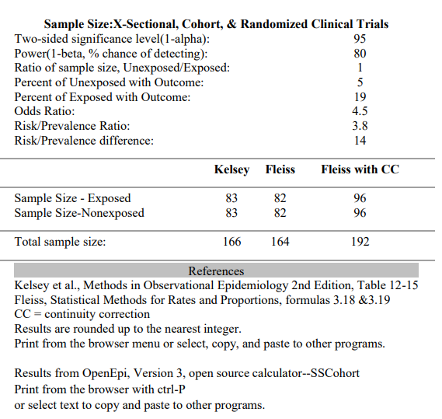

Results from OpenEpi, Version 3, open source calculator—SSMean
n = (Z_{α/2}+Z_{β})² *2*σ² / d²,
3.8 SAMPLING TECHNIQUE

Systemic random sampling (randomized sampling technique)
3.9 HUMAN SUBJECT AND CONSENT

The ethical approval for the study entitled was take form ethical review committee of Bahria University of health sciences (BUHS).
All the male and female patients of diabetes based on inclusion criteria were enrolled for the clinical trial prior taking written informed consent (attached). All the basic information of patients (such as name, age (years), sex (male / female), occupation, address, contact number) and co-morbidities (cancer, trauma, hepatic impairment, renal dysfunction, cardiovascular events and many others), body mass index, glycated hemoglobin (HbA1c), LFT, RFT, Urea, creatinine, electrolytes, RBS were recorded in attached Performa of the present clinical trial.
The patients were be divided two groups on the basis of their treatment option; group A Empagliflozin with metformin and group B Empagliflozin with linagliptin.
The study was be ethically approved by the Bahria University ethical review committee (BUMDC). Informed consent was taken before initiating the clinical trial in male and female diabetic patients.
Based on their treatment options, patients were be divided into two groups: group A (100 patients) was receive Tab Empagliflozin 12.5 mg once daily, along with Tab Metformin 500 mg orally once daily, for 12 weeks., and group B (96 patients) was given Tab Empagliflozin 10 mg once daily, along with Tab Linagliptin 5mg orally once daily, for 12 weeks.
3.10 MATERIALS
3.10.1 QUESTIONNAIRE
Questionnaire was consisting on basic information of patients, co-morbidities, clinical manifestations of diabetic patients and clinical parameters followed by drug therapy (attached as annex).
3.10.2 CONSENT FORM
Followed by the approval of research study, consent was taken from each individual before initiating therapy against weight gain (attached as annex).
3.10.3 DRUGS
- Tab Empagliflozin 12.5 mg
- Tab Empagliflozin 10 mg
- Tab Linagliptin 5 mg.
- Tab Metformin 500mg
3.10.4 INSTRUMENTS

- Glucometer
- Weighing balance
- Measuring tape
- Spectrophotometer
- ELISA Reader
- Immunoassay analyzer
- Hematology analyzer
- Refrigerator
- Freezer
3.11 PARAMETER OF THE STUDY

EFFICACY PARAMETERS
BMI, Waist circumference, Waist to hip ratio, Fasting blood glucose, Random
Blood glucose, Glycated hemoglobin (HbA1c)
SAFETY PARAMETERS
Lipid profile, Liver Enzymes, Renal function test, Pancreatic Enzymes
3.12 PROTOCOL OF STUDY
3.12.1 BODY MASS INDEX

The height and weight of a person are used to calculate their body mass index (BMI), a ratio that indicates their body composition. Utilizing the individuals' height and weight, the body mass index was calculated (BMI). Because there was no specified selection criteria, the size of the participants ranged from average to obese.

BMI is computed by dividing a person's weight in kilograms by their height in meters (m2)(Nuttall,2015).
3.12.2 WAIST CIRCUMFERENCE
To determine waist circumference, the lowest diameter of the waist, which is found immediately above the belly button was measured (Ness-Abramof &Apovian,2008).
3.12.3 WAIST TO HIP RATIO

To determine a person's W/H ratio, divide the lowest diameter of the waist, which is found immediately above the belly button, by the largest circumference of the hips. As a consequence, you'll acquire the W/H ratio ( Neovius et al., 2005)

The formula for the ratio is as follows: proportion of waist size to hip size.

Participants were instructed to stand tall and breathe deeply. The W/H ratio was calculated using a measuring tape, and the results were recorded in centimeters.

3.12.4 GLYCATED HEMOGLOBIN (HBA1C)

Utilization of this approach of HBA1c detection is advantageous. By functioning as the detergent in the hemolyzing reagent, tetradecyltrimethylammonium bromide, often known as TTAB, can reduce interference from leukocytes. Preprocessing the patient sample in order to eliminate labile HbA1c is not a required technique. This test identifies all glycated hemoglobin variants with similar HbA1c antibody-recognized areas ( Gupta et al., 2017 )
The HbA1c level is tested using a turbid metric inhibitory immunoassay to hemolyze a blood sample from the patient.
After the patient has broken their fast, the R1 reagent (the buffer or antibody) is added to their blood sample. Anti-HbA1c antibodies react with glycohemoglobin, also known as HbA1c, present in the sample to generate soluble antigen-antibody complexes. There is no development of insoluble complexes because the HBA1c molecule has only a single unique HbA1c antibody site.
Anti-HbA1c antibodies in excess combine with polyhaptens in reagent 2 (R2) to create an insoluble antibody-polyhapten complex. Using turbidimetry, the complexity of this combination may be determined with modest ease.
The chemicals in the kit were all usable upon receipt, allowing for the creation of a viable solution.
Reagents were kept at temperatures between +2 and +8 degrees Celsius for storage and stability.

PROCEDURE

Full blood samples from the patient were lysed with a hemolyzing agent so that hemoglobin could be released from the erythrocytes. After exposing the Hb sample to reagent 1, the absorbance was measured at 570 nm. The absorbance being estimated is directly affected by the quantity of hemoglobin present in the tested sample. The absorbance was then measured at 660 nm after reactant 2 was applied. The increase in sample HbA1c concentration was related to the increase in absorbance.

- Typical value: 4-6%

3.12.5 FASTING BLOOD GLUCOSE

PRINCIPLE

When ATP is available, hexokinase catalyzes the phosphorylation of glucose, resulting in the formation of glucose-6-phosphate. In the oxidation process, glucose-6-phosphate dehydrogenase utilizes NADP to convert glucose-6-phosphate (G-6-P) to gluconate-6-phosphate. Photometric measurement of the increased rate of NADPH production during the enzymatic process indicates the higher blood glucose content.
Reagents were kept at temperatures between +2 and +8 degrees Celsius for storage and stability.

PROCEDURE

- To obtain the best results from the enzymatic test used to detect glucose, it was
necessary to follow the instructions outlined in the analyzer's manual. The assay manual instructions for each analyzer were followed in accordance with the technique.
- Using the Roche/Hitachi cobas c equipment, the analytic concentration in each
Patient sample was determined automatically.
- The formula for conversion is as follows: mg/dL is 18.02 multiplied by mmol/L
g/L = mmol/L times 0.1802 ; 0.0555 x mg/dL = mmol/L
- Typical range: 70–100 mg/dL
- Preparation of the working solution: The kit's reagents were fully ready for use upon receipt.
- These storage conditions, which varied from 2 to 8 degrees Celsius, ensured the reactivity of the chemicals.
- For a detailed guidance, use the following pipetting parameters:

3.12.6 LIVER ENZYMES

3.12.6.1 ASPARTATE TRANSAMINASE

The -glutamyl molecule of the L-glutamyl -3-carboxy-4-nitroanilide molecule is transferred to the glycylglycine part through the GGT mechanism. The production of 5-amino-2-nitrobenzoate in a patient's sample is proportional to the biological activity of GGT. To obtain a precise measurement, simply take a second absorbance reading (T.H Lee et al., 2012 ).

The plasma used as a sample

- Reagents were stored at temperatures ranging between 2 and 8 degrees Celsius for reasons of storage and stability.
- A few methodological notes: the U/L unit of measurement values were rounded to the nearest whole number.
- The analytical measurement range is between three and one thousand two hundred units per liter (AMR). Its increased measurement range was 3-13200 U/L while the analyzer was in decreasing mode and equipped with a feature that automatically reran the test (1:11). When the repeat function was utilized, the findings received from the diluted sample were automatically multiplied by 11.
- Les values less than three were noted throughout the report as 3 U/L.
- According to reports, the quantity topped 13,200 units per liter.
- Calculates The GGT activity of each patient sample was automatically estimated by the COBAS 6000/8000 system.
- The following figure was serve as a standard: men 8-61 U/L and females 5-36 U/L

3.12.6.2 ALANINE TRANSAMINASE

Alanine aminotransferase catalyzes the formation of pyruvic acid and glutamic acid at a pH of 7.4 and a temperature of 37 degrees Celsius (ALT). Next, phenylhydrazine and pyruvic acid are combined to generate phenylhydrazone. This phenylhydrazone, when exposed to alkaline conditions, takes on a color that is between reddish brown and dark brown. The optical density at 505 nm can be utilized to determine the ALT enzyme activity level (T.H. Lee et al., 2012).

The plasma used as a sample

3.12.7 RENAL FUNCTION TEST

3.12.7.1 CREATININE LEVEL
In an alkaline solution, creatinine and picric acid interact to generate an orange-colored solution. It has been proven that there is a direct correlation between the absorbance of the complex and the content of creatinine in the sample (Gounden et al., 2018).

PRINCIPLE

The reaction between picric acid in the alkaline solution and creatinine in the serum produces a brilliant complex. There is a direct and proportionate link between the quantity of complex generated and the body's level of creatinine.
Maintainability of the functional preparation of the reagent
Equal amounts of Reagents 1 and 2, which are typically referred to as solutions of picric acid and sodium hydroxide, were mixed. The specimen may consist of urine, serum, heparinized plasma, or serum (avoid hemolysis). Wait 30 seconds after mixing the components before estimating the absorbance of the standard and sample using the A1 scale. Measure the absorbance, A2, of both the standard and the sample at 492 nm exactly 2 minutes later.

3.12.8 LIPID PROFILE

3.12.8.1 CHOLESTEROL

Hydrogen peroxide (H2O2) oxidizes 4-aminoantipyrine and phenol to generate quinoemine, which has a red hue and is measurable using spectrophotometry. The quantity of color produced during pigmentation is proportional to the patient's cholesterol concentration in the sample (Gounden et al., 2018).

• The fasting serum sample is shown in this section.
• Storage and stability: Reagents were kept between +2 and +8 degrees Celsius.
• The analytical measurement range is between 4 and 800 mg/dL. (AMR).
• Wide Range: 4-8000 mg/dL, Auto Rerun Capability (1:10).
>8000 mg/dL is used to signify cholesterol levels that are greater than 8000 mg/dL.

We refer to cholesterol levels of 4 mg/dL or less as 4 mg/dL.
• Reference range: less than 200 mg/dL for those under the age of 18 and less than 170 mg/dL for those under the age of 18.

3.12.8.2 HIGH DENSITY LIPOPROTEIN (HDL)

Frequently, a magnesium or dextran sulfate reagent is added to the sample to generate water-soluble complexes and low-density lipoprotein cholesterol. PEG-cholesterol esterase is responsible for transforming HDL-cholesterol esters into HDL cholesterol when reagent 2 is introduced (enzyme). PEG-cholesterol oxidase interacts with HDL cholesterol, whereas peroxidase mixes 4-amino-antipyrine and HSDA to produce a blue or purple pigment with a photometric measurement of 600 nm. This pigment is generated when these three components are combined with the previously created hydrogen peroxide (Gounden et al., 2018).

• Storage and stability: Reagents were kept between +2 and +8 degrees Celsius.
The test requires serum according to the technique. Additionally, the test was conducted using the parameters provided in the manufacturing procedure.
• The product lines of Roche are as follows:
• Zero risk Males: above 55 mg/dL, females: over 65 mg/dL
• Medium risk 35-55 mg/dL for men and 45-65 mg/dL for women

Low risk: Males: 35 mg/dl, females 45 mg/dl.
40 to 60 mg/dL is the standard range.

3.12.8.3 TRIGLYCERIDE (TG)

The test sample generated glycerol (C3H8O2) and free fatty acids after being processed with lipoprotein lipase (LPL) (FFA). In reaction to the presence of ATP (adenosine triphosphate), they make glycerol, whereas glycerol kinase is responsible for creating G-3-P (glycerol 3 phosphate) and releasing ADP (adenosine-5-diphosphate). In the presence of GPO, this dihydroxyacetone phosphate (G-3-P) changes into hydrogen peroxide (H2O2) and dihydroxyacetone phosphate (DAP) (glycerol phosphate dehydrogenase). The final product of the peroxidase-catalyzed reaction combining hydrogen peroxide, 4-aminophenazone, and p-chlorophenol is the red quinoneimine dye complex (Nordestgaard, 2017).

The chemicals in the kit had already been combined and were ready for use.

To maintain the uniformity of the reagents, temperatures ranging from +2 to +8 degrees Celsius were utilized. The following is printed on the labels of three test tubes: "empty space, model, and representative." In a test tube labeled "standard," 10 microliters of the triglyceride standard and 1 milliliter of the working solution were added. Ten microliters of serum and one milliliter of the working solution were then added to the test tube designated as the sample. An empty test tube was then filled with 10 microliters of distilled water and 1 milliliter of the working solution. The test tubes were heated to 37 degrees Celsius and held at that temperature for five minutes. The absorbance of the standard, sample, and blank was then measured in a spectrophotometer relative to a reference wavelength of 500 nm using the tubes as the test subject.

• To calculate triglycerides, multiply the result of dividing the absorbance of the sample by the absorbance of the standard by 200 mg/dL.
• Reference range: 44-148 mg/dL

3.12.8.4 LOW-DENSITY LIPOPROTEIN

• LDL cholesterol was determined using the method outlined below.
• The following formula may be used to calculate LDL cholesterol: Total cholesterol less LDL cholesterol Triglyceride-divided HDL cholesterol
• Normative range: 130–160 mg/dl
3.13 ALGORITHM OF STUDY

Male and female diagnosed T2DM patient.
HbA1c (-6.5-9) %
BMI ≥ 25 kg/m2
Normal Baseline investigations

Use of medicine other than metformin
Co-morbidites
Lactating or pregnant women.

Study population
Inclusion Exclusion
Investigations include FBS, RBS, HbA1c, BMI, Waist circumference, waist to hip ratio , LFTs, RFTs, Lipid profile, Urea, Creatinine, Urine D/R

Sample size = 200

Written Informed consent

Randomization

Group B

Group A
100 patients, Tab. Empagliflozin 12.5 mg Tab with metformin 500 mg Tab once daily orally for 12 weeks

100 patients, Tab. Empagliflozin 10 mg Tab with linagliptin 5 mg Tab once daily orally for 12 weeks

FBS, RBS, HbA1c, BMI, Waist circumference, waist to hip ratio CBC, LFTs, RFTs, Lipid profile, Urea, Creatinine .

Checked at 0, 4th and 12th weeks for groups A & B

Compilation of results and statistical analysis
3.14 STATISTICAL ANALYSIS
The Statistical Package for the Social Sciences, version 23, was used to accomplish significance analysis. All the continuous variables' (such as body mass index, waist circumference, waist to hip ratio, glycated hemoglobin, Fasting blood glucose, Random blood sugar, liver function test, renal function test, urea, creatinine, electrolytes) was presented in average and standard deviation. Categorical data (history of patient) was be recorded using frequencies and percentages. Initially, to test the normality of the data Kolmogorov–Smirnov test was used. Chi-square or T-test / Mann Whitney test was be used to compare treatments group to identify the significance between groups. A p value of less than 0.05 was considered statistically significant.

CHAPTER 4
RESULTS

This current study was aimed to compare the efficacy, safety, and tolerability of empagliflozin- metformin and empagliflozin - linagliptin combination therapy in reduction of body weight in T2DM. Participants in the study could have been of either gender and ranged in age from 40-70.
Group A received combination of Tab Empagliflozin 10.5, mg once daily, along with combination of Tab Metformin 500 mg and group B had received combination of Empagliflozin 10 mg, along with Tab Linagliptin 5mg.
The total of 200 participants were enrolled in this study and 100 was divided in each group. SPSS version 25 was utilized to generate the descriptive statistics. Frequency and percentage figures were used to represent the qualitative factors. The independent student t-test was used to compare the means, and a significance level of p = 0.05 was chosen. To represent the quantitative variables, mean values and standard deviations were utilized. The comparation was done between male of group A with male of group B and female of group A with female of group B.
Table 4.1 and Figure 4.1 has shown an analysis of the age distribution of patients according to number of patients between the age group of 40-50, 51-60, 61-70 and 71-80 years. Whereas, 49 male and 51 female were recruited in group A, and 52 male and 48 female were enrolled in group B (Table 4.2 and Figure 4.2).

4.1 EFFICACY OF TREATMENT IN THE WEIGHT REDUCTION OF DIABETIC PATIENTS AT WEEKS 0 AND 4 AND 12
At the beginning of the trial, a body mass index (BMI), waist to hip ratio (WHR) and waist circumference (WC) was identified to evaluate the prospective effect of the medicines on weight reduction in diabetic patients. All the above parameters were approximately similar between patients of each group. At the end of 4th and 12th week, the difference in BMI, WHR and WC was identified between group A male with group B male and vice versa. The analysis shown the significant differences between groups. Moreover, group A has shown more decrease in anthropometric parameters as compared to group B. The more prominent difference was found in week 12. The detail analysis of weight reduction and significant differences is represented in Table 4.3-4.4 and Figure 4.3-4.5.
The HbA1c, FBS and RBS were exhibited a degree of similarity among patients in each respective group. At the end of the 4th and 12th weeks, a discernible contrast in HbA1c, FBS and RBS was observed between male/female participants in group A and those in group B. The analysis has demonstrated statistically significant differences between the groups. Furthermore, it has been observed that both the groups exhibited better glycemic control. A significant difference was observed during the 12th week. The detail identification of glycemic index and notable differences is depicted in Table 4.3-4.4 and Figure 4.6-4.7.

4.2 SAFETY PROFILE OF TREATMENT IN THE WEIGHT REDUCTION OF DIABETIC PATIENTS AT WEEKS 0 AND 4 AND 12
At the beginning of the trial, a lipid profile was identified to evaluate the prospective effect of the medicines on the cardioailment caused by lipids. The average of Group A and B was found approximately similar. The mean HDL, TG, LDL and cholesterol level in group A was also found insignificant in week 4 and 12 (Table-4.5-4.6 and Figure-4.8).
After evaluating the likelihood that the patient would experience adverse effect, it was determined that empagliflozin - linagliptin and empagliflozin- metformin would be sufficient to achieve the desired outcome. The function of the liver was evaluated to determine whether hepatotoxicity was present or not. At week 0th, the analysis has shown approximately similar average of Group A and B male and female participants. The mean ALT and AST level in group A and B was also found insignificant in week 4 and 12 (Table-4.7-4.8 and Figure-4.9).
Pancreatic enzymes were also identified and shown insignificant difference between male-male and female-female patients of Group A and B at all weeks (Table-4.9-4.10 and Figure-4.10).
Moreover, at week 0, the average level of creatinine and urea in group A was similar with the average level in group B. Moreover, followed by the medication, the average concentration of both of these in group A and in group B was found in insignificant and under normal ranges (Tables 4.11-4.12 and Figure 4.11).
The analysis of urine DR. showed that at 4th week, the number of patients who had were 9,9,9, and 10 score was analyzed in group A male, group B male, group A female and group B female, respectively. Whereas, this score was 8, 10, 8, and 10 at week 12th. Next, glycosuria was found in all weeks in both groups. But greater frequency was observed in female patients (Table-4.13-4.14 and Figure-4.12 – 4.14).

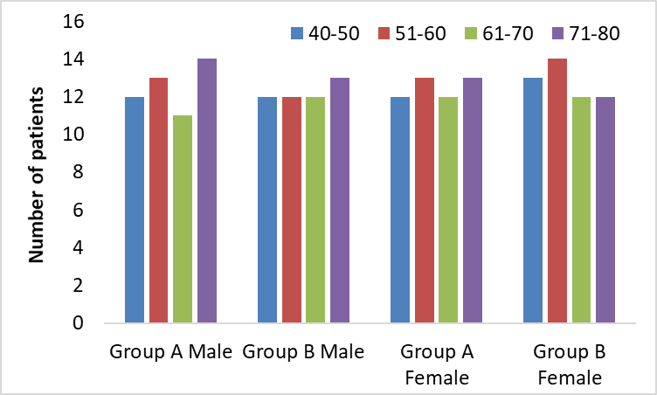
Figure 4.1: Age wise distribution of patients in each group

Table 4.1: Age wise distribution of patients in each group
Age (years) | Group A Male | Group B Male | Group A Female | Group B Female
40-50 | 12 | 12 | 12 | 13
51-60 | 13 | 12 | 13 | 14
61-70 | 11 | 12 | 12 | 12
71-80 | 14 | 13 | 13 | 12
Group A - Treated with empagliflozin- metformin, Group B – Treated with empagliflozin - linagliptin, s – significant p-value < 0.05, ns – non-significant p-value > 0.05., δ independent T- test.

Figure 4.2: Gender wise distribution of patients in each group

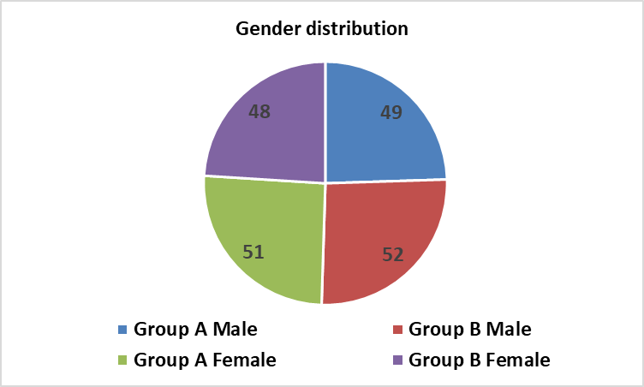

Table 4.2: Gender wise distribution of patients in each group
Group A Male | 49
Group B Male | 52
Group A Female | 51
Group B Female | 48

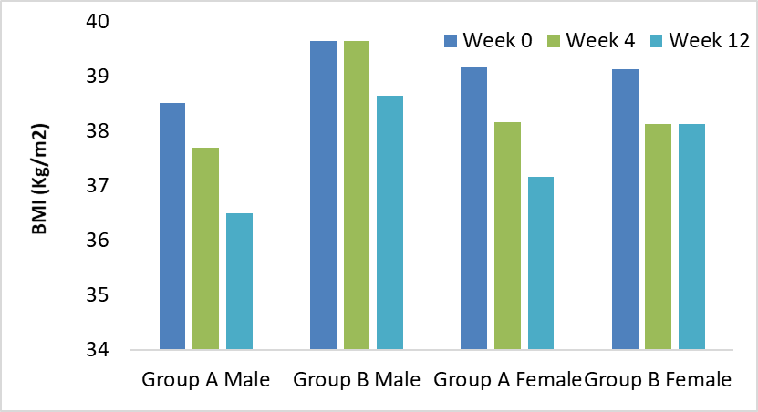
Figure 4.3: BMI of patients at week 0, 4 and 12 in both group

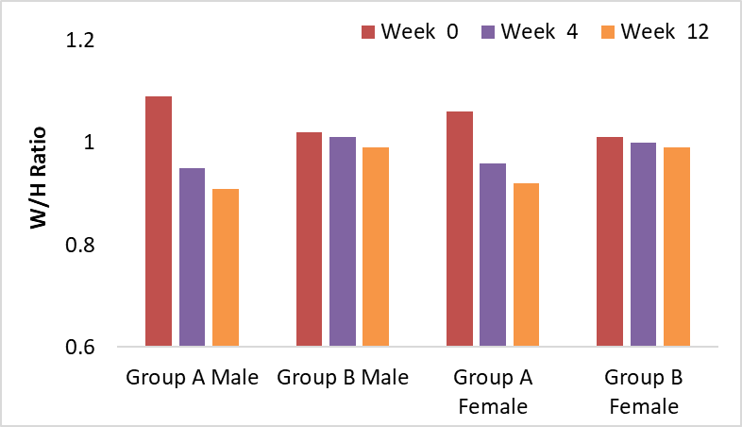
Figure 4.4: W/H ratio of patients at week 0, 4 and 12 in both group

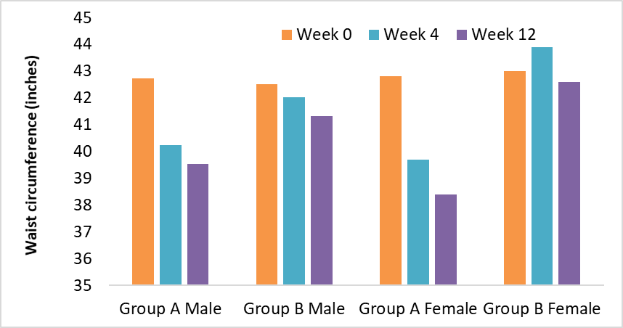
Figure 4.5: Waist circumference of patients at week 0, 4 and 12 in both group

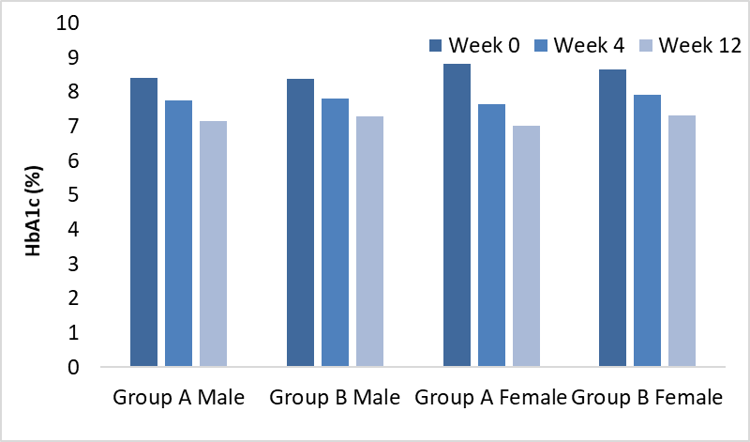
Figure 4.6: HbA1c of participants at 0, 4th and 12th week

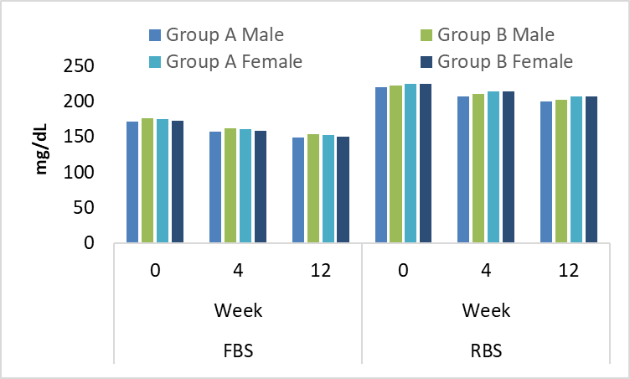
Figure 4.7: FBS and RBS of participants at 0, 4th and 12th week

Table 4.3: Efficacy profile of male at 0, 4th and 12th week
 | Weeks | Group A Male | St.Dev | Group B Male | St.Dev | P-value
BMI | 0 | 38.5 | 3.2404 | 39.64 | 2.2687 | 0.056^{NS}
BMI | 4 | 37.7 | 1.2404 | 39.64 | 1.527 | 0.0421^{S}
BMI | 12 | 36.5 | 2.2404 | 38.64 | 1.2487 | 0.043 ^{S}
W/H Ratio | 0 | 1.09 | 0.4393 | 1.02 | 0.521 | 0.235 ^{NS}
W/H Ratio | 4 | 0.95 | 0.6493 | 1.01 | 0.527 | 0.048 ^{S}
W/H Ratio | 12 | 0.91 | 0.2193 | 0.99 | 0.527 | 0.037 ^{S}
Waist circumference | 0 | 42.74 | 1.4284 | 42.52 | 1.5282 | 0.983 ^{NS}
Waist circumference | 4 | 40.24 | 2.5284 | 42.02 | 1.2582 | 0.049 ^{S}
Waist circumference | 12 | 39.54 | 3.5484 | 41.32 | 3.532 | 0.043 ^{S}
HBA1c | 0 | 8.818 | 0.909292 | 8.648 | 1.099766 | 0.253^{NS}
HBA1c | 4 | 7.644 | 0.815703 | 7.90792 | 1.032669 | 0.042 ^{S}
HBA1c | 12 | 7.016 | 1.400198 | 7.326 | 1.362892 | 0.421^{S}
FBS | 0 | 170.92 | 19.27995 | 175.34 | 11.66025 | 0.253^{NS}
FBS | 4 | 156.92 | 11.27995 | 161.34 | 15.86025 | 0.041 ^{S}
FBS | 12 | 148.92 | 14.27995 | 153.34 | 12.56025 | 0.034 ^{S}
RBS | 0 | 219.16 | 8.160276 | 221.9 | 18.29253 | 0.135 ^{NS}
RBS | 4 | 207.16 | 9.460276 | 209.9 | 15.59253 | 0.041^{S}
RBS | 12 | 199.16 | 5.760276 | 201.9 | 10.19253 | 0.037 ^{S}
Group A - Treated with empagliflozin- metformin, Group B - Treated with empagliflozin - linagliptin, s – significant p-value < 0.05, ns - non-significant p-value > 0.05., δ independent T- test.

Table 4.4: Efficacy profile of female at 0, 4th and 12th week
 | Weeks | Group A Female | St.Dev | Group B Female | St.Dev | P-value
BMI | 0 | 39.16 | 3.1597 | 39.12 | 4.1348 | 0.658^{NS}
BMI | 4 | 38.16 | 2.0397 | 38.04 | 2.2348 | 0.0431 ^{S}
BMI | 12 | 37.12 | 1.4597 | 38.14 | 3.0348 | 0.049 ^{S}
W/H Ratio | 0 | 1.06 | 0.142 | 1.01 | 0.5387 | 0.235 ^{NS}
W/H Ratio | 4 | 0.96 | 0.152 | 1 | 0.1787 | 0.044 ^{S}
W/H Ratio | 12 | 0.92 | 0.164 | 0.99 | 0.1247 | 0.047 ^{S}
Waist circumference | 0 | 42.8 | 2.429 | 43 | 1.426 | 0.983 ^{NS}
Waist circumference | 4 | 39.7 | 1.529 | 43.9 | 3.526 | 0.044 ^{S}
Waist circumference | 12 | 38.4 | 3.439 | 42.6 | 4.326 | 0.043 ^{S}
HBA1c | 0 | 8.82 | 0.91 | 8.65 | 1.10 | 0.632 ^{NS}
HBA1c | 4 | 7.64 | 0.82 | 7.91 | 1.03 | 0.031 ^{S}
HBA1c | 12 | 7.02 | 1.40 | 7.33 | 1.36 | 0.047 ^{S}
FBS | 0 | 174.3 | 14.7 | 172.3 | 14.0 | 0.253^{NS}
FBS | 4 | 160.3 | 17.2 | 158.3 | 14.7 | 0.021 ^{S}
FBS | 12 | 152.3 | 16.4 | 150.3 | 18.7 | 0.044 ^{S}
RBS | 0 | 224.8 | 17.6 | 224.8 | 12.3 | 0.235 ^{NS}
RBS | 4 | 213.8 | 12.2 | 213.8 | 18.4 | 0.0493 ^{S}
RBS | 12 | 206.8 | 11.1 | 206.8 | 11.1 | 0.037 ^{S}
Group A - Treated with empagliflozin- metformin, Group B - Treated with empagliflozin - linagliptin, s – significant p-value < 0.05, ns - non-significant p-value > 0.05., δ independent T- test.

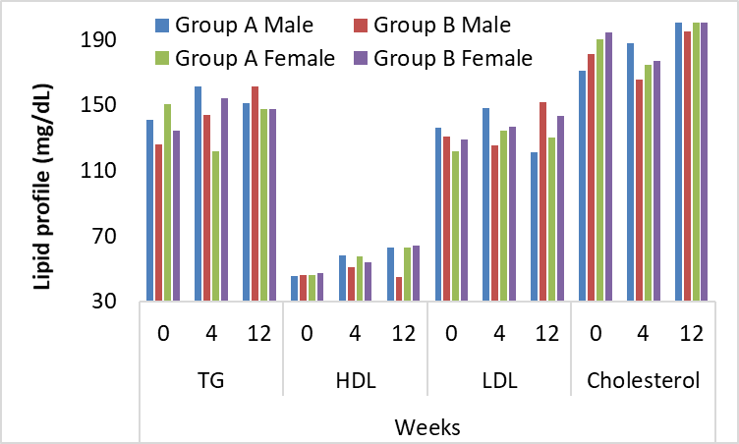

Figure 4.8: Lipid profile of participants at 0, 4th and 12th week

Table 4.5: Lipid profile of male patients at 0, 4th and 12th week
Lipid profile (mg/dL) | Weeks | Group A Male | St.Dev | Group B Male | St.Dev | P-value
TG | 0 | 141.28 | 14 | 125.9 | 9.4788 | 0.253^{NS}
TG | 4 | 161.28 | 25.973 | 144.3 | 10.612 | 0.531 ^{NS}
TG | 12 | 151 | 33.734 | 161.34 | 20.161 | 0.664 ^{NS}
HDL | 0 | 45.74 | 9.2886 | 45.9 | 9.4788 | 0.235 ^{NS}
HDL | 4 | 58.24 | 12.326 | 50.9 | 9.4788 | 0.893 ^{NS}
HDL | 12 | 63.18 | 14.183 | 45.18 | 17.207 | 0.327 ^{NS}
LDL | 0 | 136.28 | 25.973 | 130.68 | 29.309 | 0.983 ^{NS}
LDL | 4 | 147.94 | 10.807 | 125.7 | 31.638 | 0.234 ^{NS}
LDL | 12 | 121 | 33.734 | 151.58 | 8.4975 | 0.543 ^{NS}
Cholesterol | 0 | 171 | 33.734 | 181.34 | 20.161 | 0.132 ^{NS}
Cholesterol | 4 | 187.94 | 10.807 | 165.7 | 31.638 | 0.532 ^{NS}
Cholesterol | 12 | 205.9 | 9.1813 | 195.18 | 17.207 | 0.135 ^{NS}
Group A - Treated with empagliflozin- metformin, Group B - Treated with empagliflozin - linagliptin, s – significant p-value < 0.05, ns - non-significant p-value > 0.05., δ independent T- test.

Table 4.6: Lipid profile of female patients at 0, 4th and 12th week
Lipid profile (mg/dL) | Weeks | Group A Female | St.Dev | Group B Female | St.Dev | P-value
TG | 0 | 150.36 | 12.649 | 134.47 | 10.369 | 0.374 ^{NS}
TG | 4 | 121.79 | 12.621 | 154.4 | 29.782 | 0.652 ^{NS}
TG | 12 | 147.64 | 41.376 | 147.64 | 50.001 | 0.785 ^{NS}
HDL | 0 | 46.357 | 9.7301 | 47.155 | 9.1129 | 0.356 ^{NS}
HDL | 4 | 57.429 | 12.373 | 54.224 | 10.816 | 1.014 ^{NS}
HDL | 12 | 62.81 | 11.557 | 64.121 | 14.922 | 0.448 ^{NS}
LDL | 0 | 121.81 | 33.384 | 128.83 | 30.658 | 1.104 ^{NS}
LDL | 4 | 134.4 | 27.679 | 136.81 | 25.781 | 0.355 ^{NS}
LDL | 12 | 129.93 | 31.019 | 143.67 | 25.013 | 0.664 ^{NS}
Cholesterol | 0 | 190.36 | 12.649 | 194.47 | 10.369 | 0.253 ^{NS}
Cholesterol | 4 | 174.4 | 27.679 | 176.81 | 25.781 | 0.653 ^{NS}
Cholesterol | 12 | 212.81 | 11.557 | 214.12 | 14.922 | 0.256 ^{NS}
Group A - Treated with empagliflozin- metformin, Group B - Treated with empagliflozin - linagliptin, s – significant p-value < 0.05, ns - non-significant p-value > 0.05., δ independent T- test.

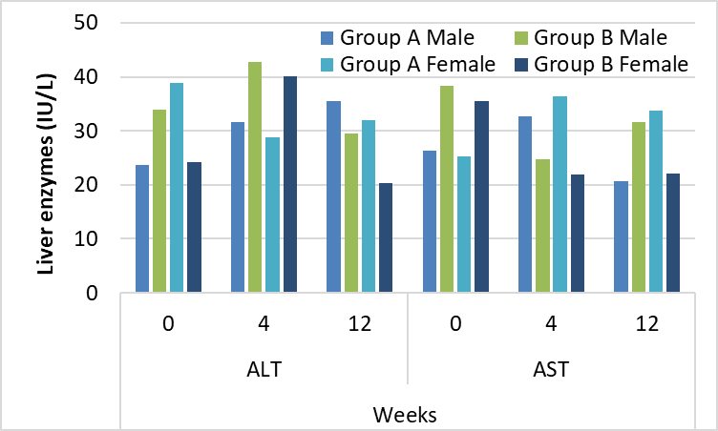

Figure 4.9: Liver enzymes of participants at 0, 4th and 12th week

Table 4.7: Liver enzymes of male patients at 0, 4th and 12th week
Liver enzymes (IU/L) | Weeks | Group A Male | St.Dev | Group B Male | St.Dev | P-value
ALT | 0 | 23.74 | 9.2886 | 33.9 | 9.4788 | 0.648^{NS}
ALT | 4 | 31.54 | 9.0671 | 42.76 | 9.6141 | 0.376 ^{NS}
ALT | 12 | 35.58 | 8.3912 | 29.58 | 8.4975 | 0.685 ^{NS}
AST | 0 | 26.38 | 12.655 | 38.3 | 13.79 | 0.274 ^{NS}
AST | 4 | 32.74 | 12.85 | 24.76 | 13.851 | 0.674 ^{NS}
AST | 12 | 20.76 | 12.33 | 31.6 | 12.615 | 0.277 ^{NS}
Group A - Treated with empagliflozin- metformin, Group B - Treated with empagliflozin - linagliptin, s – significant p-value < 0.05, ns - non-significant p-value > 0.05., δ independent T- test.

Table 4.8: Liver enzymes of female patients at 0, 4th and 12th week
Liver enzymes (IU/L) | Weeks | Group A Female | St.Dev | Group B Female | St.Dev | P-value
ALT | 0 | 38.833 | 9.4454 | 24.293 | 8.6835 | 0.377 ^{NS}
ALT | 4 | 28.714 | 9.6583 | 40.172 | 8.574 | 1.035 ^{NS}
ALT | 12 | 31.976 | 8.9891 | 20.345 | 8.1209 | 0.469 ^{NS}
AST | 0 | 25.214 | 12.959 | 35.431 | 13.49 | 1.125 ^{NS}
AST | 4 | 36.452 | 13.232 | 21.966 | 13.514 | 0.376 ^{NS}
AST | 12 | 33.714 | 9.6583 | 22.172 | 8.574 | 0.685 ^{NS}
Group A - Treated with empagliflozin- metformin, Group B – Treated with empagliflozin - linagliptin, s – significant p-value < 0.05, ns - non-significant p-value > 0.05., δ independent T- test.

Figure 4.10: Pancreatic enzymes of participants at 0, 4th and 12th week
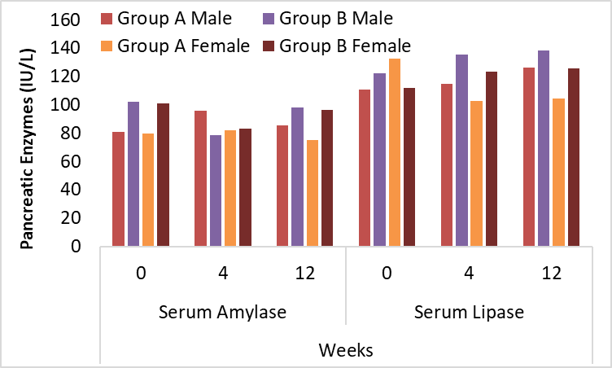

Table 4.9: Pancreatic enzymes of male patients at 0, 4th and 12th week
Pancreatic enzymes (IU/L) | Weeks | Group A Male | St.Dev | Group B Male | St.Dev | P-value
Serum Amylase | 0 | 80.78 | 8.247 | 102.12 | 7.295 | 0.983 ^{NS}
Serum Amylase | 4 | 95.68 | 9.3097 | 78.62 | 8.106 | 0.234 ^{NS}
Serum Amylase | 12 | 85.6 | 12.622 | 97.88 | 5.339 | 0.543 ^{NS}
Serum Lipase | 0 | 110.78 | 11.247 | 122.12 | 13.295 | 0.132 ^{NS}
Serum Lipase | 4 | 114.86 | 12.597 | 135.68 | 11.244 | 0.532 ^{NS}
Serum Lipase | 12 | 126.1 | 10.622 | 138.38 | 12.339 | 0.135 ^{NS}
Group A - Treated with empagliflozin- metformin, Group B – Treated with empagliflozin - linagliptin, s – significant p-value < 0.05, ns - non-significant p-value > 0.05., δ independent T- test.

Table 4.10: Pancreatic enzymes of female patients at 0, 4th and 12th week
Pancreatic enzymes (IU/L) | Weeks | Group A Female | St.Dev | Group B Female | St.Dev | P-value
Serum Amylase | 0 | 80.78 | 8.247 | 102.12 | 7.295 | 0.862 ^{NS}
Serum Amylase | 4 | 95.68 | 9.3097 | 78.62 | 8.106 | 0.113 ^{NS}
Serum Amylase | 12 | 85.6 | 12.622 | 97.88 | 5.339 | 0.422 ^{NS}
Serum Lipase | 0 | 110.78 | 11.247 | 122.12 | 13.295 | 0.811 ^{NS}
Serum Lipase | 4 | 114.86 | 12.597 | 135.68 | 11.244 | 0.411 ^{NS}
Serum Lipase | 12 | 126.1 | 10.622 | 138.38 | 12.339 | 0.614 ^{NS}
Group A - Treated with empagliflozin- metformin, Group B – Treated with empagliflozin - linagliptin, s – significant p-value < 0.05, ns - non-significant p-value > 0.05., δ independent T- test.

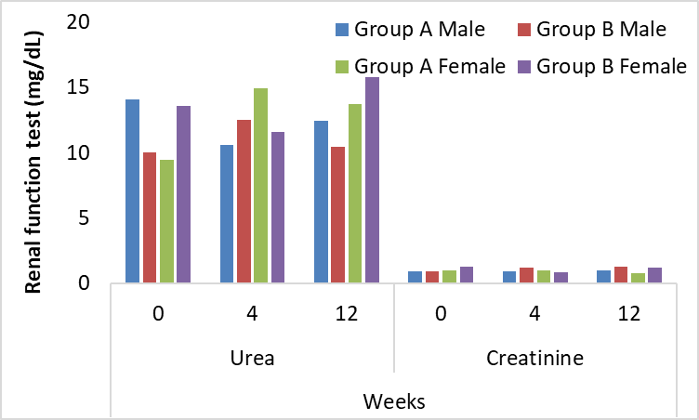

Figure 4.11: Renal function test of participants at 0, 4th and 12th week

Table 4.11: Renal function test of male patients at 0, 4th and 12th week
Renal function test (mg/dL) | Weeks | Group A Male | St.Dev | Group B Male | St.Dev | P-value
Urea | 0 | 14.06 | 5.2931 | 10.04 | 5.5179 | 0.253^{NS}
Urea | 4 | 10.58 | 4.2623 | 12.48 | 5.203 | 0.531 ^{NS}
Urea | 12 | 12.44 | 4.4085 | 10.42 | 5.0753 | 0.664 ^{NS}
Creatinine | 0 | 0.9 | 0.1498 | 0.88 | 0.1443 | 0.235 ^{NS}
Creatinine | 4 | 0.918 | 0.1508 | 1.164 | 0.1382 | 0.893 ^{NS}
Creatinine | 12 | 0.966 | 0.1465 | 1.268 | 0.1435 | 0.124 ^{NS}
Group A - Treated with empagliflozin- metformin, Group B - Treated with empagliflozin - linagliptin, s – significant p-value < 0.05, ns - non-significant p-value > 0.05., δ independent T- test.

Table 4.11: Renal function test of female patients at 0, 4th and 12th week
Renal function test (mg/dL) | Weeks | Group A Female | St.Dev | Group B Female | St.Dev | P-value
Urea | 0 | 9.4286 | 5.3563 | 13.586 | 5.3247 | 0.374 ^{NS}
Urea | 4 | 14.905 | 4.4327 | 11.603 | 4.9344 | 0.652 ^{NS}
Urea | 12 | 13.69 | 5.1679 | 15.776 | 5.4064 | 0.785 ^{NS}
Creatinine | 0 | 0.9714 | 0.1384 | 1.2672 | 0.1394 | 0.356 ^{NS}
Creatinine | 4 | 0.9738 | 0.138 | 0.8534 | 0.1314 | 1.014 ^{NS}
Creatinine | 12 | 0.7524 | 0.1292 | 1.1552 | 0.1391 | 0.245 ^{NS}
Group A - Treated with empagliflozin- metformin, Group B – Treated with empagliflozin - linagliptin, s – significant p-value < 0.05, ns - non-significant p-value > 0.05., δ independent T- test.

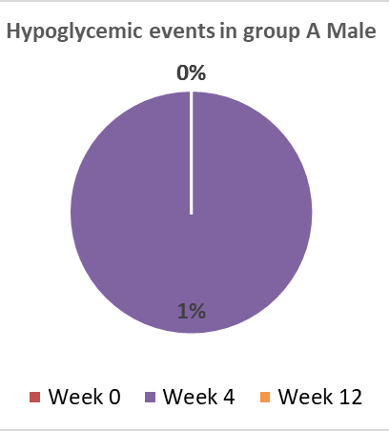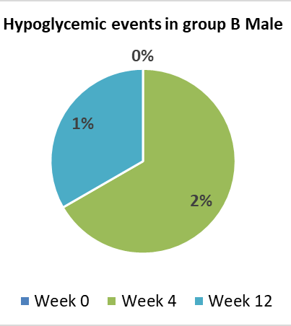
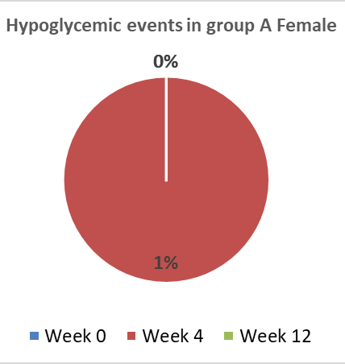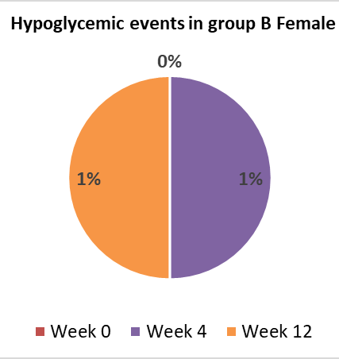
Figure 4.12: Hypoglycemic events in participants at 0, 4th and 12th week

Table 4.13: Hypoglycemic event in patients at 0, 4th and 12th week
 | Week | Group A Male | Group B Male | Group A Female | Group B Female
Hypoglycemic event (n) | 0 | 0 | 0 | 0 | 0
Hypoglycemic event (n) | 4 | 1 | 2 | 1 | 1
Hypoglycemic event (n) | 12 | 0 | 1 | 0 | 1
Group A - Treated with empagliflozin- metformin, Group B - Treated with empagliflozin - linagliptin

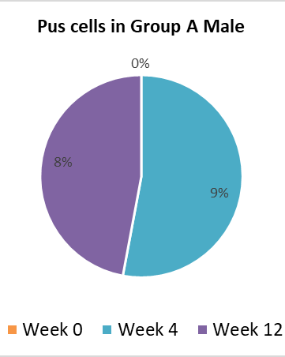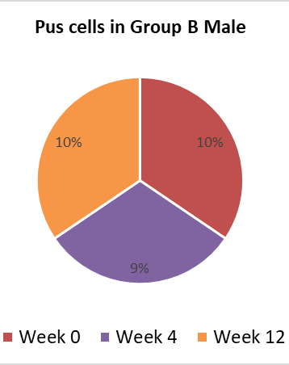
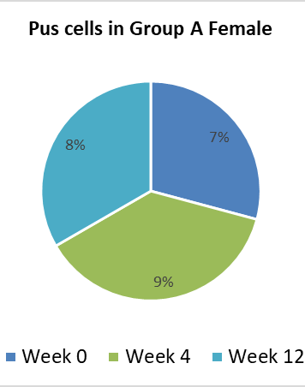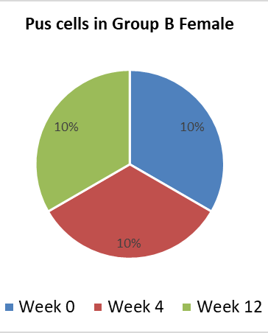
Figure 4.13: Pus cells in participants at 0, 4th and 12th week

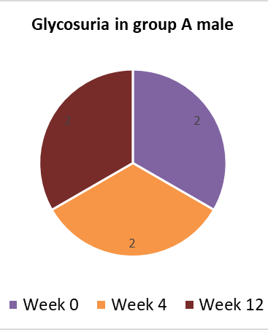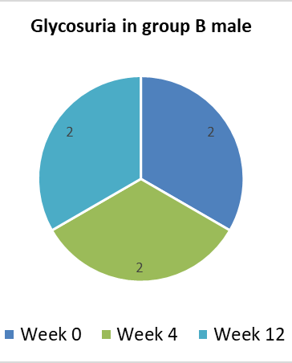
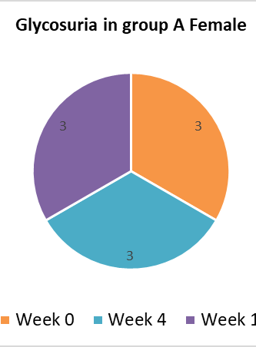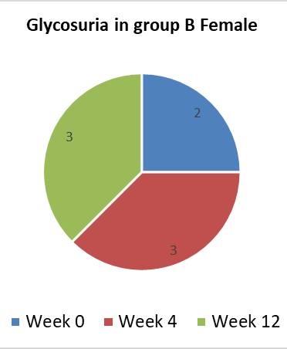
Figure 4.14: Glycosuria in participants at 0, 4th and 12th week

Table 4.13: Urinalysis in patients at 0, 4th and 12th week
Urine DR | Week | Group A Male | Group B Male | Group A Female | Group B Female
Pus cells | 0 | 0 | 10 | 7 | 10
Pus cells | 4 | 9 | 9 | 9 | 10
Pus cells | 12 | 8 | 10 | 8 | 10
Glycosuria | 0 | 2 | 2 | 3 | 2
Glycosuria | 4 | 2 | 2 | 3 | 3
Glycosuria | 12 | 2 | 2 | 3 | 3
Group A - Treated with empagliflozin- metformin, Group B - Treated with empagliflozin - linagliptin

CHAPTER 5

DISCUSSION

5.1 SEQUENCE
The global obesity pandemic, which began in the latter half of the 20th century and continues into the 21st century, has directly led to an exponential growth in the prevalence of type 2 diabetes mellitus (T2DM) in recent years. This pandemic began in the later half of the 20th century and continues into the 21st century. Because of the increased risk of microvascular, macrovascular, and metabolic problems that are associated with type 2 diabetes, the major goal for those who suffer from diabetes and obesity should be to keep their blood glucose levels under acceptable control. However, several anti-diabetic drugs, including insulin, can lead to weight gain, which may have a negative impact on the course of diabetes. This weight increase may also have an adverse effect on quality of life. (Pappachan and Viswanath., 2017; Deol et al., 2017). When choosing an anti-diabetic medication, medical professionals should place a high priority on striking a healthy equilibrium between optimal glucose control and the patient's individualised diabetes treatment plan. If physicians and scientists had a better grasp of the molecular mechanisms behind the impact that anti-diabetic medications have on obesity, they would be in a better position to design a multimodal strategy with short- and long-term therapy goals for the condition of obesity.
Insulin is one of the diabetic treatments that has been linked to weight gain, which in turn can make diabetes more severe. As a result, figuring out the most effective method for treating a diabetic patient is vital in order to select medicine combinations that have the lowest risk of making the disease even worse. And the treatment choice offers the most advantage in avoiding complications of diabetes brought on by increased weight, such as heart disease and renal disease.
According to the IDF 2019 report, there are approximately 8.5 million individuals in Pakistan who have diabetes but have not yet received a formal diagnosis. According to a study conducted by R. Williams et al. in 2020, it has been projected that poor glucose tolerance will be ranked 7th and 8th in 2030 and 2045, respectively, with an estimated prevalence of 11.8 million and 16.5 million cases.
According to the International Diabetes Federation (IDF) in 2019, it was projected that there would be an estimated 248,300 deaths related to diabetes among women in the MENA region, while men were anticipated to experience 170,600 diabetes-related deaths. The prevalence of diabetes was found to be higher among women compared to men. According to a study conducted by R. Williams et al. in 2020, Pakistan recorded the highest mortality rate due to diabetes in 2019, with a total of 159,000 deaths.
In 2019, the cost of treating diabetes in the MENA region amounted to EUR 24.9 billion. According to a study conducted by Williams et al. (2020), it is projected that the healthcare expenses associated with diabetes will amount to EUR 38.6 billion by the year 2045.
Diabetes accounted for 15.2% of total healthcare expenditures. The highest economic burden of diabetes is observed in Lebanon (20.4%), Sudan (20.7%), and Pakistan (19.7%). The Sultanate of Oman boasts the lowest DM healthcare costs, which amount to 6.8%. The annual consumption of diabetics in the MENA region exhibits variability. According to the IDF, Pakistan's estimated value is $83.
Type 1 diabetes mellitus (T1DM) is characterized by insulin insufficiency resulting from the autoimmune destruction of β cells by T-cells. Prevalence is highest during the developmental stages of childhood, adolescence, and early adulthood. Frequent urination, excessive thirst, and increased appetite are commonly observed. Type 1 diabetes mellitus (T1DM) is characterized by a reduction in insulin levels, resulting in the development of hyperglycemia and ketoacidosis (Figure 2 and 3).
Pancreatic β-cell death is the underlying cause of immune-mediated diabetes mellitus (DM). The activation of T lymphocytes in an erroneous manner leads to the onset of pancreatitis and the production of antibodies that target β-cells. According to Kakleas et al. (2015), this has the potential to predict immune system failure.
Research suggests that the loss of insulin-secreting β-cells and inflammation may contribute to the development of T1DM induced by the immune system. Nevertheless, the causal relationship between autoantibodies and the onset of immune system-mediated Type 1 Diabetes Mellitus (T1DM) has not been established. The presence of pancreatic islet autoantibodies indicating normoglycemia is indicative of the potential development of immune system-induced Type 1 Diabetes Mellitus. The presence of autoantibodies targeting pancreatic tyrosine phosphatase (IA2A) and glucamic acid decarboxylase (GADA) may serve as an indication of type 1 diabetes mellitus (T1DM) that is induced by the immune system.
The HLA DR and DQ 120 genotypes, in conjunction with insulin-secreting pancreatic β-cells, are implicated in the development of T1DM as a result of immune system-mediated mechanisms. According to Kakleas et al. (2015), environmental factors such as mumps, enterovirus, cytomegalovirus, and ljungan virus, as well as dietary habits and vitamin D insufficiency, can have an impact on human health.
There exist several categories of undetermined etiology within the context of Type 1 Diabetes Mellitus. Individuals exhibit a lifelong deficiency of insulin and are susceptible to ketoacidosis, despite the absence of β-cell autoimmunity. Patients with idiopathic type 1 diabetes mellitus experience periodic episodes of ketoacidosis and insufficient levels of insulin. The etiology of Type 1 Diabetes Mellitus (T1DM) that arises spontaneously, also known as idiopathic T1DM, has been associated with genetic inheritance, albeit not with the Human Leukocyte Antigen (HLA) system. Type 2 diabetes mellitus (T2DM) is distinguished by diminished insulin production in the pancreatic β-cells and insulin resistance (IR) in the periphery. Al-Goblan and colleagues (2014). Elevated levels of plasma fatty acids (FA), enhanced muscle glucose absorption, and increased lipolysis are associated with the development of insulin resistance (IR). The process of hepatic gluconeogenesis ensues subsequent to the aforementioned events. Type 2 diabetes mellitus (T2DM) arises concomitantly from both insulin resistance and β-cell dysfunction. Al-Goblan (2014).
Gestational diabetes is a form of glucose intolerance that arises during pregnancy. Gestational diabetes may be caused by insulin resistance and excessive insulin secretion, as suggested by various studies (Association, 2004; Kampmann et al., 2015; Zhu & Zhang, 2016). Intrauterine growth restriction (IR) typically commences during the second trimester of pregnancy and persists until the third trimester. Insulin resistance (IR) may be induced by placenta-secreted growth hormone, TNF-α, and lactogen. During pregnancy, steroid hormones such as estrogen, progesterone, and cortisol elevate the glucose insulin ratio, leading to compensatory insulin production to counteract insulin resistance. According to Alfadhli (2015), glucose intolerance can be caused by various factors such as enhanced adipose tissues, maternal adipose deposition, decreased physical activity, and high caloric intake.
Monogenic diabetes is caused by abnormalities in a single gene. Accurate diagnosis is essential in elucidating the etiology of an illness, identifying familial risk factors for diabetes, and managing therapeutic interventions. Effective management of diabetes is necessary to prevent long-term complications (Szopa et al., 2015).
Monogenic diabetes encompasses a range of genetic disorders that result in diabetes. These disorders include maturity-onset diabetes, which is associated with mutations in genes such as glucokinase, HNF1A, HNF4A, and ABCCB. Renal cysts and diabetes are linked to mutations in the HNF1B gene, while maternity inherited diabetes and deafness are associated with mutations in the mtDNA 3243 gene. Permanent neonatal diabetes is caused by mutations in genes such as KCNJ11 and insulin, while delay epilepsy and transient neonatal diabetes are linked to mutations in the 6q24 gene. Other monogenic diabetes disorders include Wolfram syndrome, Immunodysregulation polyendocrinopathy enteropathy X-linked syndrome, and Wolcott-Rallison syndrome.
Type 1 and Type 2 Diabetes Mellitus (T1DM and T2DM) have been found to induce modifications in the exocrine pancreas, leading to impaired functionality of both acinar and ductal cells. The etiology and clinical manifestations of exocrine pancreatopathy resulting from diabetes remain unclear. The investigation of exocrine-mediated diabetic pancreatopathy is necessary to identify optimal therapeutic approaches and differentiate it from chronic pancreatitis, as stated by Mohapatra et al. (2016).
Therefore, the current investigation was able to identify the effect of combination therapy with empagliflozin and linagliptin or empagliflozin and metformin on the decrease of body weight in patients with type 2 diabetes. Additionally, determines the finest treatment alternative available between these two successful combinational medicines in the fight against weight gain by determining which of the two is superior. This study found the most effective method for treating a diabetic patient, as well as the method with the lowest risk of making the patient's condition even worse, and the method with the highest potential benefit for preventing consequences of diabetes connected to weight gain, such as heart disease and renal disease.
In the current study, we have found the significant difference between the groups against obesity parameters. At the onset of the trial, we identified the Body Mass Index (BMI), Waist-to-Hip Ratio (WHR), and Waist Circumference (WC) as key measures to assess the potential impact of the medications on weight loss in individuals with diabetes. The study findings indicate similar BMI level, waist-to-hip ratio (WHR) and waist circumference (WC) level for group A and group B. At the beginning of the trial, a body mass index (BMI), wasist to hip ratio (WHR) and waist circumference (WC) was identified to evaluate the prospective effect of the medicines on weight reduction in diabetic patients. All the above parameters were approximately similar between patients of each group. At the end of 4th and 12th week, the difference in BMI, WHR and WC was identified between group A male with group B male and vice versa. The analysis shown the significant differences between groups. Moreover, group A has shown more decrease in anthropometric parameters as compared to group B. The more prominent difference was found in week 12. The detail analysis of weight reduction and significant differences is represented in Table 4.3-4.4 and Figure 4.3-4.5.
The previously reported study found that metformin is frequently referred to as a drug for type 2 diabetes that does not affect weight. Despite this common perception, similar with our findings, a previous study of several clinical trials revealed that patients treated with metformin lost a significant amount of weight in comparison to baseline or comparative therapy (Golay, 2008). Metformin may help patients lose weight (mean weight reduction was 1.1 kg) according to the findings of a recent meta-analysis (Domecq et al., 2015). It has been linked to this benefit that metformin has the potential to lower blood sugar levels. Inhibition of hepatic glucose synthesis and gluconeogenesis, indirect improvement of peripheral (muscle) tissue insulin sensitivity, and add-on effects on users are all effects that can be caused by metformin. However, these effects are not the only ones that can be caused by metformin. According to the Diabetes Prevention Programme (DPP) (DeFronzo & Abdul-Ghani, 2011; Hostalek et al., 2015), using the medicine metformin was associated with a 31% reduction in the occurrence of diabetes in high-risk persons who had impaired glucose tolerance (IGT). This was demonstrated in a way that was convincing and uncomplicated. Metformin is an effective treatment for a wide range of health problems that are either immediately or indirectly connected to diabetes. These conditions include cancer (Wu et al., 2015; Yu et al., 2014), gestational diabetes mellitus (GDM) (Jiang et al., 2015; Kitwitee et al., 2015), non-alcoholic fatty liver disease (NAFLD) (Chalasani et al., 2012), and polycystic ovary syndrome (PCOS) (Kong et al., 2015; Naderpoor et al., 2015). Metformin appears to have clear advantages for diabetic individuals, according to a variety of different types of research. The present study particularly findout the significant outcomes with the use of empagliflozin- metformin combination for 12 weeks.
In the present study, metformin was combined with empagliflozin which is as sodium glucose co-transporter 2 inhibitors. The previously reported study found the similar outcomes, as this helps the body eliminate between 60 and 80 grams of glucose through the urinary tract on a daily basis. As a consequence of this, an individual can anticipate shedding 240 to 320 calories on a daily basis, in addition to a significant amount of weight. The majority of people who take SGLT2i see weight loss of between 2 and 4 kilograms. This drop is similar across all studies and compounds, and it occurs whether SGLT2i is administered on its own or in combination with another medication that reduces glucose levels. This is significant because tests of body composition using dual energy x-ray absorptiometry (DEXA) have showed that 60 to 70% of the weight loss caused by SGLT2i, also known as dapagliflozin, is attributable to a reduction in fat content. This information is relevant because of these findings. According to Fadini et al. (2017), this is not necessarily the case when appraising a person based on their physical composition. A further study that made use of magnetic resonance imaging demonstrated that dapagliflozin reduces the amount of visceral and subcutaneous fat in the body.
Moreover, Ferrannini and colleagues noticed that weight loss stops and is significantly less than what would be predicted by the quantity of daily glycosuria if there were no change in calorie intake. This was the case even when glycosuria persisted for an extended period of time. After twenty-four weeks, the estimated and actual rates of weight reduction began to diverge from one another. This transpired throughout the entirety of the legal proceeding. According to Ferrannini et al. (2015), the individual will need to consume a greater number of calories in order to make up for the loss. Because of this impact, SGLT2i stands out from other therapies for weight loss, including GLP-1RA. GLP-1RAs make you feel fuller and drive you to eat less food, but SGLT2i induces weight reduction regardless of whether or not you ingest more calories than normal. According to Zinman et al.'s (2015) research, the weight loss that was observed after the first week of therapy with SGLT2i appears to have continued.
SGLT-2 inhibition causes the excretion of a sizeable portion of the glucose that would otherwise be filtered into the renal tubules. If this process were allowed to continue, the renal tubules would be filled with glucose. This medication, in contrast to the vast majority of other diabetic treatments, has the potential to lower glucose levels in the blood without the need of insulin. Inhibitors of the SGLT-2 enzyme that are now on the market include drugs with names like dapagliflozin, canagliflozin, and empagliflozin. Although it is possible to manage diabetes with just these drugs, it is more common practise to combine them with one or more of the many other diabetes treatments available.
The new class of drugs has been found to potentially offer two additional benefits, namely a reduction in cardiovascular mortality and an enhancement in renal outcomes. These findings have been reported in recent studies conducted by Wanner et al. (2016) and Zinman et al. (2015). The potential advantages of these drugs for the treatment of patients with diabesity are noteworthy. The literature suggests that the administration of these medications is associated with a high incidence of urinary tract infections and vaginal fungal infections (Baker et al., 2014; Kong et al., 2015; Wanner et al., 2016). In the event that the symptoms fail to exhibit any amelioration, the patient may elect to discontinue the medication.
The administration of the SGLT2 inhibitor empagliflozin during the treatment of type 2 diabetes is likely to result in an elevation in the amount of glucose that is excreted in the urine. This is due to the inhibitory effect of empagliflozin on glucose reabsorption in the kidney's glomerular filtrate. According to recent studies conducted by Jamalizadeh et al. (2021) and Ozer & Yorulmaz (2020), Emphagliflozin has been found to potentially prevent elevations in blood pressure and facilitate weight loss. Empagliflozin, in contrast, does not increase the likelihood of hypoglycemia. Empagliflozin was found to be efficacious in reducing body weight, fasting plasma glucose (FPG), and glycated haemoglobin (HbA1c) in several clinical studies, with no significant adverse effects reported (Kawamori et al., 2018). Furthermore, the aforementioned clinical investigations assessed HbA1c, body mass (2.0 to 3.4 kg), and systolic arterial pressure (Kaku et al., 2022). The clinical study revealed notable distinctions in the rates of cardiovascular mortality, hospitalisations due to heart failure, and overall mortality between the groups administered with empagliflozin and placebo.
The modes of operation of dipeptidyl peptidase-4 (DPP-4) inhibitors and GLP-1 analogues exhibit similarities. The pharmacological agents in question extend the period of action of incretin hormones by inhibiting the rate of degradation of GLP-1, which is typically synthesised in the gastrointestinal tract, through the suppression of the DPP-4 enzyme. The current pharmacological class encompasses a variety of drugs, including but not limited to sitagliptin, vildagliptin, saxagliptin, linagliptin, alogliptin, teneligliptin, and anagliptin. Nevertheless, the worldwide pharmaceutical industry is commencing to grant entry to groundbreaking agents. According to Pappachan et al. (2015), there exists substantiation that DPP-4 inhibitors can potentially reduce HbA1c levels by 0.5-1.0% without eliciting any weight gain. Considering this attribute, it is advisable to motivate physicians to administer this category of medications for managing diabesity in patients without any contradictions. According to Cai et al. (2015), Asian patients who underwent the same treatments exhibited a significantly greater reduction in HbA1c levels and enhancement in pancreatic cell function in comparison to their Caucasian counterparts. This study holds significant importance due to the established phenomenon that individuals of Asian descent, despite having similar body mass indices (BMIs) as their Caucasian counterparts, exhibit a higher prevalence of diabesity. Although clinical trials and observational studies have extensively assessed the cardiovascular safety of several DPP-4 inhibitors, yielding some promising outcomes (Filion et al., 2016; Green et al., 2015; Ou et al., 2015), it has been revealed that these medications elevate the likelihood of hospitalisation in individuals with heart failure (Li et al., 2016). Given the frequent comorbidity of heart failure and diabesity, the administration of DPP-4 inhibitors to overweight individuals with diabetes necessitates significant prudence.
Following a 24-week period of taking metformin 15, obese individuals with uncontrolled type 2 diabetes experienced reductions in weight, body fat, abdominal subcutaneous and visceral adipose tissue, as well as overall body weight (SAT and VAT). The bone mineral density and bone turnover indicators exhibited no significant changes over a period of 50 weeks.
According to Jithin (2018) and Molina-Vega et al. (2018), individuals who were administered Sglt-2 + dpp4 (Empagliflozin-Linagliptin) for a short duration experienced an average reduction of 2 kg in body weight per person. Schernthaner et al. (2013) reported a comparable outcome when administering DPP-4 inhibitors in conjunction with metformin as a triple therapy. Numerous studies have demonstrated that the concomitant use of insulin therapy and SGLT2 inhibitors may lead to weight reduction in certain populations. 38 According to Del Prato et al. (2015), the efficacy of Dapagliflozin in inducing weight loss has been demonstrated to persist for up to four years. The administration of SGLT2 inhibitors has been observed to result in a reduction in overall adiposity as well as waist circumference. The administration of sodium glucose cotransporter 2 inhibitors has been found to result in notable and sustained weight loss exclusively among individuals diagnosed with type 2 diabetes.
Metformin is a frequently prescribed medication that has been in widespread use for over four decades for the treatment of type 2 diabetes. Several research studies have demonstrated a correlation between a decrease in body weight ranging from 0.6 to 2.9 kg and a 1% decline in HbA1c levels, especially when accompanied by modifications in lifestyle (Domecq et al., 2015; Meneghini et al., 2011). Following a few months of metformin administration, patients frequently observe a reduction in weight.
According to a study, the combination of metformin and empagliflozin resulted in a greater weight loss compared to the use of metformin alone. Following a 24-week treatment regimen involving the administration of metformin and empagliflozin, a 5% reduction in body weight was observed among the study participants. Based on weight changes, it is possible that Empagliflozin and metformin were not the most effective medications for inducing weight loss in patients by week 24. Sodium-glucose cotransporter 2 (SGLT2) inhibitors exert an impact on weight reduction by augmenting urinary glucose excretion and hindering the body's adipose tissue elimination process, including both visceral and subcutaneous fat. These procedures are essential for the body to eliminate excess adipose tissue.
The lipid profile is a diagnostic tool used to assess an individual's lipid levels, including cholesterol and triglycerides, in order to evaluate their risk for cardiovascular disease.
At the beginning of the trial, a lipid profile was identified to evaluate the prospective effect of the medicines on the cardioailment caused by lipids. The average of Group A and B was found approximately similar. The mean HDL, TG, LDL and cholesterol level in group A was also found insignificant in week 4 and 12 (Table-4.5-4.6 and Figure-4.8).
In contrast to this study, previous findings indicates that the administration of a metformin regimen in conjunction with a DPP4 and an SGLT2 inhibitor yielded superior results in enhancing Chol and LDL-C levels compared to the dual therapy of metformin and linagliptin or dapagliflozin. The concomitant administration of metformin and linagliptin was also observed to elicit a comparable impact on the reduction of fasting glucose and HbA1C levels.
Metformin is considered the primary pharmacological intervention for individuals who have recently been diagnosed with Type 2 Diabetes Mellitus. The previous research provides support for earlier research indicating that metformin monotherapy significantly enhances dyslipidemia in individuals with T2DM who have not previously used statins (Lin et al., 2018). This improvement is particularly notable in the reduction of serum LDL-C, which is achieved through an AMP-activated protein kinase pathway (Xu et al., 2015). Metformin has been documented to enhance insulin sensitivity through its capacity to elevate it. Additionally, it diminishes the pace of lipolysis, which in turn reduces the transformation of free fatty acids in the liver (Shaw, 2013). A prior meta-analysis has demonstrated that the administration of metformin resulted in a reduction in body weight and an enhancement in the lipid profiles of individuals who were 60 years of age. The findings indicate that administering metformin may potentially mitigate the likelihood of significant coronary incidents and overall mortality among individuals with diabetes (Solymár et al., 2018). Whereas, due to short duration of study period, might be did not produce any effect on lipid profile of metformin combination.
The presence of dyslipidemia in individuals diagnosed with type 2 diabetes mellitus is linked to a heightened susceptibility to cardiovascular disease. Prior research has indicated that the lipid-lowering efficacy of linagliptin or metformin may be inferior to that of dapagliflozin (Liu et al., 2005) and a placebo (Cha et al., 2017). The outcomes of this previous regarding the impact of monotherapy, dual therapy, and triple therapy with metformin on the lipid profiles of patients with T2DM are in alignment with the findings of other research (Lingvay et al., 2020; Søfteland et al., 2017; Tariqi & Naughton, 2021). The findings of our investigation indicate that the lipid profile was comparably reduced by combination therapy. The study findings indicate that there were insignificant differences in the mean levels of Chol, HDL-C, and LDL-C before and after the administration of DPP4 and SGLT2 inhibitor and metformin- SGLT2 combination therapy, which lasted for an average of 3 months.
Prior research has indicated that the administration of a combination therapy involving empagliflozin, linagliptin, and metformin (Lingvay et al., 2020) or dapagliflozin, saxagliptin, and metformin has resulted in significant reductions in glucose levels among individuals diagnosed with Type 2 Diabetes Mellitus (Del Prato et al., 2018). The results of a 52-week study indicate that the reductions in HbA1c achieved through the administration of empagliflozin and linagliptin in combination were more effective than those achieved through the concurrent use of either empagliflozin or linagliptin with metformin (DeFronzo et al., 2015). To corroborate this phenomenon, the patients belonging to the metformin triple therapy cohort were segregated into two distinct groups and subjected to a reanalysis of the results. The study revealed that the incorporation of empagliflozin into the existing treatment regimen of metformin and linagliptin resulted in a superior decrease in fasting glucose, HbA1C, and cholesterol levels. We have found the significant difference in both combination groups to prevent uncontrolled glycemia.
Furthermore, in other study the incorporation of saxagliptin into the treatment regimen of metformin and dapagliflozin resulted in a more efficacious decrease in serum cholesterol and low-density lipoprotein cholesterol levels. The findings suggest that the lipid profile is impacted differently by the administration of a combination of metformin with linagliptin and saxagliptin compared to a combination of metformin with empagliflozin and dapagliflozin. The findings of our study indicate that empagliflozin may possess superior glycemic control efficacy in comparison to dapagliflozin. The findings indicated a comparable enhancement in fasting glucose and HbA1C levels to a previous investigation (Lee et al., 2018) and exhibited that saxagliptin could potentially provide superior LDL-C regulation compared to linagliptin. According to the findings of a prior cross-sectional investigation, individuals who utilised saxagliptin exhibited a notably reduced risk of cardiovascular disease in comparison to other users of DPP-4 drugs who were matched for factors such as age, sex, duration of drug use, systolic blood pressure, lipid profile, and fasting glucose (Ha et al., 2018). Nevertheless, additional extensive observational investigations are required to assess the distinctions between these medications in relation to their cardiovascular advantages or glucose regulation capabilities. This study examines the impact of combination therapy of metformin with emphagliflozin and linagliptin-empagliflozin in reduction of weight gain in patients diagnosed with type 2 diabetes mellitus.
The previously reported findings of the EMPAREG OUTCOME trial found decrease in eGFR upon initiation of SGLT2 inhibition (Wanner et al., 2016). The reduction in question has frequently been associated with the tubuloglomerular feedback (TGF). The inhibition of SGLT2 leads to a rise in sodium concentration within the tubular system adjacent to the macula densa. This, in turn, results in heightened arteriolar tone at the afferent preglomerular site, ultimately leading to a reduction in GFR. In a previous study utilising an animal model of type 1 diabetes, it was observed that administration of a solitary dose of the SGLT2 inhibitor empaglifozin led to an increase in afferent arteriolar tone. This subsequently resulted in a reduction of glomerular hyperfiltration, which is recognised as the initial stage of diabetic nephropathy.
Moreover, at week 0, the average level of creatinine and urea in group A was similar with the average level in group B. Moreover, followedby the medication, the average concentration of both of these in group A and in group B was found in insignificant and under normal ranges (Tables 4.11-4.12 and Figure 4.11).
Furthermore, it has been demonstrated through subsequent experiments that the pathophysiological pathway primarily responsible involves adenosine signalling via TGF (Kidokoro et al., 2019).
The assertion that SGLT2 inhibitors exert nephroprotective effects is substantiated by research conducted on individuals with type 1 diabetes. The study revealed that administering empaglifozin for a duration of 8 weeks led to a decrease in GFR among hyperfiltrating patients, while normofiltrating patients did not experience any significant change in GFR (Cherney et al., 2014). Furthermore, a post-hoc analysis has demonstrated that patients with type 1 diabetes who exhibit hyperfiltration have notably reduced renal afferent resistance, suggesting vasodilation, while their renal efferent resistance remains unchanged in comparison to patients with type 1 diabetes who exhibit normal filtration. Additionally, the administration of empaglifozin led to an increase in RA levels, approaching those of normofiltrating individuals, in hyperfiltrating patients diagnosed with type 1 diabetes. However, no significant impact on RE was observed (Ott et al., 2011).
Studies examining renal and intraglomerular hemodynamics have defined a glomerular filtration rate (GFR) of 135 ml/min/1.73 m2 or higher as indicative of hyperfiltration, despite the lack of a universally accepted cutoff point. Thus, it appears that both our patients and the majority of patients involved in the EMPA-REG OUTCOME trial (placebo: 73.8±21.1 vs. pooled empaglifozin: 74.2±21.6 ml/min/1.73 m2, p=ns), although not determined by inulin-measured GFR, do not exhibit values within this range (Zinman et al., 2015).
It is important to note that the presumed typical progression of diabetic nephropathy involves two phases of normal filtration, which may indicate a period of hyperfiltration. These phases occur at 100% and approximately 50% of nephron mass, respectively (Tonneijck et al., 2017). According to a postulation derived from an autopsy study on type 1 and type 2 diabetes, it is possible that lesions in the kidneys of diabetic patients may manifest prior to the appearance of clinical symptoms (Klessens et al., 2016). Although individual nephrons may be in a state of hyperfiltration, the overall glomerular filtration rate (GFR) may remain within normal limits or may even exhibit a slight reduction as a result of functional loss of nephrons. Thus, it has been proposed that FF may accurately reflect hyperfiltration at the level of a single nephron (Tonneijck et al., 2017). Based on the intraglomerular hemodynamics data presented earlier, it was observed that the combined E+L treatment resulted in a numerical decrease in FF. However, this decrease was not statistically significant and did not exhibit a clear trend-level. Therefore, it does not provide evidence for the modulation of the assumed hyperfiltration status at the level of a single nephron.
The disparate outcomes of SGLT2 inhibition on intraglomerular hemodynamics can be attributed to variations in study cohorts and potentially distinct phases of renal function. The study focused on elderly individuals diagnosed with type 2 diabetes and an eGFR>60 ml/ min/1.73 m2. It is worth noting that Cherney et al.'s findings were based on data collected from younger patients with type 1 diabetes and experimental models of diabetic nephropathy in type 1 diabetes (Kidokoro et al., 2019; Škrtić et al., 2014). The data presented in this study align with the findings of the RED trial conducted by Bommel et al. which was published recently. The RED trial demonstrated that patients with type 2 diabetes who underwent dapaglifozin treatment experienced a decrease in GFR due to postglomerular vasodilation, rather than preglomerular vasoconstriction (van Bommel et al., 2020). Consequently, it is suggested that the modulation of intraglomerular hemodynamics resulting from SGLT2 inhibition may vary significantly depending on whether it is administered in cases of type 1 diabetes or type 2 diabetes. The renal hemodynamic effects exhibit variations across different antidiabetic combination strategies. A comparative study was conducted using a randomized controlled clinical trial design to evaluate the efficacy of empaglifozin/linagliptin in comparison to metformin/insulin glargine.
In the current trial, Group A received combination of Tab Empagliflozin 10.5, mg once daily, along with combination of Tab Metformin 500 mg and group B had received combination of Empagliflozin 10 mg, along with Tab Linagliptin 5mg. Participants with diabetes were two hundred in our study. There was a significant difference between the groups for reduction in BMI, W/H ratio and waist circumference, as demonstrated by a p-value that was less than 0.0001, and after the completion of the therapy, both groups showed considerable improvement without experiencing any adverse effects. To the best of our knowledge, this is the first study to reveal that Empagliflozin 10.5, mg once daily, along with combination of Tab Metformin 500 mg is more effective than combination of Empagliflozin 10 mg, along with Tab Linagliptin 5mg. The current study is valuable because it has the potential to identify the new therapeutic strategy to minimize weight in diabetic patients.

5.2 IMPLICATION
5.2.1 THEORETICAL IMPLICATIONS
• Additional research should be carried out, and as much information as possible should be identify in order to adequately explain the effect of combination of Tab Empagliflozin with Tab Metformin and combination of Empagliflozin with Tab Linagliptin.

5.2.2 PRACTICAL IMPLICATION
• In comparison to combination of Tab Empagliflozin with Tab Metformin and combination of Empagliflozin with Tab Linagliptin, combination of Tab Empagliflozin with Tab Metformin should be recommended to prevent weight gain in diabetic population.

5.2.3 POLICY IMPLICATION
• The government should establish a policy that favours prescribing combination of Tab Empagliflozin with Tab Metformin for reduction in weight gain over any other medication.

5.3 LIMITATION AND STRENGTH OF THE STUDY
(A) LIMITATIONS
• The research was carried out in a single site throughout its entirety.
• The duration of the study, which lasted for just 12 weeks, was insufficient, despite the fact that it was long enough to reach statistical significance and clearly demonstrate the beneficial effects of medications on weight loss.
It is probable that the overall findings of the study were influenced by the fact that the patients' day-to-day eating habits were not monitored during the course of the research.

(B) STRENGTH
• The results of this study will provide medical professionals with up-to-date advice for the treatment of weight reduction.

5.4 FUTURE RESEARCH DIRECTION/ RECOMMENDATIONS
• There is little doubt about the effectiveness of combination of Tab Empagliflozin with Tab Metformin for managing weight gain in diabetic patients due to the significant outcome in the treatment of affected patients.
•Despite this, there are still a number of gaps that need to be filled in the study of these medications' long-term effects and their use in clinical practice.

5.5 CONCLUSION
In the treatment of weight gain, it has been determined that combination of Tab Empagliflozin with Tab Metformin is more effective than combination of Tab Empagliflozin with Tab Linagliptin.
• The use of combination of Tab Empagliflozin with Tab Metformin led to an improvement in the quality of life of the patient, and both combinations had better outcomes in terms of the safety profiles of diabetic patients.

REFERENCES

Aldekhail, N. M., Logue, J., McLoone, P., & Morrison, D. S. (2015). Effect of orlistat on glycaemic control in overweight and obese patients with type 2 diabetes mellitus: a systematic review and meta‐analysis of randomized controlled trials. Obesity reviews, 16(12), 1071-1080.
Altuntaş, Y. (2019). Postprandial reactive hypoglycemia. Şişli Etfal Hastanesi tıp Bülteni, 53(3), 215.
Apovian, C. M., Okemah, J., & O’Neil, P. M. (2019). Body weight considerations in the management of type 2 diabetes. Advances in therapy, 36(1), 44-58.
Aroda, V. R., Knowler, W. C., Crandall, J. P., Perreault, L., Edelstein, S. L., Jeffries, S. L., . . . Heckman-Stoddard, B. M. (2017). Metformin for diabetes prevention: insights gained from the diabetes prevention program/diabetes prevention program outcomes study. Diabetologia, 60(9), 1601-1611.
Bae, J. H., Kim, L. K., Min, S. H., Ahn, C. H., & Cho, Y. M. (2018). Postprandial glucose‐lowering effect of premeal consumption of protein‐enriched, dietary fiber‐fortified bar in individuals with type 2 diabetes mellitus or normal glucose tolerance. Journal of Diabetes Investigation, 9(5), 1110-1118.
Baillot, A., Romain, A. J., Boisvert-Vigneault, K., Audet, M., Baillargeon, J. P., Dionne, I. J., . . . Langlois, M.-F. (2015). Effects of lifestyle interventions that include a physical activity component in class II and III obese individuals: a systematic review and meta-analysis. PLoS One, 10(4), e0119017.
Baker, W. L., Smyth, L. R., Riche, D. M., Bourret, E. M., Chamberlin, K. W., & White, W. B. (2014). Effects of sodium-glucose co-transporter 2 inhibitors on blood pressure: a systematic review and meta-analysis. Journal of the American Society of Hypertension, 8(4), 262-275. e269.
Barnett, A. H. (2013). Impact of sodium glucose cotransporter 2 inhibitors on weight in patients with type 2 diabetes mellitus. Postgraduate Medicine, 125(5), 92-100.
Barnett, A., Patel, S., Harper, R., Toorawa, R., Thiemann, S., von Eynatten, M., & Woerle, H. J. (2012). Linagliptin monotherapy in type 2 diabetes patients for whom metformin is inappropriate: an 18‐week randomized, double‐blind, placebo‐controlled phase III trial with a 34‐week active‐controlled extension. Diabetes, Obesity and Metabolism, 14(12), 1145-1154.
Brand, T., Macha, S., Mattheus, M., Pinnetti, S., & Woerle, H. J. (2012). Pharmacokinetics of empagliflozin, a sodium glucose cotransporter-2 (SGLT-2) inhibitor, coadministered with sitagliptin in healthy volunteers. Advances in therapy, 29, 889-899.
Cai, X., Han, X., Luo, Y., & Ji, L. (2015). Efficacy of dipeptidyl‐peptidase‐4 inhibitors and impact on β‐cell function in A sian and C aucasian type 2 diabetes mellitus patients: A meta‐analysis 在亚洲人和白种人的 2 型糖尿病患者中 DPP‐4 抑制剂的疗效及对 β 细胞功能的影响: 一项 meta 分析. Journal of Diabetes, 7(3), 347-359.
Capoccia, K. L., & Odegard, P. S. (2021). Thiazolidinediones.
Cha, S.-A., Park, Y.-M., Yun, J.-S., Lim, T.-S., Song, K.-H., Yoo, K.-D., . . . Ko, S.-H. (2017). A comparison of effects of DPP-4 inhibitor and SGLT2 inhibitor on lipid profile in patients with type 2 diabetes. Lipids in health and disease, 16, 1-8.
Chalasani, N., Younossi, Z., Lavine, J. E., Diehl, A. M., Brunt, E. M., Cusi, K., . . . Sanyal, A. J. (2012). The diagnosis and management of non‐alcoholic fatty liver disease: Practice Guideline by the American Association for the Study of Liver Diseases, American College of Gastroenterology, and the American Gastroenterological Association. Hepatology, 55(6), 2005-2023.
Chen, G., McAlister, F. A., Walker, R. L., Hemmelgarn, B. R., & Campbell, N. R. (2011). Cardiovascular outcomes in Framingham participants with diabetes: the importance of blood pressure. Hypertension, 57(5), 891-897.
Chenchula, S., Varthya, S. B., & Padmavathi, R. (2022). Rationality, Efficacy, Tolerability of Empagliflozin Plus Linagliptin Combination for the Management of Type 2 Diabetes Mellitus: A Systematic Review of Randomized Controlled Trials and Observational Studies. Current Diabetes Reviews, 18(4), 68-78.
Cherney, D. Z., Perkins, B. A., Soleymanlou, N., Maione, M., Lai, V., Lee, A., . . . Broedl, U. C. (2014). Renal hemodynamic effect of sodium-glucose cotransporter 2 inhibition in patients with type 1 diabetes mellitus. Circulation, 129(5), 587-597.
D’adamo, E., & Caprio, S. (2011). Type 2 diabetes in youth: epidemiology and pathophysiology. Diabetes care, 34(Supplement_2), S161-S165.
Deacon, C. F., & Holst, J. J. (2010). Linagliptin, a xanthine-based dipeptidyl peptidase-4 inhibitor with an unusual profile for the treatment of type 2 diabetes. Expert opinion on investigational drugs, 19(1), 133-140.
DeFronzo, R. A., & Abdul-Ghani, M. (2011). Type 2 diabetes can be prevented with early pharmacological intervention. Diabetes care, 34(Supplement_2), S202-S209.
Del Prato, S., Nauck, M., Duran‐Garcia, S., Maffei, L., Rohwedder, K., Theuerkauf, A., & Parikh, S. (2015). Long‐term glycaemic response and tolerability of dapagliflozin versus a sulphonylurea as add‐on therapy to metformin in patients with type 2 diabetes: 4‐year data. Diabetes, Obesity and Metabolism, 17(6), 581-590.
Del Prato, S., Rosenstock, J., Garcia‐Sanchez, R., Iqbal, N., Hansen, L., Johnsson, E., . . . Mathieu, C. (2018). Safety and tolerability of dapagliflozin, saxagliptin and metformin in combination: P ost‐hoc analysis of concomitant add‐on versus sequential add‐on to metformin and of triple versus dual therapy with metformin. Diabetes, Obesity and Metabolism, 20(6), 1542-1546.
Domecq, J. P., Prutsky, G., Leppin, A., Sonbol, M. B., Altayar, O., Undavalli, C., . . . Mauck, K. F. (2015). Drugs commonly associated with weight change: a systematic review and meta-analysis. The Journal of Clinical Endocrinology & Metabolism, 100(2), 363-370.
Fadini, G. P., Bonora, B. M., Zatti, G., Vitturi, N., Iori, E., Marescotti, M. C., . . . Avogaro, A. (2017). Effects of the SGLT2 inhibitor dapagliflozin on HDL cholesterol, particle size, and cholesterol efflux capacity in patients with type 2 diabetes: a randomized placebo-controlled trial. Cardiovascular diabetology, 16(1), 1-10.
Ferrannini, G., Hach, T., Crowe, S., Sanghvi, A., Hall, K. D., & Ferrannini, E. (2015). Energy balance after sodium–glucose cotransporter 2 inhibition. Diabetes care, 38(9), 1730-1735.
Filion, K. B., Azoulay, L., Platt, R. W., Dahl, M., Dormuth, C. R., Clemens, K. K., . . . Turin, T. C. (2016). A multicenter observational study of incretin-based drugs and heart failure. New England Journal of Medicine, 374(12), 1145-1154.
Forst, T., & Pfützner, A. (2012). Linagliptin, a dipeptidyl peptidase-4 inhibitor with a unique pharmacological profile, and efficacy in a broad range of patients with type 2 diabetes. Expert opinion on pharmacotherapy, 13(1), 101-110.
Franz, M. J., Boucher, J. L., Rutten-Ramos, S., & VanWormer, J. J. (2015). Lifestyle weight-loss intervention outcomes in overweight and obese adults with type 2 diabetes: a systematic review and meta-analysis of randomized clinical trials. Journal of the Academy of Nutrition and Dietetics, 115(9), 1447-1463.
Friedrich, C., Metzmann, K., Rose, P., Mattheus, M., Pinnetti, S., & Woerle, H. J. (2013). A randomized, open-label, crossover study to evaluate the pharmacokinetics of empagliflozin and linagliptin after coadministration in healthy male volunteers. Clinical therapeutics, 35(1), A33-A42.
Garber, A. J., Abrahamson, M. J., Barzilay, J. I., Blonde, L., Bloomgarden, Z. T., Bush, M. A., . . . Garvey, W. T. (2013). American Association of Clinical Endocrinologists’ comprehensive diabetes management algorithm 2013 consensus statement. Endocrine Practice, 19, 1-48.
Ghareb, N., El-Sayed, N. M., Abdelhameed, R., Yamada, K., & Elgawish, M. S. (2019). Toward a treatment of diabesity: Rational design, synthesis and biological evaluation of benzene-sulfonamide derivatives as a new class of PTP-1B inhibitors. Bioorganic Chemistry, 86, 322-338.
Golay, A. (2008). Metformin and body weight. International Journal of Obesity, 32(1), 61-72.
Green, J. B., Bethel, M. A., Armstrong, P. W., Buse, J. B., Engel, S. S., Garg, J., . . . Korn, S. (2015). Effect of sitagliptin on cardiovascular outcomes in type 2 diabetes. New England Journal of Medicine, 373(3), 232-242.
Gronda, E., Lopaschuk, G. D., Arduini, A., Santoro, A., Benincasa, G., Palazzuoli, A., . . . Napoli, C. (2022). Mechanisms of action of SGLT2 inhibitors and their beneficial effects on the cardiorenal axis. Canadian Journal of Physiology and Pharmacology, 100(2), 93-106.
Ha, K. H., Kim, B., Shin, H. S., Lee, J., Choi, H., Kim, H. C., & Kim, D. J. (2018). Comparative cardiovascular risks of dipeptidyl peptidase-4 inhibitors: analyses of real-world data in Korea. Korean Circulation Journal, 48(5), 395-405.
Hadjadj, S., Rosenstock, J., Meinicke, T., & Woerle, H. J. (2016). Initial Combination of Empagliflozin and Metformin in Patients With Type 2 Diabetes. 39(10), 1718-1728. doi: 10.2337/dc16-0522
He, L. (2020). Metformin and systemic metabolism. Trends in pharmacological sciences, 41(11), 868-881.
Hostalek, U., Gwilt, M., & Hildemann, S. (2015). Therapeutic use of metformin in prediabetes and diabetes prevention. Drugs, 75, 1071-1094.
Inzucchi, S. E., Bergenstal, R. M., Buse, J. B., Diamant, M., Ferrannini, E., Nauck, M., . . . Matthews, D. R. (2012). Management of hyperglycemia in type 2 diabetes: a patient-centered approach: position statement of the American Diabetes Association (ADA) and the European Association for the Study of Diabetes (EASD). Diabetes care, 35(6), 1364-1379.
Jamalizadeh, M., Hasanzad, M., Sarhangi, N., Sharifi, F., Nasli-Esfahani, E., & Larijani, B. (2021). Pilot study in pharmacogenomic management of empagliflozin in type 2 diabetes mellitus patients. Journal of Diabetes & Metabolic Disorders, 20(2), 1407-1413.
James, P. A., Oparil, S., Carter, B. L., Cushman, W. C., Dennison-Himmelfarb, C., Handler, J., . . . Ogedegbe, O. (2014). 2014 evidence-based guideline for the management of high blood pressure in adults: report from the panel members appointed to the Eighth Joint National Committee (JNC 8). Jama, 311(5), 507-520.
Jiang, Y.-F., Chen, X.-Y., Ding, T., Wang, X.-F., Zhu, Z.-N., & Su, S.-W. (2015). Comparative efficacy and safety of OADs in management of GDM: network meta-analysis of randomized controlled trials. The Journal of Clinical Endocrinology & Metabolism, 100(5), 2071-2080.
Jithin, C. (2018). Prospective Study on Prescribing Pattern and Short-Term Outcomes of SGLT-2 Inhibitors in a Tertiary Care Hospital. KMCH College of Pharmacy, Coimbatore.
Jonik, S., Marchel, M., Grabowski, M., Opolski, G., & Mazurek, T. (2022). Gastrointestinal Incretins—Glucose-Dependent Insulinotropic Polypeptide (GIP) and Glucagon-like Peptide-1 (GLP-1) beyond Pleiotropic Physiological Effects Are Involved in Pathophysiology of Atherosclerosis and Coronary Artery Disease—State of the Art. Biology, 11(2), 288.
Kahn, S. E., Hull, R. L., & Utzschneider, K. M. (2006). Mechanisms linking obesity to insulin resistance and type 2 diabetes. Nature, 444(7121), 840-846.
Kaku, K., Yamamoto, K., Fukushima, Y., Lliev, H., & Yasui, A. (2022). Safety and effectiveness of empagliflozin in Japanese patients with type 2 diabetes: final results of a 3-year post-marketing surveillance study. Expert Opinion on Drug Safety, 1-14.
Kawamori, R., Haneda, M., Suzaki, K., Cheng, G., Shiki, K., Miyamoto, Y., . . . George, J. (2018). Empagliflozin as add‐on to linagliptin in a fixed‐dose combination in Japanese patients with type 2 diabetes: Glycaemic efficacy and safety profile in a 52‐week, randomized, placebo‐controlled trial. Diabetes, Obesity and Metabolism, 20(9), 2200-2209.
Kidokoro, K., Cherney, D. Z., Bozovic, A., Nagasu, H., Satoh, M., Kanda, E., . . . Kashihara, N. (2019). Evaluation of glomerular hemodynamic function by empagliflozin in diabetic mice using in vivo imaging. Circulation, 140(4), 303-315.
Kim, E. S., & Deeks, E. D. (2015). Empagliflozin/linagliptin: a review in type 2 diabetes. Drugs, 75, 1547-1557.
Kitwitee, P., Limwattananon, S., Limwattananon, C., Waleekachonlert, O., Ratanachotpanich, T., Phimphilai, M., . . . Pongchaiyakul, C. (2015). Metformin for the treatment of gestational diabetes: an updated meta-analysis. Diabetes research and clinical practice, 109(3), 521-532.
Klessens, C. Q., Woutman, T. D., Veraar, K. A., Zandbergen, M., Valk, E. J., Rotmans, J. I., . . . Bajema, I. M. (2016). An autopsy study suggests that diabetic nephropathy is underdiagnosed. Kidney international, 90(1), 149-156.
Klessens, C. Q., Woutman, T. D., Veraar, K. A., Zandbergen, M., Valk, E. J., Rotmans, J. I., . . . Bajema, I. M. (2016). An autopsy study suggests that diabetic nephropathy is underdiagnosed. Kidney international, 90(1), 149-156.
Kong, W., Niu, X., Zeng, T., Lu, M., & Chen, L. (2015). Impact of treatment with metformin on adipocytokines in patients with polycystic ovary syndrome: a meta-analysis. PLoS One, 10(10), e0140565.
Lasalvia, P., Gil-Rojas, Y., & García, Á. (2022). Cost-effectiveness of dapagliflozin compared to DPP-4 inhibitors as combination therapy with metformin in the treatment of type 2 diabetes mellitus without established cardiovascular disease in Colombia. Expert Review of Pharmacoeconomics & Outcomes Research, 1-10.
Lee, P. C. H., Gu, Y., Yeung, M. Y., Fong, C. H. Y., Woo, Y. C., Chow, W. S., . . . Lam, K. S. L. (2018). Dapagliflozin and empagliflozin ameliorate hepatic dysfunction among Chinese subjects with diabetes in part through glycemic improvement: a single-center, retrospective, observational study. Diabetes Therapy, 9, 285-295.
Lee, P. C. H., Gu, Y., Yeung, M. Y., Fong, C. H. Y., Woo, Y. C., Chow, W. S., . . . Lam, K. S. L. (2018). Dapagliflozin and empagliflozin ameliorate hepatic dysfunction among Chinese subjects with diabetes in part through glycemic improvement: a single-center, retrospective, observational study. Diabetes Therapy, 9, 285-295.
Lewin, A., DeFronzo, R. A., Patel, S., Liu, D., Kaste, R., Woerle, H. J., & Broedl, U. C. (2015). Initial Combination of Empagliflozin and Linagliptin in Subjects With Type 2 Diabetes. Diabetes care, 38(3), 394-402. doi: 10.2337/dc14-2365
Li, L., Li, S., Deng, K., Liu, J., Vandvik, P. O., Zhao, P., . . . Sohani, Z. N. (2016). Dipeptidyl peptidase-4 inhibitors and risk of heart failure in type 2 diabetes: systematic review and meta-analysis of randomised and observational studies. bmj, 352.
Lin, S. H., Cheng, P. C., Te Tu, S., Hsu, S. R., Cheng, Y. C., & Liu, Y. H. (2018). Effect of metformin monotherapy on serum lipid profile in statin-naïve individuals with newly diagnosed type 2 diabetes mellitus: a cohort study. PeerJ, 6, e4578.
Ling, J., Cheng, P., Ge, L., Zhang, D.-h., Shi, A.-c., Tian, J.-h., . . . Yang, K.-h. (2019). The efficacy and safety of dipeptidyl peptidase-4 inhibitors for type 2 diabetes: a Bayesian network meta-analysis of 58 randomized controlled trials. Acta diabetologica, 56(3), 249-272.
Lingvay, I., Beetz, N., Sennewald, R., Schuler-Metz, A., Bertulis, J., Loley, C., . . . Manning, L. S. (2020). Triple fixed-dose combination empagliflozin, linagliptin, and metformin for patients with type 2 diabetes. Postgraduate medicine, 132(4), 337-345.
Liu, J., Sempos, C., Donahue, R. P., Dorn, J., Trevisan, M., & Grundy, S. M. (2005). Joint distribution of non-HDL and LDL cholesterol and coronary heart disease risk prediction among individuals with and without diabetes. Diabetes Care, 28(8), 1916-1921.
Liu, J., Sempos, C., Donahue, R. P., Dorn, J., Trevisan, M., & Grundy, S. M. (2005). Joint distribution of non-HDL and LDL cholesterol and coronary heart disease risk prediction among individuals with and without diabetes. Diabetes Care, 28(8), 1916-1921.
Ljunggren, Ö., Bolinder, J., Johansson, L., Wilding, J., Langkilde, A., Sjöström, C., . . . Parikh, S. (2012). Dapagliflozin has no effect on markers of bone formation and resorption or bone mineral density in patients with inadequately controlled type 2 diabetes mellitus on metformin. Diabetes, Obesity and Metabolism, 14(11), 990-999.
Locke, A. E., Kahali, B., Berndt, S. I., Justice, A. E., Pers, T. H., Day, F. R., . . . Yang, J. (2015). Genetic studies of body mass index yield new insights for obesity biology. Nature, 518(7538), 197-206.
Macha, S., Mattheus, M., Pinnetti, S., Seman, L., & Woerle, H. J. (2012). Pharmacokinetics of empagliflozin, a sodium glucose cotransporter 2 inhibitor, and glimepiride following co-administration in healthy volunteers: a randomised, open-label, crossover study. J Diabetes Res Clin Metab, 1(1), 14.
Manoj, A., Das, S., Kunnath Ramachandran, A., Alex, A. T., & Joseph, A. (2020). SGLT2 inhibitors, an accomplished development in field of medicinal chemistry: An extensive review. Future Medicinal Chemistry, 12(21), 1961-1990.
Maruthur, N. M., Tseng, E., Hutfless, S., Wilson, L. M., Suarez-Cuervo, C., Berger, Z., . . . Bolen, S. (2016). Diabetes medications as monotherapy or metformin-based combination therapy for type 2 diabetes: a systematic review and meta-analysis. Annals of internal medicine, 164(11), 740-751.
Masuda, T., Muto, S., Fukuda, K., Watanabe, M., Ohara, K., Koepsell, H., . . . Nagata, D. (2020). Osmotic diuresis by SGLT2 inhibition stimulates vasopressin‐induced water reabsorption to maintain body fluid volume. Physiological reports, 8(2), e14360.
Meier, J. J., Quast, D. R., Nauck, M. A., Schenker, N., Deacon, C. F., Holst, J. J., . . . Kapitza, C. (2022). Acute effects of linagliptin on intact and total glucagon‐like peptide‐1 and gastric inhibitory polypeptide levels in insulin‐dependent type 2 diabetes patients with and without moderate renal impairment. Diabetes, Obesity and Metabolism, 24(5), 806-815.
Meneghini, L. F., Orozco-Beltran, D., Khunti, K., Caputo, S., Damci, T., Liebl, A., & Ross, S. (2011). Weight beneficial treatments for type 2 diabetes. The Journal of Clinical Endocrinology & Metabolism, 96(11), 3337-3353.
Merovci, A., Solis-Herrera, C., Daniele, G., Eldor, R., Fiorentino, T. V., Tripathy, D., . . . Abdul-Ghani, M. A. (2014). Dapagliflozin improves muscle insulin sensitivity but enhances endogenous glucose production. The Journal of clinical investigation, 124(2), 509-514.
Mingrone, G., Panunzi, S., De Gaetano, A., Guidone, C., Iaconelli, A., Nanni, G., . . . Rubino, F. (2015). Bariatric–metabolic surgery versus conventional medical treatment in obese patients with type 2 diabetes: 5 year follow-up of an open-label, single-centre, randomised controlled trial. The Lancet, 386(9997), 964-973.
Molina-Vega, M., Muñoz-Garach, A., Fernández-García, J. C., & Tinahones, F. J. (2018). The safety of DPP-4 inhibitor and SGLT2 inhibitor combination therapies. Expert Opinion on Drug Safety, 17(8), 815-824.
Naderpoor, N., Shorakae, S., de Courten, B., Misso, M. L., Moran, L. J., & Teede, H. J. (2015). Metformin and lifestyle modification in polycystic ovary syndrome: systematic review and meta-analysis. Human reproduction update, 21(5), 560-574.
Nathan, D. M., Buse, J. B., Davidson, M. B., Ferrannini, E., Holman, R. R., Sherwin, R., & Zinman, B. (2009). Medical management of hyperglycemia in type 2 diabetes: a consensus algorithm for the initiation and adjustment of therapy: a consensus statement of the American Diabetes Association and the European Association for the Study of Diabetes. Diabetes care, 32(1), 193-203.
Ogden, C. L., Carroll, M. D., Kit, B. K., & Flegal, K. M. (2014). Prevalence of childhood and adult obesity in the United States, 2011-2012. Jama, 311(8), 806-814.
Ott, C., Schneider, M. P., Delles, C., Schlaich, M. P., & Schmieder, R. E. (2011). Reduction in basal nitric oxide activity causes albuminuria. Diabetes, 60(2), 572-576.
Ou, S.-M., Shih, C.-J., Chao, P.-W., Chu, H., Kuo, S.-C., Lee, Y.-J., . . . Chen, T.-J. (2015). Effects on clinical outcomes of adding dipeptidyl peptidase-4 inhibitors versus sulfonylureas to metformin therapy in patients with type 2 diabetes mellitus. Annals of internal medicine, 163(9), 663-672.
Ozer, O., & Yorulmaz, G. (2020). Euglycemic Diabetic Ketoacidosis Associated with Empagliflozin Use in the Course of the SARS-Cov-2 Pandemic. Journal of the College of Physicians and Surgeons Pakistan, 30(10S1), S110-S110.
Pappachan, J. M., Raveendran, A., & Sriraman, R. (2015). Incretin manipulation in diabetes management. World journal of diabetes, 6(6), 774.
Salve, M. T., & Jadhav, S. B. (2021). Synthesis, Characterization, and Evaluation of in vitro Antidiabetic Activity of Novel Pyrrolidine Sulphonamide Derivative. International Journal of Pharmaceutical Investigation, 11(4), 374-378.
Sarma, S., Sockalingam, S., & Dash, S. (2021). Obesity as a multisystem disease: Trends in obesity rates and obesity‐related complications. Diabetes, Obesity and Metabolism, 23, 3-16.
Schauer, P. R., Bhatt, D. L., Kirwan, J. P., Wolski, K., Brethauer, S. A., Navaneethan, S. D., . . . Nissen, S. E. (2014). Bariatric surgery versus intensive medical therapy for diabetes—3-year outcomes. New England Journal of Medicine, 370(21), 2002-2013.
Schernthaner, G., Lavalle-González, F. J., Davidson, J. A., Jodon, H., Vijapurkar, U., Qiu, R., & Canovatchel, W. (2016). Canagliflozin provides greater attainment of both HbA1c and body weight reduction versus sitagliptin in patients with type 2 diabetes. Postgraduate Medicine, 128(8), 725-730.
Schrier, R. W., Estacio, R. O., Esler, A., & Mehler, P. (2002). Effects of aggressive blood pressure control in normotensive type 2 diabetic patients on albuminuria, retinopathy and strokes. Kidney international, 61(3), 1086-1097.
Shaw, R. J. (2013). Metformin trims fats to restore insulin sensitivity. Nature medicine, 19(12), 1570-1572.
Sims, E. A., Danforth Jr, E., Horton, E. S., Bray, G. A., Glennon, J., & Salans, L. (1973). Endocrine and metabolic effects of experimental obesity in man. Paper presented at the Proceedings of the 1972 Laurentian Hormone Conference.
Škrtić, M., Yang, G. K., Perkins, B. A., Soleymanlou, N., Lytvyn, Y., von Eynatten, M., . . . Hach, T. (2014). Characterisation of glomerular haemodynamic responses to SGLT2 inhibition in patients with type 1 diabetes and renal hyperfiltration. Diabetologia, 57, 2599-2602.
Smits, M., Tonneijck, L., Muskiet, M., Kramer, M., Cahen, D., & van Raalte, D. (2016). Gastrointestinal actions of glucagon‐like peptide‐1‐based therapies: glycaemic control beyond the pancreas. Diabetes, Obesity and Metabolism, 18(3), 224-235.
Søfteland, E., Meier, J. J., Vangen, B., Toorawa, R., Maldonado-Lutomirsky, M., & Broedl, U. C. (2017). Empagliflozin as add-on therapy in patients with type 2 diabetes inadequately controlled with linagliptin and metformin: a 24-week randomized, double-blind, parallel-group trial. Diabetes Care, 40(2), 201-209.
Solymár, M., Ivic, I., Poto, L., Hegyi, P., Garami, A., Hartmann, P., . . . Gyöngyi, Z. (2018). Metformin induces significant reduction of body weight, total cholesterol and LDL levels in the elderly–A meta-analysis. PLoS One, 13(11), e0207947.
Tariqi, A. Q., & Naughton, C. C. (2021). Water, health, and environmental justice in California: Geospatial analysis of nitrate contamination and thyroid cancer. Environmental engineering science, 38(5), 377-388.
Taskinen, M. R., Rosenstock, J., Tamminen, I., Kubiak, R., Patel, S., Dugi, K., & Woerle, H. J. (2011). Safety and efficacy of linagliptin as add‐on therapy to metformin in patients with type 2 diabetes: a randomized, double‐blind, placebo‐controlled study. Diabetes, Obesity and Metabolism, 13(1), 65-74.
Terranova, C. O., Brakenridge, C. L., Lawler, S., Eakin, E. G., & Reeves, M. M. (2015). Effectiveness of lifestyle‐based weight loss interventions for adults with type 2 diabetes: a systematic review and meta‐analysis. Diabetes, Obesity and Metabolism, 17(4), 371-378.
Tonneijck, L., Muskiet, M. H., Smits, M. M., Van Bommel, E. J., Heerspink, H. J., Van Raalte, D. H., & Joles, J. A. (2017). Glomerular hyperfiltration in diabetes: mechanisms, clinical significance, and treatment. Journal of the American Society of Nephrology, 28(4), 1023-1039.
Tzanetakou, I. P., Katsilambros, N. L., Benetos, A., Mikhailidis, D. P., & Perrea, D. N. (2012). “Is obesity linked to aging?”: adipose tissue and the role of telomeres. Ageing research reviews, 11(2), 220-229.
Van Genugten, R., Van Raalte, D., & Diamant, M. (2012). Dipeptidyl peptidase‐4 inhibitors and preservation of pancreatic islet‐cell function: a critical appraisal of the evidence. Diabetes, Obesity and Metabolism, 14(2), 101-111.
Vashisht, R., Jung, K., Schuler, A., Banda, J. M., Park, R. W., Jin, S., . . . Shervey, M. M. (2018). Association of hemoglobin A1c levels with use of sulfonylureas, dipeptidyl peptidase 4 inhibitors, and thiazolidinediones in patients with type 2 diabetes treated with metformin: analysis from the observational health data sciences and informatics initiative. JAMA network open, 1(4), e181755-e181755.
Wang, Y., An, H., Liu, T., Qin, C., Sesaki, H., Guo, S., . . . Wondisford, F. E. (2019). Metformin improves mitochondrial respiratory activity through activation of AMPK. Cell reports, 29(6), 1511-1523. e1515.
Wanner, C., Inzucchi, S. E., Lachin, J. M., Fitchett, D., von Eynatten, M., Mattheus, M., . . . Zinman, B. (2016). Empagliflozin and progression of kidney disease in type 2 diabetes. New England Journal of Medicine, 375(4), 323-334.
Weber, M. A., Schiffrin, E. L., White, W. B., Mann, S., Lindholm, L. H., Kenerson, J. G., . . . Ram, C. V. S. (2014). Clinical practice guidelines for the management of hypertension in the community: a statement by the American Society of Hypertension and the International Society of Hypertension. The journal of clinical hypertension, 16(1), 14.
Wu, L., Zhu, J., Prokop, L. J., & Murad, M. H. (2015). Pharmacologic therapy of diabetes and overall cancer risk and mortality: a meta-analysis of 265 studies. Scientific reports, 5(1), 10147.
Xu, T., Brandmaier, S., Messias, A. C., Herder, C., Draisma, H. H., Demirkan, A., . . . Heier, M. (2015). Effects of metformin on metabolite profiles and LDL cholesterol in patients with type 2 diabetes. Diabetes Care, 38(10), 1858-1867.
Yan, J., Yao, B., Kuang, H., Yang, X., Huang, Q., Hong, T., . . . Qin, G. (2019). Liraglutide, sitagliptin, and insulin glargine added to metformin: the effect on body weight and intrahepatic lipid in patients with type 2 diabetes mellitus and nonalcoholic fatty liver disease. Hepatology, 69(6), 2414-2426.
Yang, T., Lu, M., Ma, L., Zhou, Y., & Cui, Y. (2015). Efficacy and tolerability of canagliflozin as add-on to metformin in the treatment of type 2 diabetes mellitus: a meta-analysis. European journal of clinical pharmacology, 71, 1325-1332.
Yanovski, S. Z., & Yanovski, J. A. (2014). Long-term drug treatment for obesity: a systematic and clinical review. Jama, 311(1), 74-86.
Yu, H., Yin, L., Jiang, X., Sun, X., Wu, J., Tian, H., . . . He, X. (2014). Effect of metformin on cancer risk and treatment outcome of prostate cancer: a meta-analysis of epidemiological observational studies. PLoS One, 9(12), e116327.
Zhang, Q., Dou, J., & Lu, J. (2014). Combinational therapy with metformin and sodium-glucose cotransporter inhibitors in management of type 2 diabetes: systematic review and meta-analyses. Diabetes research and clinical practice, 105(3), 313-321.
Zinman, B., Wanner, C., Lachin, J. M., Fitchett, D., Bluhmki, E., Hantel, S., . . . Woerle, H. J. (2015). Empagliflozin, cardiovascular outcomes, and mortality in type 2 diabetes. New England Journal of Medicine, 373(22), 2117-2128.

