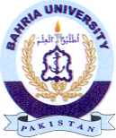Bahria University Library Islamabad
Source: Balochistan Time, Thursday Dec 21, 2023

