Value Proposition Of ‘Solar Water Heater’ For Domestic Purpose In Islamabad

Authors
Sibgha Tul Jamil 01-221092-067
Usman Ali 01-221092-078
Shakaib Tahir 01-221092-062
Umer Iftikhar 01-221092-077

Supervisor
Mam Nadia Bikthwari

INSTITUTIONAL AFFILIATION
Bahria University,
E-8 Naval Complex,
Islamabad

FALL 2010

TABLE OF CONTENTS
ABSTRACT 1
1 Chapter: Introduction 2
1.1 Broad Problem Area/Background 2
1.2 Problem Statement/Priority Issue 4
1.3 Objectives of the Study 4
1.4 Research Methodology 4
1.4.1 Type of Study 5
1.4.2 Population/Sample 5
1.4.3 Instruments and Measures 6
1.4.3.1 Questionnaire 6
1.4.3.2 Interviews 6
1.4.4 Limitations 7
2 Chapter: Literature Review 9
3 Chapter: Industry Analysis 28
3.1 Introduction 29
3.2 Conventional Gas Heaters 29
3.2.1 Local Manufacturers 30
3.2.1.1 Super Asia 30
3.2.1.2 Singer 30
3.2.2 Characteristics of Conventional Gas Heaters 31
3.3 Solar Water Heaters 32
3.3.1 Local Vendors and Manufacturers 32
3.3.1.1 Catkin 33
3.3.1.2 Solar Geyser 33
3.3.1.3 Asjid Energy Systems 34
3.3.2 Characteristics of SWH’s 34
3.3.3 PEST Analysis 35
3.3.3.1 Political 35
3.3.3.2 Economical 36
3.3.3.3 Social 36
3.3.3.4 Technological 36
4 Chapter: Organizational Overview 38
4.1 Introduction 39
4.1.1 Goals 39
4.1.2 Projects of AEDB 40
4.1.2.1 Latest Projects 40
4.1.2.1.1 Bio-mass plant in Karachi 40
4.1.2.1.2 Wind farms in southern Sindh 41
4.1.3 AEDB Programs Regarding SWH 41
4.1.3.1 Promotion campaigns by AEDB 41
4.1.3.2 Training programs 42
4.1.3.3 Renewable Energy Association of Pakistan 42
4.1.3.3.1 Reap and training program 43
4.1.3.4 SWHs and AEDB 43
4.1.4 SWOT Analysis of AEDB 44
4.1.4.1 Strengths 44
4.1.4.2 Weaknesses 44
4.1.4.3 Opportunities 45
4.1.4.4 Threats 45
5 Chapter: Identification of Issues 46
5.1 Lack of Information regarding the Usage of SWH 46
5.2 Limited Access to the Product 46
5.3 Increase in cost for Consumers 46
5.4 Government of Pakistan is not playing an active role in promoting alternative products 47
5.5 Vendors don’t have resources for promotion 47
5.6 Survey Analysis 47
6 Chapter: Possible Options/Alternatives 60
6.1 Advertising 60
6.1.1 Discounts/Subsidies 60
6.1.2 Brochures 60
6.1.3 Personal Selling Tactics 61
6.1.4 Outdoor Advertising 61
6.2 Collaboration between AEDB and Vendors to Influence Government Decisions 61
6.3 Bylaws and Municipal Administration 62
6.4 Grass Root Level Training 63
6.5 Market Space and Market Place 64
7 Chapter: Best option/recommendations 65
7.1 : Mass Awareness Program 65
7.1.1 Advantages of This Option 66
7.1.1.1 Reach the Masses 66
7.1.1.2 Introduce the Product 66
7.1.1.3 Highlight Features 66
7.1.1.4 Provide Detailed Information 66
7.1.1.5 Time Bound and Effective 67
7.1.1.6 Tangible Results 67
7.1.1.7 Holistic Approach 67
7.1.2 Disadvantages of This Option 67
7.1.2.1 High Costs 67
7.1.2.2 Limited Penetration 68
7.1.2.3 Governmental Dependence 68
8 Chapter: Action Plan 69
8.1 Stage 1: Appreciation and Recognition in Democratic Institutions 69
8.1.1 Time Frame 69
8.1.2 Resolutions to be Adopted 69
8.1.3 Features of Resolution 70
8.1.4 Role of AEDB 70
8.1.5 Role of State organs 70
8.2 Stage2: Mass Awareness Campaigns 70
8.2.1 Time frame 70
8.2.2 Role of AEDB and State Organs 71
8.2.3 Theme of Advertising Campaigns 71
8.2.3.1 Energy Conservation and Alternative Measures 71
8.2.3.2 Gas consumption and related problems 71
8.2.3.3 Promotion of SWHs 72
8.2.3.4 Product Knowledge 72
8.2.3.5 Pricing Option 72
8.2.4 Advertising and Marketing Mix 72
8.2.5 Sales Management and Vendor Relations 74
8.3 Stage 3: Market Infrastructure Development and Grass Root Level Skill Development: 74
8.3.1 Development of Designated Markets 74
8.3.2 Setup in Poly-Technical Institutions 74
8.3.3 Development of Logistics support in supply lines 75
8.3.4 Influencing Factors 75
8.3.4.1 Political Factors 75
8.3.4.2 Economic Factors 76
8.3.4.3 Weather Conditions 76
8.3.4.4 National Demand 77
8.3.4.5 International prices of petroleum products 77
9 Bibliography 78
10 Chapter: Annexure 83
10.1 Annexure A: Call Reports 83
10.1.1 AEDB 83
10.1.1.1 Date and Time of Meeting 83
10.1.1.2 Persons Interviewed 83
10.1.1.3 Interview Sheet 83
10.1.2 Vendors/Manufacturers 84
10.1.2.1 Date and Time of Meeting 84
10.1.2.2 Persons Interviewed 84
10.1.2.3 Interview Sheet 84
10.2 Annexure B: Questionnaire 87
10.3 Annexure C: Comparison of Solar Water Heaters with Traditional geysers 91

ABSTRACT
In today’s world where non renewable energy reserves are rapidly running out and are simultaneously contributing to the depleting environment, the need for alternative sources of energy is on the peak, especially for energy deficient countries like Pakistan.
Lack of awareness and inadequate infrastructure support are the main factors which contribute to the fact that even today, the common man does not have many alternatives to daily life electricity and gas usage. This paper focuses on how Solar Water Heaters (SWH) can help end this reliance on fossil fuels, and how this ever increasing energy deficiency gap can be reduced substantially.
The research is based on highlighting the value of an alternative energy product SWH to the domestic sector in Pakistan. The aim is to give recommendations to AEDB (Alternate Energy Development Board), and all relevant organs of the state, which are responsible for the promotion of SWHs as well as the local vendors to promote this product to people in an effective way.
The best way to switch consumers from using traditional geysers is to start mass level advertising campaigns in both print and electronic media. Along with that Government should set laws and make it compulsory to install SWH in new residential areas.

Chapter: Introduction

Broad Problem Area/Background
Figure 1: Solar Water Heater
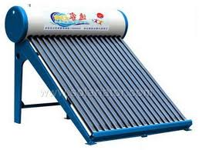
(Compact Pressurized Solar Water Heater)
Pakistan is facing energy crisis which has worsened in the past few years. The growing energy demands for domestic sector are increasing rapidly. As a result the nation is facing severe energy crisis. The solution to this problem is using an alternative/renewable energy resource which is a substitute of electricity and gas because these are consumed copiously and as a result industries shut down because there is no energy available to run the units.
SWH is a valuable product for customers. This product is very economical as it does not require any monthly billings from consumers. It is using solar energy so, not consuming any electricity or gas for its working. Only the cost of buying is incurred by the consumers but that cost is in turn going to benefit them in the long run as the cost will be recovered within 2 to 3 years in reduced billings. In this way a lot of electricity as well as gas can be saved which has become very expensive in Pakistan and a common man is not capable to bear the huge burden of bills. By using this product the money saved in the form of reduced billings can be used for other purposes to improve the standard of living of people.
SWH require little maintenance costs and the usable life is about 10-15 years. It is also one of the best ways to lower carbon footprint and help protect the environment. This product is one of the most suitable ways to reduce greenhouse gas emissions.
SWH comes in various sizes i.e. from 85 to 400 litres. This provides a capacity to store large amount of hot water. This capacity can further be increased through additions of more systems in series. Another viability of a SWH is an option for hybrid connection i.e. gas or electricity to ensure continuous supply of hot water at optimum temperature on cloudy days so that there is no shortage of hot water for user.
Use of SWH for domestic sector results in curtailing the energy shortages and the energy saved would be used for more productive purposes such as in industrial units. SWH is a valuable product for the domestic sector but the problem being faced is lack of awareness regarding its efficiency, use and benefits. There are 16 vendors registered with Alternative Energy Development Board (AEDB) and overall 30 vendors providing the product in the country. AEDB is a governmental organization and working on different projects related to alternative/renewable energy.
As SWHs falls in a category of alternative/renewable energy products so, AEDB has to promote this product in a way that people get aware of this and buy it for their domestic use but AEDB does not have an adequate amount of funds as well as resources to make the benefits of this product visible to the domestic sector as well as to help vendors in using modern technology so that all the manufacturing is done in Pakistan.

Problem Statement/Priority Issue
Lack of awareness about SWHs leads to increase in energy consumption and subsequent energy shortage (for domestic sector).

Objectives of the Study
- To determine the awareness level of domestic citizens regarding the benefits, use and efficiency of SWH.
- To convey SWH performance details to domestic customers along with the price, benefits, efficiency and technology.
- To give recommendations to AEDB and vendors about how to augment the selling of SWH and to make domestic customers aware of it.

Research Methodology
Methodology is the total frame work of a research project. This includes various stages and phases of the exercise of the data collection, nature of units of data collection and selection of tools of data collection. All these, in turn, are manifestations of the theoretical logic and rationale underlying the selection of problem to be investigated and operationalization of the same. Thus methodology, in sum, equals the philosophy underlying any research project.

Type of Study
Applied research is used which refers to scientific study and research that seeks to solve practical problem and to find solutions to everyday problems.
This research highlighted the alternatives for solving the problem related to SWH’s acceptance which was basically lack of customer awareness. Apart from that secondary data was analyzed that gave an in depth understanding of the working of solar heaters. Interviews with vendors and AEDB officials along with the questionnaires that were filled from the citizens of different sectors of Islamabad further helped to identify the main issues related with the associated problem. After doing an in depth analysis, strategies in the form of solutions were formulated to make the value of SWH visible to the domestic sector as well as to create a demand for this product.

Population/Sample
Neumann (1996) has defined sampling as a process of systematically selecting cases for inclusion in a research project. It is like random assignment.
A sample is a finite part of a statistical population whose properties are studied to gain information about the whole.
When dealing with people, it can be defined as a set of respondents (people) selected from a larger population for the purpose of a survey.
Survey was conducted from the citizens living in different sectors of Islamabad. Their feedback regarding SWH was taken. Questionnaires were given to people of age groups ranging from twenty to fifty five. The sample size for research was approximately 100 and there was a random selection of people from different sectors.

Instruments and Measures

Questionnaire
A questionnaire is very useful technique in order to acquire data qualitatively as well as quantitatively. The research included closed-ended questions. In this research a set of relevant questions about product were designed in the form of questionnaire. Separate questionnaires were designed for citizens in Islamabad to know about their awareness level, what features they prefer in buying the product, whether they think alternative energy products can reduce energy crisis or not. Questionnaires were used because of the low cost associated with them and response from audience was quick.
Data entry and tabulation for nearly all surveys was easily done with software package. The target audience received same questions in the same order and that helped to ensure consistency. The questionnaires were given in printed form and the data was analyzed with the supervisor using software packages like SPSS.

Interviews
Interviews were conducted with officials of AEDB in addition with selected vendors/manufacturers related with the promotion of product and what steps they are taking to make this a valuable product. Before conducting interviews researchers gathered all information with regards to SWH. Questions asked were relevant to the topic and to the point. Researchers did a brainstorming session in developing an interview format and time of interview was 30 minutes.

Limitations
Limitations were in convincing AEDB to give financial incentives like funds to the manufacturers or vendors to use modern technology in developing this product. Moreover, due to personal interests, the government officials rejected some of the proposed recommendations for making SWHs a success.
Domestic sector was not willing to pay high price and to bring the price lower, there must be more supply of SWHs in the market. AEDB with the cooperation of government had a main role to play in facilitating vendors to invest in making the parts needed in the manufacturing process on a broad scale.
People still preferred using the traditional gas geysers because they had loyalty associated with them. This was due to the fact that people were satisfied with the durability, heating efficiency and price of traditional geysers. Therefore domestic sector need to be assured regarding the quality and efficiency of SWHs. So, one of the most important aspects to be considered was that a paradigm shift was needed to switch consumer perceptions.
Close monitoring on manufacturers was required to ensure that cheap material was not being used for making different parts as this had an ultimate effect on the performance of end product. Vendors needed to focus on providing quality so that people would convey positive word of mouth regarding the product to others as well.
Unfavorable weather conditions had an effect on the heating efficiency of SWH and they created a negative perception concerning the product in the minds of customers. This in turn affected the sales and resulted in low sales and decrease in demand. If there was no sunshine for four days then the need of people which was hot water was not going to be satisfied.
Politically the bureaucrats were in favor of buying rental power plants which needed lump sum amount of foreign exchange. Instead of that government should have invested on promoting solar technology which was more economical for the country.

Chapter: Literature Review
Figure 2: Working of SWH

(Google Images)

(Davis, 1956) did research on SWH for arctic season in Greenland and revealed that SWH is the only source which can solve the problems of the people living there. Cost is not an issue for the people living there. Sunlight is available abundantly there and it can easily be trapped by building a pilot plant as snow in this area never melts. Twenty five scientists from the Permafrost Research Establishment of U.S known as SIPRE had conducted research there. A pilot installation in arctic will solve all difficulties of human life. The changes in weather conditions as well as the amount of snow in the ice cap can affect the supply of oil and other materials needed for doing research at that place.
(Morse, 1977) believes that there are wide opportunities for utilizing energy from sun in Australia. The consumption of energy in Australia is increasing day by day. Australia has set a target of about 20% to meet the primary energy needs of the country in maximum 25 years. Solar heat generating systems which are capable of generating heat at temperatures of 100 C and 150C are included in this program. Collectors will be placed on the roofs of houses and factories. About 40% of country’s energy requirements will be met using solar energy. Integrated system of solar energy as well as fuel will be used to provide energy to domestic and industrial sector. Australia’s Commonwealth Scientific and Industrial Research Organization (CSIRO) is also doing research and development in the field of solar energy in Australia. All funds needed for research and development are provided by the government. Different reports have been published on flat plate collectors, thermal storages and on industrial process heating. CSIRO had an influence on the Australian government and it decided thereby to install SWHs in the northern territory of government offices. 30,000 installations have been already done in Australia regarding solar applications. Australia is lucky to have manufacturers of SWHs who have the expertise needed to implement the programs effectively and they have done this by manufacturing high quality collectors.
Different experiments have been done in Australia in which rock air storage was combined with solar air heaters to provide thermal storage. SWH for residential purpose is meeting about 40-60% of total energy requirements. In some parts of Australia the pay back period of SWH varies from three to almost 10 years. Solar heating of swimming pools is being done by using cheap collectors having no glass cover. (Morse, 1977)
(Duffie & Beckman, 1976) believed that solar heating and cooling for buildings using flat plate collectors is going to be a broad application of solar collectors. These collectors are manufactured on a small scale in U.S and they could be of great use to supply thermal energy to buildings at temperatures of less than or 100 C. For conversion towards installing SWHs, the best place to start with is new residential construction. For encouraging the use towards such energy, government must give incentives in the form of taxes. Two main reasons have been given for the failure of solar energy. The first one is the high costs associated with solar energy due to which it has not been able to compete with natural gas. Second is that there is no constituency for the development of solar energy as it was in the case of nuclear energy. In countries like Australia, Japan and Israel millions of SWHs have been installed. Different experiments have been done in U.S regarding the heating and cooling of SWHs and many of them have been installed in residential areas like hotels and schools.
There have been several problems with respect to the architecture of SWHs i.e. whether to install them on the surface of roofs or in vertical walls. Solar energy systems consists of flat based collectors. Ducts and energy storage unit used to store energy. Many of the heating systems that were installed in U.S give satisfactory performance and reduce bills. Solar air cooling technology has not yet been as remarkable as solar heating technology. Improvements in the economics of SWHs will occur gradually as mass production will increase and improvement in technology will be made. Wide use of this product will create new business opportunities. (Duffie & Beckman, 1976)
(Butti & Perlin, 1983) explained the sudden rise and popularity of SWHs in California. Years ago people used to heat water on stoves and in villages, very seldom gas heaters were available. Gas was expensive those days and people couldn’t afford to warm water like that. Then first SWH was discovered in the form of metal water tanks painted in black and then placed in sun but they took lot of time to heat water. Then a manufacturer by the named of Kemp solved this problem by placing a hot box in tanks to keep it warm. These were the first SWHs that were discovered and they were named “Climax” which was sold in eight different sizes. This was a remarkable asset to utilize sunshine.
Climax became so popular that it was introduced in Southern California as well and almost every household had them. Later on ‘Walker’ heater was introduced and it was attached with the conventional heating system to ensure hot water at all times. In 1905 the rights to sell climax were acquired by Solar Heater Company and it was run by Charles Haskel. Improvement in Climax was made as it was sold in one large rectangular tank in stead of several tanks and placed on roof tops. The problem with Climax, Walker and Hassel’s model was that they could not function properly on cloudy days. (Butti & Perlin, 1983)
In 1909 William J. Bailey introduced day and night SWH that changed the industry completely and brought a revolution. It had two units: solar heater collector and storage water tank had coiled pipes and they were placed in the glass box that warm the water and then it was passed through conventional gas heaters so that it won’t cool down. Day and night water heaters reduce gas consumption by 75%. In 1913 the weather in California had a sudden shift and a cold layer spell keeping the temperature very low. Because of this cold weather the water inside day and night heaters froze so, Bailey tried solving this problem with using alcohol and distilled water by placing it in the collector and after heating it passed through coils. (Butti & Perlin, 1983)
Government will install 50,000 SWH’s in northern areas to save the gas consumption. The prices of these will be subsidized to encourage people to buy them. In India the prices of SWHs have been subsidized up to 80 % to encourage customers to buy them. Financial incentives will be given to mass production on a large scale. Tube well users will also be motivated to use solar power in order to lower the electricity load. (Ahmed, 2010)
Pakistan can overcome the energy crisis by utilizing on renewable energy resources. Western countries have developed renewable energies using wind, biomass and solar. AEDB has launched a consumer confidence act for the promotion of SWHs in which it is giving money back guarantee to consumers. Three sectors of the economy which are domestic sector, transport sector and industrial must be convinced to reduce the energy crisis. (Bukhari, Countering energy crisis with alternative resources, 2010)
Energy shortage which is one of the biggest problems of Pakistan must be solved if Pakistan has to progress in the industrialized sector. Electricity is produced in Pakistan using electromechanical generators which run by power lines and transmit electricity to far places. 33% of the energy being produced in Pakistan is through hydro and 2% by nuclear. AEDB is a body formed by government which is currently working on developing solar and wind power plants. The abundant energy available in the country can be transmitted into solar energy with the help of solar panels. (Khan, 2010)
There are many advantages and disadvantages of SWHs. These days there is a shortage of gas, water along with one of the most common one which is electricity. The causes behind these shortages are something which is not yet known. (Khan, 2010)
If a look at the climate of Pakistan is taken than it becomes clear that summer season lasts longer than the winter season. For a country like Pakistan using a solar system will be more appropriate as compared with Europe. Work in this field is being done by many scientists and engineers. Their point of view is that this technology is going to have a high price in the beginning but gradually the prices will come down as it is a principle of economics. (Khan, 2010)
In Pakistan the energy from sun has been used for many different purposes like drying clothes etc but for producing electricity this energy has been used recently. The energy from sun is sufficient to meet the power needs of Pakistan. The various techniques that have been used around the world to produce electricity from sunlight include solar cells, solar water heating and solar towers. (Khan, 2010)
Solar cells convert light into electricity and can run bulbs and lights. Energy from these satellites is also being used to run satellites. Solar water heating is also being used to heat water in the panels which then provides warm water which is effective to use. Solar towers are another technique in which a tower is put in a green house and this is used to run turbines. (Khan, 2010)
There are seldom advantages from using this technology and these are that it does not require any fuel so there are no bill charges, effective to be used for chargers and garden lights. There are certain limitations which are also associated with using this energy and these include its unreliability to function properly at night and that it is costly. (Khan, 2010)
In Pakistan by training the manpower this energy can be very effective in producing electricity. Pakistan is blessed with plenty amount of sunlight and it won’t face the problems being faced by other countries. (Qadri, 2008)
(M.A.Alghoul) in Review of Materials for Solar Thermal Collectors focuses on how to reduce the cost of materials in making a solar thermal collector such as SWH and how to improve its efficiency. All the parts involved in the system of solar collector and the working of it have been discussed.
The basic features of solar thermal collector materials are discussed such as its transparent cover, insulation, evacuated tube collector, absorber, heat sheets and phase change material. The main idea behind it is to understand the materials and their qualities and how a SWH is built, taking advantages of these materials. (M.A.Alghoul)
The techniques used in the process are also well described and how they can be used in the SWH. The cost is the most important thing in today’s world and in order to make this solar thermal collector mechanism acceptable, all the cost has to be controlled so that it can be imparted to all the processes. The advanced technology used in solar thermal collector is critically reviewed in terms of the cost and the materials used in the making of it. The most important materials which help in reducing cost and improving efficiency include low iron glass transparent covers, vacuum insulation, elective coating materials and super conducting working fluid. All these materials help in making solar thermal collector work effectively with low material cost. (M.A.Alghoul)
SWHs are more cheap and efficient to use as compared to conventional ones because of the technology and parts used in the making of it. Therefore the acceptance of SWH can be made possible if this solar thermal collector with low material cost and better efficiency are used. (M.A.Alghoul)
(Bukhari, Countering energy crisis with alternative resources, 2010), focuses on Countering Energy Crisis with Alternative Resources with especially SWH and what steps have the government taken to promote it. This also gives an overview of what actually the situation is in the country and where are the weaknesses lying. All the sectors have also been highlighted which are consuming most of the energy and further recommendations are made to improve the crises.
SWH technology has been stated as one that can save a lot of energy for the other sectors to get benefit out if it. Many countries have introduced this technology and it has been successful in achieving their goals. Talking about the AEDB, the contributions made by them are also mentioned related to promotion of SWH as they are the major consumers of gas in the country. That leads to shortage for the industrial sector as the household usage is increasing day by day. To cut the household usage of gas, SWH awareness is being created among the people and how efficient it is in saving cost. (Bukhari, Countering energy crisis with alternative resources, 2010)
Talking about the achievements of NUST, it has helped many households and villages with the help of this technology. With many future projects in place, NUST plans to provide electricity through solar technology and help the country come out of this energy crisis. The conditions in Pakistan are good to use solar energy as most of the times the sun is out and it can be utilized if proper strategy is made. (Bukhari, Countering energy crisis with alternative resources, 2010)
With the passage of time Government of Pakistan has become serious about this issue and has made a plan for the future in order to get out of this crisis. Still a lot of work has to be done in the promotion of alternative energy technology and implementation of the conservation policies is the most important thing. All the industries today are facing energy crises which have made unemployment to rise and industries to shut down their operations. Therefore Pakistan needs to shift to solar energy and start using it in order to prosper in the future. (Bukhari, Countering energy crisis with alternative resources, 2010)
(Solar Water Heating Pays For Itself Five Times Over, 2009) Research conducted in India suggests that a SWH estimated payback period comes out to just two years. A 1000 – liter system operating in a hostel was analyzed in the research and a report was published in “International Journal of Global Issues” on the success of the project.
The developed countries are focusing on the advanced technological approaches on renewable energy resources e.g. photovoltaic cells, harnessing wind energy and wave to produce electricity. But the cost of these systems is too high, which prohibit the use of such system for developing countries. (Solar Water Heating Pays For Itself Five Times Over, 2009)
The research conducted in Dr. Panjabro Agricultural University in India, which calculated the cost and benefit analysis of using SWH and, according to their the results, SWH as compared to electrical energy approaches gives 60% approx internal rate of return. (Solar Water Heating Pays For Itself Five Times Over, 2009)
Solar energy is the only alternative energy which has wide range of uses i.e. water heating, air heating, producing electricity and the most effective use of it is for thermal purpose. (Solar Water Heating Pays For Itself Five Times Over, 2009)
Most important fact which comes forward is about the payback period of SWH which is only about 2 years. If it compared to photovoltaic which have payback period of more than a decade, so the investment in this product is much more feasible and cost effective. According to the article, the research team suggests, that the SWH installed in university campus, which were analyzed in the research will effectively pay for itself four to five times with a given estimated working life of 20 years. (Solar Water Heating Pays For Itself Five Times Over, 2009)
(Hande, 2006), explains
Financing SWHs and how the change in government policy on SWHs, has not only increased investment but also the demand in different metropolitan areas of India.
Initially, the government policy in the early 1990’s was to provide capital subsidies to attract investment in the growing industry. The process of providing these subsidies was monitored by the Ministry of Non-Conventional Energy Sources (MNES). However, the policy failed to attract any new investment, because of the bureaucracies’ existent in the process of availing capital subsidies. (Hande, 2006)
However, once the policy was changed in the mid 1990’s to provide interest subsides that was used to provide financing for purchase of SWHs by commercial banks, at interest rates, lowers than the prevailing ones, the demand for SWHs expanded greatly. (Hande, 2006)
As the demand for SWHs rose, so did the investment, and the author provides the example of the State of Karnataka, where the total manufacturers rose from a mere 6 to more than 60 manufacturers by the end of the decade. (Hande, 2006)
(Roger H. Bezdek, 1979) did research on the Economic Feasibility of Solar Water and Space Heating. The study is about the use of direct sun’s light for the means of easing U.S energy problem. It was conducted in four main cities of USA and has three economic decision criteria to determine economic feasibility on the basis of payback time, years of down payment recovery and years to positive cash flow. The performance of solar water and space heating was compared in each city and the incentives are directed towards applications for supplying hot water mainly for domestic purpose. The economic feasibility of SWH and space heating is compared with the other options/alternatives like electricity, fuel oil and natural gas.
SWH is economically viable when it has positive cash flow realized in 3 years or less, down payment is recovered in 5 years or less and payback is achieved in 10 years or less. At present SWH is economically viable in some regions of USA. It is competitive in areas where the alternative is electricity whereas it is not competitive in those areas where fuel oil or natural gas is used for heating systems. The purpose to introduce tax credit is basically to make it more competitive. At present utility pricing policy insulates the consumer from the true costs of new supplies by “rolling in” the price of the new supply with the price based on existing gas supply contracts. Another serious barrier to solar panel penetration of the commercial market is the present federal income tax provisions that permit full expensing of fuel and utility costs. The net effect of these tax code provisions is to discriminate against the more capital-intensive solar energy technologies. (Roger H. Bezdek, 1979)
(Stasinopoulos) has given a new concept of Sunny vs. Sunny Roofs developing in Europe that says that roofs are a better place to collect solar energy rather than the wall.
The previous preconception was that walls, especially those facing the equator were the best place to collect solar energy, because at the equator, the intensity of the sunshine is the highest.(Stasinopoulos)
The incidence of solar rays on walls is reduced significantly, when compared to the roof of the same building. Some of the impracticality of using walls to collect solar energy, such as the total size available to install equipment which is reduced because of the need to have windows and emergency exists, the shadows being formed of adjacent buildings and the threat of vandalism on walls, such impracticalities do not exist in the use of walls.(Stasinopoulos)
Although equipment’s like SWH’s and solar cells are being placed on the roof of a given building, equipment like air collectors to heat buildings are placed on the walls, which reduced their efficiency to a great extent. (Stasinopoulos)
Examples of the school, factories and sports halls, buildings have been given that do not utilize their roofs to collect solar energy and then givens practical examples of buildings in London and Athens that used roofs to collect solar energy to heat the buildings and provide natural light, one of which was a school in Athens, which used its roofs to heat the school and provide natural sunlight. (Stasinopoulos)
(SBP introduces financing facility for renewable energy , 2009)According to the circular issued by the State Bank of Pakistan (SBP), sponsors of new power projects can avail financing facility from banks/development finance institution. According to the circular, the financing facility would be given to new power generation projects that would be using alternate energy to generate up to 10 MW of electricity.
Sponsors of new project can avail the financing facility for locally manufactured or imported plants, machinery and equipment’s. The total financing facility would be for a maximum of 10 years, with a 2 year grace period. The main advantages of this facility is that it would promote alternate energy in Pakistan, as potential investors would be able to avail this facility and finance their projects at a low cost of debt. The current increase in the financing rate offered by commercial banks to the end user, has increased the interest costs for potential investors, reducing the benefits of using debt to raise funds. However, with the issue of the circular, the government expects increase in investment by both local and foreign investors. (SBP introduces financing facility for renewable energy , 2009)
(Several projects of renewable energy likely , 2010) On the visit of a business delegation on renewable energies from Germany, the German Ambassador held a press conference, where he informed the guests on the potential of renewable energy in Pakistan. According to the ambassador, the envoy has estimated that Pakistan has the potential of harnessing 41,722MW of hydro power, 346,000MW of wind energy and 2.9 million MW of solar energy from its unique natural conditions. Currently, Pakistan is only harnessing 6,600MW in the form of hydro-power schemes. The ambassador emphasized the importance of Germany’s economic and development assistance to Pakistan in the energy sector, which includes projects like the Tarbela Dam in 1985, and assured its assistance in the future.
Pakistan has a vast potential to tap renewable energy and meet the current and future energy needs of the country. Renewable energy is not only sustainable but also costs less to produce. The government should take the assistance of countries like Germany, which are in the forefront of technological advancements in renewable energy and provide assurances to them regarding the security of their personal and investments in the country, as this is the biggest concern of any multinational coming into Pakistan. (Several projects of renewable energy likely , 2010)
(Muhammad, 2008), believes that cheap and reliable energy resource are the engines of an economy and this is the right time to think about the alternative energy resources of energy. As Pakistan is blessed with enormous glaciers which are the sources of water for rivers as well as water from such sources could be used to produce cheap electricity. Pakistan should give more consideration towards the construction of reservoirs and dams for the production of large amount of electricity to become among the world’s best economy. According to the statistics, double the amount of energy can be produced which requires to run the overall industry including textile that is currently facing severe energy shortages.
Countries all around the world are exploiting wind and solar energy resources and a lot of research is taking place on it. China on the other hand moved one step forward by offering turbines for home as well as for industrial sector use. In Pakistan there are number of suitable locations available to introduce wind turbines. (Muhammad, 2008)
Most of the areas in Pakistan are blessed with plenty of sunshine. By introducing solar panels for generating electricity Pakistan can overcome and fulfill most of the energy needs. So, sooner Pakistan exploits its energy resources like wind and solar, earlier it will become self sufficient in producing energy and fulfilling needs. (Muhammad, 2008)
(Power & Alternative Energy exhibition concludes, 2010) The power and alternative energy exhibition was held at the Karachi Expo Center, and displayed locally, as well internationally manufactured products regarding power generation and alternative energy. 17 countries, including China, India, Malaysia, USA and UAE participated in the exhibition, showing their products to the foreign, as well as local investors. Almost 125 high level trade delegations participated in the exhibition and showed interest in the wide variety of products being offered.
Exhibitions, like the power and alternative energy exhibition are a great way of increasing awareness among local businessmen and investors but also a way to show indigenously produced local products like SWHs to the world. These exhibitions provide local manufacturers with access to international buyers at a single location and can benefit local manufacturers with export orders for their products. Lastly, it also increases the prospects of potential investment in alternative energy in Pakistan, not only from local but also international companies alike. (Power & Alternative Energy exhibition concludes, 2010)
(Govt to promote solar water heaters to cut gas consumption, 2009) Government is giving an overview about the Governments efforts in promoting SWH’s and wind projects in Pakistan to reduce energy consumption and meet the growing demands of electricity. Government of Pakistan is going to provide support to produce SWHs in Pakistan as their use is going to reduce the energy consumption in the country.
Raja Pervez Ashraf insisted AEDB to promote these SWHs and create a market for them. AEDB’s role was to hold meetings with investors and industries to find a way to promote investment in this sector. The article also highlights the Northern Areas Electricity Development Company formed by government to set up power generation projects. AEDB had also given letter of intent to a private company in order to set up a hydel project of 16-20 MW on Gilgit River. Furthermore, a company would also start setting up its wind farm in Jhimpir. This will be the country’s second wind farm. (Govt to promote solar water heaters to cut gas consumption, 2009)
(Kabir, 2003) discuses Prospects of Solar Energy in Pakistan as it has faced increased deficiency in power generation over the years. The electricity consumption has tripled in the past 20 years and with our increased reliance on thermal energy, the costs of producing electricity has also risen due to increase in imported fuel costs.
Solar energy in this situation provides an opportunity to meet our energy needs, as due to our location, we have ample sunlight all year round. However, there are both pros and cons of adoption this new technology in Pakistan. (Kabir, 2003)
The main advantage of adopting this technology, is the electrification of rural far flung areas, which would cost a lot, if they were to be electrified using the traditional electrification system. This would especially be true, with respect to areas of Sindh and Baluchistan. (Kabir, 2003)
The main problems however, with adopting this technology is that Pakistan lack the technological capabilities of adopting this technology. The capabilities of producing solar panels that capture sunlight to produce electricity are scarce. Furthermore, because we have used conventional methods to produce electricity, we have yet to produce appliance that can run on less energy, which is required when using solar energy. Also the dusty atmosphere prevalent in our country also reduces the efficiency of solar energy in the country. (Kabir, 2003)
Recently, however, the government of Pakistan has increased development of solar technology in Pakistan. Engineering universities are being provided funds to develop appliances run on solar technology like SWHs, cookers and dryers. Furthermore, organizations like Pakistan Council for Renewable Energy Technology (PCRET) have started promotional campaign to create awareness, while also starting up new programs to develop and expand solar technology in the country. (Kabir, 2003)

Chapter: Industry Analysis

Figure 3: Conventional Gas Heaters
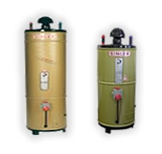

(Gas Applications)

Introduction
Water heaters or geysers as they are called in our local language can be seen installed in every house. These water heaters provide hot water, which is used domestically for cooking, cleaning and bathing purpose. Water heaters remain an essential item for any home in Pakistan and thus the market for water heaters has expanded and numbers of local manufacturers are producing them locally.
Although the water heater market has shown a number of innovation worldwide by producing water heaters that can run on natural gas, propane gas, electricity, heating oil, liquefied petroleum gas and solar energy. In Pakistan, however, the traditional tank storage heaters that run on natural gas are most popular and being produced in great quantities by local manufacturers to meet the local demand. Use of electricity run water heaters has remained almost negligible because of the high tariffs of electricity prevalent in the country. Recently, however, with the increase in knowledge and reduction in costs, due to imports from china, a number of people are switching over to SWH’s. This trend has especially taken place in the northern areas of Pakistan, where an extensive network of natural gas pipeline is not prevalent.

Conventional Gas Heaters
As discoveries of natural gas started to take place in the 1950’s in Baluchistan, a wide network for natural gas supply was built. These discoveries led to increased use of gas run geysers, which in the initial days were imported into the country. These geysers increased the efficiency of water heating, which would initially be done by heating water by burning wood.

Local Manufacturers
Today, a number of local manufacturers are producing gas heaters to meet the local demand. Few major ones are listed below:

Super Asia
Super Asia is one of the finest Pakistani brands available in the market. The company produces a wide array of consumer appliance which includes washing machines, air conditioners, water coolers, microwave ovens, fans and water heaters. The company has 25 years of experience and has achieved the ISO 9002 certification for its quality.
The company initially started producing gas water heaters, which it produces in 30 and 55 gallon specifications but later also introduced electric water heaters and became the first Pakistani brand to produce them. All the components and assembly of the water heater takes place in Pakistan by using local raw materials, except for the powder coated paint which is imported. (About Us)

Singer
Singer Pakistan was established in 1877, and started its business by producing sewing machines. Today, however, it has grown into a diversified business by become a retailer of other consumer electronics, but also as a manufacturer of one. Singer manufacture’s televisions, refrigerators, air conditioners, gas stoves, washing machines, sewing machines, small appliance like toasters and steam irons and finally water heaters
Singer manufacturers gas water heaters, and are one of the oldest in the market. It uses a combination of both local and imported technology and spare parts. Its glass wool and thermostat are imported. Furthermore, unlike Super Asia, Singer produces water heaters in three specifications- 15, 30 and 35 gallon. (Singer)
Apart from the well know brands of Super Asia and Singer, other brands include Millat and Cannon.

Characteristics of Conventional Gas Heaters
All of the conventional gas heaters use a central heating plate and adjustable thermostat to heat water in the cylindrical tank built in the water heater. The thermostat allows user to manage the water temperature to their desire. In the local market, the conventional gas heaters would come from 15-35 gallon specifications for domestic purposes, with larger specifications of 50 gallon and above available for businesses.
The price of gas water heaters ranges from Rs.12000-15000, with installation charges ranging from Rs.700-1000. A warranty of 1 year is provided for the thermostat, while a 3 year warranty is provided for the tank. The average useful life of a gas water heater is considered to be 15 years. According to local vendors, average monthly sales of 15-25 water heaters take place.
As gas water heaters are produced locally, the maintenance costs and repairs over its life time is reduced significantly. Local plumbers have received ample knowledge about its working and are able to fix any problems associated, even after the warranty period is expired at minimal changes.
One of the main concerns with using conventional gas heaters is that it increases utility bills. Recently, however, the Sui Northern Gas Pipelines Limited (SNGPL) introduced a new technology, experimentally to houses in Islamabad and Lahore, which was developed indigenously at the department. The new technology uses a stainless steel cone filled with gypsum, inserted into the tank of the water heater. This cone, according to the department, increases the heating efficiency which would reduce natural gas consumption by 33%, reducing utility bills. (SNGPL makes gas geysers energy 'efficient', 2010)

Solar Water Heaters
With the rise in utility tariffs and increased knowledge, SWHs are gaining increased acceptance in Pakistan. These were initially used in the northern areas of Pakistan, where an extensive network of natural gas supply is not available. However, lately, increased use is taking place in urban centers like Islamabad. SWH use solar energy to heat water and is considered to provide free hot water, once the initial costs are paid back.

Local Vendors and Manufacturers
In Pakistan, a number of vendors exists that supply imported SWHs from countries like China and Germany in the local retail markets. These vendors not only provide installation services, but also after sales maintenance services. Although the number of vendors is on the rise, the number of manufacturers is not on the rise, as the technology is new for our local manufacturers and requires huge investments. Some of the major vendors include:

Catkin
Catkin was established in 1996 and is providing a range of services and products in solar energy systems, central heating, centrifugal fans, flexible piping and associated services. It is located in Islamabad, near the dry port which eases transportation and timely delivery of products. Furthermore, Catkin is registered with ISO 9001-2000 and is a certified engineering company.
Catkin is associated with Reap (Renewable Energy Association of Pakistan) which is an association for promoting renewable/alternative energy products. Catkin is importing SWHs from China and provides both flat plate and evacuated tubes SWH’s. The company is installing SWHs in Islamabad and adjoining areas of Bhara Khou, Bani Gala and Murree. Furthermore, it is collaboratively working with Chinese trainers who are training its staff to properly install the SWH. It is also working on promotional campaign to create awareness about the product. (About us )

Solar Geyser
Solar Geysers is another company located in Islamabad that is providing SWHs to the masses. Solar Geyser, unlike other companies in the business, manufactures evacuated tube SWHs at its plant. These SWHs adhere to international product quality and engineering standards and because they are designed in-house are also easy to use and install. Solar Geyser also provides installation and after sales services and has been installing SWHs across Pakistan. (Company Profile)

Asjid Energy Systems
Asjid Energy Systems located in Sialkot is another local manufacturer of SWH. Like Solar Geyser, Asjid Energy Systems designs, manufactures and also provides after sales services.
Asjid Energy Systems goes a step further by manufacturing a range of other products that run on solar energy, which include, solar collectors, solar power systems, solar invertors, solar lanterns, solar torches and lights and solar submersible pumps.
Asjid Energy Systems has also developed hybrid SWH’s, which can also heat water from natural gas or electricity, if solar energy is not available, for example at times of rain and thunderstorms. (Asjid Energy Systems)
Apart from the above mentioned vendors and manufacturers some other vendors include: Sharif International, Adaptive Technologies, Petrocon, Aireng Industries, Pegasus and Izhar Energy Services.

Characteristics of SWH’s
In Pakistan, there are two types of SWHs available in the market i.e. flat plate and evacuated tubes. Flat plate SWHs are insulated, weatherproofed boxes that contain a dark absorber plate under one or more glass or plastic (polymer) covers. They may also contain tubes, which run within the box to heat water. The evacuated tubes SWH on the other hand feature parallel rows of transparent glass tubes. Each tube contains a glass outer tube and metal absorber tube attached to a fin. The fin's coating absorbs solar energy but inhibits radiative heat loss. Using evacuated tubes is an excellent way in which heat loss to the environment which is inherent in flat plates can be reduced. Since heat loss due to convection cannot cross a vacuum, it forms an efficient isolation mechanism to keep heat inside the collector pipes. (Solar water heating)
Currently most of the vendors and local manufacturers prefer the evacuated tubes SWH’s due to their increased efficiency in heating water and having the solution to the inherent problems faced by the flat plate SWHs.
The prices of SWHs, that are recommended for domestic use range from Rs. 15000-30000, with installation charges ranging from Rs.2000-4000. SWHs have a usable life of 10-15 years and warranty period ranges at an average of 4 years. Furthermore, SWH has the capability to keep water hot for a maximum of 72 hours if not used.
Currently, because the product and technology is new to the masses, it has to be properly installed by professionally trained people, which increases after sales maintenance and services costs.

PEST Analysis

Political
- Changes in tariffs and duties on import of evacuated tubes can affect the sales of SWHs.
- Lobbying from conventional gas heaters manufacturers can hinder production expansion and favorable laws to promote SWHs.
- Changes in construction laws to sanction the use of SWHs can increase demand.
- The government of Pakistan signing joint ventures with foreign companies to establish plants to manufacture SWHs can increase local presence of product in markets.
- Providing subsidies by the government on purchase of SWHs can increase both demand and supply.

Economical
- Increasing Inflation and associated rise in prices is going to negatively affect the sales of SWH.
- Providing discounts and subsidies will increase the sales of SWH.
- Low interest rates and incentives will result in increase of investment in this sector.
- Providing consumers personal loans at low interest rates can increase the demand for SWHs.
- The changes in foreign exchange rate, especially with Yuan and Euro will have adverse affect on the demand for SWHs, as the costs would rise.
- Rising utility tariffs and gas shortages will have a favorable effect on the demand of SWHs.

Social
- Increased knowledge on the greener environment will have people becoming more conscious to use environmental friendly technology like of SWHs.
- Social circle of people around affect the purchasing trends of others.

Technological
- Time is needed for any new technology to become acceptable for masses.
- Modern technologies used and innovation taking place around the world can impact/change the technology used and design of SWH.
- Increase in investment by foreigners will increase the pace of technological transfer and increase of indigenous production.

Chapter: Organizational Overview

Figure 4: AEDB logo

(Alternative Energy Development Board)

Introduction
The Government of Pakistan established Alternative Energy Development Board (AEDB) in May 2003 to act as the central national body on the subject of alternative/renewable energy in Pakistan. It basically acts as a facilitator between Government of Pakistan and the investors coming into the sector. AEDB being an autonomous body has been created for the purpose of implementation of various policies, programs and projects in the field of alternative/renewable energy technologies. The objective of AEDB is to assist and facilitate development and generation of alternative energy in order to achieve sustainable economic growth. (Alternative Energy Board of Pakistan)

Goals
Following are the goals of AEDB:
- To make national strategy, plans and policies for utilization of alternative/renewable energy resources, so that the targets approved by the Federal Government in consultation with the Board would be achieved.
- To work as a body for monitoring, evaluating and certification of alternative/renewable energy products and projects.
- To provide/act as one window facility for promoting and facilitating alternative/renewable energy projects.
- To set up alternative/renewable energy power pilot projects through JV or partnership with private or public entities in order to generate awareness and motivation of the need to take such initiatives for the benefit of general public and for the country.
- To conduct surveys and feasibility studies to spot opportunities for energy generation through alternative/renewable energy resources.
- Undertaking financial, technical and economic evaluation of the alternative/renewable energy proposals and to provide support in filling of required licensing applications to NEPRA.
- Coordinating with the National as well as International agencies for promotion and development of alternative/renewable energy.
- Supporting in implementation and development of plans with relevant authorities and provincial governments for off-grid electrification.
(Terms of Reference)

Projects of AEDB
AEDB is currently working on different projects of alternative/renewable energy related to Wind, Hydel, Solar Thermal, Bio Diesel, Fuel Cell and Bio Mass.

Latest Projects

Bio-mass plant in Karachi
An American firm ‘Sheladia’ has undertaken a viability study for generation of up to 10 megawatts (MW) of electricity from solid waste in Karachi under a US-funded project. The plant will be set up under public-private partnership. Once the feasibility studies are over, the plant will be constructed by the end of 2010 at a cost of $325,000. Apart from the plant, 8 collection stations would also be constructed to ensure that the waste is collected in these centers during the day and is transported to the dumping site in the night. (AEDB issues LoI for biomass power plant, 2010)

Wind farms in southern Sindh
Fauji Fertilizer Company (FFC) secured Letter of Intent from AEDB for establishing a 50MW Wind Power Project in Jhampir District Thatta Sindh. Fauji Fertilizer Company has signed a wind turbine supply agreement with Nordex, a reputed wind turbine manufacturer, in March 2010 for its 50MW wind power project. (Nordex Supplying Wind Turbines in Pakistan)

AEDB Programs Regarding SWH

Promotion campaigns by AEDB
AEDB recently started many promotional campaigns with coordination of PICRET and with different vendors to make people aware of the SWH and its features. Most of the population of the twin city doesn’t know whether vendors of SWHs are present or not. There are almost sixteen vendors registered with AEDB all over Pakistan and in total about 30 vendors exist. The awareness of SWH is very low, therefore AEDB has taken initiative and started some joint promotional campaigns in order to make people aware of how SWH would help them in the long run as compared to the conventional one. The advertisements are done through print media and television.
In future, AEDB is planning to start many promotional campaigns in schools like City School and Beconhouse etc. In Pakistan there are nearly 30 vendors and of them sixteen are registered with AEDB. So future is bright and with passage of time all vendors would register with AEDB making it more effective in promotion.

Training programs
AEDB has brought many investors from other countries in order to help support the local vendors and market to grow. Many different training programs have been launched by GTZ (German), Chinese and American companies in order to make the people of AEDB and vendors get a first hand knowledge of the product and how to install it.

Renewable Energy Association of Pakistan
Renewable & Alternative Energy Association of Pakistan (REAP) is the first ever registered entity of the country in alternative and renewable energy sector with a mission to minimize the national dependence on conventional resources of energy by promoting renewable resources. REAP is an organization made by vendor with the assistance of AEDB so as to provide them a platform to move forward and help them grow in the future. AEDB has taken this step in order to make vendors interact with foreign companies as they don’t have the budget to do proper marketing and facilities to launch themselves.
REAP is standing in line with the Ministry of Water & Power and AEDB on order to help promote usage of solar energy.
REAP has been promoting itself to get better awareness within political circles and also among general masses. It has participated fully in all the stakeholders events of the energy sector in Pakistan especial allocation of stalls from E-Commerce Gateway and display of REAP logo on all the Energy relevant events. REAP has also been involved in the meeting with many donors and also with other companies like GTZ, to help promote itself and improve investment opportunities within the sector. (Introduction)

Reap and training program
Installing SWH is a complex task and cannot be installed by just anyone. Keeping this in view, REAP Executive Committee developed a training program for the trainers and for those who had knowledge of plumbing, so that a maximum number of workers may be skilled and pioneered to the techniques of installing SWH. After regular meetings of the Executive Committee of REAP with GTZ officials, from time to time, a training program on SWHs was designed, agreed and accomplished between REAP and GTZ. The training program covered areas like sizing, designing, installation and maintenance training. (SWH Training Program)
Keeping in view the importance and urgency of the renewable alternate energy, REAP has also conducted exhibitions with time to time, highlighting the importance of SWHs and other renewable technologies. These exhibitions have been conducted with the help of AEDB, foreign donors and environmental agencies like the WWE.

SWHs and AEDB
ADEB, after starting an accelerated program to launch SWH, is now in talks with international agencies like the World Bank, to help provide a subsidy of around $25 million to replace around 400,000 traditional gas heaters to SWHs by 2015. ADEB also plans to subsidize the market price of the products, rather than provide the SWHs for free. Companies that will provide the subsidized products would also have to provide warranties and maintenance services.
(http://www.thenews.com.pk/daily_detail.asp?id=211824)

SWOT Analysis of AEDB

Strengths
- Being an autonomous body, it has its own policies and budgets, which can increase pace of project completion.
- Have brought foreign, as well as local firms to invest in the sector.
- Increasing aid and training from foreign development agencies like USAID and UNDP, increase the financial capabilities and trust of AEDB to attract investment in the sector.
- Working on pilot projects to manufacture alternative energy products like the flat plate SWHs.

Weaknesses
- Tradition of adhocism and red tapeism can create administrative inefficiencies and slow progress on present and upcoming projects.
- AEDB was established in 2003, its late establishment has meant that the pace of potential investment in the sector is very less, as compared to neighboring countries like India.
- Lack of technical professionals in environmental studies and alternative energy employed in AEDB
- Delay in developing a renewable energy policy has reduced the pace of investment in the sector.

Opportunities
- Setting up alternative energy pilot projects in house, especially in areas where investment is minimal or to attract future investments in an untapped sector.
- Develop promotional campaigns to create awareness if alternative energy and products in Pakistan.
- Provide monetary and training support to potential business coming into the sector.
- Setting up joint ventures with foreign companies for technology transfer to manufacture alternative energy products like photovoltaic cells and wind turbines, which will increase investment in the country and create employment opportunities.
- Develop academic courses with leading universities in the fields of alternative energy.

Threats
- Lack of cohesive approach between the federal and provincial government can decrease the progress on existing projects and hinder future projects.
- Lack of support from supporting ministries, like Ministry of Water & Power.
- Lack of coordination between AEDB, PCRET and REAP.
- The worsening economic conditions of the country, especially changes in interest rates and exchange rates can reduce investment in alternative energy

Chapter: Identification of Issues
The key issues that have been identified from our survey are as follow:

Lack of Information regarding the Usage of SWH
As SWH is an entirely new product for Pakistani market because of that there is limited information available to the people. People even in a capital area like Islamabad are not well aware / informed about the usefulness, features, working etc of the product and some even heard of it for the first time. So, if that is the case in the most educated area then we can expect the awareness of SWHs in other cities to be much lower than this.

Limited Access to the Product
Currently there are about 16 registered vendors of SWHs in Pakistan. The shops/offices of these vendors are mostly in houses and industrial places but not in the main markets as well as there are no appropriate display centers for the products because of which potential customers are not aware about the SWHs availability in the market. In the total sample size very few people know from where they can buy the product or have some information about the vendors.

Increase in cost for Consumers
As people don’t know that the cost for buying the SWH pays off in the long run, they are still using the traditional geysers and paying high gas bills. They are not familiar with the reduced bills that will result from using gas heaters.

Government of Pakistan is not playing an active role in promoting alternative products
It is the responsibility of government to give funds to organizations who want to use technologies like wind, solar and thermal in saving energy which can be utilized for more prosperous purposes like in industries for manufacturing products which when will be exported will be a source of foreign exchange for the country.

Vendors don’t have resources for promotion
SWH is a new product with solar technology. So vendors who are selling this product should take the initiative and steps to make the people in Islamabad aware about it but unfortunately they don’t have many finances for that.

Survey Analysis
As a way to understand the issues and problems regarding the usage of SWHs in Islamabad and the effectiveness of vendors and government agencies in promoting them, a primary research was being conducted by distributing questionnaires to a sample of 100 respondents in different areas of Islamabad.
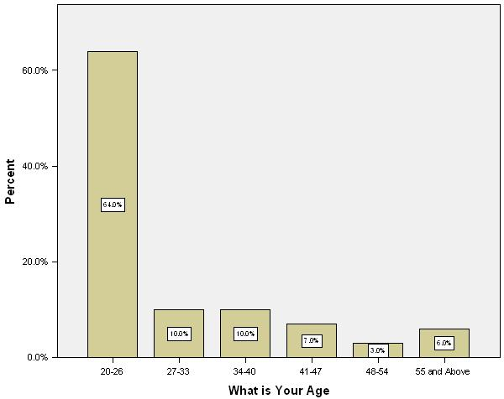
Among the respondents that answered our questionnaire, 52% were male, while 48% were female. Furthermore, 64% of the respondents answered were in the age group of 20-26, while 27-33 and 34-40 accounted for 10% each. Other age brackets of 41-47, 48-54 and 55 and above accounted for 7%, 3% and 6% respectively. The high percentage of respondents being in the 20-26 age brackets can be considered as a limitation as majority of questionnaires were filled from university students who belonged to this age group. However, this age group is also a future opportunity for SWHs, as they will become future homeowners and it would be helpful to get an insight on their perceptions about solar water heaters.
Table 1: Comparison of survey age groups

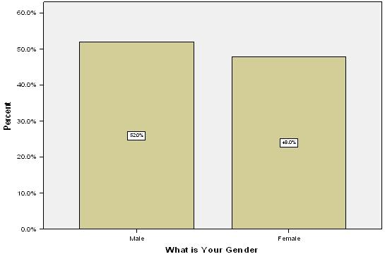
Table 2: Comparison of survey results regarding gender
Among the respondents that filled the questionnaire, 97% of them used the conventional gas heaters, while the remaining used SWHs. As part of questionnaire, it was asked whether the conventional gas heaters were efficient in heating water and whether they were efficient in reducing utility bills. It was a surprise to know that, those of whom that responded that they used conventional gas heaters, 26% and 57% of the respondents strongly agreed and agreed respectively, that they believed that conventional gas heaters are efficient in providing hot water.

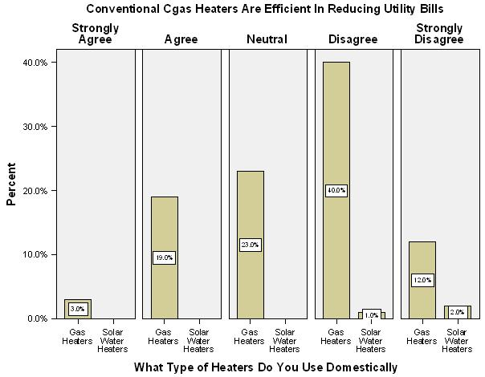
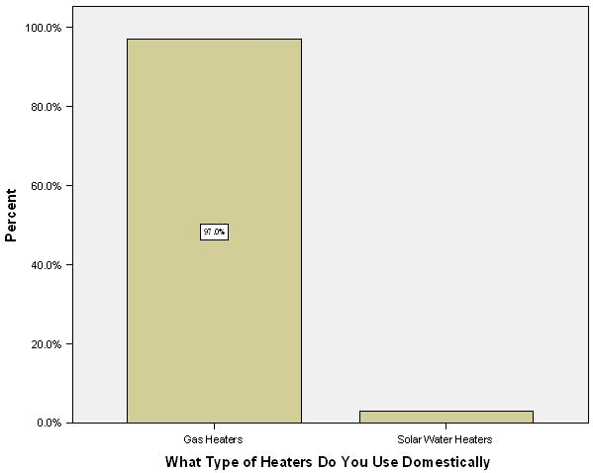
Table 3: Survey results regarding comparisons of water heaters being used
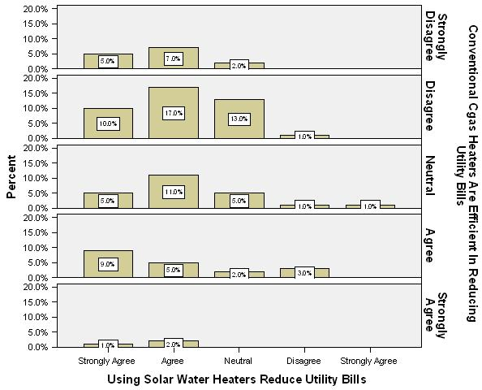
Furthermore, to the question, whether, conventional gas heaters were efficient in reducing utility bills, the same respondents strongly disagreed to the question around 12%, while those that disagreed were 40%. However, 23% of the respondents remained neutral to that question and so the end result was, that even with the people, that use conventional gas heaters, there is a huge chance for them to switch, if a new product is provided to them that can reduce their utility bills.
Table 4: Survey results regarding effectiveness of SWH to reduce utility bills

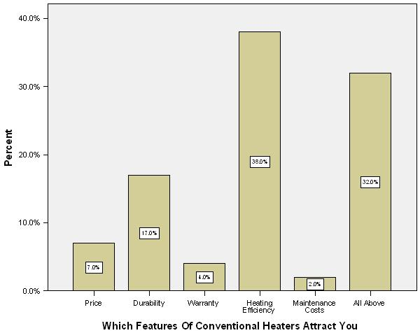
To get an insight on the use of conventional gas heaters, it was asked from respondents as to which feature, they regarded as the most important, while purchasing one. Among the options were price, durability, warranty, heating efficiency and maintenance cost. 38% of our respondents considered heating efficiency as the most important factor; however, 32% also responded that all the factors were important while purchasing a conventional gas heater. Thus while purchasing a conventional gas heater; people considered all the above factors very important while purchasing.
Table 5: Comparisons of features being favored by consumers
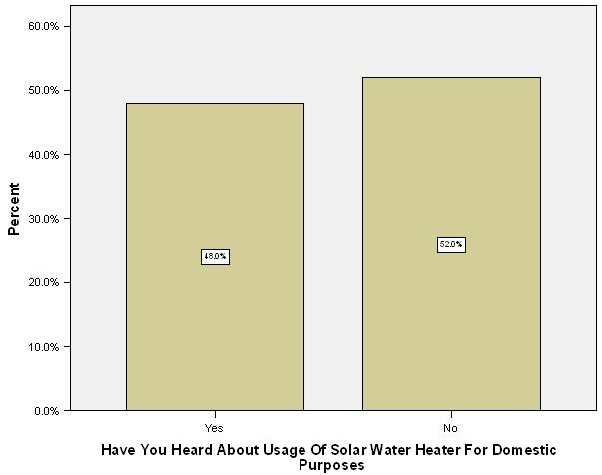
The next part of the questionnaire was to understand what people thought about SWHs. The first question was whether people had heard about the use of SWHs for domestic purposes. 52% of the respondents answered that they hadn’t heard about the usage of SWHs for domestic purposes, while the remaining 48% answered that they had heard about such usage. This was an astonishing result, because before the questionnaire result it was believed that most of the people would not have heard about such usage.
Table 6: Results on usage of Solar Waters Heaters domestically
The next question was whether the respondents would be willing to switchover to SWHs. To no surprise, an overwhelming majority of 72% answered that they would be willing to switch over to SWH. However, if the detail of results is considered, by considering the respondents gender, it was found out that 41% female and 31% male were willing to switch over to SWH. While those that had responded negatively to the question, 21% of them were male. Being a male dominated society and major decisions being made by men, the conclusion was that even though 72% were willing to switch over to SWHs, the percentage of men respondents is very small. Furthermore, of those that responded negatively, which were 28%, 21% percent were male. Thus it is essential that the mind set of male society should be changed and their positive response must be increased, while decreasing their negative one.
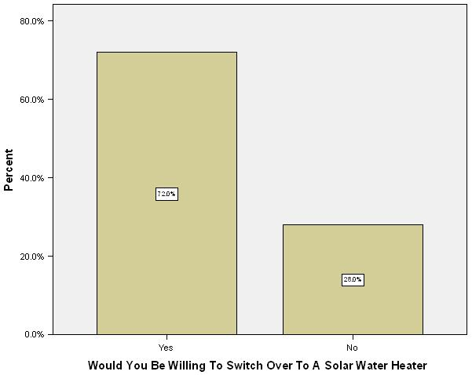
Table 7: Results on willingness to switchover to SWHs
With regards to the features which were considered as the most important when purchasing a SWH, the same list of features were provided to the respondents, that they has filled earlier for the conventional heater. As most respondents were using conventional gas heaters, thus 49.5% responded that all the features, which included price, durability, warranty, heating efficiency and maintenance costs were important, which is consistent with the novelty of the product.
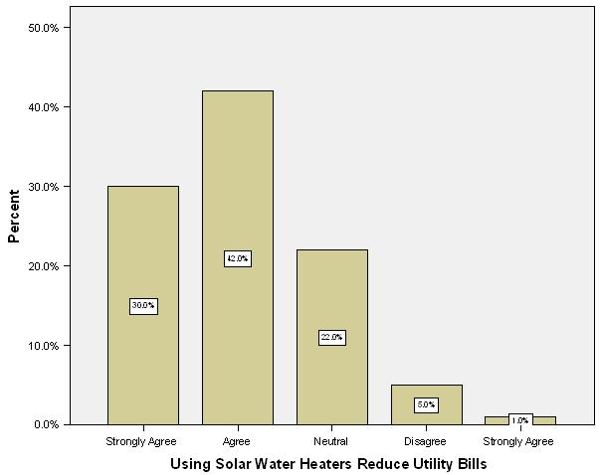
Table 8: Results on the effectiveness of using SWHs
This is consistent with the earlier question, in which it was asked from respondents if they thought that conventional gas heaters were efficient in reducing utility bills. Of the 30% respondents that have agreed with the SWHs reducing utility bills, 5% and 10% of them had initially strongly disagreed and disagreed respectively that conventional gas heaters were efficient in reducing utility bills. Furthermore, of the 42% that had agreed with SWHs as being efficient, 7% had initially strongly disagreed, while 17% had disagreed, with conventional gas heaters as being efficient is reducing SWHs.
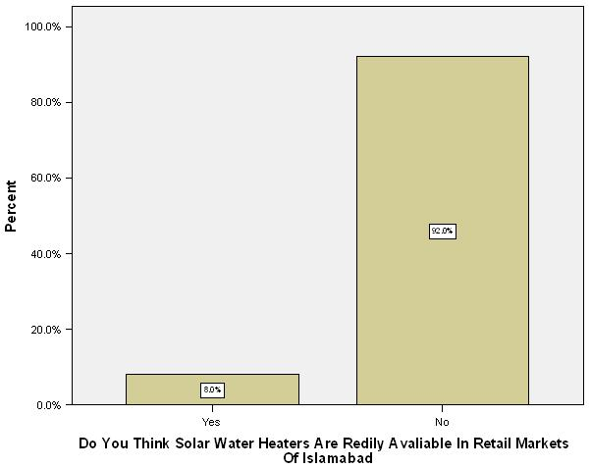
On the question, whether SWHs were readily available in the retail markets of Islamabad, it was no surprise that 92% of the people responded negatively to the question. The implication of this question is especially greater for those people that want to switch over to SWH. Of the 72% people that considered switching over to SWH, 67% responded that they did not think that SWHs were available in retail markets of Islamabad. This situation needs to be changed by the vendors to increase their sales.
Table 9: Results on the availability of SWH in retail markets of Islamabad
One reason why people lack the knowledge of SWHs is the lack of promotion by local vendors. This was one of our questions and the results of this question were consistent to the earlier question because 19% respondents strongly disagreed, while 38% disagreed to the fact that SWHs were efficiently promoted by local vendors.
One of the last questions regarding the actual purchase of SWHs was whether discounts or subsidies would entice customers to purchase the product, 28% of respondents agreed to the statement, while 51% of them agreed. Thus this shows that apart from effective advertising, vendors can increase their sales by offering discounts on SWHs or the government can even step up by providing subsidies on the SWHs i.e. reducing its price.
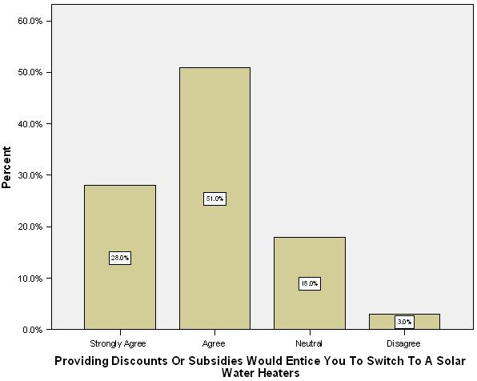
Table 10: Results on the impact of Subsidies or Discounts on purchase of SWH
Another question was whether SWHs were worth purchasing. This question differed from the actual purchase question, because it would look at respondent preferences, which may include quantitative preferences like reducing utility bills and qualitative preferences like having a green lifestyle. The response of the question suggested that 18% strongly agreed with the statement, while 60% agreed with the statement.
Last part of the questionnaire was designed to get input from the respondents, whether they thought that products like SWHs can reduce our energy crisis. To the question, 93% agreed to the statement, while 7% rejected the statement. This shows that individual steps like switching over to SWHs can create a collective step towards reduction in energy crisis of Pakistan.
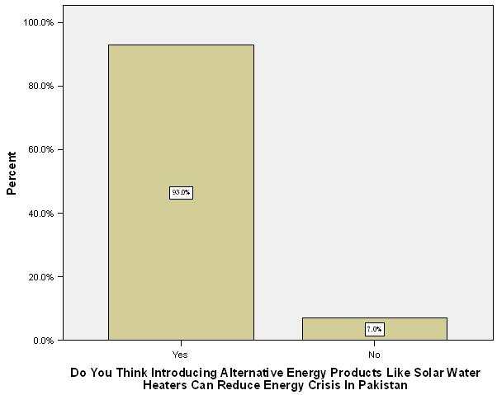
Table 11: Impact of using SWHs on reducing energy crisis of Pakistan
Last question was regarding the role of the government of Pakistan in introducing alternative energy products like SWHs. The response that was received suggested that the government was not playing an active role in introducing such products because 28% of our respondents strongly disagreed, while 48% disagreed to the statement.
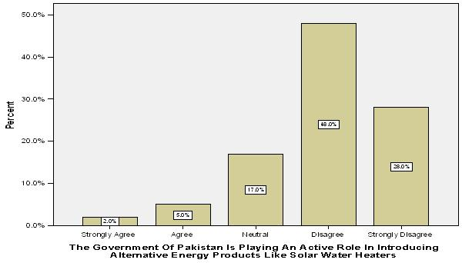
Table 12: Perception about the role of the government in promoting SWHs

Chapter: Possible Options/Alternatives

Advertising
Advertising about the SWHs could be given in print as well as electronic media exclusively. Information regarding different types, tank sizes, and evacuated or flat plate tubes along with the prices, warranty and installation must be given through ads in newspaper and on different TV channels. Vendors can also collaborate with media to promote their product and they can do these themselves.
Sui Gas can give ads in the winter season to aware people regarding the energy savings and reduced bills that can result from using SWHs. People these days use technologies that are good for environment and are user friendly. Advertising will definitely create an image in the minds of customers regarding the product.

Discounts/Subsidies
Short term promotional tools like discounts, money back guarantee, and buy one get one free offers could be given to customers so that they will buy the product. As people are price conscious such offers will help in increasing the sales of product. Vendors can use these offers during off season or at the time of launching their product so that customers at least consider buying the product. When SWHs market share will increase and they will become stable then these offers should be discontinued.

Brochures
Brochures and flyers should be distributed in various sectors of Islamabad, schools, universities and offices. As well as seminars could be organized to give information to customers regarding the product.

Personal Selling Tactics
Vendors must train their sales people in explaining to customer how this product will meet their need of obtaining hot water at an affordable price. Sales people must have good communication skills as well as proper information regarding the product.

Outdoor Advertising
Wall chalking for SWHs can also be done by printing them on bus stops, vans and small kiosks will make people aware about the product.

Collaboration between AEDB and Vendors to Influence Government Decisions
Government needs to play an important role in order to make the country self sufficient in alternative energy products. The energy that is going to be produced through these means is very cheap and will be a source of earning for Pakistan.
It is the responsibility of the government to encourage GTZ, U.K companies and American firms to train the vendors and sales people in Pakistan in making and installing SWH’s by using modern technologies. This is a turnkey operation scenario.
Government can make it compulsory for the new housing schemes and plazas being built to install SWHs. This will reduce the gas consumption in country and this will help in saving energy for industries.
AEDB should arrange seminars and business expo’s to encourage investors to invest in this valuable product. It should tell them about the future prospects of this product and high returns associated with it. It should provide funds needed to vendors to invest in making these SWHs in Pakistan while using those technologies that are used all over the world.
Vendors can increase the sales of SWH’s by giving dealers commissions if they sold particular number of units. Likewise sales people should be given transport expense and bonuses if they sell more than the given target which was given to them. Similarly discounts and money back guarantees should be given to the customers so that they will buy the product.

Bylaws and Municipal Administration
With the increase in population of Pakistan, new private and government housing societies and sectors are being developed by CDA. So the government can by law make it compulsory for housing societies and new sectors of CDA to install SWHs when constructing a new house. By doing so it would increase the usage of SWH and with passage of time it would replace the traditional gas geysers. The biggest challenge for selling a SWH is that people are reluctant to buy it in the first place. If it’s installed in a sector or society in every house, a time will arrive when everyone will demand SWH’s for the house. It’s usually a perception and word of mouth that makes people buy a new technology after learning from the experience of others.
Therefore by doing so if the government can bylaw and through other municipal administrations add this compulsion of installing a SWH in the new house, soon the sales and the usage will increase. Housing Societies like CDA, DHA and Bahria Town if makes SWH mandatory for every constructor of the house to install it, within no time people would start purchasing it and demand will rise immediately.

Grass Root Level Training
Without the exposure and know how no person can run, install or work on a SWH. This is the biggest hurdle for the SWHs to become popular due to limited skilled people available who can fix them. German and Chinese have given recent trainings to vendors on how to fix and install SWHs. But still ordinary plumbers aren’t known to it and cannot fix or install it at all. Therefore grass root level training must be organized for local plumbers so as to make SWH more reliable and people start relying on it as compared to ordinary gas geyser. As SWHs are new so people who are knowledgeable about their installation are in small number and therefore if a problem arises they can’t be reached or contacted. Hence by giving training to ordinary plumber they can be easily accessed and SWH can be fixed on time.
There could be a course or a subject regarding solar products especially SWH be added to different polytechnic institutes. By doing so the awareness about it would increase and the general skills of the workers will improve. If any problem arises the ordinary plumbers would know how to fix it and eventually decrease the fatigue of the person who has the SWH in his house. Therefore this is necessary for polytechnic institutes to add a course regarding it in order to help make SWH acceptable to everyone.

Market Space and Market Place
As SWH is new in the market and ordinary geysers being readily available in the market, so usually everyone buys it as its reliable and cheap in their view. But it’s not the case as SWH is more reliable and cost effective in the long run then the ordinary one. It’s just that initially everyone is reluctant to buy a new product and they don’t know its features or value in future. This is mainly because of the lack of awareness among the people and they aren’t readily available in the market. Ordinary shops don’t keep them and usually don’t give them space in their market. Hence making it even tougher for the SWHs to become known to people.
If proper market place is given to SWH and awareness is created among the people soon the sales would increase. When people would use it, they would recommend others to buy it as well. Hence by creating more awareness among those who don’t have any idea about such a product which is available in the market. Now due to energy crises and gas load shedding in winters, this can be an answer to the problem. By introducing it in the market and giving it the space & place duly required, SWH can be an instant hit. It can only be purchased if it’s being displayed in the ordinary shops and not in vendor’s showroom as they are located far away and they can’t be approached. Vendors can deliver it to the shops on order and demand so that local buyers can be catered and making the product accessible to all.

Chapter: Best option/recommendations
The best option can be described in brief so that the action plan can thus be developed keeping in view the considerations outlined in the best option. Keeping in view the multitude of options available, a coherent and consistent strategy can only be developed once all the alternatives have been evaluated in detail. In order to develop a consistent strategy a closer look must be taken at what option best suits the requirements and the objectives of the program.

: Mass Awareness Program
The researching team finds that the best option to achieve the stated objective is to launch a massive national level awareness and education campaign which not only introduces the product but also had the following detailed components:
- Introduce and visually identify the product.
- Familiarize the product features and specifications.
- Educate and make aware people about the features, their usages and their fragilities.
- Provide fundamental information regarding the various stake holders, the related governmental agencies and vendors.
- Give address and phone numbers to those who need to have detailed information and access to the product.
- Help create the required market place, which will then be able to harbor the product in the open market.
As stated above a single option is not going to be sufficient and a coherent and well coordinated strategy is the need of the hour. Even still the option which has been selected as the best has the following advantages:

Advantages of This Option
This option has been selected keeping in view the following benefits.

Reach the Masses
This option has the biggest advantage it enables the program to directly reach and address the masses. This makes it pivotal to the attainment of the objective of the program, which is to switch people towards SWHs.

Introduce the Product
The most important aspect of this option is its ability to introduce the product at length to the target market. This not only merits this option above others but also enables this option to be closest to the objective of making the product commonplace substitute of the gas water heater, being used in the domestic sector of the economy.

Highlight Features
This option enables the program to easily educate the people about the product features and thus enable them to be better informed to make a purchase decision.

Provide Detailed Information
The mass awareness program can also be used to provide detailed information about various aspects of the program, and thus enable the users, vendors and other stake holders to have perfect information about the market.

Time Bound and Effective
The awareness program is time bound, the advertising and marketing portion has a specific duration, and then the national and governmental agencies role has a specific time period.

Tangible Results
The results and the success of this option can easily be measured by using statistics such as the number of sales, the number of technicians taking technical training, the increase in the number of vendors, and so on and so forth.

Holistic Approach
With this option a holistic approach can be communicated to all the stake holders, vendors and end users. This enables this option to be more comprehensive in approach and thus shall enable it to achieve the intended objective with ease.

Disadvantages of This Option
This option has a number of disadvantages as well. It is not possible to come up with a single point agenda that covers all aspects of a program which shall be executed at the national level. Therefore the disadvantages for the chosen best option are outlined here under:

High Costs
Advertising and marketing on national television, private TV channels and cable news networks, is very expensive. As air time rates are very high in Pakistan. Therefore during the initial phase of aggressive marketing and advertising the costs will be very high. Same is the case with national level news papers, which charge high rates for their front and back pages.

Limited Penetration
Since the newspapers are automatically targeted at those individuals who have the literacy to read news papers, and the TV is not commonplace so the penetration of the advertising and the mass awareness program may be hindered.

Governmental Dependence
This program is majorly dependent upon the government, institutions and organs related to the government. Therefore it may be speculated that red tape and nepotism negatively effect on the entire program and undermine its credibility.

Chapter: Action Plan
The action plan that has been proposed consists of the following three major stages or components. Various corporations, state organs and state owned enterprises shall play their respective roles at one of the following three stages:

Stage 1: Appreciation and Recognition in Democratic Institutions
The first stage of the action plan starts from the recognition of the need for power conservation and adoption of alternative measures instead of the conventional ones. The best arena to kick start a national level awareness and recognition wave is by highlighting such issues in the democratic institutions, that is the National and Provincial assemblies. Once the elected representatives of the people shed light on this sensitive issue then further work can be stated with state owned enterprises and state organs.

Time Frame
The first stage cannot be time bound by any means, as the debates in the democratic organs of the state can be initiated at any moment. Gathering support for the political level awareness of the program cannot be time bound as well.

Resolutions to be Adopted
The national and provincial assemblies should adopt resolutions which highlight the importance of energy conservation and make a part of law so that prompt implementation can be facilitated.

Features of Resolution
The resolution which is to be adopted in the national and provincial assemblies must highlight the following issues: the need for energy conservation, finding and adopting alternative means of energy, speedy and effective implementation of alternative means of energy is made possible, with all the support which can be given by the federal as well as the provincial administrations.

Role of AEDB
AEDB as an organ under the federation has a proactive role to play in bringing about this resolution, including political maneuvering and lobbying in favor of the resolutions.

Role of State organs
State organs and power regulatory authorities such as WAPDA and PRPCO have a huge role to play in making this plan a success. It is dependent upon their input and work to get the alternative means of energy more popular and accessible for the general public and also to encourage investment in such sectors.

Stage2: Mass Awareness Campaigns
The second stage consists of raising the awareness level of the target market, and in general raising the literacy level of the people regarding the product. This stage can also be termed as “National Level Awareness Program”.

Time frame
The second stage is going to have a definite time frame, once the state organs such as NEPRA, PEPCO, and WAPDA etc have the requisite political support the second stage is not going to last for not more than a year.

Role of AEDB and State Organs
Once again the AEDB and rest of the state organs have a vital role to play in this stage of the program. They need to provide a platform from where the initial national level awareness programs is going to be be launched. Similar to the ones which were launched by such establishment for the conservation of electric power in the recent and still worsening energy crises of Pakistan.

Theme of Advertising Campaigns
The advertising campaigns must remain effective from about six months to one year; the objectives of these advertising campaigns shall be as follows:

Energy Conservation and Alternative Measures
The first theme of the advertising program is to emphasize on energy conservation and educating the masses about the need to conserve energy.

Gas consumption and related problems
This campaign is going to highlight the advantages of using solar water heater. Gas water heaters are inefficient and very costly, plus the consumption of gas in the domestic sector at a large scale adversely impacts industrial consumption and pricing, thus hampering industrial development and growth.

Promotion of SWHs
The most fundamental part of the objective of this national level campaign is to raise awareness level for the usage and the promotion of SWHs.

Product Knowledge
Disseminating product knowledge to the general public is a key factor in making the product a success.

Pricing Option
The campaign in the print media is going to emphasize upon the pricing and the purchase options that can be made available to the general consumers by the vendors and retail out let store managers.

Advertising and Marketing Mix
The second most important part of the awareness campaign is the advertising and marketing mix that is to be used by the various institutions such as AEDB and WAPDA etc to execute this public awareness program.
The use of electronic media such as Television, Radio and Internet is dependent upon the requirements of the comprehensive awareness program.
Following is a sample of how the various forms of media will be used for executing the marketing and advertising mix.
Type of Media | Frequency and Duration | Objectives
Electronic Media (TV, Radio and Internet) | TV is for the initial six months of the campaign with a frequency of 3 to 5, 45 seconds spots per day on National Television and maximum 5 (Five) private channels  Radio is to be used for disseminating detailed information about pricing, performance and the availability of the product. | To introduce the product in the market.  To generate a positive image of the product.  To educate the general public about the price, features and the availability of the product.
Pint Media (Newspapers, Brochures, Flyers and Banners) | The print media is a consistent medium to be used for the entire length of the promotional campaign. | To disseminate information, to give details of the product and the offerings.  To promote special offers and limited time deals.  To introduce the vendors and facilitate the customers in reaching them  To enhance and identify the main stake holders of the entire plan such as AEDB.
Outdoor media, sponsorships and Events. | Once a month, within the budgeted expenses. | To generate goodwill and for philanthropic measures.

Sales Management and Vendor Relations
One of the most important aspects of generating sales and managing the sales force is sales management. The main of objective of sales management is to provide the sales men right training and giving the appropriate discretionary authority with an organizational policy of decentralization to enhance the sales output of the firm.

Stage 3: Market Infrastructure Development and Grass Root Level Skill Development:
All of these stages have detailed steps involved which have been discussed at length. Here it is very important to delineate as to how this action plan is to be executed and what are the important factors that may influence the efficiency and effectiveness of this plan.

Development of Designated Markets
In developing infrastructure support for SWHs, the first and most important step is the development of designated markets for these products which have the capacity to become market places and serves as market spaces.
These markets are going to train the workers in maintenance and repair. This is going to promote an industry atmosphere where competition and economies of scale. Geographical expansion is going to result as the customer base will expand.

Setup in Poly-Technical Institutions
In order to properly train mechanics and repairmen for the SWHs, the existing extensive setup of poly technical institutions can be used. Government and organs like WAPDA and AEDB can sponsor the launching of training programs for these workers. These programs can help workers to develop skills in the following categories: installation, maintenance & repairing, after sales service.

Development of Logistics support in supply lines
Supply lines need to be developed in order to fully accommodate the handling and delivery of the product to places where alternatives are not available and the availability of this product will have a direct impact on daily life.
If the supply lines are not developed and the required logistics support is not available then the product will not reach the designated markets and the consumers will not be able to gain the benefits of the product to its fullest.

Influencing Factors
Factors influencing the effectiveness and efficiency of the program are listed here under as these have a huge impact on the success or failure of the program and its eventual outcome.

Political Factors
First and foremost is the issue of the acceptance and recognition of the need of this action plan and the awareness of the democratic setup to set up measures of energy conservation. Keeping this in consideration the first stage of the plan can only be regarded as the starting point where this plan of action will actually become a nationally accepted course of action and that obviously cannot be achieved without political maneuvering. So the first factor influencing the plan is the political factor. Unfavorable and uncertain political environment can lead to this plan being a still birth and consequently all the state owned enterprises and organs will also not be able to gather support and momentum behind this action plan.

Economic Factors
From the availability of funds for executing and advertising the plan to the potential of the open market to absorb and subsequently maintain this initially expensive product, the economic factors are very crucial in playing a vital role in the execution and success of this plan. If the plan is not able to correctly access the market potential then the plan is not going to be financially viable and in uncertain economic times, this plan may be further in jeopardy.

Weather Conditions
SWHs cannot operate in cloudy conditions, and therefore the rainy season of Pakistan, also known as the monsoon season is thus a time when the sales and the advertising of this product needs to be monitored cautiously. Sind and Baluchistan which have ample sun shine and very low chance of cloud cover are ideal for the sale of the product, and these provinces have vast districts where conventional electric lines have not been laid and thus those areas are still not on the national grid. The electric water heater sales teams can thus use these areas to their benefit and provide them with cheap alternative to burning fuel wood which is very difficult to find.

National Demand
Demand for the natural gas and power consumption play a very important role for the demand for SWHs, as the demand for gas increases the shortfall of supply will increase. As solar water heaters are the closest substitute available to the domestic users so their demand is going to increase automatically.
On the other hand the discovery of natural gas and development of new gas fields can result in a negative impact for the sales of this product because in that scenario the readily available natural gas will be preferred over the incurring of additional cost of purchasing and installing the SWHs.

International prices of petroleum products
As the prices for petroleum products and natural gas rise in the international markets, the consumption for industrial and domestic setups becomes more and more expensive. The sales of SWH can thus be affected as they provide a suitable alternative to these expenses.

Bibliography
Butti, K., & Perlin, J. (1983). Free Hot Water Day & Night Solar Water Heaters in California. Retrieved Aug 31, 2010, from Jstor: http://www.jstor.org/stable/25158137
Davis, H. M. (1956, Jan 21). Solar Heater for Arctic Desert. Retrieved Aug 15, 2010, from Jstor: http://www.jstor.org/stable/3936235
Duffie, J. A., & Beckman, W. A. (1976, Jan 16). Solar Heating and Cooling. Retrieved Aug 31, 2010, from Jstor: http://www.jstor.org/stable/1742010
Morse, R. N. (1977). Solar Energy in Australia. Retrieved Aug 31, 2010, from Jstor: http://www.jstor.org/stable/4312278
Roger H. Bezdek, A. S. (1979, March 23). Economic Feasibility of Solar Water and Space Heating. Retrieved June 15, 2010, from Jstor: http://www.jstor.org/pss/1747235
Stasinopoulos, T. N. (n.d.). Sunny Walls Vs. Sunny Roofs. Retrieved July 15, 2010, from Emerald: http://www.emeraldinsight.com/journals.htm?issn=0956-6163
M.A.Alghoul, M. S. (n.d.). Anti-Corrosion Methods and Materials. Retrieved June 10, 2010, from Emerald: http://www.emeraldinsight.com/journals.htm?issn=0003-5599
Muhammad, S. S. (2008, July 15). Pakistan's Energy Crunch. Retrieved July 17, 2010, from American Chronicles: http://www.americanchronicle.com/articles/view/68351

Hande, H. H. (2006, Feburary 10). India: Financing Solar Water Heaters . Retrieved June 30, 2010, from Renewable Energy World: http://www.renewableenergyworld.com/rea/news/article/2006/02/india-financing-solar-water-heaters-43139
Qadri, F. R. (2008, May 30). Solar Energy (Pakistan Base). Retrieved July 15, 2010, from Articlesbase: http://www.articlesbase.com/motivational-articles/solar-energy-pakistan-base-432624.html
Bukhari, S. R. (2010, Jan 31). Countering energy crisis with alternative resources. Retrieved Aug 02, 2010, from Pakistan News: http://www.pakistannews.com.pk/articles/countering-energy-crisis-with-alternative-resources.html
Kabir, A. (2003, March 03). Prospects of solar energy in Pakistan. Retrieved July 28, 2010, from Dawn: http://www.dawn.com/2003/03/03/ebr11.htm
Bukhari, S. R. (2010, Jan 30). Countering energy crisis with alternative resources. Retrieved July 15, 2010, from pakistannews: http://www.pakistannews.com.pk/articles/countering-energy-crisis-with-alternative-resources.html
Khan, K. A. (2010, Jul 02). Way forward from loadshedding. Retrieved Aug 03, 2010, from The Nation: http://www.nation.com.pk/pakistan-news-newspaper-daily-english-online/Opinions/Columns/02-Jul-2010/Way-forward-from-loadshedding/1

(n.d.). Retrieved July 10, 2010, from Alternative Energy Board of Pakistan: www.aedb.org/Ordinance/aedbact.pdf
(n.d.). Retrieved July 29, 2010, from Asjid Energy Systems: http://www.asjidenergysystems.com/about-us.html
About Us. (n.d.). Retrieved July 15, 2010, from Super Asia: http://www.superasia.biz/aboutus.php
About us . (n.d.). Retrieved July 10, 2010, from Catkin Engineering Sale & Services : http://www.catkin.com.pk/aboutus.php
AEDB issues LoI for biomass power plant. (2010, Sep 22). Retrieved Aug 12, 2010, from Dawn: http://www.dawn.com/wps/wcm/connect/dawn-content-library/dawn/the-newspaper/business/aedb-issues-loi-for-biomass-power-plant-290
Ahmed, M. (2010, May 20). Concessional rates: Govt to offer 500,000 solar geysers in northern areas. Retrieved July 15, 2010, from Daily Times: http://www.dailytimes.com.pk/default.asp?page=2010\05\20\story_20-5-2010_pg5_12
Alternative Energy Development Board. (n.d.). Retrieved from http://www.aedb.org/Main.htm#
Compact Pressurized Solar Water Heater. (n.d.). Retrieved from Diytrade: http://www.diytrade.com/china/4/products/3410653/COMPACT_Pressurized_Solar_Water_Heater.html
Company Profile. (n.d.). Retrieved July 05, 2010, from Solar Geyser : http://www.solar-geyser.com/companyprofile.html
Gas Applications. (n.d.). Retrieved from Singer Pakistan: http://www.singer.com.pk/catalog.aspx?catid=3&catname=gas%20appliances
Google Images. (n.d.). Retrieved from Google: http://www.google.com.pk/imgres?imgurl=http://image.made-in-china.com/4f0j00dBOarQtzHgkm/Single-Pipeline-Working-Station-Solar-System-Water-Heater-SP116
Govt to promote solar water heaters to cut gas consumption. (2009, August 29). Retrieved July 17, 2010, from The Nation: http://www.nation.com.pk/pakistan-news-newspaper-daily-english-online/Business/29-Aug-2009/Govt-to-promote-solar-water-heaters-to-cut-gas-consumption
Introduction. (n.d.). Retrieved July 29, 2010, from Renewable & Alternative Energy Association of Pakistan : http://www.reap.org.pk/
Nordex Supplying Wind Turbines in Pakistan. (n.d.). Retrieved July 17, 2010, from Alternative Energy Board of Pakistan: http://www.aedb.org/news3.htm
Power & Alternative Energy exhibition concludes. (2010, March 30). Retrieved July 21, 2010, from The Nation: http://www.nation.com.pk/pakistan-news-newspaper-daily-english-online/Business/30-Mar-2010/Power--Alternative-Energy-exhibition-concludes
SBP introduces financing facility for renewable energy . (2009, December 01). Retrieved June 01, 2010, from Dawn: http://www.dawn.com/wps/wcm/connect/dawn-content-library/dawn/news/business/13+sbp+introduces+financing+facility+for+renewable+energy-za-05
Several projects of renewable energy likely . (2010, April 16). Retrieved June 28, 2010, from Dawn: http://www.dawn.com/wps/wcm/connect/dawn-content-library/dawn/the-newspaper/business/several-projects-of-renewable-energy-likely-640
Singer. (n.d.). Retrieved July 20, 2010, from Singer Pakistan: http://singer.com.pk/catalog.aspx?catid=3&catname=gas%20appliances
SNGPL makes gas geysers energy 'efficient'. (2010, January 08). Retrieved July 20, 2010, from The Nation: http://www.nation.com.pk/pakistan-news-newspaper-daily-english-online/Business/08-Jan-2010/SNGPL-makes-gas-geysers-energy-efficient
Solar water heating. (n.d.). Retrieved July 09, 2010, from Wikipedia: http://en.wikipedia.org/wiki/Solar_water_heating
Solar Water Heating Pays For Itself Five Times Over. (2009, March 13). Retrieved July 20, 2010, from Science Daily: http://www.sciencedaily.com/releases/2009/03/090309105021.htm
SWH Training Program. (n.d.). Retrieved July 23, 2010, from Renewable & Alternative Energy Association of Pakistan: http://www.reap.org.pk/swhtp.php
Terms of Reference. (n.d.). Retrieved July 15, 2010, from Alternative Energy Development Board of Pakistan: http://www.aedb.org/TermsOfReference.htm

Chapter: Annexure

Annexure A: Call Reports

AEDB

Date and Time of Meeting
11th July 2010
9:30 AM to 11:30 AM

Persons Interviewed
Khalil Khetran (Deputy Director Solar, AEDB)
Anwar Ali (Director Media & Marketing, AEDB)

Interview Sheet
Talking about the role of AEDB in the last year or so, Mr. Khalil and Mr. Anwar said that they have introduced evacuated tube SWHs which are far more efficient and store more energy then previous flat ones. They also said that evacuated tubes are much better then traditional ones as their working is smooth and fewer problems occur. The PVC tubes used in the SWH are also imported from abroad so that the quality is up to the standard. Also they said that at the moment there are sixteen registered vendors with the AEDB and with the passage of time it would increase as vendors are more than that.
Also they said that AEDB has attracted many foreign investors from Germany and America to invest in this sector and help in developing this market. They have organized many trainings and workshops so as to create awareness among the people and how to install it. They have started many projects with AEDB and made a difference with the passage of time. Also AEDB has given an offer to its customers that with in a year there would be money back guarantee. This has helped in selling SWHs as one could return it if he isn’t satisfied with it.
Giving an answer to a question regarding problems faced, they said the biggest problem with the promotion of SWH is that there is a lack of awareness among the people and usually majority doesn’t know whether such product is available in the market or not. Also the other problem is that of lack of funding that has made its promotion campaign even weaker and without funds one cannot promote a product.

Vendors/Manufacturers

Date and Time of Meeting
17th July 2010
10:00 AM to 12:15 PM

Persons Interviewed
Riffat Hussain (Director Sales & Marketing, CATKIN Technologies)
Iftikhar Qaisrani (Manager, NDI)

Interview Sheet
Giving the answer to the question of promoting SWH both Mr. Riffat and Mr. Iftikhar said that they have invested a lot in sales team and promotion of SWHs in many cold areas like Murree, Barakahu etc. where there is no gas or supply is less. In such areas the acceptance is more as compared to developed areas where the gas is available and people prefer traditional gas geysers over SWHs. Also vendors have promoted SWHs in local newspapers and gave advertisements jointly with AEDB. Recently training was conducted by Germans (GTZ) in order to promote the use and make people aware of how to install it and how it works. The basic issue was its installation and how to fix any problem if arises. Germans training workshop helped in promoting it a lot and gave an insight to SWHs as a whole.
Giving answer to the question of hindrances both said that the biggest drawback of SWH in their view was that it cannot work in the days when there is no sunlight but at the same time it can store energy up to 72 hours. This is a weakness but with such storage capacity it wouldn’t be a problem if the sun doesn’t come out for three days. The other issue is that the demand for SWH is very low due to low investment in advertisement as the budget is limited for vendors to spend. If the government takes some serious interest in promoting SWH soon the sales would double from nearly 140 sales annually to twice of it in semiannually. The other hindrance is that the usable life of SWH is limited to maximum of ten to fifteen years and it then needs to be changed as the tubes have a life and it can’t work after that. So this is a potential threat as people always look at the life of the product before buying it and it’s also a drawback of SWH.
Giving recommendations Mr. Riffat and Mr. Iftikhar said that firstly AEDB and REAP has to work collaboratively and achieve its objectives that it set initially. The Government has to fulfill its promises that it made to REAP and jointly move towards one direction that at the moment isn’t the case. Government has its own agenda’s and are not combining with REAP which has created many problems for them Secondly the media has to play a role in promoting SWH as without their help it wouldn’t be possible to make it known to all. With the passage of time, media has become very strong in the last five years or so. Hence if there help is there, one time would come when SWH would be in every house. Thirdly the vendors can themselves make brochures and distribute them in as many areas as possible so as to let people know that such a product is available and these are its benefits. By using such marketing technique the cost is less and one can reach out to distant areas easily. Lastly the vendors can initially give discounts to customers so that the sales could increase and people recommend it to others. With the acceptance being low at the moment, discounts can help in promoting it and making customers buy it.

Annexure B: Questionnaire
As part of our final project, we are conducting a survey regarding the value proposition of SWHs (solar geysers) for domestic purposes in Islamabad. We would appreciate it dearly, if you could spare your valuable time and fill out the questionnaire and help us in completing our project. Thank You.

Gender:
- Male
- Female
Age:
- 20-26
- 27-33
- 34-40
- 41-47
- 48-54
- 55 and above

- What type of heaters (geysers) do you use domestically?
- Gas Heaters
- SWHs

- Conventional gas heaters are efficient in providing hot water?
- Strongly Agree
- Agree
- Neutral
- Disagree
- Strongly Disagree

- Conventional gas heaters are efficient in reducing utility bills?
- Strongly Agree
- Agree
- Neutral
- Disagree
- Strongly Disagree

- Which feature of conventional heater attracts you to purchase it?
- Price
- Durability
- Warranty
- Heating Efficiency
- Maintenance Costs
- All Above

- Have you heard about usage of SWHs for domestic purposes?
- Yes
- No

- Would you be willing to switch over to a SWH?
- Yes
- No

- Which feature of SWH would attract you to purchase it?
- Price
- Durability
- Warranty
- Heating Efficiency
- Maintenance Costs
- All Above

- Using SWHs reduce your utility bills?
- Strongly Agree
- Agree
- Neutral
- Disagree
- Strongly Disagree

- Do you think SWHs are readily available in retail markets of Islamabad?
- Yes
- No

- SWHs are being efficiently promoted by local vendors?
- Strongly Agree
- Agree
- Neutral
- Disagree
- Strongly Disagree

- Providing discounts or subsidies would entice you to switch to a SWH?
- Strongly Agree
- Agree
- Neutral
- Disagree
- Strongly Disagree

- SWHs are worth purchasing?
- Strongly Agree
- Agree
- Neutral
- Disagree
- Strongly Disagree

- Do you think introducing alternative energy products like SWHs can reduce energy crisis in Pakistan?
- Yes
- No

- The Government of Pakistan is playing an active role in introducing alternative energy products like SWHs?
- Strongly Agree
- Agree
- Neutral
- Disagree
- Strongly Disagree

Annexure C: Comparison of Solar Water Heaters with Traditional geysers
Features | SWH | Traditional Geyser
Price | Rs. 15000-25000 | Rs. 12000-15000
Capacity | 80 to 400 liters | 15 to 35 gallons
Installation Charges | Rs.2000-4000 | Rs.700-1000
Usable Life | 10-15 years | 15 years
Warranty | 2 to 4 years | 1 year for thermostat & 3 years for the tank
Temperature Of Warm Water | 70 degree  Centigrade | 80 to 90 degree Centigrade

