Bahria University Library Islamabad
Source: The News, Sunday Dec 17, 2023



Bahria University Library Islamabad
Source: Pakistan Observer, Sunday Dec 17, 2023

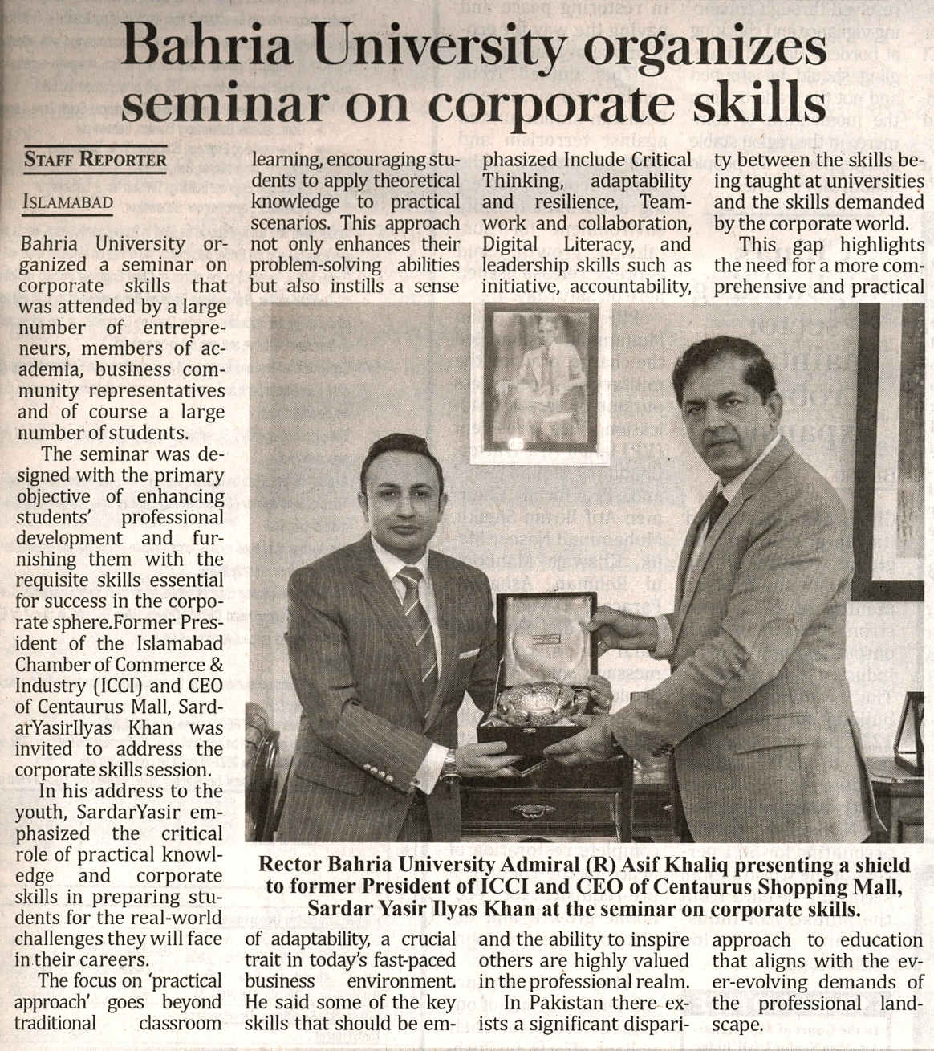

Bahria University Library Islamabad
Source: Daily Jang, Sunday Dec 17, 2023

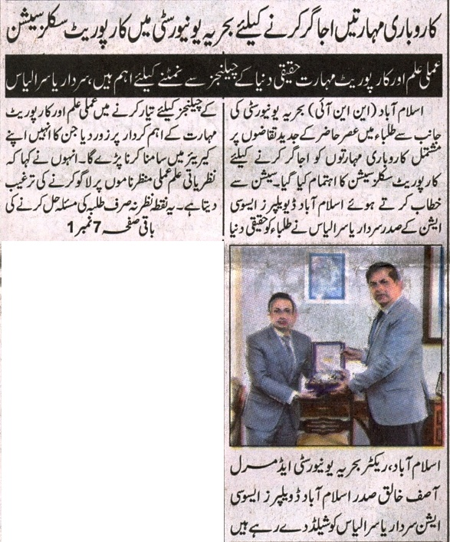
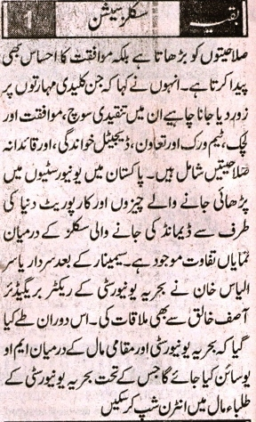

Bahria University Library Islamabad
Source: Daily Express, Sunday Dec 17, 2023

