Chapter No. 1
Introduction

The study determines the affect of global financial crises of Pakistan banking sector. The entire world knows about the global financial crises that how it was started and affected the world and how it affected the Pakistan economic system specially the banking sector of Pakistan.
The global financial crises have been called by the leading economists the world bad and critical financial crises since related to the great depreciation of the 1930. It contributed to the failure of the key business, decline in consumer wealth and riches estimated in trillion of US dollars and the notorious decline in economic activities.
The trigger of crises was the bursting of housing bubble in the united state which peaked in 2006.The sub prim mortgage default rate already rising and the adjustable rate mortgage (ARM) began to spiral hurriedly. The easy credit terms and other incentives encourage the investors to invest in housing, so they started to borrowing money from the banks and other financial institution without any hesitation, having no future planning and contingency approach but abruptly the housing prices became down.
As the financial crises started by the grounds of soft loaning policies of the Europe and after that they were unable to recover those loans. It has directly affected the developing countries by making their balance of trade deficit. It has affected the economic satuation of those countries directly.
The problem of global poverty has many reasons at its back. The stock markets, banks and financial markets of the developed countries got crashed. All the industrial countries were strictly affected by this downward spiral. It leads to the poverty by the way of unemployment.
In the beginning that the financial crises started in America than expended towards European countries and not directly affected the developing countries because mostly developing countries not directly linked to credit crunch in USA but gradually the influence of global crises spread towards developing countries including Pakistan.
The financial crises also known as credit crunch. Credit in and of itself is an important thing. Credit promotes growth and jobs. As credit crucial with the investor and borrower point of view. The interest on credit is allowable taxable amount, which can be deducted by earning before interest and taxes (EBIT).
It is true that credit boost the financial position. We have studied that global crises effect allover the developed countries banking sector and near to bankruptcy because of global financial debts, while Pakistan banking sector affected slightly due to minimum global financial debts.

1.1 Broad problem area / Background

The banking sector of Pakistan is one of the largest contributors in the development of Pakistan economy. Different factors affect the Pakistan economy such as inflation, increased rate of unemployment and recession possibility in country.
The study is providing information about the reasons that why the financial crises affect allover the world as well as Pakistan, specially the banking sector. We know that global crises have no direct impact on the Pakistan banking sector largely but we can not refute the indirect impact of other factors on the banking sector. The other factors are concern with the telecom industry and FMCG (Fast moving consumer goods).
I would prefer to express that global crises affect all the industries in developed countries by which they were not able to operate on high expansion range in other countries as well as in Pakistan, i.e. McDonald ,other FMCG and telecom companies' employees have accounts and other transactions with Pakistani banks. Downfall rose in these companies, it affected the banks.

1.2 Rational of the study

The research comprises that, in start the global financial crises started from U.S.A and further spread towards all developed countries but not bring to a halt on it, it further spread to the devolving countries include Pakistan. The Pakistan banking sector not affected directly but affected indirectly. The foreign banks in Pakistan are highly affected as compare to the local banks.

1.3 Problem statement

The core statement is "Global financial crises impact on banking sector of Pakistan”. It has been determined that the international global financial crises affected telecommunication and FMCG (Fast Moving Consumer Goods).It encounters the factor, that how global economic instability effected Pakistan. Either overall Pakistani economy has been affected or only macroeconomic indicators have been shown.

1.4 Objective of the study

Objective of the study is to find out the reasons of financial crises prevailing in Pakistan.
- To determine the factors which contributing to these crises and these factors affect the banks directly or indirectly.
- To find out the crises effect on the Pakistan and determine the banking position after the crises.

1.5 Methodology of study

For the study data collected through quantitative and qualitative approaches. For quantitative base data collection questioner has been distributed among bank employees while for qualitative base data collection interviews have been conducted with the senior employees of the banks.

1.6 Theory of bank
It determined the implication of bank and explains the existence of banks. In the past it was so difficult to extract the suitable definition of the banks or bankers. But some have offered an adequate and comprehensive definition. Initiating from the time of J W Gilbert, he defined as banker is a dealer in capital or more appropriately a dealer in money. Banking liquidity refers to assets that can change or converted to cash with out any efforts. Money in the cash form is considered as the most liquid asset in the banking industry (Freixas & Rochet, 2008). In order to perform the banking role, Banks offer saving, deposit and current account facilities to the clients.
  - Description of terminologies
Economist
People who deal with the matters of economy and have adequate knowledge about it.
Macroeconomic Indicators
Macroeconomic indicators demonstrate the level of economic development and point toward either economic growth or a turn down.
Utilization of super class of rich politician’s wealth
They are the people, who play with the riches of the country. They take control of foremost portion of wealth and use it for their own concern.

Chapter No. 2
Literature Review

Economic crises in Pakistan are very obvious and hazardous. Economy presents a very true picture of poverty over the entire globe. Money rotates in fewer people’s hands. Economy of Pakistan has been affected unfavorably due to downfall in American economy. They had drastically dragged Pakistan debts by their financers, advisors and planners.
Pakistan’s big class is consisted of rich people who are businessman too. They are always in seeking of higher living standards. They strive to get rid of hunger and poverty. Money only circulates in their hands. And they don't let the poor ones to get hold of money. The way, wealth of people is distributed injustibly among those who don't deserve it calls for a drastic distribution of wealth and power in the country. Philosophy and efforts are inevitable in this concern. It will require innovation to sort out economic problems of the country. Financial institutions are needed developed that distribution of wealth distributed on the basis of equality and economic crises are sorted out in true means. New policies and regulations needed to be made. So that by financial institutions rotation of money took place justifiably which also stated by (Hassan N. Gardezi, 2010).
Major financial crises that took place in Indonesia with adverse effect gives an insight that major reasons of financial down turn is poverty. This results in high food prices, fuel prices and higher rate of unemployment. Now this is the same scenario that has been confronted by Pakistan. Instead of looking at the reasons of poverty, it is necessary to seek the ways to mitigate the tragic human consequences, stabilizing the economy and restore growth in real incomes. This argument related with statement of (World Bank, 1998).
Contemporary advocates stress upon the differences between free financial flow and free trading of goods and services. The gaps include far great variation of financial asset prices compared to the prices of goods and services and poor banking management.
2.1 The role of Capital Inflows in Emerging Markets
The major benefit of capital inflows in private sector has tended to increase current account deficits, reduce domestic interest rates, and raise collective investment rate in host economies.
During 1990, institutional investors become more aware to diversify their portfolios within the banks. For this reason international banks are ready to help in emerging markets. IMF is considered as more helpful in helping World Bank. It is useful in advising the roles for banks to perform for the best practices in emerging markets.
2.2 Problems faced by Financial Sector
It has been seen that a lot of banks have been established but they don't have sufficient capital and face a high level of foreign debt without hedging against foreign exchange risk. The risk in financial markets is emerging countries has revived the need of restrictions on financial flow in international capital markets.
2.3 Standard Theory of Economic Growth
According to this theory, saving acts as a vehicle that takes economic growth from one step to other higher one. Saving can emerge by both domestic and foreign sources.
In East Asia, locally owned and controlled banks are mainly responsible for intermediating the domestic and foreign savings to ultimate borrowers. So the banking sector can be said to play the role similar of a road. Sounder the road safer is the journey. More information about the economic condition would reduce the causes of risk. Major reforms of banking practices can be taken for the prevention of risk. This statement also justified by (Tony Makin, 1999)
2.4 Effects of banking Competition
Banks always strive to gain more and more market power. And they do so by getting more and more of their customers. It is essential for banks To build long run lending relationships. To get more customers they use different sort of ways. They attract them through different ways. They try to get newly established firms as their customers. They expect to get more future rents from them once they become profitable eventually in future.
It is generally considered that banks with more market power should get big pool of entrepreneur with it. And then it should favor them through out the life of that organization. They should build a long term relationship with them. Because new entrants are potentially capable towards high return oriented projects. It would guarantee a high return opportunity to banks. My words also supported by (Peterson and Rajan, 1995).
In International level the agreements for example GAT that has been administrated by WTO directly. This agreement requires that member countries eliminate the discriminatory policy among them and work on fair means. Descriminationary policies are for foreign banks that are needed to e eliminated. To remove the effect of crises, south Asian banks should also respond to other changes that regularly take place to overcome the crises in the globe financial markets. Formulation of policy and its implementation should comprise correct information, which leads to decision making and the pricing behavior that is relevant to their market concentration.
A basic limitation is that no studies precisely tell the situation of south Asian banks. Most of the studies have covered only banks of European and American and developed countries banks. Pakistan's banking sector is strongly regulated by the State Bank of Pakistan.
If we see at the banking sector deregulation and liberty were very prominent when banking was diverse in Pakistan. In the way that private banks started emerging heavily into Pakistan. They basically made of banks more relaxing to the previous ones. Licensing restrictions were removed. It allowed the foreign bank to remove the debt factors. It is also described by the (state ban annual reports 2009)
2.5 World Bank's Crises
The main mission of World Bank is 'economic development' and to reduce poverty. It provides funds to those countries that are needy. It provides them on the basis that when those countries catch the pace of their economy they would return the money to the World Bank. But developing countries like Pakistan have not returned its money to it.
When World Bank came into existence, it had two core objectives ahead. One was to help out Europe; this was the objective that it achieved successfully. Its second objective was to help poorer countries to develop their economies. This objective was also some what achieved. But was not achieved completely. This statement same argued by (Luiz Carlos, Bresser Pereira, 2010)
There is a confusion that due to absence of control and prevailing strategy is basic cause of crisis in monitory terms. Due to this reason, downfall of banks takes place.
Throughout the decade of 80, it has been seen that this bank has not worked as development bank instead it needs to revise its strategy. The big drawback it faced was due to provision of enormous loan to those countries that were always in need of money and did not returned money to it. The development strategy that it started, it had to leave it due to inappropriate strategy.
The second reason of this response is inner introduction of adjustments of loans that are unavoidable for formation of policies. This statement same argued by (Luiz Carlos, Bresser Pereira, 2010)
2.6 Downfall at America's economy
America sub prime mortgage crises are very vital that has been caused due to sudden raise in property prices by which the financial crises and financial downfalls occurred in the America. There was low interest rate in 2004 and 2005, and it added easy credit conditions that were caused by both housing bubbles and credit bubbles. The total losses that have been faced are around trillion in dollars. Housing and credit bubbles made the economy more fragile. Financial institutions failed to recognize the reason of this trouble. They were unable to figure out which policy should be accepted. Mortgage market Sub prime borrowers have typically was week and repayment was delayed.
It is remarkable here that subprime rate is costly. It has a risk of default by the borrowers. If the borrower is regularly making the payments the giver on this can make payments. Central banks are responsible to make the monitory decisions and fix the rate of inflation and facilitate advantageous system. This statement also described by (Martin Wolf, 2009).
TDS are financial tactics that are used against risk. These risks are related to financial crises. They increase the chances of insurance. They create the uncertainty across the system. For this reason, companies are required to pay covering mortgage.
Shadow banking system has become crucial for the credit markets. They are not subjected to the same problem.
2.7 Overall Financial Market Impact
Financial crises began in 2007 and impacted overall. During 2007, at least 100 mortgage companies were either shut down. In this case the top management treated. When financial crises take place, financial firms are tended to emerge. Financial speculation gives an uphill to the world food prices and oil prices. This is because of commodity super cycle which also stated in (Quorter, 2008)

2.8 Preventive Actions and responses
Since the crises taken place, action is taken on it. Major insecurity has raised the directedness. Major financial institution is taking preventive measures. Today many companies are splitting the loans facility. Financial system has climbed up. IMF has estimated that the downfall has risen to 1 trillion dollars. One year later 2008, it was estimated that losses are exceeded to 4 trillion dollars which also stated in (Quorter, 2008)
2.9 What could cause economic disaster?
A study shows the factors contributing crises are education, income, financial development, and most important size and acts of the government. They have found out that economic disasters and development are not directly related. Where there is more education, there is less financial bursts which also stated by (Toya and Skidmore, 2007)
If it is seen on the scenario of Pakistan, the position is altogether opposite. In a more recent study, it has been seen that with such equipments they are better able to cope up with the calamities, as such as also described by ( Noy , 2008)
2.10 Elaboration of Credit Crunch
A decline in the supply of credit crunch that is result of low willingness that is to be lending by other banks that are in to providing this facility. Most factors that do limit credit supply by banks also affect alternative sources of financing. However, there are certain factors that are unique to banks, such as increased regulatory oversight and the banks own reaction of decline of value of the assts does not affect profitability. In this perspective, a credit crunch results from rational profit-maximizing behavior of lenders under asymmetric information.
More specifically, banks may not be willing to increase their interest rate enough to eliminate excess demand if the adverse selection and incentive effects of such an increase lead to decreasing expected profits. Understanding whether weak growth of business comply on credit is related to a credit crunch. Weak demand for credit is important from a policy perspective.
If the supply of credit or the willingness to lend plays an important role, then structural measures for example, regulatory changes and intervention to strengthen the banking system may be needed to remove the obstacles to growth. With this in mind, a disequilibrium model of credit supply and demand is estimated to identify the factors determining business credit.
The results of the empirical analysis suggested that, even though there could be some evidence of a credit crunch immediately after the banking crisis, bank lending since 1993 has been reduced mainly in reaction to a decline in credit demand, rather than to a credit crunch. This statement also described by (CEYLA PAZARBAIOGL, 1997).
It is analyzed, that the main reason of credit crunch is collapse of investments and credit adversity in banks. (Saarenheimo, 1 995) The global recession has no doubt presented a great challenge for those who want to sustain ethically. (Peattie and Peattie, 2009)
Due to this reason ethical issue of unemployment arises. It causes high interest rate and high prices of houses. Due to these reasons financial pressure rises. This will slow down the development process and the consumer market. These are called the ethical challenges. That is faced across the world. It is to sustain the value of the goods.This statement also described by (Kleanthous and Peck, 2007)
2.11 The Current recession.
Current recession is on economic downfall that has been predicted. The whole world’s economy shows the true picture. Marketing is the core center of the balancing, production and consumption of the goods and services. The customer is always in favor of the products that are branded. And they could trust upon them. If the seller will provide such well services up to the mark they will stop it. This statement also argued by (Kleanthous and Peck, 2007)
Communism and socialism had become very crucial and the have raised a sense of compatibility after the Soviet Union. (Pryor, 1985).
Economies of the region describe the true picture of the formalities of viewing. Suring the past recent years it has been seen that the financial system over the globe has changed rapidly. Due to the financial system, the current framework of finances has been spread nationally and internationally. They have emerged as swaps, debt and obligations that have mushroomed the markets.
Policymakers bifurcated over the fundamental situation of these forces that have made the systemic stability more or less important. Some say that flexibility has arisen and this has reduced the financial system risk. But this is also the point that these grown flexibilities should be implemented on larger scale. Its also stated by (Benati, 2004; Stock and Watson, 2005)
2.12 Crises in Modern Arena
This model contains two factors, consumers and intermediaries. Consumers are well groomed and are people that would ultimately use the production and technology. The financial crises have many aspects. Regardless of past, there is new use of applications that they should use.
Financial crises are termed on broader scenario and encircle a big proportion. There occurs a sharp downfall of prices of assets. Failure in negotiating with the party or due to the intrusion of the third party for example stock exchange. (De Bonnies, 1999)
There are certain difficult systems that prevail upon the classical approach. If the system is complex then all the factors including it are complex. And there is no control globally that could control this system then.
A complex financial system is very hard to arrange and manage. Their newness is hard to tackle. So it is better to take preventive actions on it. They are reliable for longer period of time but for shorter period their stability is on question. If sudden disaster comes, it may get destroyed. (Mandelbrot and Hudson, 2004)
Financial crises also change the stability of the concerned institution. Manipulation plays a very important role here. Manipulation encounters the doubling strategy to sort out the problems. They take the important analysis. Manipulation of huge and powerful organizations is important too. They call for high level of legitimacy and to cope up with those situations that call for arising illegitimacy. (Oliver, 1991)
Failure in system leads to market failure of the system. It would happen to such amount that government would have to take action then. Markets have to accept the factors to take it to the acceptable level. This is good for those who like to have a balance. Not for those who don’t like balance and they leave the problem on the way it is. It’s also stated by (Koch an, 2008)
2.13 Commercial vs investment banks
While causes behind a major financial crisis are not unique, scarcity of cash flows also acknowledged as "liquidity crisis", "credit crunch", etc. appears to be a common outcome of any financial crisis. Cash flow lack may occur due to chaos in the banking sector and credit, currency, and debt markets and intensified by stock market volatility and systematic declines in macroeconomic variables such as production, employment, real income, and increases in interest rate spread.
A bank experiences liquidity crisis when its liabilities i.e. depositors' accounts, borrowings, shareholders' equities, etc exceed its assets i.e. loans, securities, capital investment, etc.
Commercial banks usually enlarge loans to the real estate markets and household consumptions. If banks do not earn the compulsory returns from real estate loans, liquidity crisis emerges resulting in insolvency situation.
Similarly, if a large number of customers unexpectedly withdraw deposits, commercial banks endure from cash flow crisis. On the other hand, investment banks invest more violently as they enjoy relaxed regulations and reduced supervisions.
Investment banks help firms to go to public, endorse securities and raise money through initial public offerings. If the values of equities, financial instruments, securities received as collateral, etc. decline, or any of its investments fails, investment banks end up with more liabilities than assets resulting in liquidity crisis. Its also justified by (Brunnermeier, 2009).
2.14 Liquidity crisis
Liquidity crisis is more likely to occur when banks rely on the short term of the debt and the long term of investments i.e. when maturities of their liabilities are shorter than assets. Confronted with liquidity crisis, banks find it difficult to raise capital; creditors begin to withdraw money fearing further insolvency in near future. As such, crisis intensifies and may lead to bankruptcy. This is core reason why banks use "securitization" to raise long-term funds for advance loans. Its also justified by (Brunnermeier, 2009).

Chapter No 3
Methodology

3.1 Collections of data
For conducting such kind of research the particular setting and environment would be the basis of data. The coloration method has been used here such as questioner and personal interview that identify level of accuracy. Mainly to pursuing the thesis work, data has been collected by two sources.
- Primary source of data
- Secondary Sources of data

3.1.1 Primary source of data

Primary source of data that is interview and questioners have been used For the purpose of collecting data by the researcher. For this purpose of research different banks in Islamabad and Rawalpindi region has working in different banks such as staff members of the banks. They are observed personally. Different type question have been asked by them and obtaining their views about this issue. Questioner has been conducted in Rawalpindi and Islamabad region only. For the research open and closed end questioners kept for different kind of answer to cover all the particular aspects. Advantage of such kind of data collection is to collect the data in short period of time.

3.1.2 Secondary source of data

Secondary source of data that is internet, books have been used for collection of data. For this purpose of research State bank annual reports have been studied from internet and different books have been studied in library at university.

3.2 Population

For this research the overall population consisted of banks. Their segregated details are as follows:
There are several banks that have been taken for the purpose of research.
3.2.1 Name of banks.
- Standard charter bank
- RBS
- Habib bhank limited
- United bank limited
- Allies bank limited
- Silk bank
- NIB bank
- MCB
Categories of the employees that have been chosen for conducting the questioner are as follows.

3.2.2 Categories of employees
CSM (customer services Manager)
CSO (customer services officer)
G3 OFFICER
G1 Manager
MTO

3.3 procedures

For the purpose of this study, qualitative and quantitative types of research have been used. The narrative data has been used here to get insight study on large bases. Interview and questioners have been used as source of the study. Sampling techniques have been used which is more accurate to find out inputs and responses towards different questions. The responses of the questions have been presented in percentage form.

3.4 The treatment of the data

After getting the complete data first it was tabulated and than converted to percentages, that summarized and represented all the data. Pie chart has been used for the purpose of data representing for the contribution of all the percentages and values in total.

3.5 Scope and limitation
This particular research study has a broad area and the given time is too short for covering all the probable aspects of research study. The prime focus of the research work was on Islamabad and Rawalpindi. Due to the above mention reason data congregation was on limited bases. Research was limited to 100 no. of respondents which all were bank employees. Data gathered trough banks in Islamabad and Rawalpindi region only because of lack of resources and while these banks represent all the banking sector of Pakistan.
Major limitations are Information getting personally. People were trying to conceal the accurate information especially financial data. Such a thesis required lot of time and money and it could conduct on enormous range. this study has limitations due to the shortage of time and lack of money,. Due to limited resources, inspecting the financial data of all the organization could not made possible and bankers didn't agree to provide financial data. For this reasons there was bundle of hurdles to conduct the study.

Chapter No 4
Results and Discussions
This chapter concentrates on the outcome gathered by different working personnel. Results have been gathered through questionnaire as well as personal interviews with workforce. The result is being presented in the form of tabulation and pie-charts. All the questions are presented one by one and responses are determined in the form of percentage. Questionnaire distributed among Bank employees.
  - Questionnaire conducted among Bank employees
4.1.1 Question No. 1:
Did all the banks comply with central bank?

NO | Alternative options | response number in percentage
1 | Yes | 100%
2 | NO | 0%

Justification:
After summing up this question, 100% from the whole sample accept that all the banks comply with central bank. There is 0% negative response.

Pie chart representation
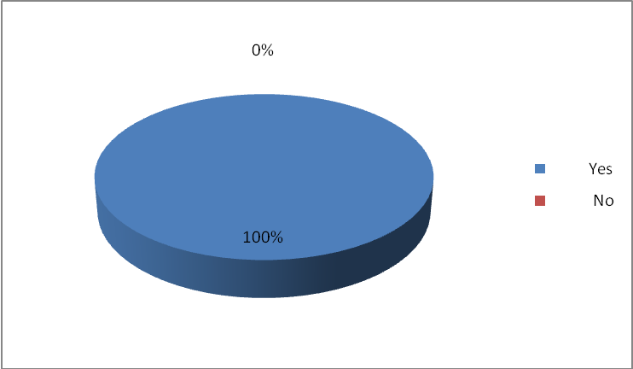

4.1.2 Question No. 2: Is the state of economy is connected with financial crises of Pakistan?
NO | Alternative options | response number in percentage
1 | Yes | 80%
2 | NO | 20%

Justification:
To recapitulate this question, 80% from the entire sample agreed that the state of economy is connected with financial crises of banks and 20% providing negative response and argued that the state of economy is not connected with financial crises of banks.
Pie chart representation

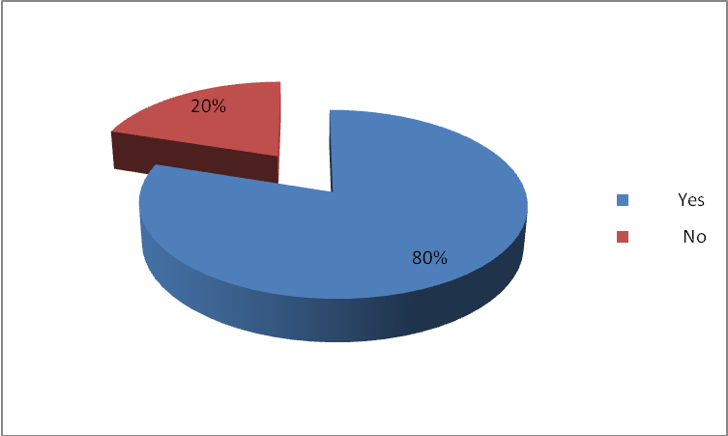

4.1.3 Question No. 3:
Do you thing there is any significant relationship between poor management of capital base of bank and the financial crises in banking sector?

NO | Alternative options | response number in percentage
1 | Yes | 90%
2 | NO | 10%

Justification:
To summing up this question, 90% among the whole sample think that there is any significant relationship between poor management of capital base of bank and the financial crises in banking sector while 10% among the whole population think that there is no significant relationship between poor management of capital base of bank and the financial crises in banking sector.
Pie chart representation
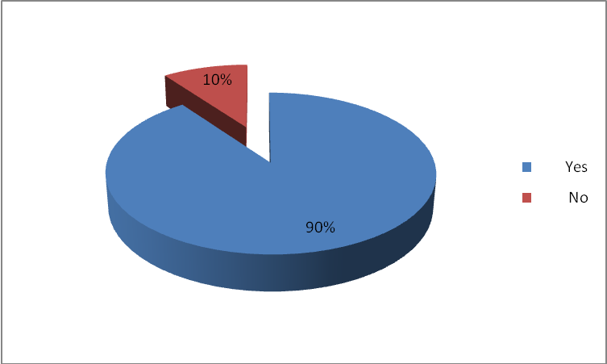

4.1.4 Question No. 4:
Do you think foreign direct investment is healthy for Pakistani banks?
NO | Alternative options | response number in percentage
1 | Yes | 70%
2 | NO | 30%
Justification:
To summarize this question, 70% among the whole sample think that foreign direct investment is healthy for Pakistani banks while 30% agreed that foreign direct investment is not affective for Pakistani banks

Pie chart representation

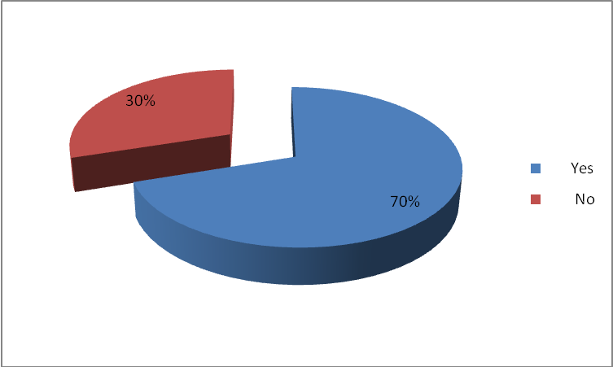
4.1.5 Question No. 5:
Did global financial crises affect Pakistan banking sector directly?
NO | Alternative options | response number in percentage
1 | Yes | 60%
2 | NO | 40%

Justification:
To sum up this question, 60% of the whole sample decided that the global financial crises affect Pakistan banking sector directly, while 40% disagree with this statement.
Pie chart representation
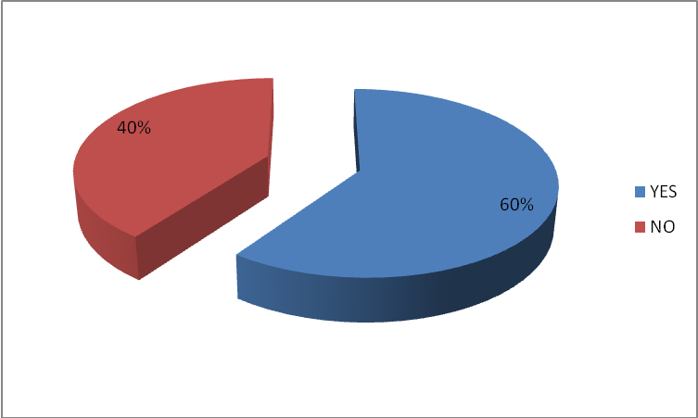
4.1.6 Question No. 6:
Did FMCG (Fast moving consumer goods) and Telecom industry effect banking sector of Pakistan?
NO | Alternative options | response number in percentage
1 | Yes | 70%
2 | NO | 30%

Justification:
Resulting from this question, 70% among the entire sample think that FMCG (Fast moving consumer goods) and Telecom industry effect banking sector of Pakistan while 30% against of this statement.
Pie chart representation
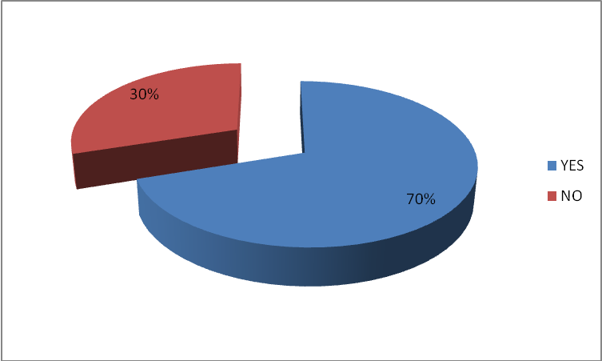
4.1.7 Question No. 7:
Is there any performance and financial deficiency in banking sector of Pakistan after global financial crises?
NO | Alternative options | response number in percentage
1 | Yes | 50%
2 | NO | 50%
Justification
To summarize this question, 50% among the whole sample believe that there is performance and financial deficiency in banking sector of Pakistan after global financial crises, while 50% against of such a statement.
Pie chart representation
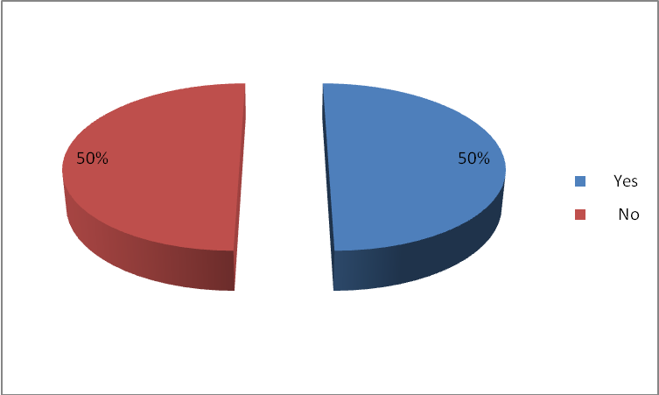
4.1.8 Question No.8:
Do you thing there is any relationship between top level management of consolidation banks and the present financial crises in banking sector?
NO | Alternative options | response number in percentage
1 | Yes | 90%
2 | NO | 10%

Justification:
Resulting from this question, 90% among the whole sample believe that there is any significant relationship between top level management of consolidation banks and the present financial crises in banking industry while 10% gave negative respons
Pie chart representation
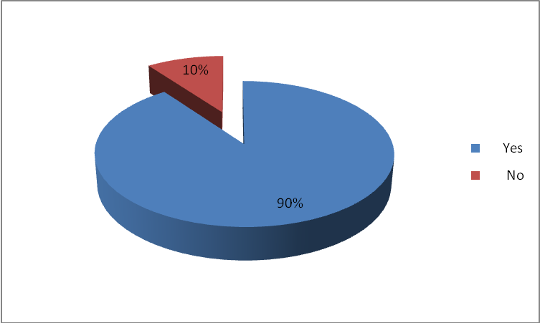

Chapter No. 5
Conclusion and Recommendations

5.1 Conclusion

The purpose of this research study is to emphasis and determined the impacts of the global financial crises on the Pakistan banking sector. It becomes necessary because the present financial crisis and credit crunch in the Pakistan banking sector has been indirectly affected. The primary source of data collected determined that the state bank met with billion of capital base requirement in the banking sector. Each bank has proportion of capitalization kept with state bank.
Banking data shows that the banking sector before the global financial crises was sound and enough to support the nation’s economic stability and development and until that is to some extent in same position. The deposit growth in 2004 was 21.9 while it gone to decline in proceeding years and in 2009 it declined to 6.8. This is reflected by decrease in average money deposited by the clients.
The Pakistani banks and financial institutions brought adequate change during the last few years due to the consolidation as well as diversification. Since 2000, more than 40 transactions of merger and acquisitions have been executed with in banks. On the other hand the bank expend their operations into the areas where the banking system not popular.
As the FDI and FMCG companies working in Pakistan, these FDI directly interrelated with the financial crises of the particular countries. Due to crises the affected countries started to minimize their operation in all over the world such as in Pakistan. The working personals had opened their accounts in Pakistani banks and all over transaction were doing through banks .So due to minimizing of the operations they did withdrawal their deposits and minimize the transaction.

5.2 Recommendation

The Pakistani banks do not have access to long term deposits by which they can not grant long term loans to the clients. Due to this the local banks rely on the foreign financial institutions and banks for credit lines.
In order to avoid this Pakistani Government trough state bank of Pakistan should strengthen and organize the growth of institutions like health insurance, pension funds, mutual funds and housing funds etc. This could be achieved with sound financial decisions of the financial experts.
The State bank should decline the borrowing rates to encourage the borrowers to borrow the money and further invest in investment firms by which the country production and manufacturing should be enhance. Further these investors deposit their money in the banks. So this is a channel process from borrowing to lending of capital. Government should find alternative ways to fund their budget deficit by which the pressure of financings projects in Pakistan should be reduce.

Appendices 1
Questionnaire
Name
__________________
Designation
__________________
Bank name
__________________

Question No. 1:
Did all the banks comply with central bank?
- Yes
- No

Question No. 2:
Is the state of economy is connected with financial crises of banks?
- Yes
- No
Question No. 3:
Do you thing there is any relationship between poor management of capital base of bank and the financial and economic crises in banking sector?
- Yes
- No
Question No. 4:
Do you think foreign direct investment is healthy for Pakistani banks?
- Yes
- No

Question No. 5:
Did global financial crises affect Pakistan banking sector directly?
- Yes
- No
Question No. 6:
Did FMCG (Fast moving consuming goods) and Telecom industry effect banking sector of Pakistan?
- Yes
- No
Question No. 7:
Is there any performance and financial deficiency in banking sector of Pakistan after global financial crises?
- Yes
- No

Question No.8:
Do you thing there is any relationship between top level management of consolidation banks and the present financial crises in banking industry?

- Yes
- No

Question No.9:
What is your personal view about the impact of financial crises on banking sector of Pakistan?
__________________________________________________________________________________________________________________________________________________________________________________________________________________________________________

Thank you

Referencing

- Hassan Gardezi, 2010, “The Making of the Elite: The Landlords”, Neo colonial alliences and the crises of Pakisnan, Vol. 1, No. 2 (Dec., 1970 - Jan., 1971), pp. 3-6, Middle East Research and Information Project.

- World Bank, 1998, “The World Bank and the Social Impact of the Indonesian Crisis”, Population Council, Population and Development Review, Vol. 24, No. 3 (Sep., 1998), pp. 664-666, Population Council.

- Tony Makin, 1999, “PREVENTING FINANCIAL AND ECONOMIC CRISES IN EAST ASIA ” Asian Survey, Vol. 39, No. 4 (Jul. - Aug., 1999), pp. 668-678, University of California Press.

- NICOLA CETORELLI, 2004, “Real Effects of Bank Competition”, Journal of Money, Credit and Banking, Vol. 36, No. 3, Part 2: Bank Concentration and Competition: An Evolution in the Making A Conference Sponsored by the Federal Reserve Bank of Cleveland May 21-23, 2003 (Jun., 2004), pp. 543-558, Blackwell Publishing.

- Shrimal Perera, Michael Skully and J. Wickramanayake, 2003, “Overview of South Asian banking Industries”, Bank market concentration and interest spreads: South Asian evidenc, Vol. 5 No. 1, 2010 pp. 23-37 q Emerald Group Publishing Limited, 1746-8809.

- CEYLA PAZARBAIOGL, 1997, “A Credit Crunch? Finland in the Aftermath of the Banking Crisis”, International Monetary Fund, Vol. 44, No. 3 (Sep., 1997), pp. 315-327.

- Searching for: Global Financial and economic crises and its Impact on Pakistan,
  - Accessed on: August 19, 2010
  - Available at: www.emeraldinsight.com/reprints

- Rasmussen, 2004, “Literature review”, Economic impact of natural disasters’ fatalities, Vol. 37 No. 6, 2010 pp. 429-441 q Emerald Group Publishing Limited 0306-8293.

- Searching for: Global Financial crises and its Impact on Pakistan,
  - Accessed on: August 19, 2010
  - Available at: www.wikipedia.com

- Brunnermeier, 2009, “Liquidity crisis: commercial vs. investment banks”, Greed, financial innovation or laxity of regulation? A close look into the 2007-2009 financial crisis and stock market volatility, Vol. 27 No. 2, 2010 pp. 110-134 Emerald Group Publishing Limited 1086-7376

- Allen 2002, “Definitions and common patterns”, New thinking on the financial and economic crisis, Vol. 5 No. 1/2, 2009 pp. 36-55 Emerald Group Publishing Limited 1742-2043.

- Gai et al. 2006, “Systemic crises in the modern financial system”, Systemic risk in modern financial systems: analytics and policy design, Vol. 8 No. 2, 2007 pp. 156-165 Emerald Group Publishing Limited 1526-5943.

- Scott, 2001, “Institutional theory and the crisis: a view of the iron cage, inside-out”, The global financial crisis: an institutional theory analysis, Vol. 5 No. 1/2, 2009 pp. 26-35 Emerald Group Publishing Limited 1742-2043.

- Nielsen, 2008, “The ethical marketplace”, Will ethical consumers sustain their values in the global credit crunch? Vol. 26 No. 6, 2009 pp. 674-687 Emerald Group Publishing Limited, 0265-1335.

- Luiz Carlos Bresser Pereira, 1995, “Development economics and the World Bank's identity crisis”, Review of International Political Economy, Vol. 2, No. 2 (Spring, 1995), pp. 211-247, Taylor & Francis, Ltd.

- Soludo, 2009, “Problem Background”,
The impact of global financial crises on the Nigerian banking industry,ISSN 1401-4084, ISRN SLU- EKON-EX- No.577—SE.
- State bank annual report 2009-2010

18. Quorter, 2008 Financial Market Impact. emerald Group Publishing Limited.

