
Bahria University Library Islamabad
Source: Pakistan Observer Wednesday Nov 29, 2023

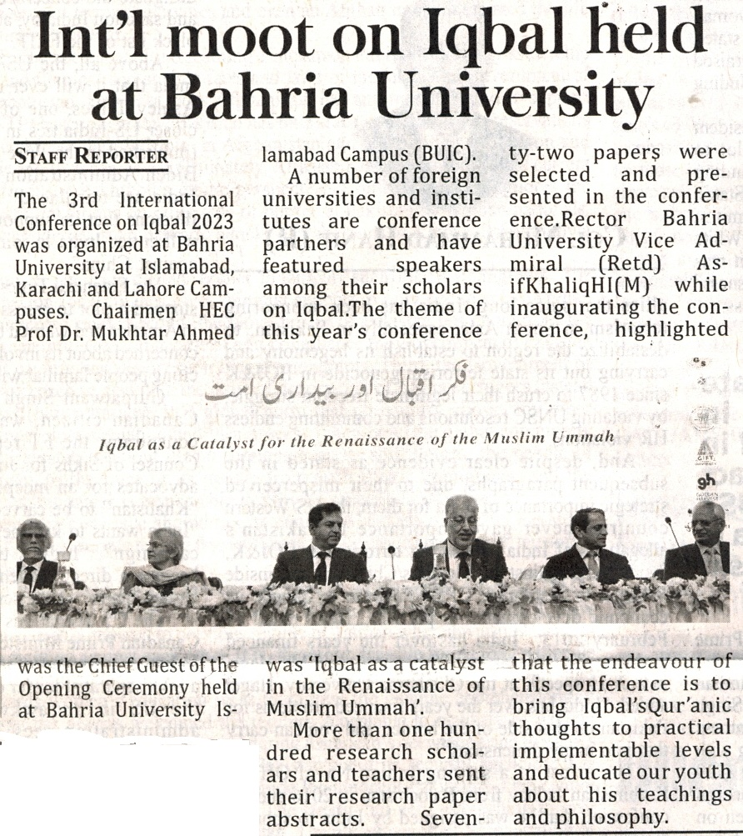

Bahria University Library Islamabad
Source: The Frontier Post Wednesday Nov 29, 2023

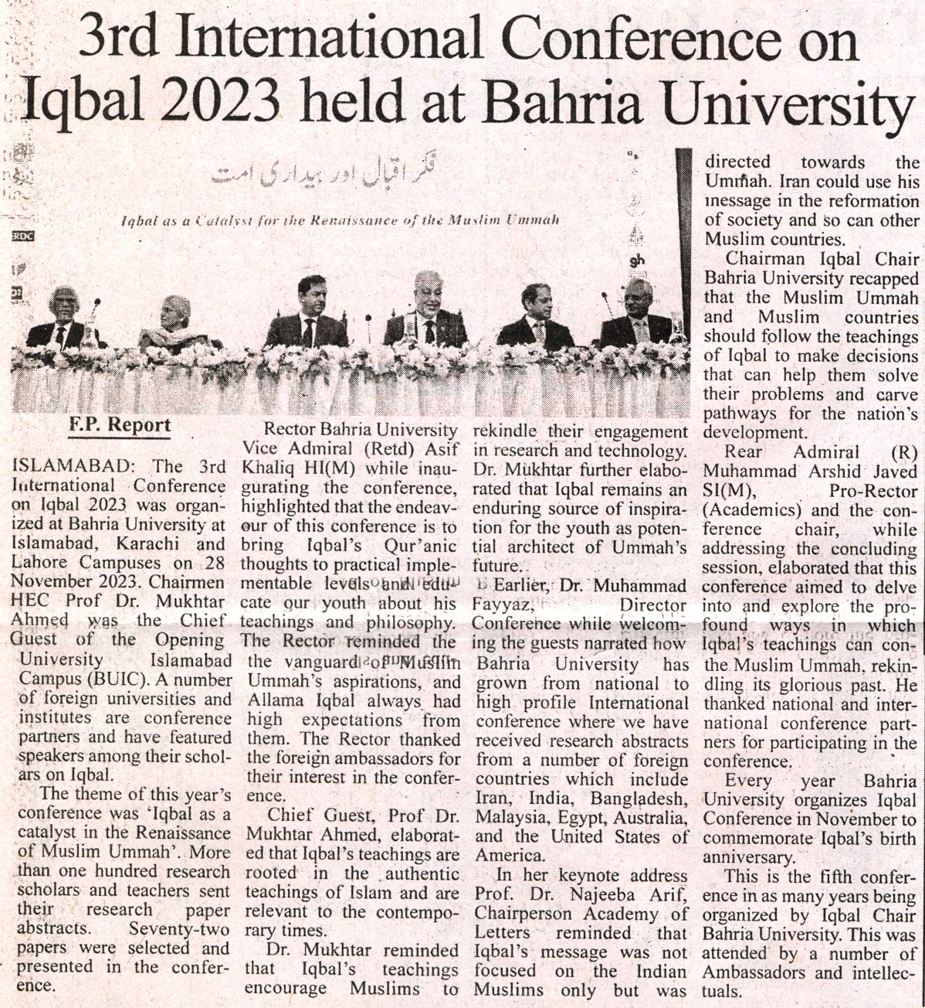

Bahria University Library Islamabad
Source: Daily Dunya Wednesday Nov 29, 2023

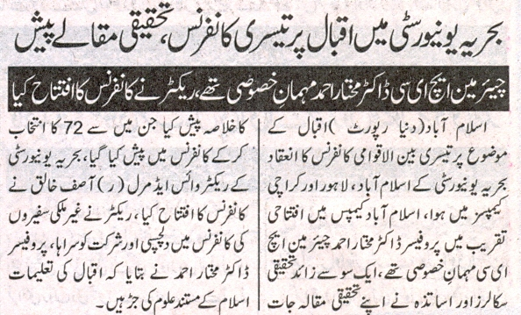

Bahria University Library Islamabad
Source: Daily Express Wednesday Nov 29, 2023

