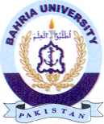
Bahria University Library Islamabad
Source: Dawn,Express Tribune & Daily Jang Sunday Nov 19, 2023

