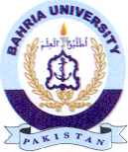Bahria University Library Islamabad
Source: Express Tribune & Express, Saturday Nov 18, 2023

