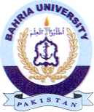
Bahria University Library Islamabad
Source: Dawn & Jang Sunday Nov 12, 2023

