Determination of Lucky Cement and DG Cement Stock Valuation
Muhammad Zeeshan Saleem
01-221082-042
Fawaz Yazdani Dar
01-221082-094

MBA 2008-09

acknowledgement

First and foremost we would like to thanks ALLAH ALMIGHTY, because without his blessings we would not have had the patience and expertise to commence such a responsibility and now as our final project has reached its conclusion we would like to recognize the external dispensation and goodwill.

We would also like to thanks project supervisor Ms. Nadia Jawed, as without her assistance, the project could not have reached its cessation, also true motivational support from teacher Mr. Muhammad Akbar. We are truly indebted to each one of them.

EXECUTIVE SUMMARY

Project is based on finding the best alternative method for valuing the firm under consideration; the project revolves around the valuation of Cement Manufacturing companies namely Lucky Cement and DG Khan Cement.

In the initial phase the overall industrial developments which includes interest rate movements, exchange rate effects on turnover, fuel cost (furnace oil (FO)), distribution cost, were discussed which will frame the basics of assumption used for valuation purposes includes discounted cash flow, P/E ratio and EBITDA valuation methods.

Best option out of available techniques which includes discounted cash flows, multiples valuation, and dividend discount model, along with the reasoning of selecting the option is mentioned in the topics which will leads towards valuation of the firms.

Table of Contents

1. INTRODUCTION 1
1.1. Project Background and Overview 1
1.2. Global Cement Industry 1
1.3. Cement Industry of Pakistan 2
1.4. The problem/opportunity 4
1.5. Rational for project research 4
1.6. Problem Statement 5
1.7. Project Objectives 5
1.8. Research methodology 5
2. LITERATURE REVIEW 8
3. INDUSTRIAL ANALYSIS 13
3.1. Investment Argument to invest in Cement: 13
3.2. Cost Factors: 13
3.3. Cement Industry: Happenings 17
3.4. CCP’s aggressive stance against cement manufacturers: 18
3.5. Seasonality Impact: 19
3.6. Current Scenario: 19
3.7. Post FY2010 24
3.8. Industrial Ratio Analysis: 27
4. company Analysis 35
4.1. DG Khan 35
4.2. Lucky Cement 37
5. Valuation Techniques 43
5.1. PE Ratios Analysis 43
5.2. EBITDA MULTIPLE 47
5.3. DCF Model: 51
6. Action Plan 64
6.1. Discounting method as an alternative method: 64
6.2. Drawbacks of Multiples 65
7. References 67
8. Annexure: 70

Table of Figures
‎3-1 Historical trend of Coal prices 14
‎3-2 Historical prices of Furnace Oil 15
‎3-3 Futures Prices of Crude Oil 16
‎3-4 CPI inflation trend 17
‎3-5 Historical trend of local cement prices 21

INTRODUCTION

Project Background and Overview
It is very important before starting a Project to know about the Industry and its factors which have direct and indirect influence on firms, because these indicators will help in this project in the valuation of the firms, the dimension for this project is to value firms from Cement industry. This industry has major contribution in GDP as well as in national exchequer and have healthy signs for exports growth (Pakistan Economic Survey 2009).

Global Cement Industry
In 1824, the basic ingredient of concrete was produced and patented by a British stonemason. In current scenario approximately 2.8 billion tons of Portland cement is used every year and it is expected to grow as the world’s economy flourishes. Different nature of Portland cement is contrived to assemble various chemical and physical requirements (Today’s cement industry, 2010).
Currently cement demand is not showing growth as it did in last 3 years, cement demand was bolster not only because of boom in local industry but also export avenues showed a great potential and the export avenue was expected to show a turnover of $1 billion. But due to ongoing financial crisis across the globe the construction activities halted as the cash vanishes from the market. Emerging markets like Sri Lanka, Middle East and African countries which is mainly comprised of emerging economies showed a great potential for cement exports. On the other hand, in local market the demand for housing and sustained government spending in infrastructure development by emerging economies is offsetting recession in mature markets.
Though, at present, demand is growing, but at a decelerated pace, the phase is momentary. Long-term projections indicate healthy demand growths, as world economy stabilizes and construction activity picks up across global markets into the next decade (Global Cement Production to Approach 4 Billion Tons by 2012).
World cement production in 2007 was estimated to be 2.6bn tons and is forecast to reach approximately 4bn tons by 2012. China alone accounts for 50% of the world’s total cement production. China, India and USA are the largest producers as well as consumers of cement.
China is by far the largest cement consuming nation in the world, with consumption of 1,270mn tons of cement in 2007. India is the second largest cement consuming nation, followed by USA, consuming 169mn and 115mn tones respectively. The emerging economies are expected to account for as much as 85% of global cement demand in 2020.

Cement Industry of Pakistan
Cement industry is indeed a highly important segment of industrial sector that plays a pivotal role in the socio-economic development. Though the cement industry in Pakistan has witnessed its lows and highs in recent past, it has recovered during the last couple of years and is buoyant once again.
The last few years have been a golden period for cement manufacturers, when the government increased spending on infrastructure development. High commercial activity and rising demand for housing on account of higher per capita income has kept cement off take growth in double digits. The cement sector is contributing Rs.30 billion to the national exchequer in the form of taxes (Pakistan Economic Survey 2009).
There are four foreign companies, three armed forces companies and 16 private companies listed in the stock exchanges. The listed companies (APCMA and KSE 100 index ) include:
- Askari Cement Ltd
- Bestway Cement Ltd
- Cherat Cement Co. Ltd
- DG Khan Cement Co. Ltd
- Dandot Cement Ltd
- Fecto Cement Ltd
- Fauji Cement Co. Ltd
- Flyng Cement Ltd
- Gharibwal Cement Ltd
- Kohat Cement Co. Ltd
- Lucky Cement Ltd
- Maple Leaf Cement factory Ltd
- Mustehkum Cement Ltd
- Pakistan Cement Ltd
- Pioneer Cement Ltd
- Dewan Cement Ltd
- Attock Cement Pakistan Ltd
- Dadbhoy Cement Industries Ltd
- Al-Abbas Cement Ltd

The problem/opportunity
This project will explain the best methodology to find out the fair value of chosen firms. Through this project investors will be able to get a comprehensive review on both methodologies that are alternative compared to relative method, building confidence for their future investment decisions. This would also give investors a glance or future glimpse on Lucky cement and DG Cement.

Rational for project research

Motivation for research problem and Importance of this proposed work
Stock market is facing ups and downs, cement industry is also facing similar issues like energy crisis and influence of stock market along with negative rumors due to which new potential investors are hesitating and becoming risk averse because of their wrong perception about cement industry. The retention of existing investors and to develop interest for new investors, it has become need for this industry to show the fair value of firm through best alternative methods.

Contribution
Contribution in this project is the selection of best alternative method along with the valuation of selected firms through DCF Methods.

Benefits of proposed plan
This plan will provide the clear picture of firm analysis by involving all the economical and industrial issues.

Problem Statement
The project is designed to select the best alternative method to find the fair value of the Lucky Cement and DG Cement.

Project Objectives
- To find the value of two different selected companies in cement sector through alternative valuation techniques.
- To select the best valuation technique.

Project audience
Audience for this project would be Investors and the financial institutions.

Research methodology
This research is exploratory in nature as descriptive is used when the objective is to provide a systematic description that is as factual and accurate as possible. This kind of study is undertaken in order to ascertain and be able to describe the characteristics of the variables of interest in a situation. The goal of this type of study is to offer the researcher a profile of relevant aspects of the phenomena of interest from an individual, organizational, industry oriented or from any other point of view.

Target industry, company
Cement Industry would be target industry where Lucky and DG Cement are the firms for the analysis because both these firms are the top ranked firms on KSE 100.

Population/sample
Following are the two firms chosen for the project:
- DG Khan Cement
- Lucky Cement
Lucky and DG cements are considered to the big giants of Pakistan cement sector accounting hefty share in local markets and also contributing sturdy share in exports.

Procedure
This project will find the value of a company using Discounted Cash Flow as an alternative method along with at the Relative Valuation method in which Price/Earning multiple and EBTDA methods are used.

Type of data (primary and secondary data)
Primary data included our target firms where we had face to face interview with executives from respective industry to foresee the future growth. Whereas secondary data included data from KSE, financial articles, economic survey of Pakistan , different investment bank’s review on cement industry and books like investment analysis and portfolio management by Kieth brown and Frank Rielly.

Scope and Limitation:
The scope of this project includes different types of valuation techniques in practice and choosing the best method for valuation.
Limitations on the techniques side is that, it is difficult to use dividend discount model for the firms as during the last year companies didn’t announce any dividend which makes it difficult to use dividend discount model.

LITERATURE REVIEW
Valuation theories classify; time-varying one-period expected returns, news about cash flows, and news about future expected returns as the three possible sources of return variation. With the exception of the existence of markedly lived bubbles in asset prices, if an asset's return is high, its current expected one-period return must have been high, anticipated cash flows must have increased and/or future anticipated returns decreased.(Peter Hecht 2005)
The Campbell-Shiller, present-value formula permits one to divide stock returns into three components: one-period expected returns, changes in cash-flow prospect (i.e., cash-flow news), and changes in expected returns (i.e., expected-return news). Stock return volatility must originate from one-period expected returns, cash-flow news, and/or expected-return news. Similarly, the correlation between stock returns and various cash-flow proxies must begin from three sources: association of cash-flow proxies with one-period expected returns, cash-flow news, and/or expected-return news. (Campbell J. Y. & R. J. Shiller, 1988 and 1998)
Linke and Kim, Ezzell and Porter (1974) argues that these limitations as to cash-flow patterns are not essential and that a weighting approach to computing the cost of capital is applicable as long as the firm's leverage position is maintained.(John R. Ezzell and R. Burr Porter 1974, and Charles M. Linke and Moon K. Kim 1976)
The current weighted-average cost-of-capital concept is valid for establishing the optimal capital structure that maximizes the value of the firm. In addition to this, it is pertinent for use as a cutoff rate in the evaluation of capital projects. (Timothy J. Nantell and C. Robert Carlson 1975)
Companies using trading or transaction multiples are often more valued. In these methods, a ratio or multiple of value relative to a performance measure is estimated for comparable firms or a set of guideline. Earnings before interest, taxes, depreciation, and amortization (EBITDA) and earnings before interest and taxes (EBIT), net income, and revenue are commonly used performance measures. Value is estimated by multiplying the ratio by the performance measure for the company being valued. (Kim, Moonchul, and Jay Ritter, 1994)
Two assumptions are the preliminaries of multiples or comparables valuation. Firstly EBITDA is proportional to recital measure and second is companies in consideration have future cash flow expectations proportional to and risks similar to those of the firms being valued. If these assumptions are convincing, the comparable method will give a more precise measure of value than any other discounted cash flow approach, because it incorporates contemporaneous market expectations of future cash flows and discount rates in the multiple. (Kim, Moonchul, and Jay Ritter, 1994)
In practice, however, the comparable companies are not perfect matches in the sense that cash flows are not proportional and risks are not similar. Also, there is no obvious method to determine which measure of performance—EBITDA, EBIT, net income, revenue, and so on—is the most appropriate for comparison. Consistent with these concerns, Kim and Ritter (1994) find that analogous methods are not particularly successful in pricing initial public offerings. (Kim, Moonchul, and Jay Ritter, 1994)
Earning measures and discounted cash flows are considered to be important valuation measures on the basis of its findings. Value is rising function of future payoffs and a falling function of risk. Kaplan and Ruback (1995) examine the valuation properties of the discounted cash flow (DCF) approach for highly leveraged transactions. While they conclude that DCF valuations fairly accurate transacted values, they find that simple EBITDA multiples result in alike valuation precision. (Jing Liu, Doron Nissim and Jacob Thomasi, accepted 2001)
In most of the compensation models, Compensation structure for management is tied with the stock performance. The relative importance of valuation can help entrepreneurs to set a true value goal for their agents. (Gerald T. Garvey and Todd T. Milbourn 2000)
With the introduction of the Sharpe-Lintner-Mossin capital asset pricing model (CAPM) and; the more recent multifactor arbitrage pricing model (APM), much of the previous advance in multi period decision making was placed in jeopardy until someone could specify the appropriate CAPM or APM discount rate for project cash flows. Fortunately, some of the previous advance can be salvaged, providing a one-period setting is assumed. However, the multi period extension has been less successful.
While Bogue and Roll show that a multi-period CAPM can be developed for financial control, a pre-specified "beta" or "project-market covariance" is required. However, as Myers and Turnbullx point out, it is characteristically very hard to identify a project's beta. Hence, the requirements of the multi period CAPM and APM are almost as limiting as that of a pre-specified discount rate. (Bogue M.C. and R. Roll., May 1974)
The ability of the CAPM to explain value and growth stocks’ prices is tested empirically. The results suggest that mispricing relative to the CAPM is not a significant factor in predicting the prices of value and growth stocks. Cash-flow betas (measured by regressing firms’ log ROEs on the market’s log ROE) fundamentally explain the prices of and long-horizon returns on price-to-book-sorted portfolios, with a premium consistent with the theory.
Empirical results as that of the theoretical results by Stein (1996), supported the use of the CAPM in capital budgeting, as long as the betas are measured from cash flows or long-term stock returns. It suggests that once a project is undertaken, the stock market values it approximately “right,” i.e., consistently with the model’s present-value calculation. (Randolph B. Cohen Christopher Polk, Tuomo Vuolteenaho.2003)
Banz (1981), sorts on size and three like those in KSS consistently reject the central CAPM hypothesis that explains probable return. Moreover, in recent years the size effect has been displaced as the prime embarrassment of the CAPM. (EUGENE F. FAMA and KENNETH R. FRENCH 1996)
The research beforehand done on CAPM may corroborate the out of place use of CAPM model hurdle rates by companies, though empirical substantiation on inability of CAPM to elaborate short period (one year) expected returns. For example, Graham and Harvey (2001) state: “It is very interesting that CFOs pay very little attention to risk factors based on momentum and book-to-market value.” (Randolph B. Cohen Christopher Polk, Tuomo Vuolteenaho.2003)
Three CAPM-based approaches are used to estimate discount rates corresponding to firm-level, industry-level, and market-level measures of risk. All the three methods mentioned above perform well in contrast to those using comparable transactions and companies. Beneath the most realistic assumptions, the industry- and market-based approaches perform best. Although the DCF approaches perform at least as well as the comparable-based approaches, it has been observed that the comparable-based anticipations add explanatory influence to the DCF-based estimates. (Steven N. Kaplan and Richard S. Ruback 1995)
The tactics of using information from both types of approaches in practical valuation settings where comparable values are also available is most appropriate. The discounted cash flow valuation methods provide consistent estimates of market value as compare to relative approach. Thus, CAPM-based approaches to discount rates are the most authentic ones as compare to those based on size or book-to-market ratios. (The Valuation of Cash Flow Forecasts: An Empirical Analysis, STEVEN N. KAPLAN and RICHARD S. RUBACK 1995)

INDUSTRIAL ANALYSIS

Investment Argument to invest in Cement:
Rising per capita income ($1046:2009)( Economic Survey of Pakistan 2009-2010) ‘’Economic Survey of Pakistan 2010’’and large infrastructure outlays are key drivers of domestic demand. Strong regional demand is on account of supply limitations in high consumption and growth economies.
Economies of scale have made some cement producers well positioned to take advantage of the favorable demand scenario.

Cost Factors:

Coal:
Coal is considered to be major fuel input for energy as well as for dry process of Kiln. During May till Aug 2008 price hike was seen, where prices peaked $198 metric ton. Currently coal prices hovers around $100 to $110 per ton, and it is supposed that coal prices are expected to increase in future which will add to the energy cost.
Coal prices bottomed out during 4qFy09 as the global economic slowdown and monsoon season in Central Asia and Australia urged the miners to rationalize their output (Coal prices to surge in 2010 despite ample supply (www.commodityonline.com ). Lower price levels attracted massive stock piling by major countries mainly utilizing coal as a substitute over expensive FO and gas for power generation as they expected increase in their industrial output on the back of economic recovery. Increasing demand for the commodity is exerting upward pressure on its prices – FOB Newcastle index has risen 13% since June’09 and 24% from 4qFy09 average. Prices are expected to rise later during Fy10 as the upcoming heating season and major shift towards coal fired power plants by larger industrialist regions including China, India and Britain would likely result in rising demand for coal, especially in Asia. The dreaded increase in prices would likely hurt domestic cement industry’s margin in FY 2010-11.( Source: www.indexmundi.com)

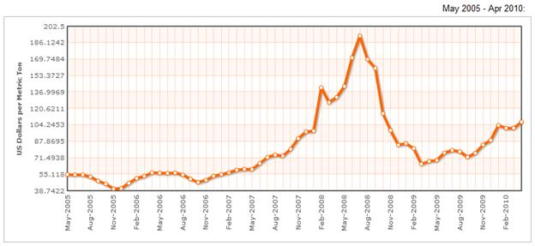
‎3-1 Historical trend of Coal prices

Oil
During April $5 increased was seen in Furnace oil prices reaching more than $84 per barrel In April (can be referred to the following figure)( Crude Oil Spot Prices, www.indexmundi.com) and its impact can be seen in local markets as well where furnace oil prices increased by PKR 2,900, attained PKR 51,348 per ton compared to PKR 29,875 April last year which shows a growth of 80%. Currently FO’s per tones price is around Rs46,226, and correlation between local and foreign oil prices is high, and it is expected that as the recession ends the oil prices will again raise (Furnace oil rate down by Rs1,030 a ton (www.nation.com.pk)
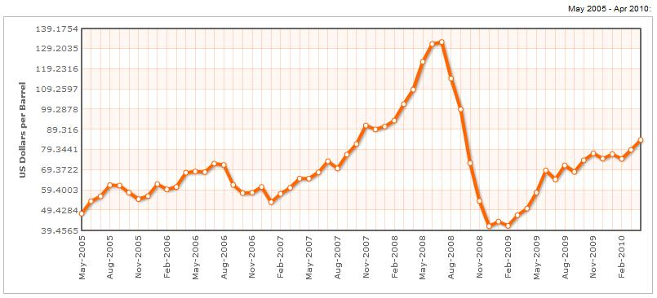
‎3-2 Historical prices of Furnace Oil
Source: www.indexmundi.com

Futures:
In the figure 3, future crude oil prices are expected to reach $84 per barrel which can further add to the woes of the industry in terms of energy cost(Source: www.indexmundi.com )

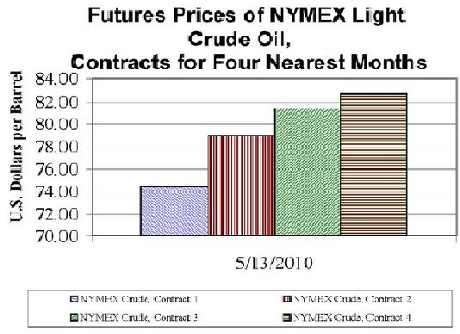
‎3-3 Futures Prices of Crude Oil
Source: www.EIA.com

Interest Rate:
Relatively high 6-month Karachi Interbank Offered Rate (KIBOR), which was at 12.2 percent in May 2010 expected to be increased because pacing up inflation in the overall economy. Inflation on the basis of YoY for the month of April 2010 was 13.26 % in CPI and 14.55% YoY for food inflation (Economic Survey of Pakistan 2010), on the basis of this data it can be expected that the financial charges will increase the cost and hit the bottom line.
Recently State Bank of Pakistan, increased the policy rate to 13%, which was previously 12.5%. This additional cost will affect the bottom line of the industry. This will ultimately push the six month KIBOR rate to 12.76% and squeeze the margins (Increase in policy rate to affect borrowers (www.dailytimes.com.pk)
‎3-4 CPI inflation trend
Statistical Dept of Pakistan

Cement Industry: Happenings

Cartel breakdown hurting the industry (August, 2009)
During 2008-09, eight small cement manufacturers with cumulative plant capacity of 12.07mn tons (28% of the total installed capacity) have reportedly suspended production due to unfeasibly low cement prices in the local market Cement prices are hovering at a low level of PKR235/bag in the North and PKR270/bag in the South with the exceptional case of ACPL which is selling as high as PKR300/bag in the South.
Local cement prices have declined as low as PKR235/bag in the North (from PKR310/bag in 4QFY09) primarily because of price cut in August (PKR40/bag within a fortnight) following quota arrangement breakdown between the cement manufacturers. On the other hand rising cost of production (10% rise in imported coal prices during last three months to $79/ton and expected rise in power tariffs) and subdued growth in local dispatches for FY10 on the back of economic slowdown and curtailment in infrastructural development spending is likely to further dent profitability in FY10. Moreover, small manufacturers, due to high cost of production (Gharibwal Cement, Dandot Cement and Flying Cement) as well as high interest payments on loans acquired for plant expansion are suffering the brunt of this double whammy with eight small cement manufacturers suspending their production during last two months. We expect the prevailing industry issues to help the key players (who have strong group backing) to increase their market share and to maintain their local dispatches for FY10 despite the unfavorable conditions. (Industry horizon clouded with negatives, Invisor Securities Ltd)

CCP’s aggressive stance against cement manufacturers:
Competition Commission of Pakistan in its recent hearing on 25th Aug 09 concluded that APCMA and twenty leading cement manufacturers of the country were indulged in operating a cartel in the industry since May 2003. The commission has issued orders to fine the involved parties, charging all the manufacturers 7.5% of their turnover stated in their respective recent financial statements (Fy08) and a fixed penalty of PKR 50mn on APCMA itself. These penalties which are not deductible for tax purposes if imposed will cause major dents in cement manufacturers’ Fy10 earnings (Heightened risks materializing (Invisor Securities Ltd)
CCP had restrained itself from taking any adverse action as per the orders of Lahore High Court till the next hearing on 29th Sep 09. Cement manufacturers can appeal against this order of CCP in the Supreme Court within 60 days of its issuance. Owing to the strong evidence held by the commission, we expect that cement manufacturers will end up paying the imposed penalties (Cement Sector rising to challenges (JS Global)).

Seasonality Impact:

As expected local cement prices recovered FY10:
We believe local cement prices will start recovering during the later part of 3QFY10 as delayed construction activities are expected to kick in on the back of end of winter season and some pick up in development spending, while full year effect of lower cement prices will likely hurt margins.

Current Scenario:

Local Market:
Considering the persistent demand from some export avenues and improved economic conditions in the country, the overall sector showed a growth of 9.30% YoY basis which includes 14.63% YoY basis growth in local dispatches and -0.89% YoY decline in exports.
Local cement dispatches showed a tremendous support to the cement industry though analyst was expecting total dispatches of 29-30 M tons (KASB estimates, Mapping 2010 opportunities (KASB morning shout)) dispatches overall (APCMA).

Table ‎3-1 Historical performance of Cement industry
APCMA

Local cement prices after the boom of 2008 take a steep and hovers around Rs 275/bag on average as shown in the graph, but we expect the prices will go up to Rs. 300/bag or above in 1st quarter of FY11. Also CCP penalty hit also would effect the bottom line of the major players of the industry.
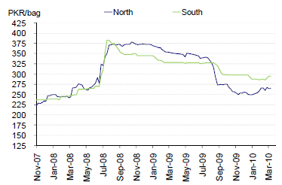
‎3-5 Historical trend of local cement prices

Export market:
Pakistan’s cement manufacturers have been aggressively catering to export market where there is robust construction and development activity such as Iraq, Afghanistan, South Africa and Sri Lanka with total exports showing massive growth of 39% during FY09 despite global recession. However, we do not expect any growth in export during FY10 and beyond due to high base effect, weak global economic condition and more importantly regional expansions becoming operational. We expect export volumes to remain flat in Afghanistan and Iraq where construction activity is underway, with manufacturers selling at lower prices to compete in the market. India on the other hand has never been a key export destination with export market share of less than 7%. We expect Indian avenue to be completely shut from post FY10, owing to its own expansions coming online. We have resultantly assumed low growth in the export market and this slight growth will bank on new and existing African markets which have quite potential for cement imports.

Table ‎3-2 Historical trend of export prices
APMCMA and Economic survey of Pakistan 2010

Inland Transportation Subsidy
The government providing 35 per cent inland freight subsidy on exports to manufacturers should improve fundamentals of the sector in the near future, said JS Global Capital, analyst, Atif Zafar.
Those plants located in northern region needs to bear cost of transportation of around $11 to $17 per ton to move the dispatches towards the Karachi seaport, which is over and above the manufacturing cost of $32-$37 per ton depending on the quality of plant, location and other factors. After the announcement of inland subsidy to make the cement exports competitive in international market, northern plant’s transportation cost will reduce by $5 per ton and $ 1.25 per ton for southern plants (Fiscal Review 2010 Business Recorder).
Lucky Cement will benefit by Rs1.27 billion, DG Khan Cement by Rs0.39 billion, Lafarge Pakistan Cement by Rs0.27 billion and Maple Leaf Cement by Rs0.13 billion because of the subsidy, according to JS research.

Margins expected to remain depressed:
Despite achieving marginal improvement in demand, industry is currently facing difficulties due to the prevailing plunge in domestic and export retentions. Moreover, margins would likely keep worsening further, considering the rising fuel and energy prices and higher inland transportation costs borne by the manufacturers, especially in northern region. We expect 10-12% increase (from current levels) in domestic prices in 1hFy11 to provide some support to the faltering margins.

Efficient producers expected to rule:
Considering the prevalent demand/supply situation and rising input costs, we believe that manufacturers with established local/export supply lines and efficient cost of production like Lucky, Attock and DGKC would likely perform better than the rest of the industry. As rising input prices, depressed retentions and higher average debt servicing of the industry has forced many smaller players to halt/restrict their production process, this bode well for the few larger players to expand their market shares. While overall industry would continue to face subdued margins and constrained cash flows during 2hFy10, nearness to the port, persistent export demand, lower debt levels and efficient production processes will shelter southern players such as Lucky and ACPL from potential adversities. On the other hand, shifted focus towards local markets and limited supply from smaller players in northern region will continue to bode well for DGKC’s dispatches growth; however, margins would likely remain stagnant.

Post FY2010

Domestic Demand and Production Capacity:
Internationally renowned companies like EMAAR (UAE), Al-Ghurair (UAE), Nakheel (UAE), Meinhardt (Singapore), and ENSHAANLC (UAE) are currently implementing mega projects in Pakistan.
Spending on public sector development program has surged, from PKR 160.0 billion in FY2004 to PKR 663.0 billion in FY2011 (Fiscal Review 2010 Business Recorder) .There is an estimated backlog of 3 million housing units in Pakistan.
Thatta Cement, plans to double capacity to capture benefit of rising demand in local as well as in export market. It is expected that the plant will be operative in two years with an investment of Rs. 3 billion to raise production to 3,000 tons a day from 1,500 tons.( Thatta Cement Plans to Double Capacity as Pakistan, Overseas Demand Rises (www.bloomberg.com))

Exports:

African export window expected to narrow
In the wake of rising freight costs during Fy09, Pakistan’s cement industry had taken the advantage of its geographical proximity to the cement deficient regions of Africa. The industry dispatched nearly 1.5mn tons during Fy09 mainly through the ports of Djibouti and Mozambique. However, East African Cement Producers Association are now pushing local authorities to restore Common External Tariff(CET) back to 35% as the prevailing lower duty of 20% has provided ample room for cheaper imports from Pakistan into the region, trading at 30-40% below local prices. The association further reveals that higher cost of energy and transport in the region increases their cost of production and demands a rise in import tariff to ward off dumping of cheap cement. Moreover, the industry claims that they can meet the local demand with existing production capacity of 9mtpa compared with demand of 6 mtpa.( Vulnerable export venues, Invisor Securities Ltd). If enforced, the higher tariff will likely reduce Pakistan’s competitive edge over local producers and the exporters will have to compromise at lower prices.

Drying down GCC markets
Robust construction and development activities along with imposed ban on cement exports from surplus producing countries in the region had resulted in a supply gap in GCC during Fy09. Taking lead from the supply shortfall, local prices jacked up to USD 100/ton in the region and thus provided room to cheaper imports from Pakistan at USD 85-90/ton (Vulnerable export venues, Invisor Securities Ltd). However, as the demand growth in the region halted, owing to global economic meltdown and the surplus producers lifted their export ban, local cement prices declined to USD 85/ton as of Sep’09.
Moreover, about 25% of the announced development projects in the region stand aborted and local industry operated at lower utilization levels of 70% in 1qFy10. Considering the tapered demand growth and continuing capacity buildup the, the region will likely face capacity overhang in Fy10 and thus unlikely allow any further room for cement imports. This shall severely hurt Pakistan’s export demand, as GCC absorbs more than 50% of the country’s export dispatches.

Indian capacity expansions adding to industry woes
Having close proximity to the two largest cement manufacturers namely India and China has always been a cause of concern for Pakistan’s cement industry. However, the higher demand for cement in these countries had restricted their ability to largely exploit export opportunities available in the region. But the rising trend of capacity expansions in India would severely dent Pakistan’s export prospects mainly in Middle East and Far East markets. Indian cement production capacity which is currently 240 mtpa is growing at a rapid pace of 9% p.a. the second fastest after China, and the country is expected to add 50mtpa additional capacity by the end of Fy10 (Sector structure/Market size (India Brand Equity Foundation)). Considering the rapid expansions will lead to an oversupply situation, the local government has eased out export restrictions in Southern Indian region and local cement companies are now penetrating in export markets of Middle East, Sri Lanka and Africa. The dreaded supply glut in India will not only hurt Pakistan’s export potential of ~ 700-800-K ton across the borders but it will also bring its dire consequences of increased competition in regional export venues. Considering the precarious horizon over export markets, we believe that the industry would lose 15-20% of its export business in Fy10, while the situation will likely worsen going forward unless cement demand in the region regains its growth momentum.

Industrial Ratio Analysis:

Revenue, EBIT(1-t) and NI comparison
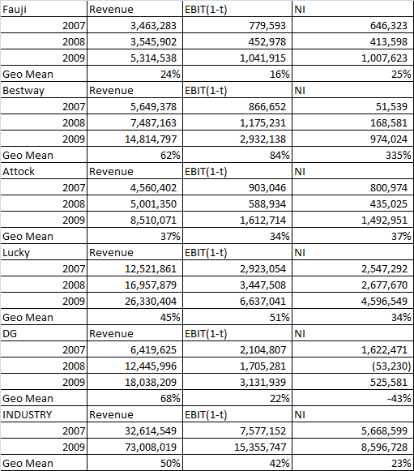
Table ‎3-3 Historical Trend of Revenue, EBIT(1-t) and NI growth
Respective company’s financial statements
Five major players performance have been measured for their last 3 years, geometric means been considered as it takes the compounding effect of the growth from the base year.
The overall industry showed a tremendous growth in the periods under consideration showing 50% growth in revenue, 42% growth in EBIT (1-t) and 23% growth in NI. NI couldn’t get the same growth rate as of revenue and EBIT (1-t) because of high distribution cost and higher fuel cost.
The companies under consideration for the valuation purposes (DG and Lucky cement) showed tremendous growth and DG beat industry in terms of revenue growth, which shows strong selling network locally as well surplus from the exports as well, and Lucky beat the industry in EBIT (1-t) which shows strong operational processes.

ROC and ROE
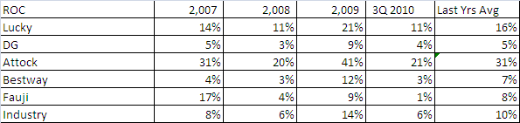
Table ‎3-4 Return on Capital
Return on capital for the overall industry was 10% for the last three years, which is a healthy sign of relief for the top performers of the industry, and in the last FY09 overall ROC stands for 14% mainly because of higher exchange rates and higher retention prices in local industry. So it can be expected that this extra return will wash away as the local market stabilizes and exchange rate stabilizes.
Lucky showed a 21% ROC for the FY09, which is because of mainly reasons discussed above so a healthy indicator would be last 3 years average performance which is 16%. On the other hand DG showed 9% ROC in FY09 but the last three years average was 5%, but for valuation purposes it is assumed that DG must show returns equivalent to industrial average.
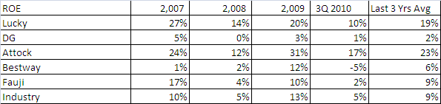
Table ‎3-5 Return on Equity
The return on capital for the overall industry is 9% for the last 3 years average, which is quite low than the cost of equity factor ( will be discussed in valuation part), for the last FY09 the industry should 13% return which is also lower than the cost of equity. These lower returns are because of higher debt factor on the balance sheet of almost all the companies who were in expansionary phase or currently in expansionary phase.
Lucky in FY09 showed a return of 20% return mainly because of higher exports backed by high exchange rate, a consistent factor can be seen in last 3 years average where it is 19% which is considerable healthy sign.
On the other hand DG because of higher financial cost and COS mainly consistent of more than 6 billion fuel dost, return were quite low for the last 3 years average as well as for the FY09. So as the company pursued waste heat recovery power plant a significant portion will fall down as higher savings are expected in term of fuel cost.

Operating and Net Income Margins
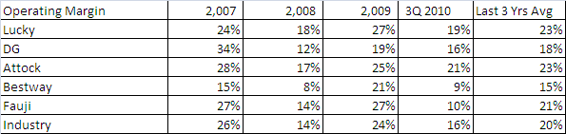
Table ‎3-6 Historical trend of Operating Margins of the industry
The overall industry operating margin stands at 20% for the last 3 years, and in the last year higher margins in FY09 than industry average mainly because of higher exports with exchange rate effects, but significant higher margins cannot be seen because of higher fuel cost compounded by higher distribution cost. To improve the overall margins of the industry government subsidize the inland transportation by 35% of the cost in the last and current FY.
Lucky showed margins above than its peers and stands at 23% for the last 3 years average and 27% for the FY09, mainly because of efficient processes and strategic decisions regarding fuel hedging decisions.
As far as DG is concern it is performing a slight below than the industrial average’s for last 3 years and FY09, mainly because of high COS, which instigated them to take steps in making fuel cost low by adding power plant.
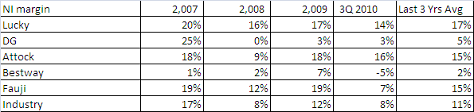
Table ‎3-7 Historical trend of Net Income margins of the industry
Industry’s last 3 years average stands at 11% and 12% for the last FY09, which shows consistency in NI margins.
Lucky’s NI margins are quite higher than industry which can be eroded in future as the competition grows in local as well as in export market for local as well as from foreign manufacturers.
On the other hand DG’s Ni margins are quite lower than industry, but decisions regarding fuel and manufacturing process efficiency can push the NI margins to industrial levels.

Debt Ratio:
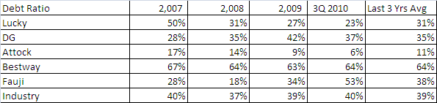
Table ‎3-8 Historical trend of Debt Ratio of the industry
As the industry is highly debt based and some of the firms showed low or negative margins because of financial cost. Overall 39% of the overall assets are supported by debts during the FY09, but most of the long terms debt will be out of the balance sheet in next three years, which will be discussed in company’s analysis.

Reinvestment Rate:
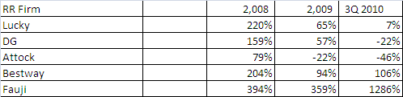
Table ‎3-9 Reinvestment rate (firm) of Industry
Reinvestment rate of firm is based on change in non cash working capital plus net capital expenditure as a factor of EBIT(1-t), which shows the ending of expansionary phase of the major industrial players in FY08,except for Fauji cement who is in process of expanding the production capacity. So to calculate the reinvestment rate for the firm it is advisable that the reinvestment rate should be calculated through fundamentals rather than taking average of historical data.
Reinvestment rate = Growth/ROC
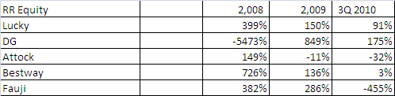
Table ‎3-10 Reinvestment rate (equity) of Industry
Reinvestment rate for equity accommodates an additional factor of net debt (new debts- debts repayments), as it is evident from the above reinvestment rates major firms are having high reinvestment rates because of high debt payments.

Factors of Reinvestment Rate:
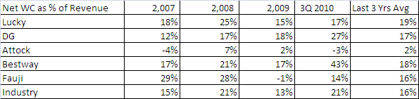
Table ‎3-11 Working Capital as % of Revenue
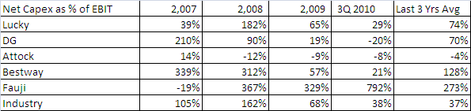
Table ‎3-12 Capex as % of EBIT
Debts can be calculated through
= debt ratio* reinvestment rate (firm)
This shows how much reinvestment done by firm will be supported through debts.

Industrial Production Capacity:

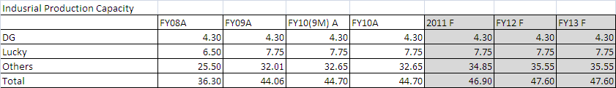
Table ‎3-13 Industrial Production capacity (forecasted)
Companies under consideration (DG and Luckky) don’t seems to be interested in capacity expansions, only the expansion will comes from Fauji cement’s new plant by end of 2011, and Thatta Cement plant by the end of 2012.

company Analysis

DG Khan
D.G. Khan Cement Company Limited (DGKCC), a unit of Nishat group, is the largest cement-manufacturing unit in Pakistan with a production capacity of 5,500 tons clinker per day. It has a countrywide distribution network and its products are preferred on projects of national repute both locally and internationally due to the unparallel and consistent quality. It is list on all the Stock Exchanges of Pakistan.
DGKCC was established under the management control of State Cement Corporation of Pakistan Limited (SCCP) in 1978. DGKCC started its commercial production in April 1986 with 2000 tons per day (TPD) clinker based on dry process technology. Plant & Machinery was supplied by UBE Industries of Japan.
(DG cement official website 2010)

Overview
DGKC was established in 1978 by the State Cement Corporation of Pakistan. In FY1992 it was acquired by the Nishat Group (NG) through a privatization deal. Currently, it has a combined rated capacity of 13,400 tons of clinker per day. It is the second largest cement producer in the country. Nishat Mills Limited a NG enterprise owns 31.4 percent of DGKC’s common equity. Its low cost producer advantage seems sustainable. DGKC’s equity portfolio of PKR 16.2 billion is likely to continue to supplement its bottom line growth over the medium term. Sum-of-the-parts valuation suggests that the scrip is trading at a discount of 46.1 percent to its December 2008 target price of PKR 91.0/share. DGKC market capitalization is 12.4B and its shares outstanding are 253.5 M.

Optimization and Expansion
In the past, DGKC’s earnings had increased at a CAGR of 32.2 percent per annum. This was largely driven by an increase in gross profit margins from 23.3 percent in FY2003 to 31.7 percent in FY2007. Increase in other income dividends from associated companies from PKR 120.2 million in FY2003 to PKR 479 million in FY2007 also helped support the bottom-line growth.
DGKC plans to double its capacity to 26,000 tons of clinker per day by FY2010 in 2009 and now it’s been implemented. DGKC is aiming to tap potential cement demand growth expected from Gwadar and Afghanistan. It is focusing on getting easier access to the Karachi port for exporting cement to Middle East and India. Furthermore, the said expansion is likely to help sustain its market leadership in the Northern region.

Ongoing projects

Optimization of chakwal plant:
The company has started work on optimizing plant capacity by 15.0 percent to 2.4 million tons of cement per annum.

Expansion of Dera Gazi Khan plant:
DGKC is working on expanding its raw mill and kiln capacities at the DGK plant. Once all expansions are complete, the production capacity at DGK plant should reach 11,500 – 12,500 tons of clinker per day.

Investment portfolio
DGKC holds an investment portfolio with a current market value of PKR 16.2 billion. These comprise stakes in MCB Bank Limited (57.7 million shares), Nishat Mills Limited (20.2 million shares), Nishat Chunian Limited (7 million shares) and Adamjee Insurance Company Limited (2.9 million shares). For 9M-FY2008, other income—mainly dividends—contributed PKR 663 million, or 7.4 percent of the company’s total revenue. Other income is projected to grow at an average rate of 5.0 percent per annum till FY2011.

Lucky Cement

The Company:
Lucky Cement Limited is the largest cement producer in Pakistan. Its shares are traded on the Karachi Stock Exchange, and are part of the KSE 100 Index. Its symbol in the Karachi Stock Exchange (KSE) is 'LUCK'. The highest share price the company witnessed, since its creation, was PKR 147.00 (per share). This price was achieved on the 18th of April 2008.

History
Lucky Cement Limited was founded in 1996 by Abdul Razzak Tabba. The company initially started with factories in the Pezu district of the North West Frontier Province (N.W.F.P). They now, also, own a factory in Karachi. Lucky Cement Limited has been sponsored by Yunus Brothers Group (YB Group) which is one of the largest business groups of the Country based in Karachi and has grown up remarkably over the last 50 years. The YB Group is engaged in diversified manufacturing activities including Textile, Spinning, Weaving, Processing, Finishing, Stitching and Power Generation. The Group consists of a number of industrial establishments other than Lucky Cement Limited.
(Lucky Cement official website 2010)

Overview
LUCKY was incorporated in 1993. It is sponsored by the Yunus Brothers Group. The Group is involved in textiles, cement, and power generation industries. In 1996, LUCK started commercial production with an annual capacity of 1.2 mmt of clinker. It has enhanced its capacity by 5 times since then. Currently, it has a total production capacity of 6.5 mmt per annum. LUCK is the largest cement producer in the country with local and export market shares of 12.0 percent and 30.9 percent, respectively in FY2008.
The company is operating two plants—at Karachi and Pezu. In FY2008, the company offered 60 million shares through GDR and was listed at the London Stock Exchange.
Capacity investment of PKR 17.2 billion over the last three years has resulted in an increase in its production capacity to 6.5 mmt per annum of cement in FY2008. LUCKY’s local and export market shares have also gone up from 8.4 percent and 10.2 percent in FY2004 to 12.9 percent and 30.9 percent in FY2008, respectively.
Capital investment of PKR 17.2 billion over the last three years has positioned LUCKY to exploit opportunities in both local and export markets. LUCKY is the largest cement producer in the country. In FY2008 its local and export market shares were 12.9 percent and 30.9 percent, respectively. The scrip is trading at a 31.1 percent discount to its December 2008 target price of PKR 102.0/share. Market capitalization (PKR billion) is 22.7 and Shares outstanding (million) 323.3.

Past performances:
Earnings grew by 83.0 percent on average over the last five years. Net sales increased by an average rate of 57.0 percent per annum over the last five years. Gross margin has increased from 20.2 percent in FY2004 to 30.0 percent in FY2008. Increased cement prices and efficient production techniques have contributed to increase in margins.

New and Recent projects
In order to sustain its industry position and capitalize its competitive strengths, the company is in the process of implementing several projects.

Expansion of Karachi plant
The company had started installing one additional line of 1.3 mmt. This expansion came on-line in the FY2009.

Conversion from furnace oil to gas
Rising crude oil prices have triggered the company’s decision to run its captive power plant from furnace oil to gas for its Pezu plant. Conversion from coal to gas is expected to result in cost efficiencies of 3.0 to 4.0 percent if LUCKY opts for full conversion.

Infrastructure
In order to facilitate exports, LUCKY has set up its own export infrastructure at Karachi port. So far, LUCKY has developed transportation and loading facilities for 6,500 tons of bulk cement per day. The company is also setting up silos at the Karachi port.

Investment considerations
Interest rate risk: the company is highly leveraged and has somewhat mitigated the impact of interest rate risk by swapping half (including cross currency swaps of PKR 5.1 billion) of its floating rate loans to fixed rate. It has also included pre-payment option in all of its loans.
Operational risk: Increase in industry capacity is likely to result in a decrease in capacity utilization over the next 3 years. The company has mitigated this by aggressively seeking export contracts. It is targeting contract tenures of 1-2 years so as to hedge against surplus capacity.
Input cost variability: About 55.0 percent of cost of sales comprises of fuel and power. The company uses coal, furnace oil, and gas as fuel but is still quite exposed to input cost fluctuation.

Exports to the rescue again

Event
Lucky Cement for 1HFY10 announced net earnings of PKR1,908mn (EPS PKR5.90), recording a YoY decline of just 1.5% in bottom-line. However, PAT declined by 27% QoQ in 2QFY10. We have revised our earnings estimates and target price for LUCK.

Impact
Revenue growth remained stagnant: Despite 21% YoY rise in volumetric sales to 3,183k tons (29% increase in exports and 12% increase in local sales), top line declined by 2% to PKR 12,116 due to 20% YoY drop in net retention prices to PKR190/bag (retention prices had dropped to PKR175/bag on domestic level during 1HFY10). However sizable increase of 29% YoY in export volumes balanced the bottom line in the end.

Production costs also remain unchanged: COGS increased by a mere 1% YoY to PKR 7,592 despite lower coal prices due to 21% YoY rise in volumetric sales. However on a per ton basis, COGS declined by a substantial 17% owing to YoY decline in international coal prices. Subsequently, gross profits declined by only 7% YoY, while operating profits dropped by a sizeable 28% YoY, due to massive 57% increase in distribution cost (29% YoY rise in volumetric export sales coupled with increase in inland transportation charges and ocean freights.
Lower other charges and financial cost supported earnings: Other operating expenses declined by a massive 75% YoY to PKR164mn in 1HFY10 (company bore exchange losses last year). Due to switching of long term loans carrying high markups to low cost export refinance (thanks to rise in export volumes) and decline in KIBOR, financial charges witnessed a 64% YoY decline to PKR298mn.

Waste heat recovery projects to reduce cost by Lucky and DG cement:
In order to reduce manufacturing costs Lucky Cement and DG Cement are budding waste heat recovery projects. This project has approved by Clean Development Mechanism program within the framework of Kyoto protocol of United Nations Framework Convention on Climate Change (UNFCC).
Due to the high prices FO-based power plants became unfeasible. The industry moved towards national grid and gas fired power plants to meet its power requirements. We have seen that there were 19% hike in electricity during 2hFy10 and scarcity of natural gas in the country would likely prove to be burdensome under the prevailing squeezed margins for the industry. Under these difficult times, commissioning of waste heat projects is expected to bring ~25-30% reduction in power costs while it would also ensure uninterrupted supply for the companies.

Valuation Techniques

PE Ratios Analysis
In relative valuation we used price earning multiple in order to forecast the value of firm for the next 3 years.
This method not only involves the historic data but also the future data as well so one cannot get rid of future workings. From historic data we found industrial average price earning with the help of this we forecasted price per share by multiplying it with future EPS of each firm for their respective future years one by one.
So for above workings we found the price per share from 2007 till 2010. We used data from KSE100 index. In order to have share market price we choose each year’s price on the last day of December. From the annual reports, net income was taken and it was divided by the number of shares in order to have EPS (earning per share). After that, price per share was divided by EPS which determined PE ratio for each year of individual firms. Average of these ratios was used to find the PE ratio of each company.
In KSE100 we used three other top ranking cement firms which are Attock Cement, Fauji Cement and Bestway Cement. We took the average PE ratio of these three firms and took their average to find the average of the Industry.

Industrial Average P/E ratio
We have evaluated Industrial Avg. PE ratio as follows:
Industrial Avg. PE ratio = 19.60
Following are the workings for industrial average.

Attock Cement
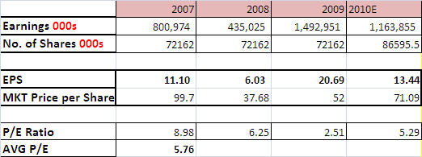

Fauji Cement
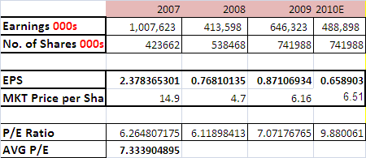

Bestway Cement
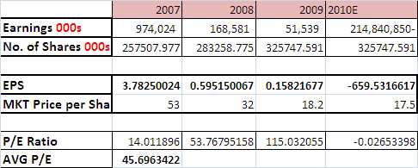

Price per Share
Future EPS for each firm have been determined which is shown in the following tables. In order to find out the new price per share we have multiplied each firm’s EPS from 2011 to 2013, with the industrial average PE based on historic data which we already have determined.

Lucky Cement
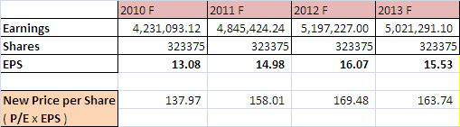

DG Cement
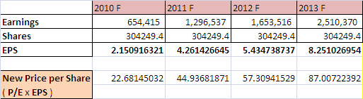

EBITDA MULTIPLE
Another method that we used was the earnings before interest & taxes, depreciation and amortization multiple.
Here we took EBIT and added back depreciation and amortization values for the year 2007 till 2010 from the financial statements but for forecasted depreciations we used percentage rate applied on plant and equipment in each year from past analysis and took the average of percentage rate applied on prior years which we applied on future value of plant and equipment. Please note that we added forecasted capex for each future year in cumulative plant and equipment value of respective future year. Shown as below:
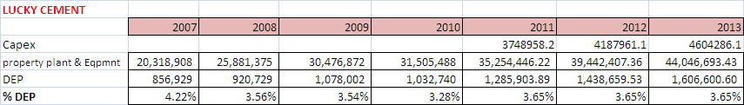
In above table we added forecasted capex of 2011 in plant and equipment of 2010 and then applied the average rate of dep from 2007 to 2010 which is 3.65% on forecasted plant and equipment of 2011.
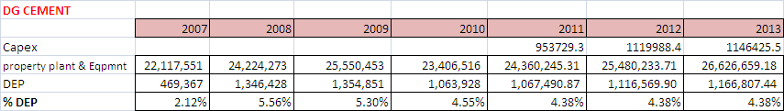

Due to lack of values and negligible ones we didn’t take any amortization in the firms we choose. The reason why we choose trend analysis for depreciation was that there were different depreciated items with different depreciated rates and methods which were not clearly addressed in financial statements.
After finding EBITDA values for the years 2007 till 2010 for selected firms we calculated EBITDA per share, then we used prices from KSE 100 we calculated EBITDA multiple which is price per share divided by EBITDA per share for each year. Then we took the average of EBITDA multiples for each year.
After calculating the EBITDA multiple for each years we estimated EBITDA for the future years 2011 – 2013. After that we estimated EBITDA per share for these years & then multiplied them by the average multiple of the firm. This is how we calculated the price for each year for the years 2011-2013.

LUCKY CEMENT
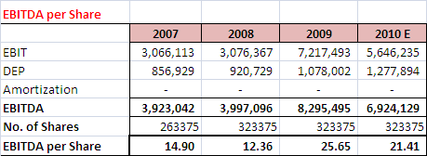

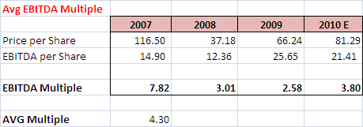
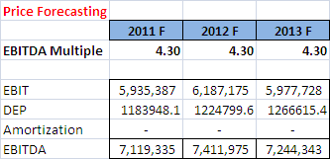
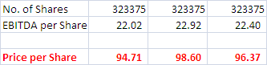

DG KHAN CEMENT
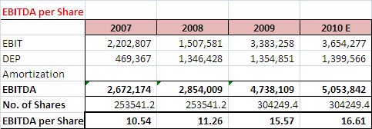

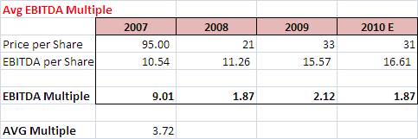
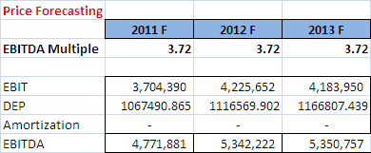
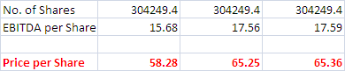

DCF Model:

DG Cement:

Summary of Balance Sheet and Income Statement:
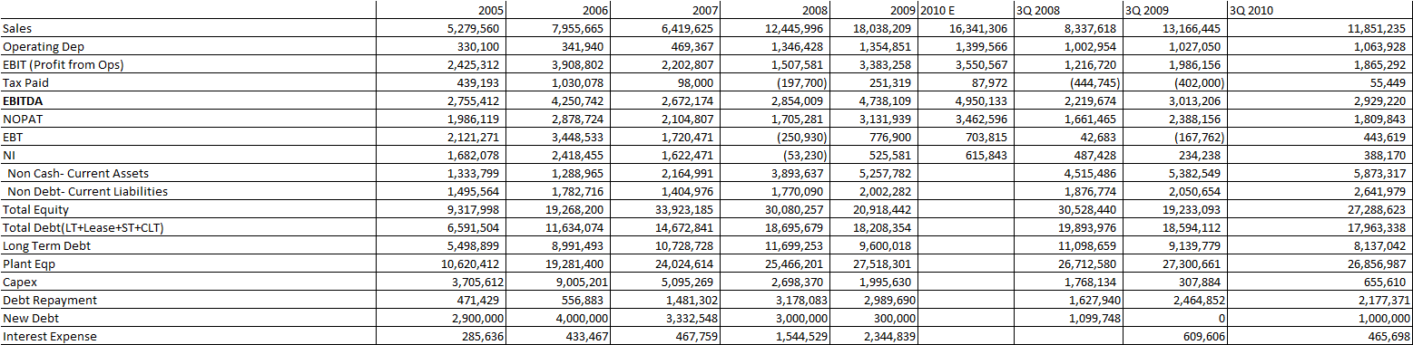
DG Financial statements 2008, 2009 and 3Q 2010

Above are the actual figures from the company’s financial statements used for valuation purposes.

Effective Price of Cement Per ton:

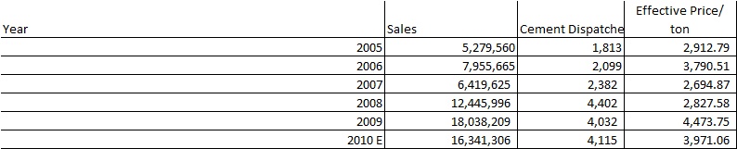
Table ‎5-1 Effective Cement sales price of DG cement
Financial Statement of DG 2005-10

Effective price of cement per tons show that how much company earned on sale of each ton of cement blended (local and export dispatches). These figures clearly shows that the effective sale price on FY09 was much higher than any of the year in consideration backed by strong local retention prices as shown in the previous section as well as the exchange rate fluctuation put a strong positive influence. Though the sale declined but company manages to increase its sales by Rs. 5.5 billion.

Debt Repayment Schedule
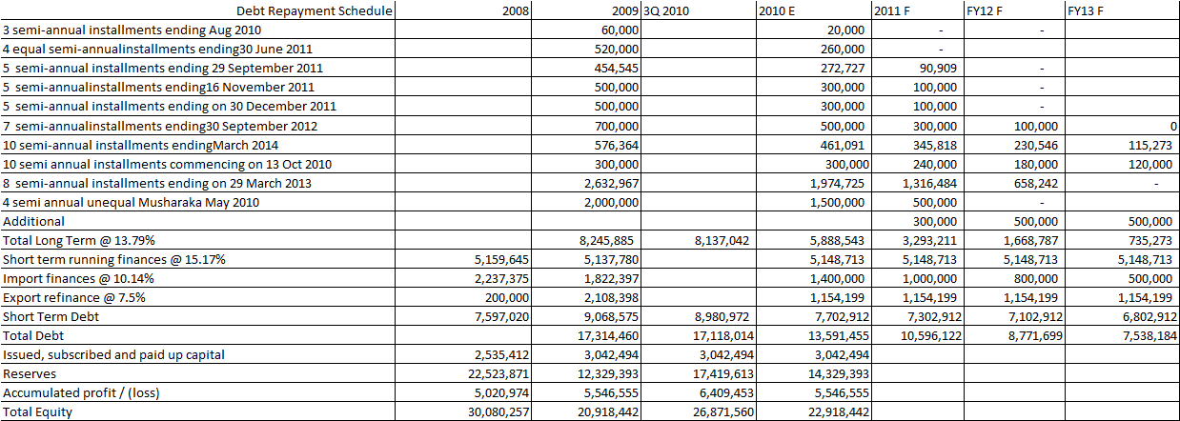
Table ‎5-2 Debt Repayment Schedule of DG cement
Financial Statements of DG 2009 and 3Q 2010

During the current FY10, company only got Rs. 300 million new long term loan from Habib bank, and we expect that company will be able to raise this figure to Rs. 500 million in next periods under consideration. It is noticeable that approximately on Rs. 735 million long term loan portfolio will be left on the balance sheet of the company which helps to understand; the company is not in a plan of any capital project execution in near future.

Valuation Model Inputs
Marker Risk Premium, Risk Free Rate & Beta:
Market Risk Premium | 5.5%
Risk free rate (PIB 10yrs, May 2010) | 12.65%
KIBOR 6 month | 12.79%
www.sbp.org.pk

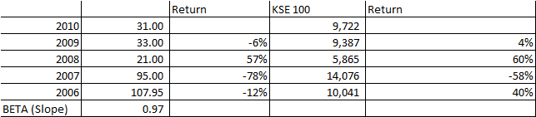
Table ‎5-3 Beta Calculations
www.sbp.org.pk

Explanation of Important Inputs:
Effective Tax rate | 32%
Cost of Equity | 18.01%
Cost of Debt | 8.96%
WACC | 13%
Growth | 3%
The average effective tax rate for the last 3 years is 32% of the EBT, the cost of equity is quite high because of high risk free rate (PIB: 12.65%) and market risk premium standing at 5.5%, cost of debt is based on having net tax effect of 35% nominal rate, and the same is used for weighted average cost of capital (WACC) calculations. The weights are based on market value for the equity in WACC calculation model and book value of debts been considered.

Reinvestment Rate:
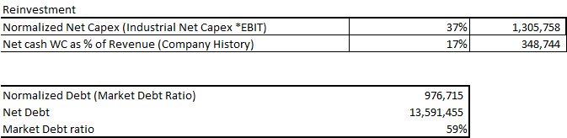
Table ‎5-4 Reinvestment rate for firm and equity
The capex spending are been normalized for DCF model, because as the company’s own capex comes out to be 70% of EBIT which is quite high from the industrial norm standing at 37%, so there was a desperate need to normalize these spending at industrial level.
Net working capital needs are also to be normalized on the company’s historical patterns, and this can’t be normalized to industrial average because every company has different cement manufacturing plants and each has its own specifications.
Debts are been calculated on the new debt ratio estimated for FY10, because as it is been already discussed that major portion of long term debt will be wipe out after the growth period, which is mainly called growth phase because of waste heat recovery power plant. The figure of normalized debt is based on the assumption that the company will maintain the debt ratio during growth phase and on the basis of that the reinvestment requirements of firm will be financed through debt.

Free Cash Flow (FCF):
For the purpose of free cash flow estimations two methods been adopted free cash flow to firm (FCFF) and free cash flow to equity (FCFE). The major assumption for growth period selection is capital expenditure on waste heat recovery power plant which will push the firm into positive growth.
Growth Rate=Return on capital* Reinvestment rate for the firm
Which shows a growth of -0.93% during the FY10E, for terminal value growth rate FCF cannot be more than the growth rate of the economy in which it operates, hence 3% growth rate in the company’s figure is expected for the future transactions.
The flow of growth rate and reinvestment rate shows a movement towards the terminal estimates and reinvestment rate RR(firm) for the terminal year is been calculated through the following formula
RR (firm)= Growth/ROC
Table ‎5-5 FCFF model DG cement
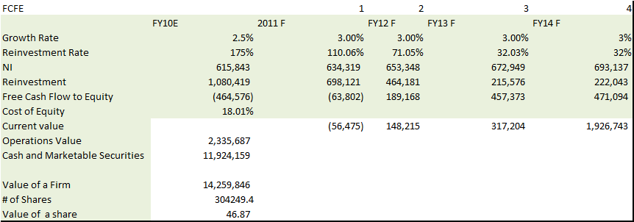
Table ‎5-6 FCFE model DG cement
Both of the estimates shows that the value per share is expected to increase from current level of Rs 31, so a buy stance is recommended.

Lucky Cement:

Summary of Balance Sheet and Income Statement:

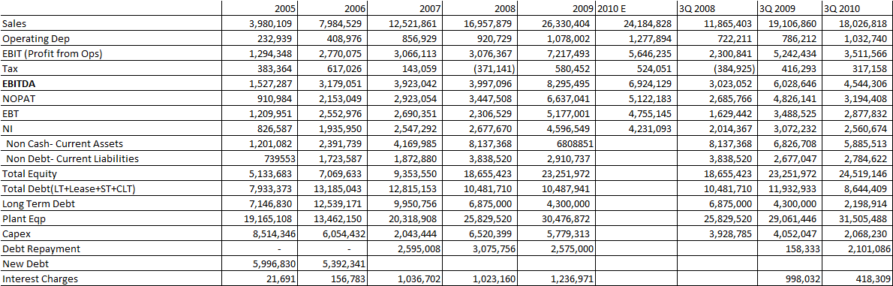
(Lucky Financial Statements of 2005 to 3Q 2010)

Effective Price of Cement Per ton:
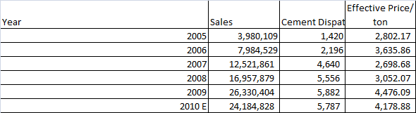
Table ‎5-7 Effective Cement sales prices of Lucky cement
In case of Lucky, effective cement price for the FY08 and FY09 do have significant difference, which is mainly because of export driven effective price of cement per ton and the exchange rate jump from FY08 level to FY09 level.

Debt Repayment Schedule:
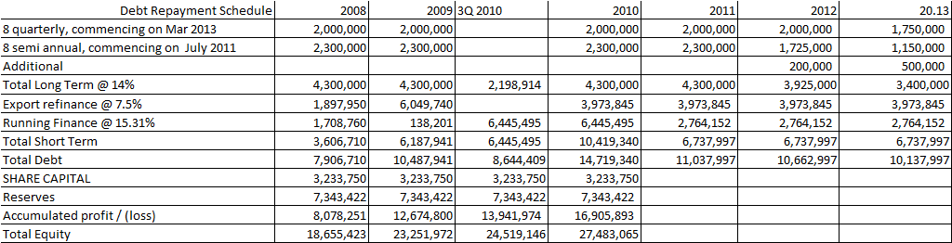
Table ‎5-8 Debt Repayment Schedule Lucky cement
Financial Statements of Lucky cement 2008 to 3Q 2010

As the expansionary phase passes by the long term loan portfolio will decrease substantially on balance sheet, which shows that company do not have further capital expenditure plans after waste heat recovery power plant. The rates of debts been calculated on the basis of debt rates provided in financial statements.

Important Inputs

Marker Risk Premium, Risk Free Rate & Beta:
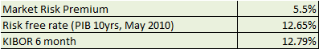
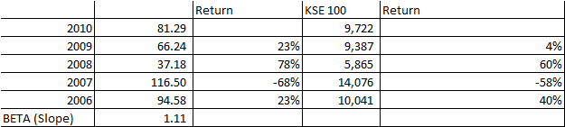
Table ‎5-9 Beta calculations for Lucky cement

Explanation of Important Inputs:
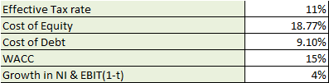

Reinvestment Rate:
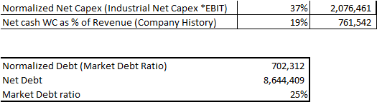
Table ‎5-10 Reinvestment rate for firm and equity of Lucky cement
Capex for Lucky is been normalized to industrial average because if we take historical average of reinvestments it comprised of 74% of the EBIT which is not possible for the firm moving towards stable phase.
There is also a need to normalize net working capital of the firm on the historical trends which is considered to be the true representative of the company norm.
Debts are been calculated on the new debt ratio estimated for FY10, because as it is been already discussed that major portion of long term debt will be wipe out after the growth period, which is mainly called growth phase because of waste heat recovery power plant. The figure of normalized debt is based on the assumption that the company will maintain the debt ratio during growth phase and on the basis of that the reinvestment requirements of firm will be financed through debt.

Free Cash Flow (FCF):
For the purpose of free cash flow estimations two methods been adopted free cash flow to firm (FCFF) and free cash flow to equity (FCFE). The major assumption for growth period selection is capital expenditure on waste heat recovery power plant which will push the firm’s operating and NI to further new level.
Growth Rate=Return on capital* Reinvestment rate for the firm
This investment will put a growth factor of approx. 10% in NOPAT and will reach stable growth phase at 4% which is based on the assumption that Lucky will drive extra benefit from the export margin and hence enjoy more growth than rest of the industry.

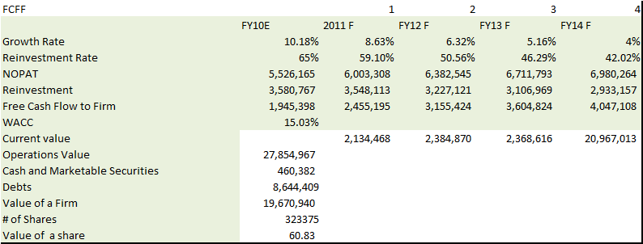
Table ‎5-11 FCFF model of Lucky cement
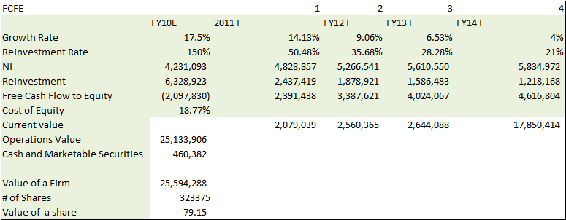
Table ‎5-12 FCFE model of Lucky cement
As these estimations show that the future value of lucky will be lower than its current market value of Rs. 81 per share, hence a selling stance can be establish after FCF estimations.

Action Plan

Discounting method as an alternative method:
We have used different methods for the fair value estimation in the cement sector the best option that came out is a discounting cash flow method. The best thing in this method is that this method expresses the future cash earnings impact on present value of a business. This method works only when it comes to future cash flows which are later discounted into present value at the discount rate which should be influenced by the economical and other factors. DCF method also takes other factors into account which has to be considered for evaluation.
This method involves all the free cash flows into account available to stake holders. As mentioned above that discount rate are used based on risk factors reflecting economical environment and others factors as well in the end this results in perception for business risk which is later account for in the DCF method. Even the valuation of plant and equipment takes a vital role during the DCF valuation.
Valuation of firm also gets the impact of intangibles like market share, competition and firm’s impression on market, one cannot convert this into money value or in money terms so the DCF method is the method that takes these factors into account. This we have done during our forecasting based on fundamentals analysis and our assumptions. As far as these assumption are concern we made it of market share, cost reduction planning like waste heat recovery, trading and manufacturing etc which is later converted into financial definition.

Drawbacks of Multiples

Price Earnings:
These ratios are measured on the relative basis with the historical impact and this reflects the analysis skewed by the benchmark that is being used. After some time period there would be a time when whole industry will face overvalued scenario which being less expensive than a benchmark, doesn’t mean that it is cheap because there might be chances that that benchmark itself might be overpriced.
There are few factors affecting the PE ratio e.g. any firm that has sold one of its businesses would have artificially inflated Earnings and a lower PE as a result. Another factor that is PE ratio which could be wrongly estimated high or low due to the reported earnings inflated buy one time accounting charges and gains.

EBITDA:
One of the most drawback not to use it for evaluation is it does not involves taxes and interests, which are cash items because companies have to pay interest and taxes in cash. It also doesnot exclude all non cash items only the depreciation and amortization are excluded as its name shows. Bad-debt allowances, inventory write downs, and the cost of stock options are not adjusted for EBITDA among all non items.
In DCF we have proper measurements of cash flow but here we don’t have, due to which changes in working capital are being ignored. More investments in working capital consume cash. Lets talk about the earnings in EBITDA. In public company limited EBITDA would be misleading when it comes to earnings of those public firms that are over or under reserved for warranty costs or restructuring expenses would be skewed.
Through EBITDA it makes company look less expensive that it really is. When analysts look at the stock price multiples of EBITDA rather than bottom line earnings, they produce lower multiples.

References
- Explaining Returns with Cash Flow Proxies, Peter Hecht 2005
- Campbell, J. Y., & R. J. Shiller, 1988, "The Dividend-Price Ratio and Expectations of Future Dividends and Discount Factors," Review of Financial Studies, 1, 195-228.
- Campbell, J. and R. J. Shiller, 1998, "Valuation Ratios and the Long-Run Stock Market Outlook," The Journal of Portfolio Management, Winter 1998
- (John R. Ezzell and R. Burr Porter. "The Weighted Average Cost of Capital: Some Questions On Its Definition, Interpretation and Use: A Comment." Presented at the 1974 Annual Meeting of the Midwest Finance Association.)
- (Charles M. Linke and Moon K. Kim. "More on the Weighted Average Cost of Capital: A
- Comment and Analysis." Journal of Financial and Quantitative Analysis (forthcoming).)
- (THE COST OF CAPITAL AS A WEIGHTED AVERAGE...TIMOTHY J. NANTELL* AND C. ROBERT CARLSON* 1975).
- (Kim, Moonchul, and Jay Ritter, 1994, Earnings, book value, and comparable firms in the valuation of IPOs, Working paper, University of Illinois, Champaign, Illinois.)
- (Equity Valuation Using Multiples JING LIU,* DORON NISSIM,t AND JACOB THOMASI Received 2 January 2000; accepted 27July 2001).
- EVA versus Earnings: Does It Matter Which Is More Highly Correlated with Stock Returns? GERALD T. GARVEY AND TODD T. MILBOURN 2000).
- (Bogue, M. C, and R. Roll. "Capital Budgeting of Risky Projects with Imperfect Markets for Physical Capital." Journal of Finance, 29 (May 1974), 601-613).
- (THE PRICE IS (ALMOST) RIGHT, Randolph B. Cohen Christopher Polk, Tuomo Vuolteenaho.2003).
- (The CAPM is Wanted, Dead or Alive EUGENE F. FAMA and KENNETH R. FRENCH*1996)
- (The Valuation of Cash Flow Forecasts: An Empirical Analysis, STEVEN N. KAPLAN and RICHARD S. RUBACK*1995).
- Weekly petroleum prices status, 2010.Retrieved from http://www.eia.doe.gov/emeu/international/prices.html#Crude
- Hike in furnace oil price pushes up cost of power generation, May 2010. Retrieved from http://www.onepakistan.com/finance/news/pakistan-business-general-news/6386-Hike-furnace-oil-price-pushes-cost-power-generation.html
- Crude Oil (petroleum) Monthly Price, 2010. Retrieved from http://www.indexmundi.com/commodities/?commodity=crude-oil&months=60
- Coal, Australian thermal coal Monthly Price, 2010. Retrieved from
http://www.indexmundi.com/commodities/?commodity=coal-australian&months=60
- CPI index, 2010. Retrieved from http://www.statpak.gov.pk/depts/fbs/statistics/price_statistics/monthly_price_indices/mpi4/mpi.htm
- Farhan Sharif, 2010. Retrieved from http://www.bloomberg.com/news/2010-07-13/thatta-cement-plans-to-double-capacity-as-pakistan-overseas-demand-rises.html
- Coal prices to surge in 2010 despite ample supply, Oct 2010. Retrieved from http://www.commodityonline.com/news/Coal-prices-to-surge-in-2010-despite-ample-supply-22154-3-1.html
- Local FO prices drop, imported up, Feb 2010. Retrieved from http://www.dailytimes.com.pk/default.asp?page=2010\02\02\story_2-2-2010_pg5_10
- Razi Syed, Increase in policy rate to affect borrowers, Aug 2010. Retrieved from http://www.dailytimes.com.pk/default.asp?page=2010\08\03\story_3-8-2010_pg5_10
- Habib-ur-Rehman, Manufacturing, Economic Survey of Pakistan 2009-10. Retrieved from http://www.finance.gov.pk/survey/chapter_10/03_Manufacturing.pdf
- India Brand Equity Foundation, 2010. Retrieved from http://www.ibef.org/industry/cement.aspx
- Global Economic Prospects, 2010. Retrieved from http://siteresources.worldbank.org/INTGEP2010/Resources/GEP2010Summer2010-SARAnnex.pdf

Annexure:
Lucky Cement:
Balance Sheet:
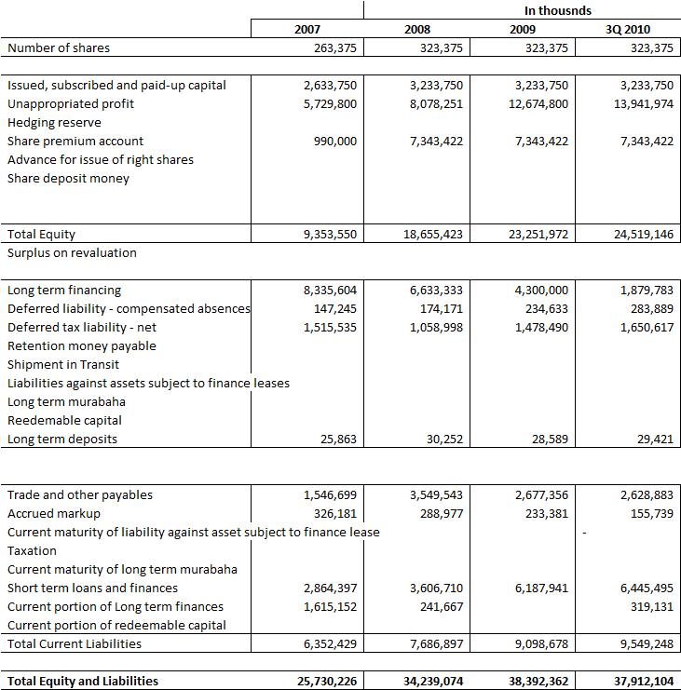
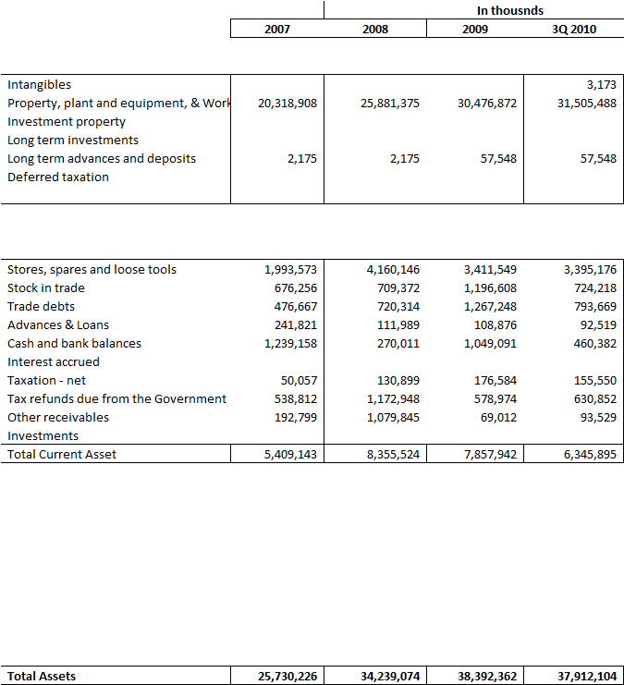

Income Statement:
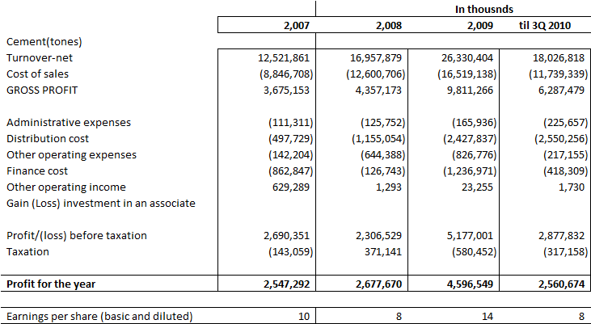

DG Cement:
Balance Sheet:
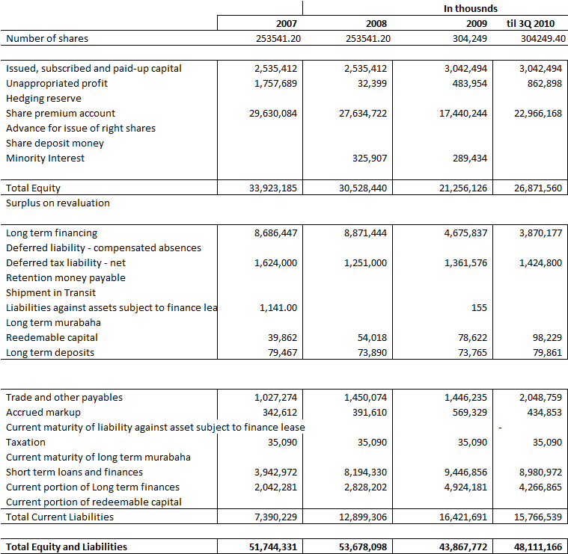
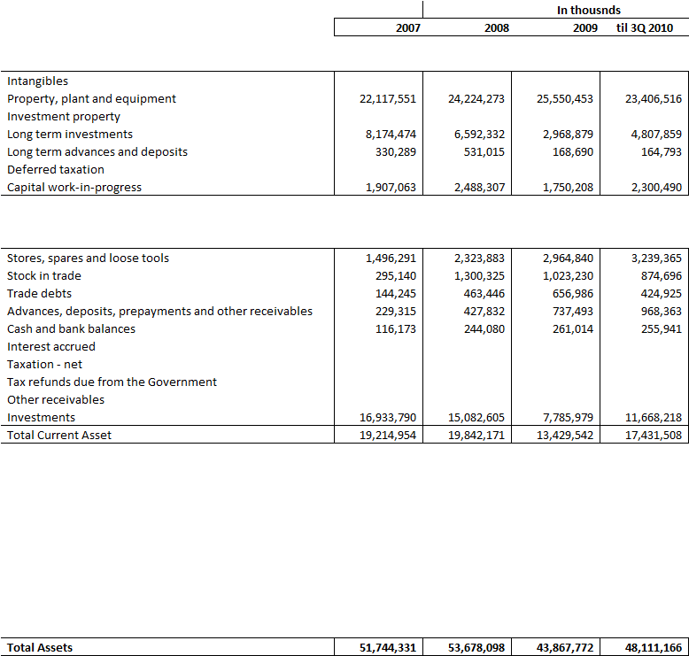

Income Statement:
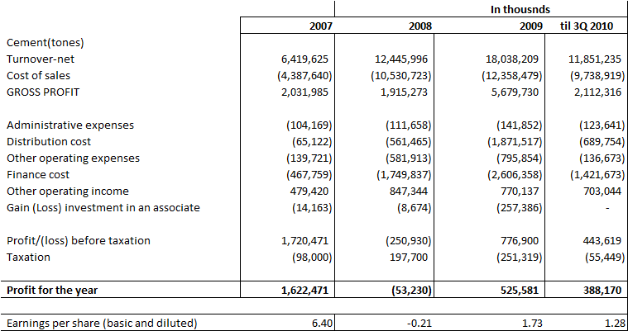

Attock Cement:
Balance Sheet:
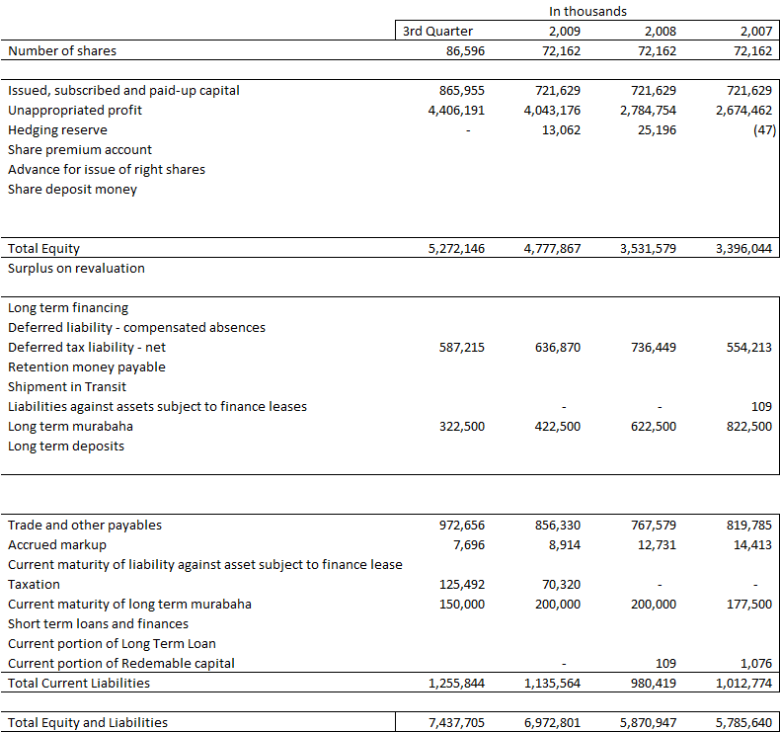

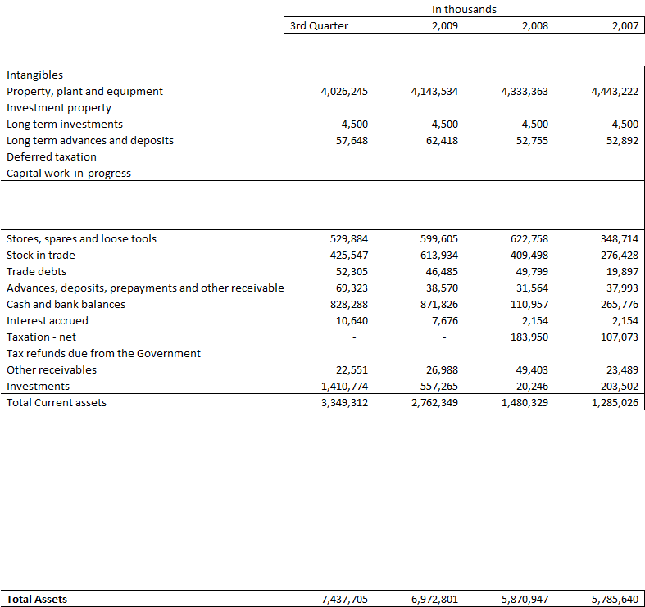

Income Statement:

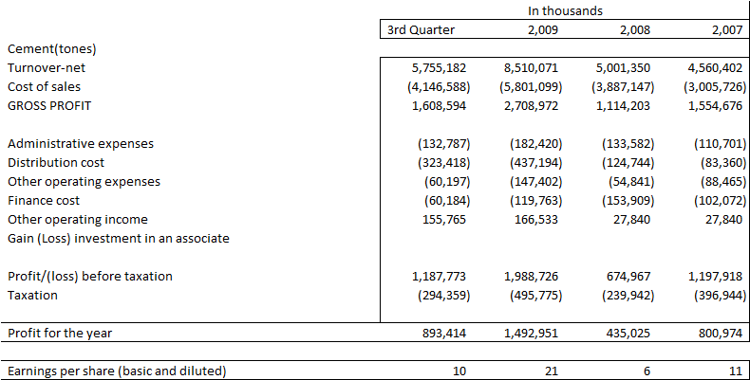

Bestway Cement:
Balance Sheet:
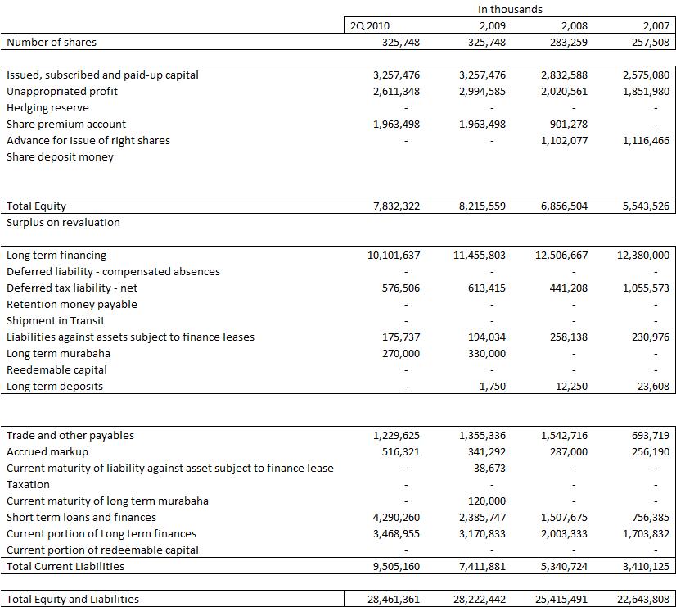
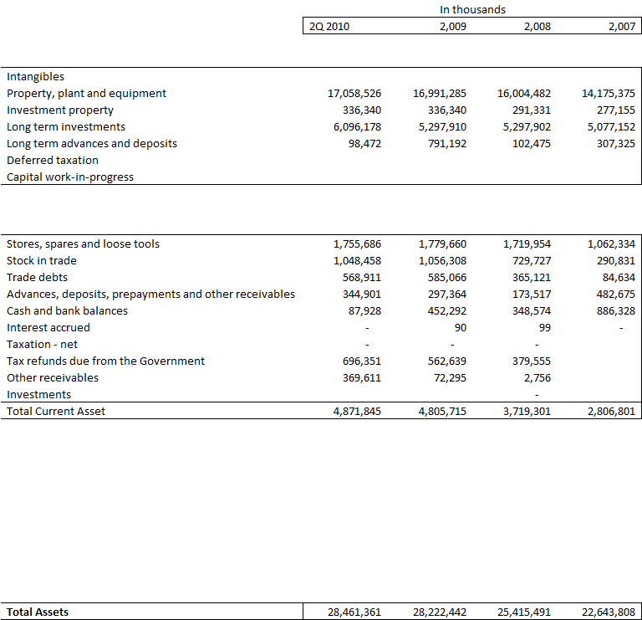

Income Statement:
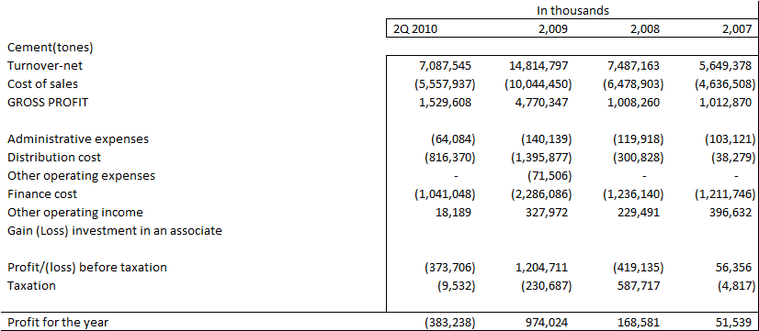

Fauji Cement:
Balance Sheet
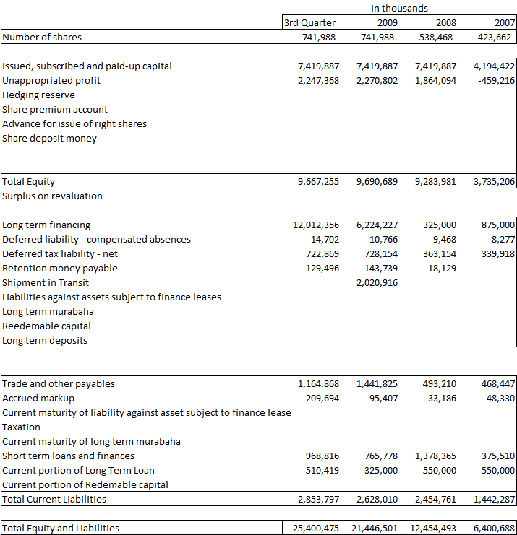
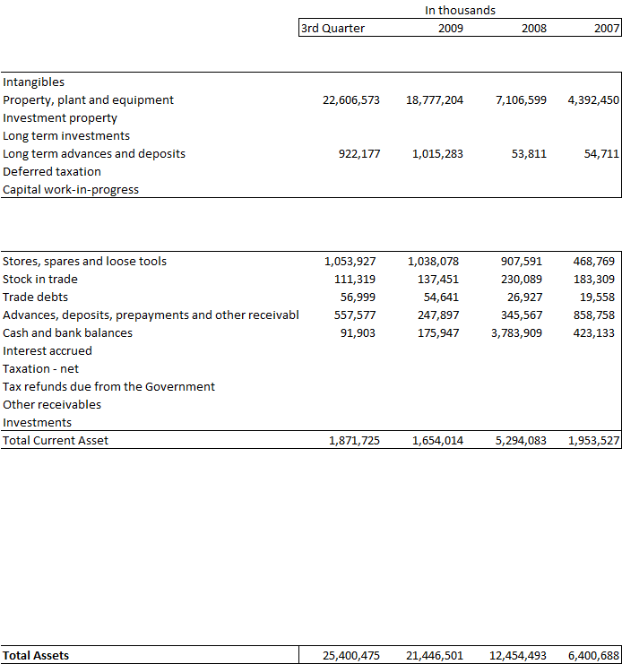

Income Statement:
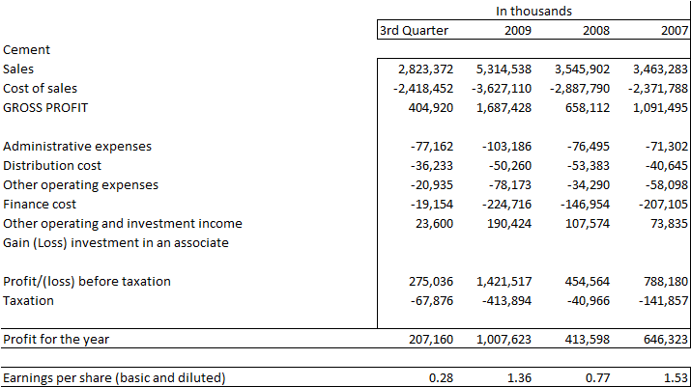

WACC Calculation Model:
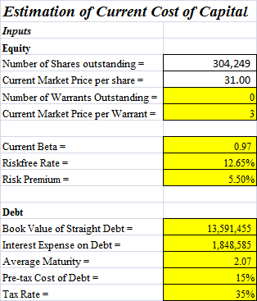
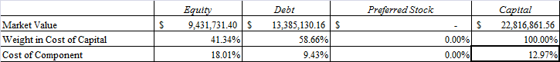
Note: this is an excel based model, and inputs vary with the company

