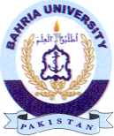Bahria University Library Islamabad
Source: Dawn & Jang, Sunday Oct 22, 2023

