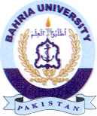Bahria University Library Islamabad
Source: Jang, Thursday Oct 05, 2023

