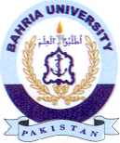
Bahria University Library Islamabad
Source: Pak Observer Saturday Jul 08, 2023

