
Bahria University Library Islamabad
Source: Nai Baat Saturday Jul 08, 2023

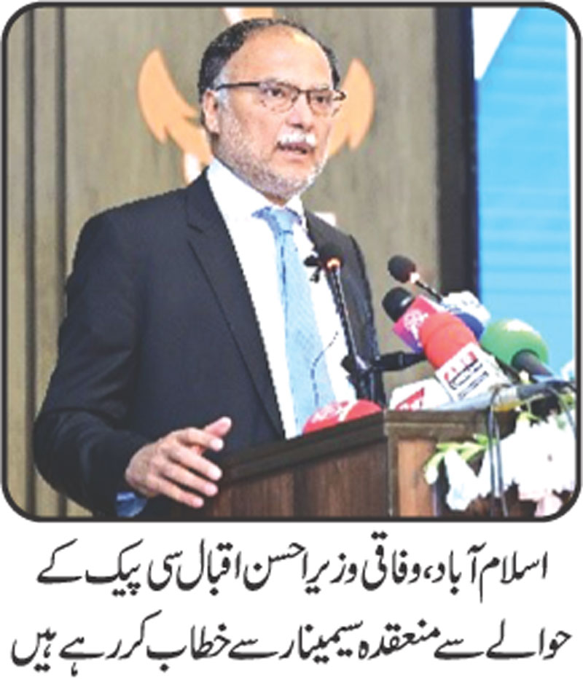

Bahria University Library Islamabad
Source: Nai Baat Saturday Jul 08, 2023

