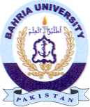
Bahria University Library Islamabad
Source: Express, Sunday Jul 09, 2023

