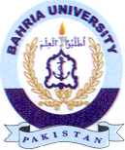
Bahria University Library Islamabad
Source: Express Tribune & Jang, Sunday July 16, 2023

