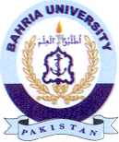
Bahria University Library Islamabad
Source: Express Tribune & Nawa-i-Waqt, Sunday May 28, 2023

