
Bahria University Library Islamabad
Source: Dawn, Sunday May 28, 2023

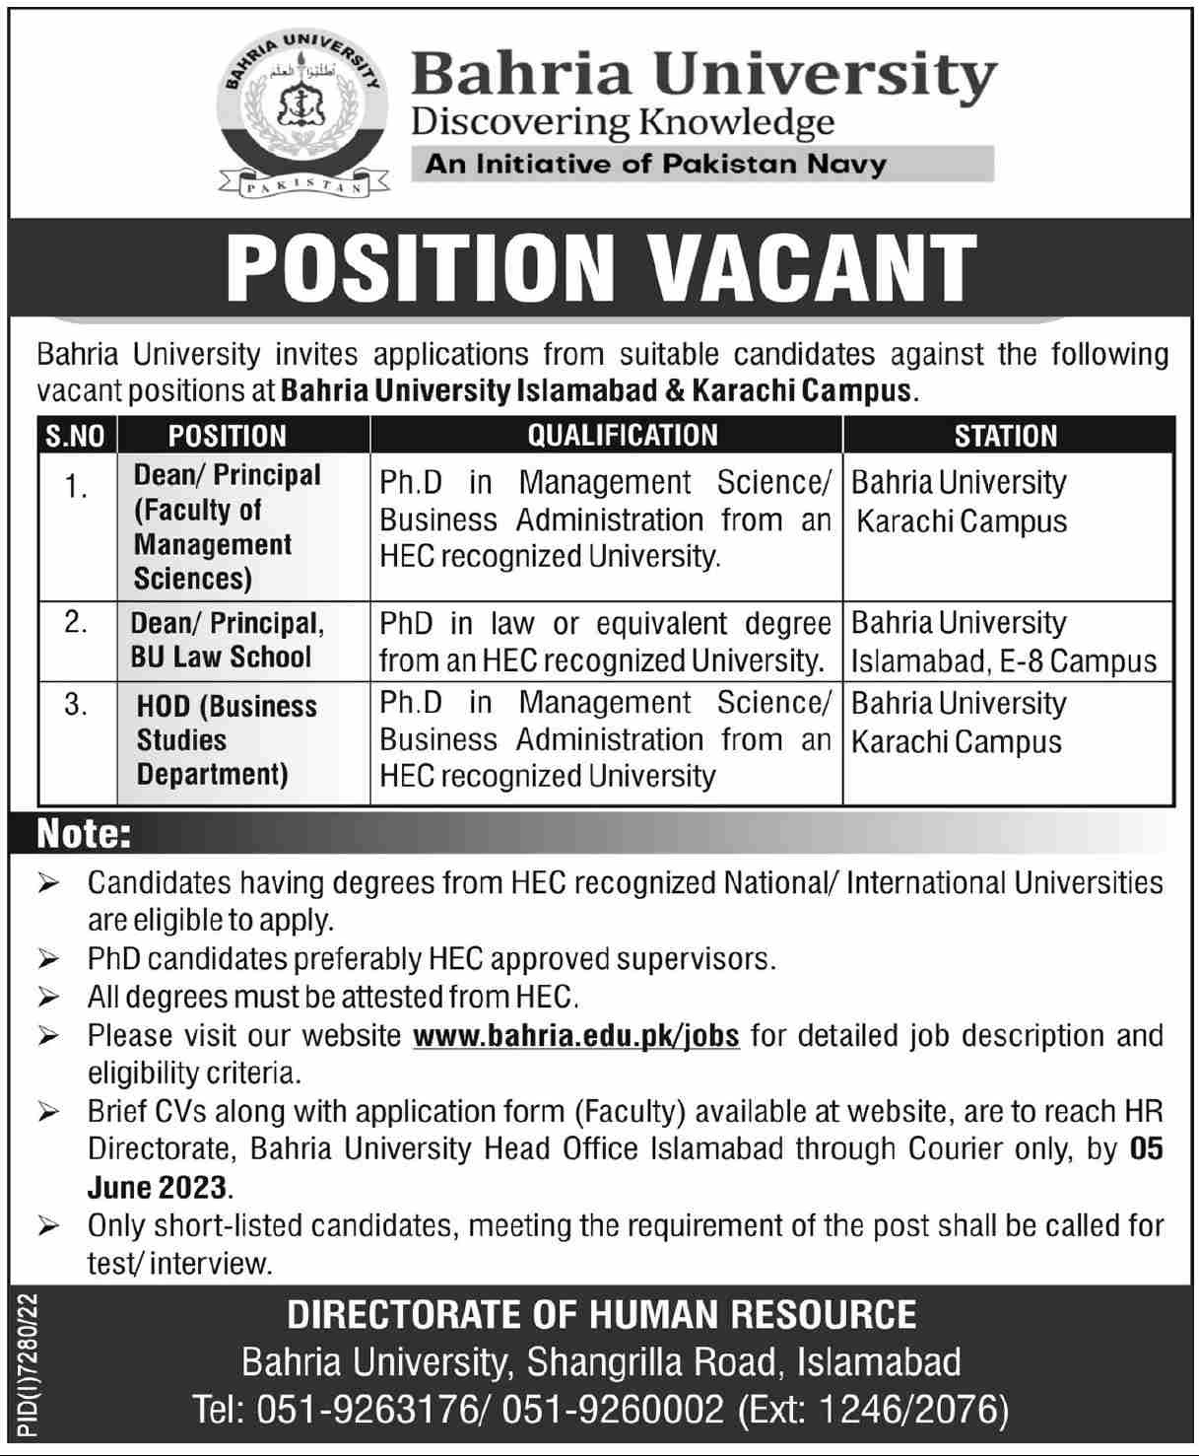

Bahria University Library Islamabad
Source: Dawn & Jang, Sunday May 28, 2023

