
Bahria University Library Islamabad
Source: Express Truibune, Friday May 26, 2023

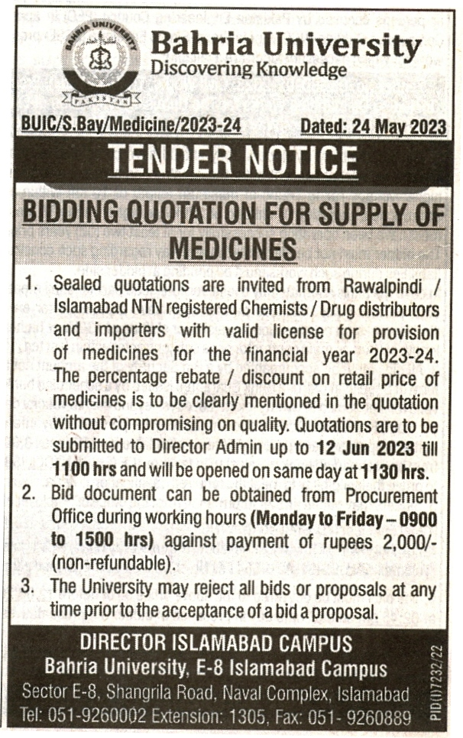

Bahria University Library Islamabad
Source: Nawa-i-Waqt, Friday May 26, 2023

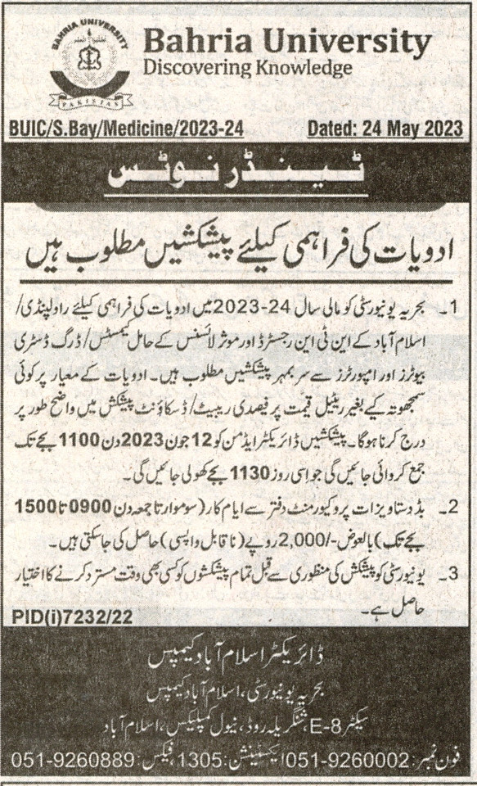

3

