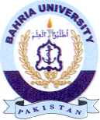
Bahria University Library Islamabad
Source: Express Thursday May 18, 2023

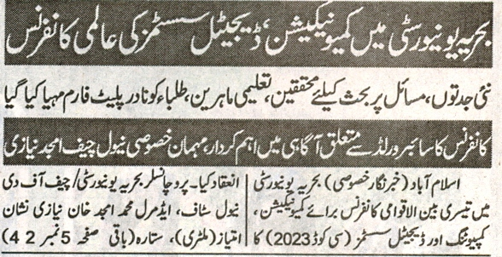
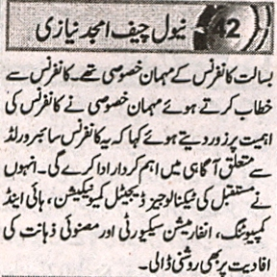

Bahria University Library Islamabad
Source: Nai Baat Thursday May 18, 2023

