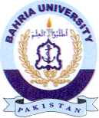
Bahria University Library Islamabad
Source: The News Thursday May 11, 2023

