
Bahria University Library Islamabad
Source: Pakistan Observer Saturday March 18, 2023

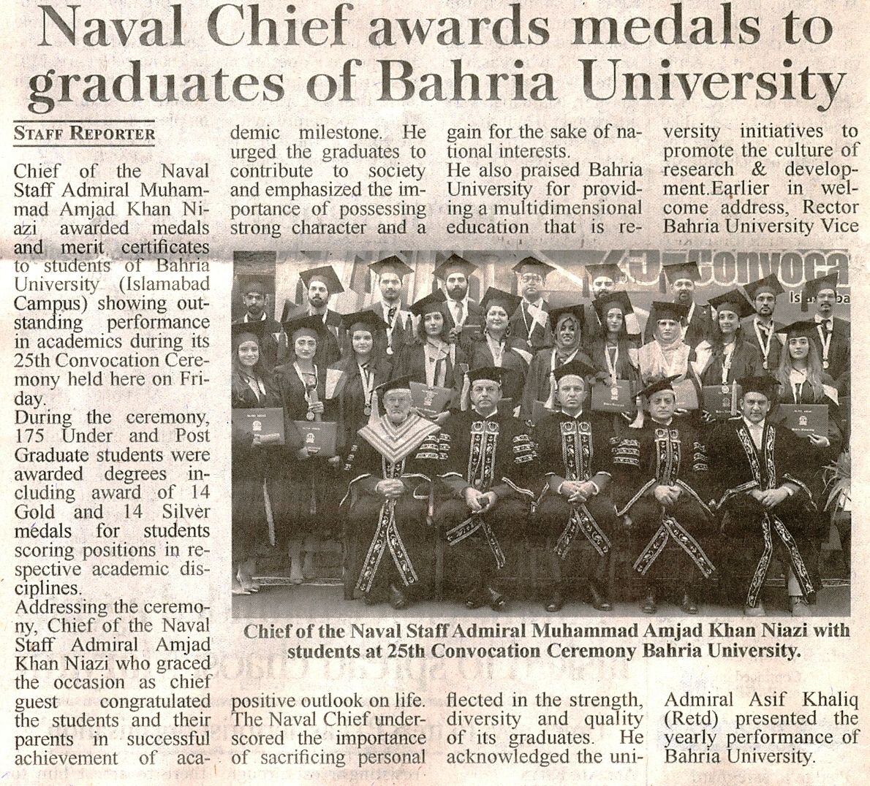

Bahria University Library Islamabad
Source: Nawa-i-Waqt Saturday March 18, 2023

