
Bahria University Library Islamabad
Source: The News, Saturday Mar 04, 2023

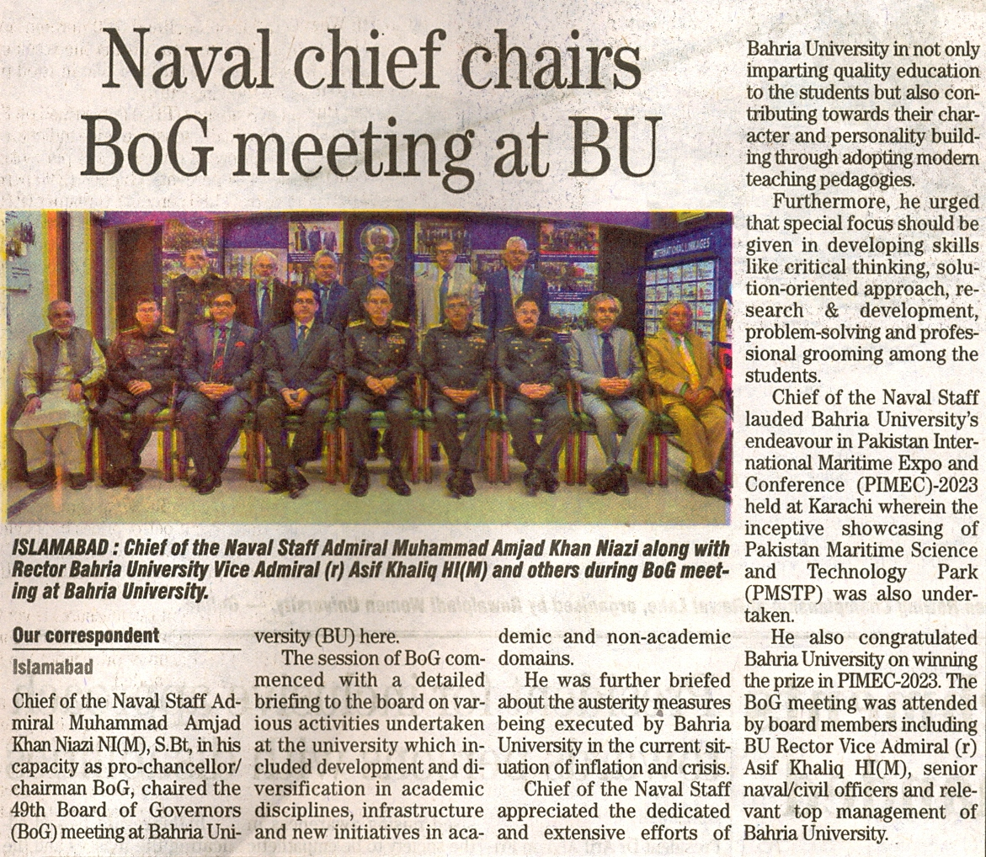

Bahria University Library Islamabad
Source: Pakistan Observer, Saturday Mar 04, 2023


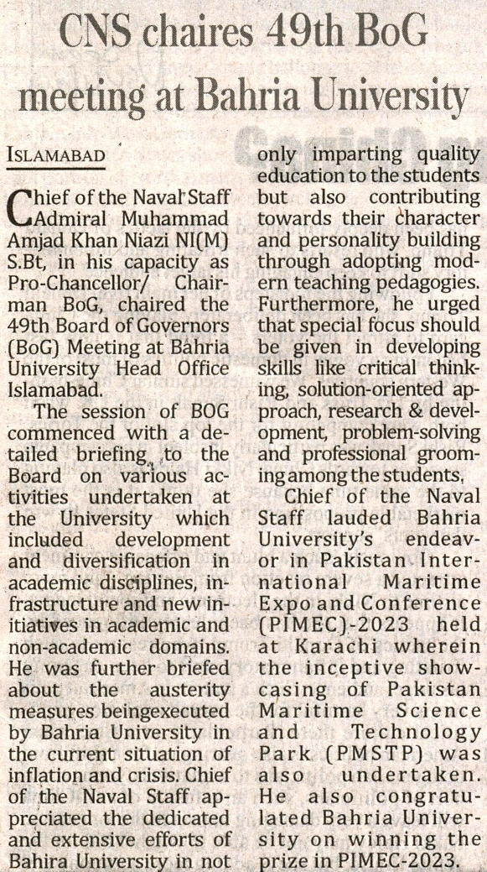

Bahria University Library Islamabad
Source: Jang, Saturday Mar 04, 2023

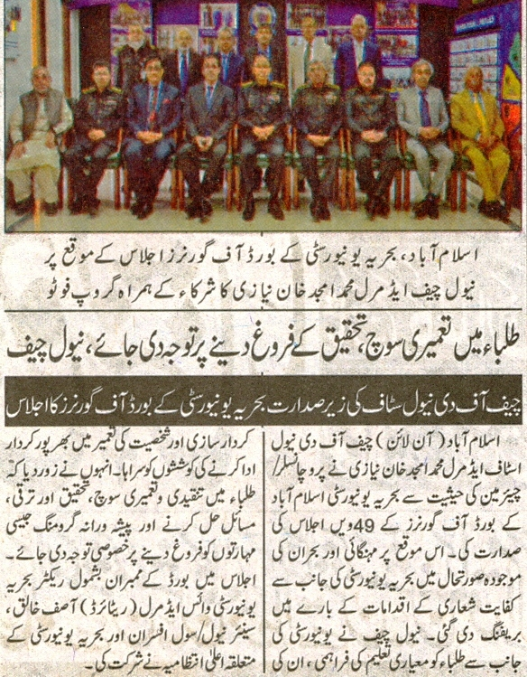

Bahria University Library Islamabad
Source: Dunya, Saturday Mar 04, 2023

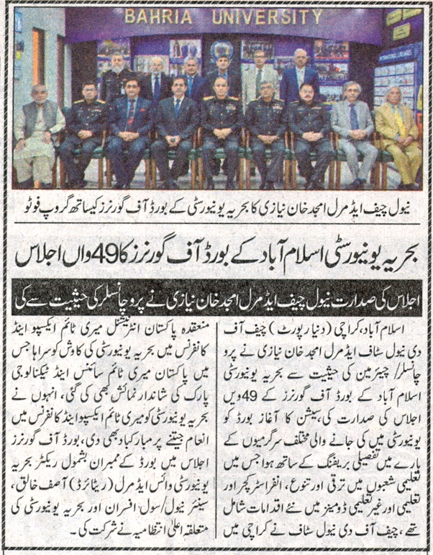

Bahria University Library Islamabad
Source: Express, Saturday Mar 04, 2023



Bahria University Library Islamabad
Source: Nai Baat, Saturday Mar 04, 2023

