
Bahria University Library Islamabad
Source: Dawn, Monday Feb 13, 2023

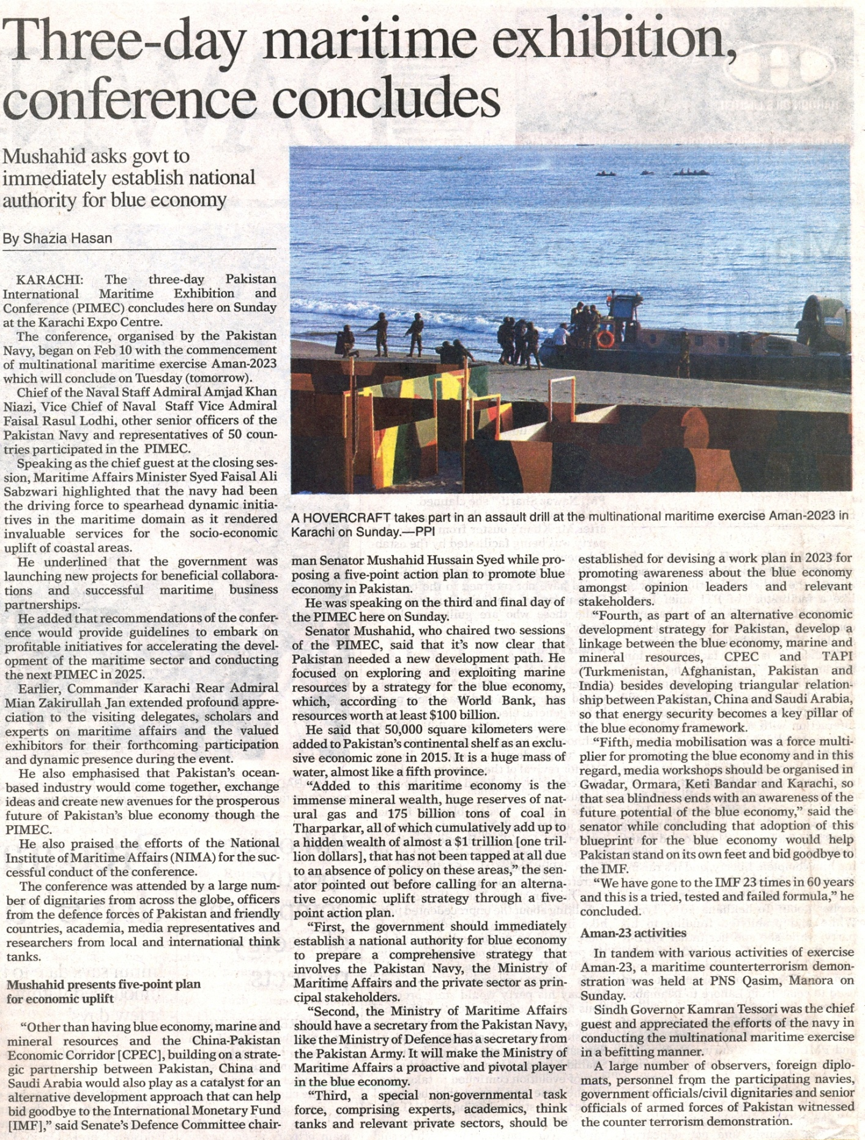

Bahria University Library Islamabad
Source: Daily Times, Monday Feb 13, 2023



Bahria University Library Islamabad
Source: Jang, Monday Feb 13, 2023

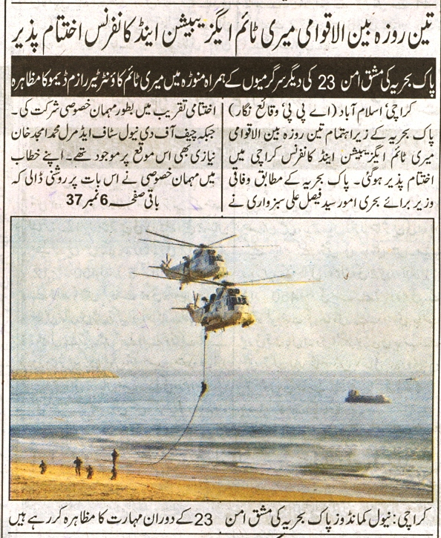
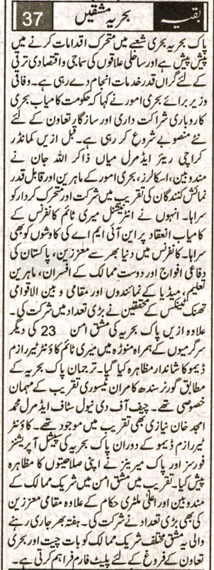

Bahria University Library Islamabad
Source: Dunya, Monday Feb 13, 2023


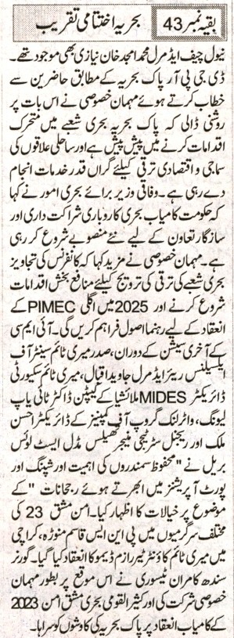

Bahria University Library Islamabad
Source: Express, Monday Feb 13, 2023


