
Bahria University Library Islamabad
Source: The Nation, Sunday Feb 12, 2023

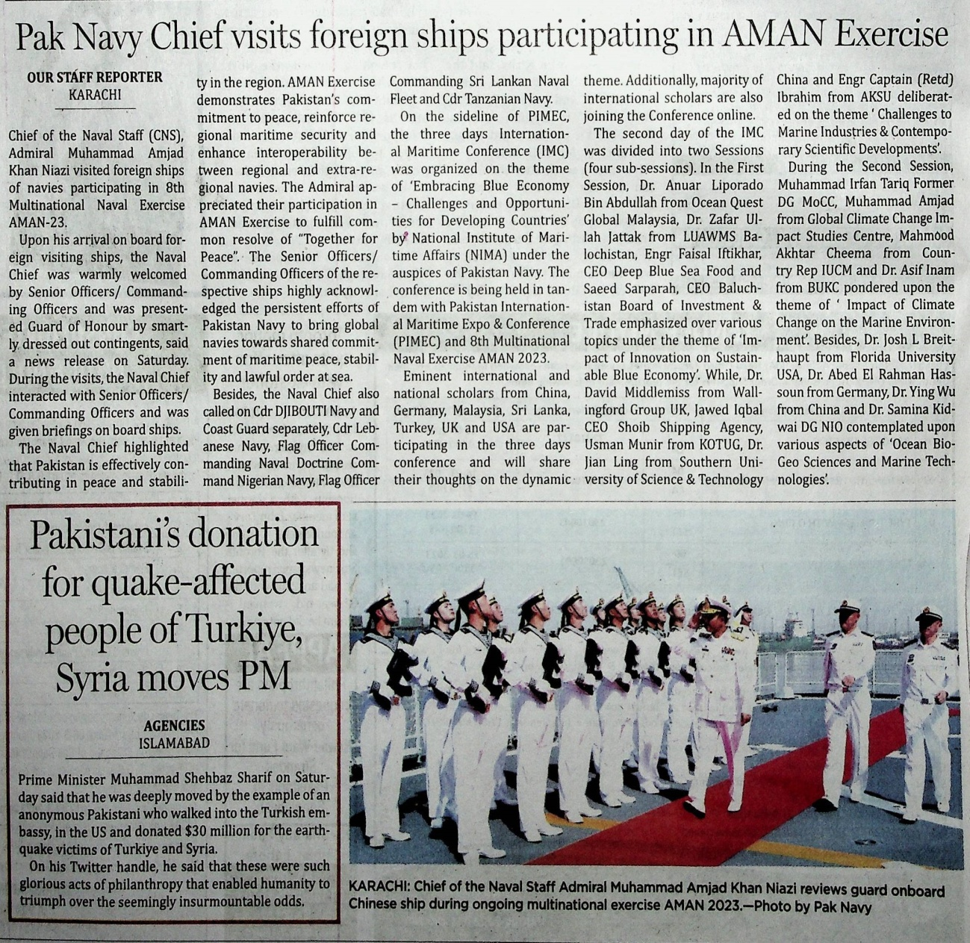

Bahria University Library Islamabad
Source: Frontier Post, Sunday Feb 12, 2023



Bahria University Library Islamabad
Source: Dunya, Sunday Feb 12, 2023

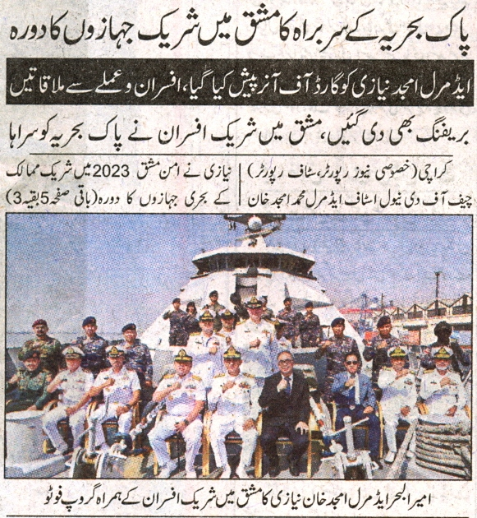
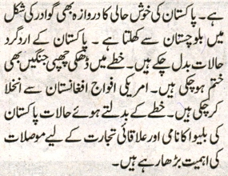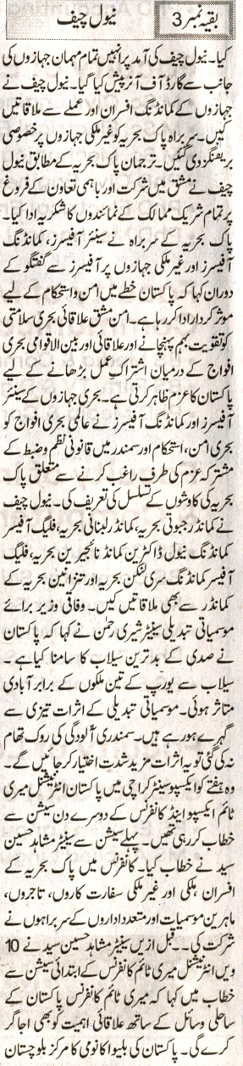

Bahria University Library Islamabad
Source: Nai Baat, Sunday Feb 12, 2023


